1. select * from customer_5 order by customername;
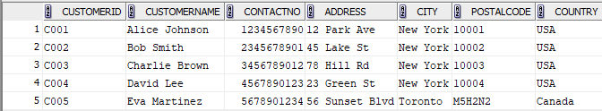

2. select * from orders_5 order by orderdate;
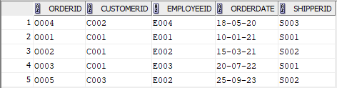

3. select * from employee_5 where DoB >='01-01-1981' order by DoB DESC;


4. select * from orders_5 where customerid in (select customerid from customer_5 where country='USA') order by OrderDate desc;
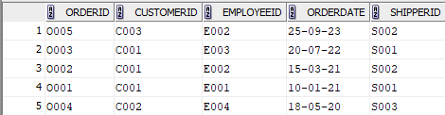

5. select distinct customerid, count(*) as total_orders from orders_5 group by customerid order by customerid;
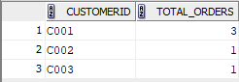
6. select city, count(customerid) as Total_Customers from customer_5 group by city;


7. select distinct customerid from orders_5 group by customerid having count(orderid)>2;


8. select distinct City from customer_5 group by city having count(customerid)>3;


