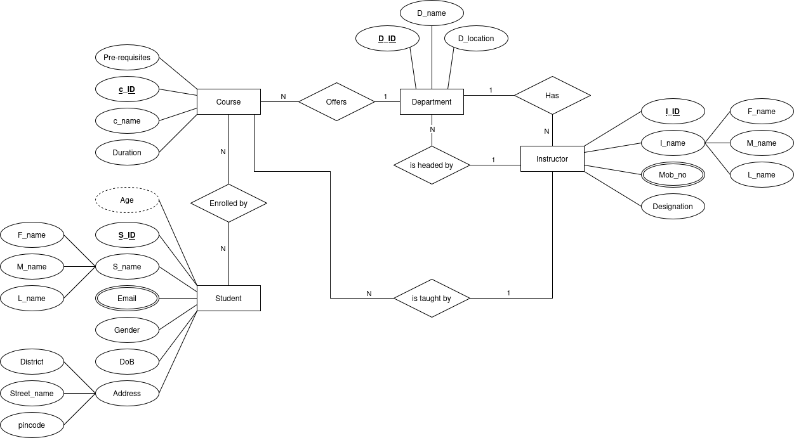

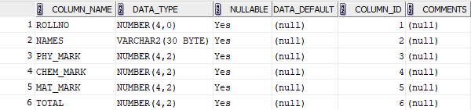
STUDENT TABLE:

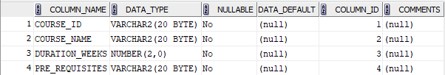
COURSE TABLE:

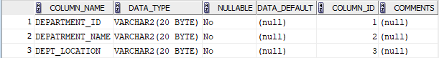
DEPARTMENT TABLE:

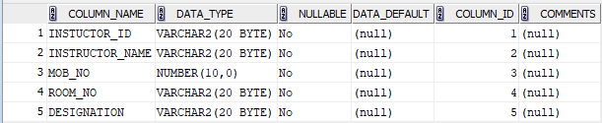
INSTRUCTOR TABLE:

