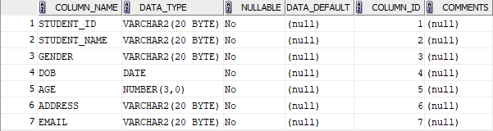
STUDENT

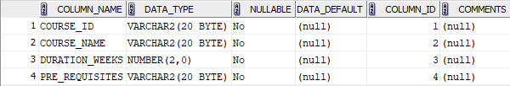
COURSE

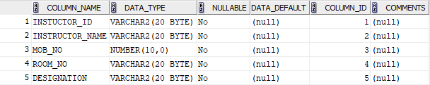
INSTRUCTOR

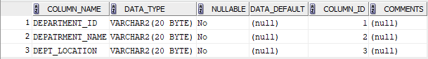
DEPARTMENT

