Employee Table:
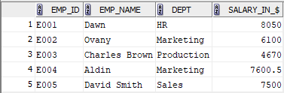

1. SELECT * FROM EMPLOYEE WHERE SALARY_IN_$>7000;
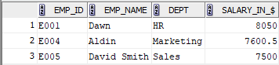

2. UPDATE EMPLOYEE SET SALARY_IN_$=8200.00 WHERE EMP_NAME='David Smith';
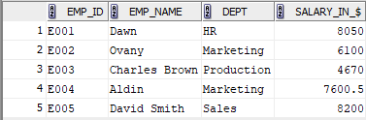

3. INSERT INTO Employee VALUES('E006', 'Daniel Harris', 'Production', 6700.00);
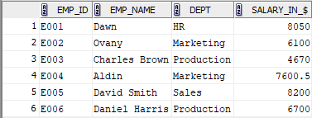

4. DELETE FROM EMPLOYEE WHERE EMP_ID='E003';
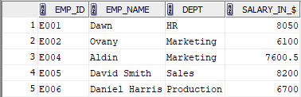
5. SELECT * FROM EMPLOYEE WHERE EMP_NAME NOT LIKE 'D%' AND EMP_NAME NOT LIKE 'O%';
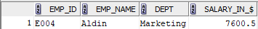

6. SELECT DEPT, SUM(SALARY_IN_$) FROM EMPLOYEE GROUP BY DEPT;
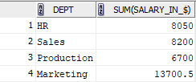

7. UPDATE EMPLOYEE SET SALARY_IN_$=salary_in_$+(0.05)*salary_in_$ WHERE DEPT='Production';
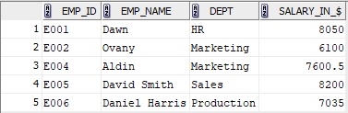

8. DELETE FROM EMPLOYEE WHERE SALARY_IN_$<7000;
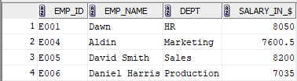

9. SELECT EMP_NAME, SALARY_IN_$ FROM EMPLOYEE WHERE SALARY_IN_$=(SELECT MIN(SALARY_IN_$) FROM EMPLOYEE);
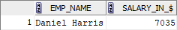

10. UPDATE EMPLOYEE SET SALARY_IN_$=8200.00 WHERE DEPT='Marketing';
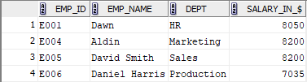

11. SELECT * FROM EMPLOYEE WHERE EMP_NAME LIKE 'A%';
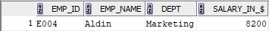

12. SELECT * FROM EMPLOYEE WHERE EMP_NAME LIKE '%it%';
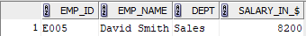

13. SELECT DISTINCT UPPER(DEPT) FROM EMPLOYEE;
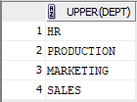

14. SELECT * FROM EMPLOYEE WHERE DEPT LIKE 'M_r%ket%';
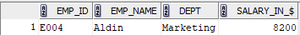

15. SELECT DISTINCT UPPER(REVERSE(DEPT)) FROM EMPLOYEE;
