Lab05 Python for Geoprocessing

Please copy the data to your owner folder.
Open ArcGIS Pro, create a new project, browse to your own data location, add monroe_county_major_roads.shp, monroe_county_wetlands.shp, Buffer.shp.

1 Manually set the geoprocessing environment variable
https://pro.arcgis.com/en/pro-app/latest/tool-reference/main/arcgis-pro-tool-reference.htm
https://pro.arcgis.com/en/pro-app/latest/tool-reference/environment-settings/what-is-a-geoprocessing-environment.htm

https://pro.arcgis.com/en/pro-app/latest/help/analysis/geoprocessing/basics/what-is-geoprocessing-.htm

Q1: Click ‘View’ Python window then input the code and see what happened.
>>> arcpy.analysis.Clip("monroe_county_wetlands.shp","Buffer.shp","wetlands_clip.shp")
Answer:
arcgisscripting.ExecuteError: Failed to execute. Parameters are not valid.
ERROR 000732: Input Features or Dataset: Dataset monroe_county_wetlands.shp does not exist or is not supported
ERROR 000732: Clip Features: Dataset Buffer.shp does not exist or is not supportedFailed to execute (Clip).
____________________________________________________________________

Q2: Input the following script.
>>> arcpy.analysis.Clip (r"C:\Users\Desktop\Lab05\monroe_county_wetlands.shp", r"C:\Users \Desktop\Lab05\Buffer.shp", r"C:\Users\Desktop\Lab05\wetland_clip.shp")
Answer:
<Result 'D:\\GeoDS\\7305\\lab\\Lab05_data\\Lab05_data\\wetland_clip.shp'>
____________________________________________________________________

Environment variable can be set in ArcGIS Pro or be defined in script.
On the ArcGIS pro ribbon Analysis Geoprocessing Environments
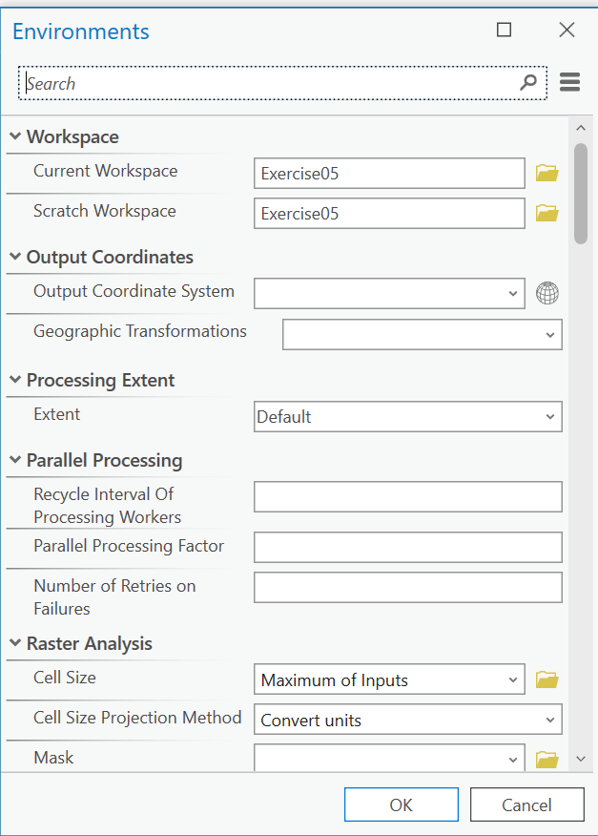

Set workspace
import arcpy
arcpy.env.workspace = r'C:\Users\Desktop\Lab05'
arcpy.env.scratchWorkspace = r'C:\Users\Desktop\Lab05'
arcpy.env.overwriteOutput = True
arcpy.analysis.Clip("monroe_county_wetlands.shp","Buffer.shp","wetlands_clip_1.shp ")
print('clip done')

Q3: After the environment setting, what happened when you input the script in Q1 again?
Answer:

<Result 'D:\\GeoDS\\7305\\lab\\Lab05_data\\Lab05_data\\wetlands_clip.shp'>

___________________________________________________________________________________

Q4: List out the advantages for this script(Q3) compares to the previous scripts(Q2).
Answer:

The Q3 script is much more efficient. By defining the workspace,I can use short filenames instead of typing long, repetitive paths for every tool. This makes the code cleaner and helps me avoid typing mistakes.
____________________________________________________________________________

2 Define variable on script
You can assign the value of a parameter to a variable, then use the variable in the code that calls the tool.
Open IDLE or vscode and input the following scripts and see what happened. Or you can input them in the txt file then change the extension from .txt to .py.
Clip_1
import arcpy
arcpy.env.workspace = r'C:\Users\Desktop\Lab05'
arcpy.env.scratchWorkspace = r'C:\Users\Desktop\Lab05'
arcpy.env.overwriteOutput = True

in_feature = "monroe_county_wetlands.shp "
clip_feature = "Buffer.shp"
out_feature = "wetlands_clip_1.shp"
xy_tolerance =""
arcpy.analysis.Clip(in_feature, clip_feature, out_feature, xy_tolerance)
print ("Finished clip process!")

Q5: Attach the screenshot of the result (shapefile in the ArcGIS Pro) in the following pages.
Answer: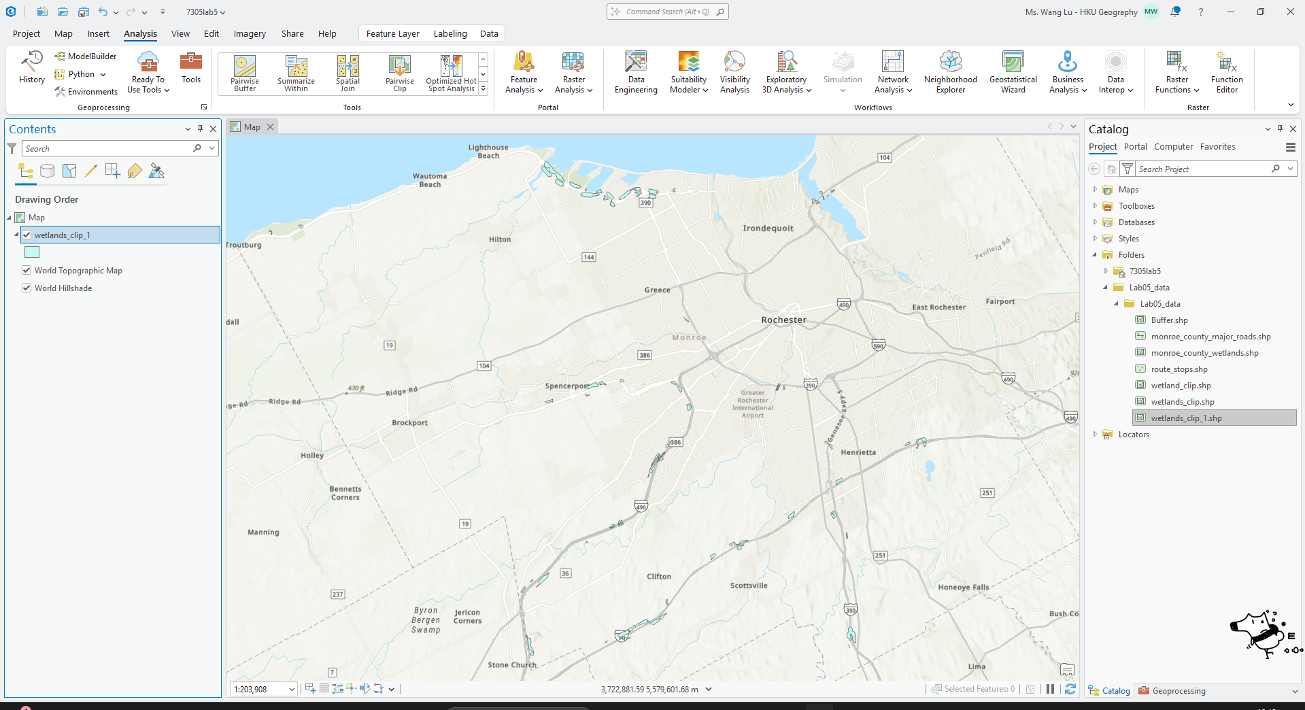

___________________________________________________________

3 Find the geoprocessing tools
ArcGIS Pro Analysis Tools Geoprocessing type in “clip”
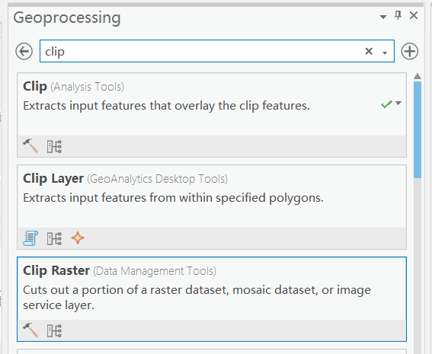
Select Clip (Analysis Tools)
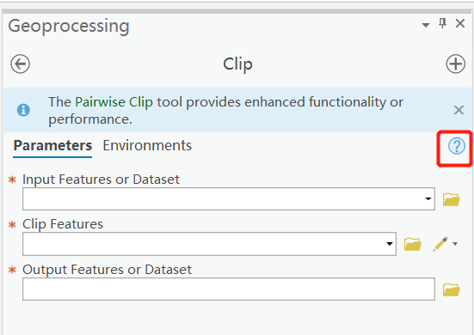
Click the button to show help
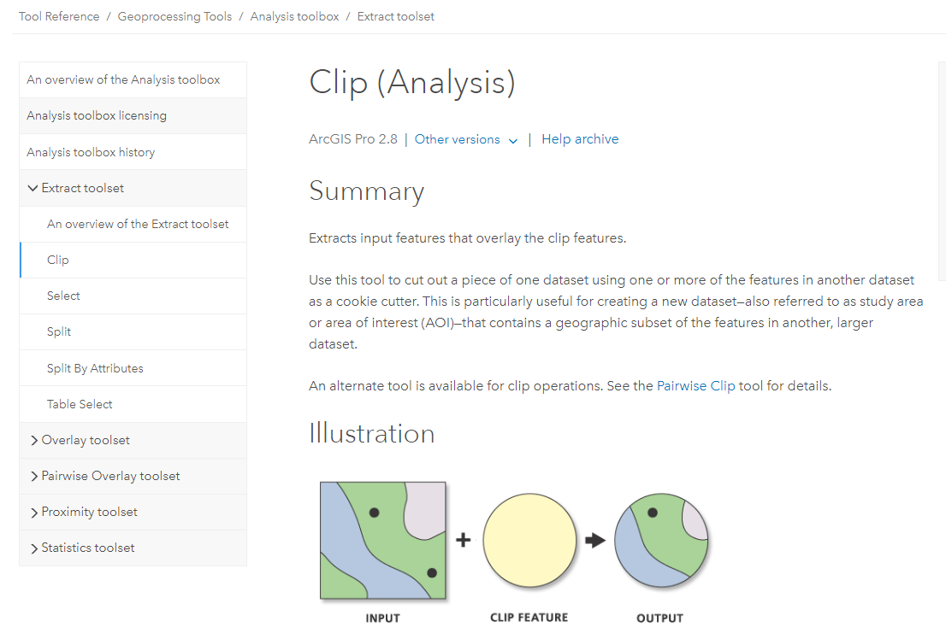

Parameters
arcpy.analysis.Clip(in_features, clip_features, out_feature_class, {cluster_tolerance})

Clip example 2 (stand-alone Python script)
The following Python script demonstrates how to use the Clip function in a stand-alone script
# Name: Clip_Example2.py
# Description: Clip major roads that fall within the study area.

# Import system modules
import arcpy

# Set workspace
arcpy.env.workspace = "C:/data"

# Set local variables
in_features = "majorrds.shp"
clip_features = "study_quads.shp"
out_feature_class = "C:/output/studyarea.shp"

# Execute Clip
arcpy.analysis.Clip (in_features, clip_features, out_feature_class)

Q6: What is the syntax for the “buffer” tool. What are the required parameters and optional parameters?
Answer:

Required Parameters: in_features,out_feature_class,buffer_distance_or_field
Optional Parameters:{line_side}, {line_end_type}, {dissolve_option}, {dissolve_field}, {method}

All the geoporcessing tools in ArcGIS Pro are the functions of ArcPy. There are also a number of ArcPy functions that are not in geoprocessing tools. Such as arcpy.Exists()

An overview of ArcPy functions—ArcGIS Pro | Documentation

Q7: Try the following code and put the result in the respective question.
import arcpy
res = arcpy.Exists(r"C:\Users\Desktop\Lab05\wetland_clip.shp")
print(res)

Answer:

False

Q8: Try the following code and put the result in the respective question.
Env : setting, lab05_env01.py
#enviroment setting
import arcpy

arcpy.env.workspace = r'C:\Users\Desktop\Lab05'
arcpy.env.scratchWorkspace = r'C:\Users\Desktop\Lab05'
arcpy.env.overwriteOutput = True

#print("The workspace now is in: {0} ".format(arcpy.env.workspace))
print(f'The workspace now is in: {arcpy.env.workspace}')
Answer:
The workspace now is in: D:\GeoDS\7305\lab\Lab05_data\Lab05_data
___________________________________________________________________________
Env: listing, lab05_env_list.py
import arcpy
environments = arcpy.ListEnvironments()

# Sort the environment names
environments.sort()

for environment in environments:

# Format and print each environment and its current setting.
# (The environments are accessed by key from arcpy.env.)

print(f'{environment:<35}:{arcpy.env[environment]}')

The list returned from the function containing the geoprocessing environment variable names, optionally limited by a wildcard filter.
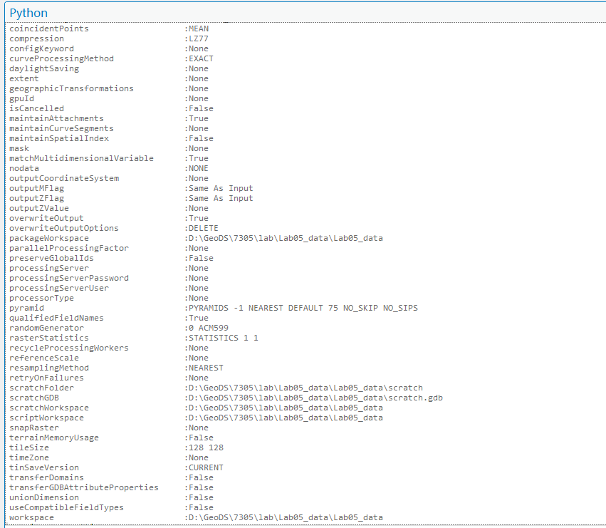

Q9: What does the ListEnvironments() mean?
Answer:
It is a function that returns a list of all geoprocessing environment variable names.
______________________________________________________________________________

4 Change the spatial reference of a shape file (arcpy function):
In ArcGIS Pro, drag the route_stops.shp layer into the current map document. It shows warning message of ‘Map data source is missing coordinate system information.’. We can set the spatial reference of route_stops.shp as same as the one of Buffer.shp.
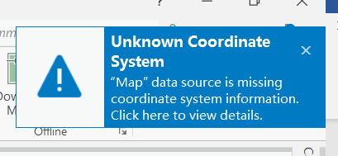

Help of Define Projection
By using ArcGIS Pro, we can define the projection of the features by click ArcGIS Pro menu Analysis Geoprocessing Toolboxes Data Management Tools Projects and Transformations toolset Define Projection
Define the spatial reference
# Name: lab05_spatial reference.py
# Description: Records the coordinate system information for the specified input dataset or feature class

# import system modules
import arcpy

# set workspace environment
arcpy.env.workspace = r"C:\Users\Desktop\Lab05"

try:
# set local variables
in_dataset = "route_stops.shp"

# get the coordinate system by describing a feature class
dsc = arcpy.Describe("Buffer.shp")
coord_sys = dsc.spatialReference

# run the tool
arcpy.management.DefineProjection(in_dataset, coord_sys)

# print messages when the tool runs successfully
print(arcpy.GetMessages(0))
print('Finsih successfully')

except arcpy.ExecuteError:
print(arcpy.GetMessages(2))

except Exception as ex:
print('An Error occurred!')

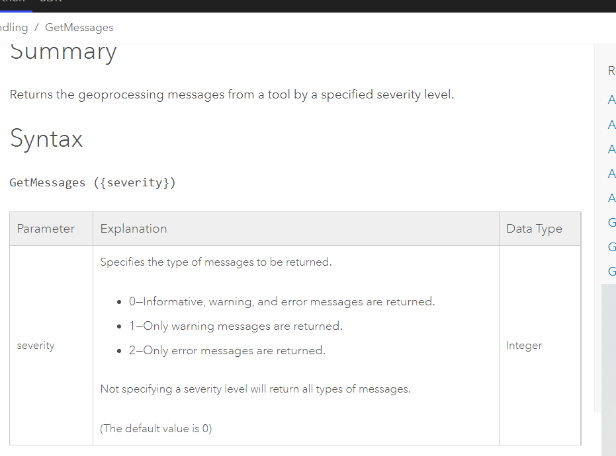

Projection example 1 (For exercise)
The following Python window script demonstrates how to use the Projection function in immediate mode.
import arcpy
# input data is in NAD 1983 UTM Zone 11N coordinate system
input_features = r"C:\Users\Desktop\Lab05\route_stops.shp"
# output data
output_feature_class = r"C:\Users\Desktop\Lab05\stops_projected_1.shp"
# create a spatial reference object for the output coordinate system
out_coordinate_system = arcpy.SpatialReference('NAD 1983 StatePlane California V FIPS 0405 (US Feet)')
# run the tool
arcpy. management.Project(input_features, output_feature_class, out_coordinate_system)
print('Finished successfully')

Projection example 2
The following stand-alone script demonstrates how to process all the feature classes in a Geodatabase.
# Name: lab05_spatial reference_projection_2.py

# Description: Project all feature classes in a geodatabase
# Requirements: os module

# Import system modules
import arcpy
import os

# Set environment settings
arcpy.env.workspace = r" C:\Users\Desktop\Lab05"
arcpy.env.overwriteOutput = True

# Set local variables
outWorkspace = r"C:\Users\Desktop\Lab05\Results"

try:
# Use ListFeatureClasses to generate a list of inputs
for infc in arcpy.ListFeatureClasses():

# Determine if the input has a defined coordinate system, can't project it if it does not
dsc = arcpy.Describe(infc)

if dsc.spatialReference.Name == "Unknown":
print('skipped this fc due to undefined coordinate system: ' + infc)
else:
# Determine the new output feature class path and name
print(infc)
outfc = os.path.join(outWorkspace, infc)

# Set output coordinate system
outCS = arcpy.SpatialReference('NAD 1983 UTM Zone 11N')

# run project tool
arcpy.management.Project(infc, outfc, outCS)

# check messages
print(arcpy.GetMessages(0))

except arcpy.ExecuteError:
print(arcpy.GetMessages(2))
print('oh no 1')

except Exception as ex:
print(ex.args[0])
print('oh no 2')

Assignment

Answer the questions in the lab manual.

Define the projection of “route_stops.shp” with a coordinate system's factory code (or authority code).

The factory code of “NAD_1983_StatePlane_Texas_Central_FIPS_4203_Feet” in ESRI is 102739.( https://spatialreference.org/ref/esri/102739/)
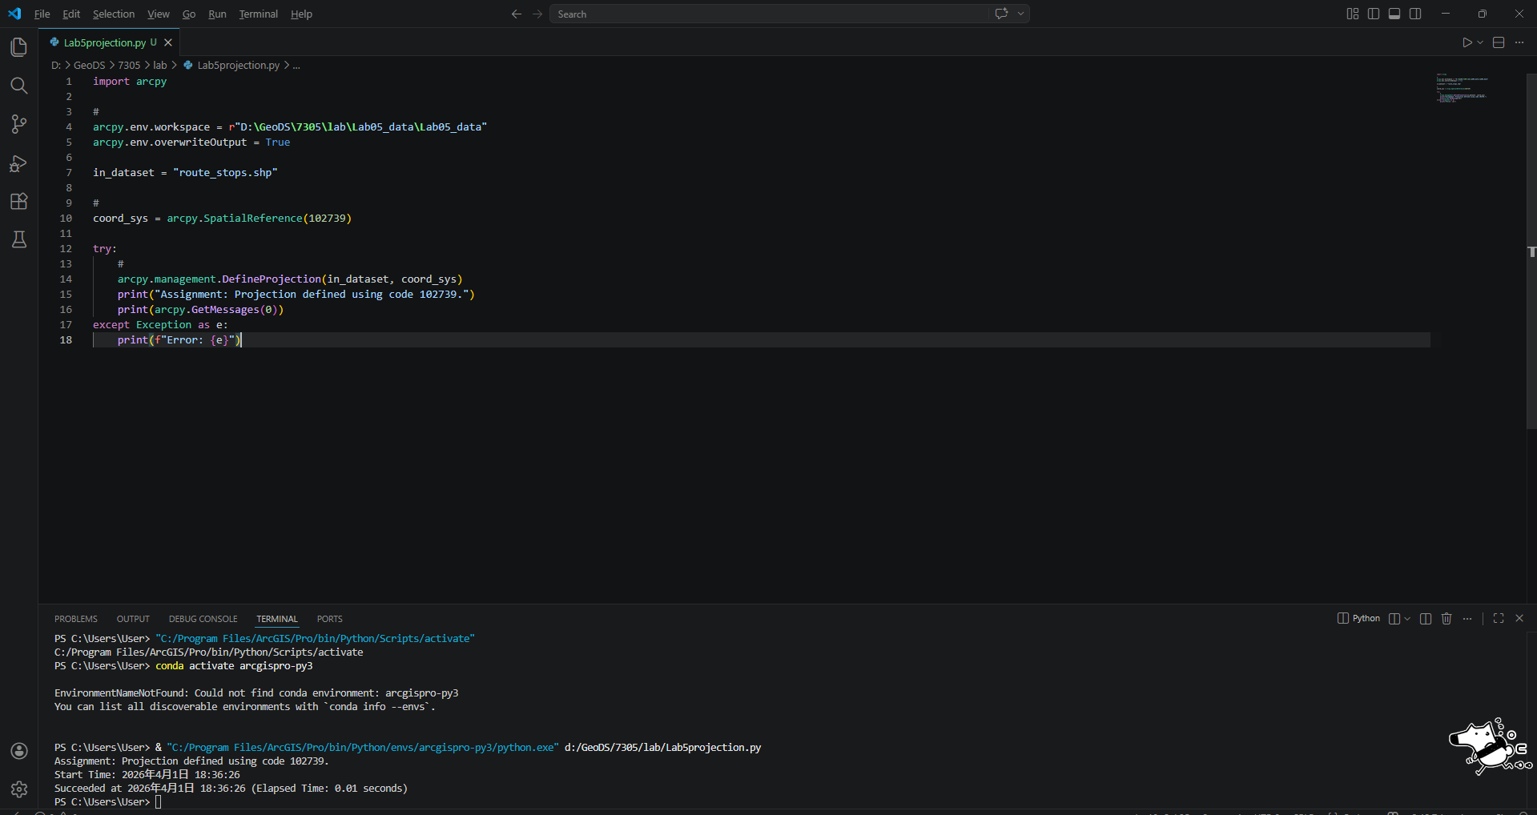

Please save your codes as a .py file and screen capture of the python results.
Zip the all the files together and submit to the Moodle.

Annex : Python Try Except

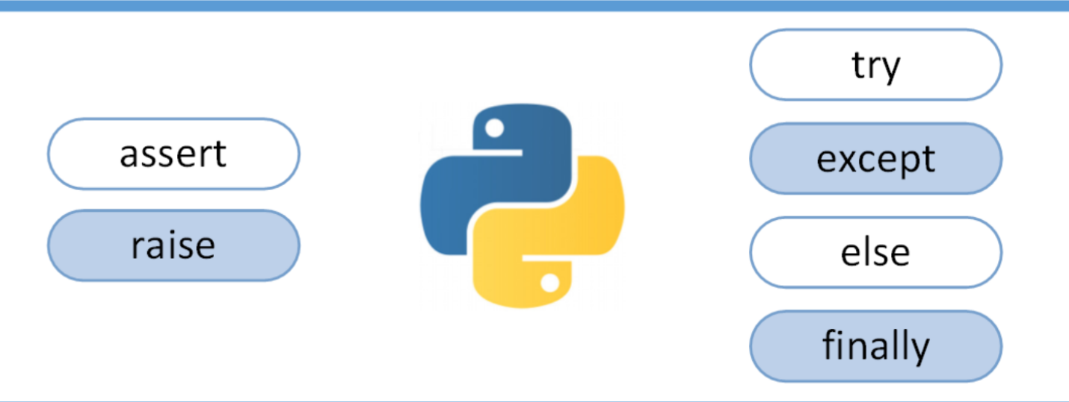
The try block lets you test a block of code for errors.
The except block lets you handle the error.
The else block lets you execute code when there is no error.
The finally block lets you execute code, regardless of the result of the try- and except blocks.
For example:
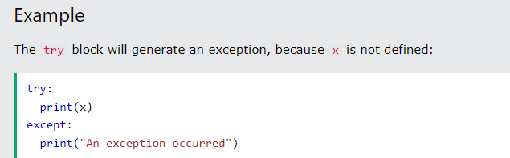
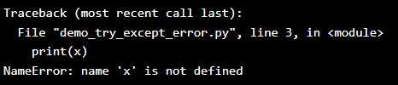
Else
