The University of Hong Kong
Department of Geography

Course code and title:
GEOG7305 Programming for Geospatial Data
Full name of student:
WANG,Lu
Student number:
3036616049
Type of assignment (e.g. essay, practical exercise, etc.):
Lab01 Data Flow Diagram

Project Title: HKU Smart Library Seat Management System
- Project Proposal & Reasons
  - Proposal
A real-time seat booking and monitoring system integrated with HKU Student ID and IoT sensors.
  - Reasons
This system cloud optimize the utilization of library study spaces and prevent prolonged seat-hogging behavior,and reduce unnecessary energy consumption.
- System Description
The HKU Smart Library Seat Management System is a smart tool designed to help students find and book study seats easily. Following the SSADM method, the system focuses on how information moves between users and the database,we could see the process starts when a student sends a Booking Request, which includes their ID and the seat they want to choose and the system uses the Identity Verification process to check the student's information in the Student Info database(D1),which ensures the student is allowed to use the library.
After first process, the Seat Monitoring process receives signals from sensors on the library seats and this information could be saved in the Seat Status database(D2) that make the smart system always know which seats are empty. Finally, the system connects the student's request with the seat data to send a Booking Confirmation.This system makes the library more efficient and helps HKU become a greener and smarter campus.
- System Specification
- Inputs
Student ID, Seat Selection, Booking Time, Sensor Signals.
- Outputs
Booking Confirmation,Booking Status, Management Reports for Admin.
- Data Stores
D1 | Student Info
Holds student credentials and eligibility status.
D2 | Seat Status Table
Stores seat IDs, current states (Available/Occupied),Expiry Time.
- Data Flow Diagrams
  - Context Diagram
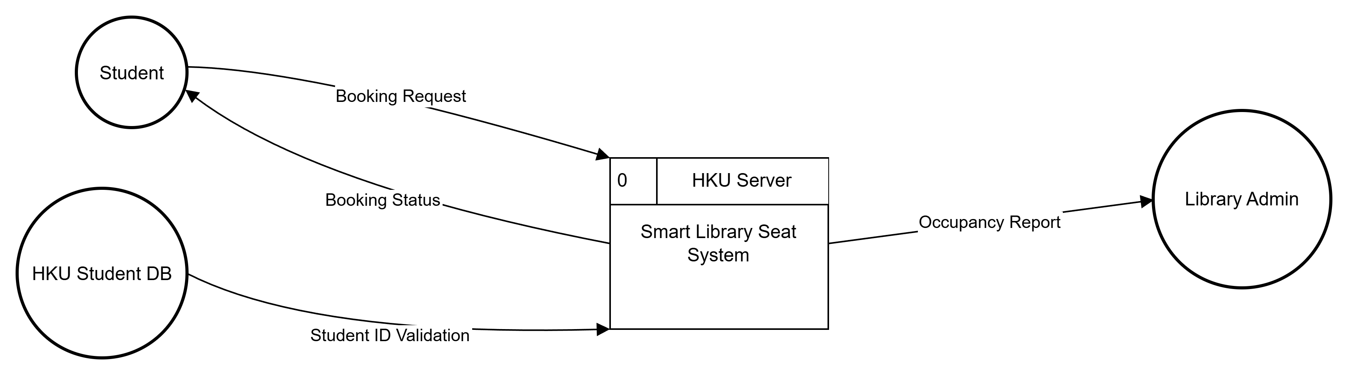
Figure 1. Context-level DFD representing the system boundary.
The context diagram shows the overall interaction between the system (Process 0) and external entities like Students and HKU Student DB.

4.2 Level 1 Diagram
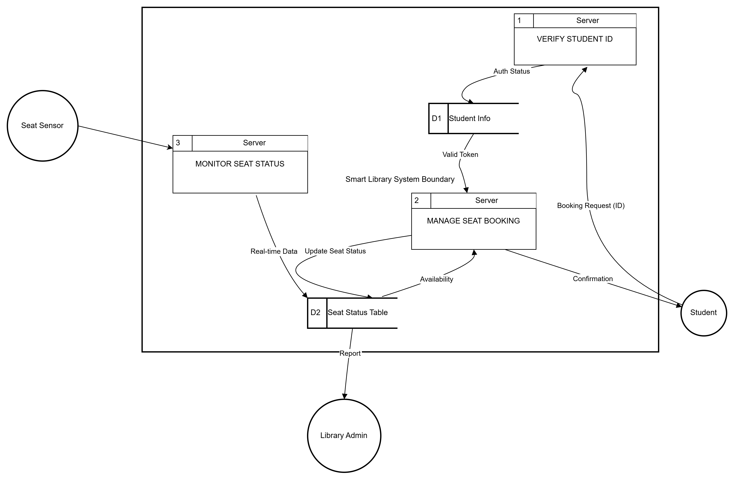
Figure 2. Level 1 DFD decomposing the system into primary functional processes.
The level 1 diagram illustrates how data flows between identity verification, booking management, and sensor monitoring activities.

4.3 Level 2 Diagram

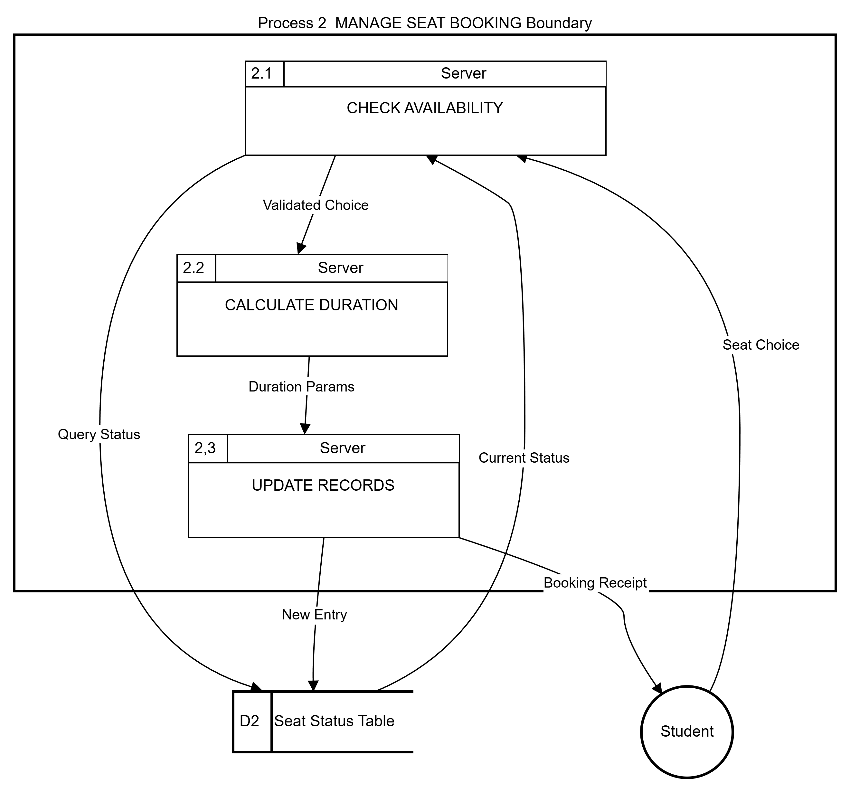
%3CmxGraphModel%3E%3Croot%3E%3CmxCell%20id%3D%220%22%2F%3E%3CmxCell%20id%3D%221%22%20parent%3D%220%22%2F%3E%3CmxCell%20id%3D%222%22%20edge%3D%221%22%20parent%3D%221%22%20style%3D%22curved%3D1%3BstartArrow%3Dnone%3BendArrow%3Dblock%3Brounded%3D0%3BentryX%3D0.25%3BentryY%3D0%3BentryDx%3D0%3BentryDy%3D0%3B%22%20value%3D%22Duration%20Params%22%3E%3CmxGeometry%20relative%3D%221%22%20x%3D%22-0.2057%22%20y%3D%22-4%22%20as%3D%22geometry%22%3E%3CmxPoint%20y%3D%22-1%22%20as%3D%22offset%22%2F%3E%3CArray%20as%3D%22points%22%2F%3E%3CmxPoint%20x%3D%22249%22%20y%3D%22269%22%20as%3D%22sourcePoint%22%2F%3E%3CmxPoint%20x%3D%22245%22%20y%3D%22330%22%20as%3D%22targetPoint%22%2F%3E%3C%2FmxGeometry%3E%3C%2FmxCell%3E%3C%2Froot%3E%3C%2FmxGraphModel%Figure 3. Detailed breakdown of Activity 2: MANAGE SEAT BOOKING.
This level 2 diagram reveals the internal sub-processes (2.1, 2.2, 2.3) used to handle a specific booking transaction from the manage seat booking process.`

