Software Design Document (SDD)
Aegis Track
Version 1.0
Submitted To
Ms. Reshma Raveendran

Submitted By
Pavan K Shiju (VJC23CS156)
Deon Johny (VJC23CS)
Anjoe Mervin (VJC23CS034)
Dawn Jose (VJC23CS071)

Contents
1 INTRODUCTION 1
1.1 Purpose 1
1.2 Scope of the Project 1
1.3 Intended Audience 1
2 DEFINITIONS 2
3 CONCEPTUAL MODEL FOR SOFTWARE DESIGN DESCRIPTION 3
3.1 Software Design in Context 3
3.2 Software Design Descriptions Within the Life Cycle 4
3.2.1 Influences on SDD Preparation 4
3.2.2 Influence on Other Life Cycle Artifacts 4
3.2.3 Design Verification and Validation Role 5
4 DESIGN DESCRIPTION INFORMATION CONTENT 5
4.1 Introduction 5
4.2 SDD Identification 6
4.3 Design Stakeholders and Their Concerns 6
4.4 Design Views 7
4.5 Design Viewpoints 7
4.6 Design Elements 8
4.6.1 Design Entities 8
4.6.2 Design Attributes 8
4.6.3 Design Relationships 10
4.6.4 Design Constraints 10
4.7 Design Rationale 11
4.8 Design Languages 12
5 DESIGN VIEWPOINTS 12
5.1 Introduction 12
5.2 Context Viewpoint 12
5.3 Use Case Diagram 13
5.4 Information Viewpoint 14
5.5 Interface Viewpoints 14
5.5.1 System Interface 14
5.5.2 Application Interface Viewpoint 15
5.6 Interaction Viewpoint 17
5.6.1 Activity Diagram 17
6 TECHNOLOGY STACK 19
6.1 Programming Languages 19
6.2 Frameworks 19
6.3 Database 19
6.4 Tools / IDEs 19

List of Figures
- Use Case Diagram for AEGIS TRACK Anti-Theft Monitoring System . . . 13
- Entity Relationship (ER) Diagram of AEGIS TRACK System . . . 14
- Component / Architecture Diagram of AEGIS TRACK Anti-Theft System . . . 15
- AEGIS TRACK Mobile App Dashboard Interface . . . 16
- Login / Sign-In Interface of AEGIS TRACK App . . . 17
- Registration / Sign-Up Interface of AEGIS TRACK App . . . 17
- Activity Diagram of AEGIS TRACK Anti-Theft System . . . 18
ii

INTRODUCTION
The Smart Anti-Theft Security System is an IoT-based solution designed to enhance the safety of personal belongings such as bikes, lockers, and bags. The system uses an ESP32-CAM module to detect tampering, capture images, and send real-time alerts to a mobile application. By integrating embedded hardware, a Python backend, and a Flutter frontend, the project provides instant notification, visual evidence, and remote monitoring in a compact and cost-effective manner.

Purpose
The purpose of this project is to develop a smart and reliable anti-theft security system that can detect unauthorized tampering, capture image evidence, and notify the user instantly through a mobile application. The system aims to enhance the safety of personal belongings by providing real-time monitoring and remote access in a cost-effective and efficient manner

Scope of the Project
The scope of this project is to design and implement a smart IoT-based anti-theft security system capable of detecting tampering, capturing image evidence, and sending real-time alerts to a mobile application. The system integrates ESP32-CAM hardware, a Python backend, and a Flutter frontend to enable remote monitoring and location tracking. It is intended for securing personal belongings such as bikes, lockers, bags, and small devices in a cost-effective and scalable manner.

Intended Audience
The intended audience for this project includes:
- Project Developers and Programmers – To understand the system design, implementation details, and integration of hardware and software components.
- Project Guide and Faculty Members – To review the technical structure, functionality, and performance of the system.
- Students and Researchers – To study and reference the IoT-based security system design and implementation.
- End Users (General Public) – Individuals who require a smart and affordable anti-theft solution for securing personal belongings such as bikes, lockers, and bags.

DEFINITIONS
Term | Definitions
ESP32-CAM | A microcontroller module with built-in Wi-Fi and camera used for image capture and IoT communication
Flutter | A cross-platform mobile application development framework used for frontend development.
Python Backend | Server-side application developed using Python (Flask/FastAPI) to handle data processing and APIs.
REST API | Representational State Transfer Application Programming Interface used for communication between system components.
Alert | A notification generated when tampering is detected.
Image Evidence | Captured image stored as proof during a tamper event.
Iot | Internet of Things; network of interconnected devices communicating over the internet.
Database | Structured storage system used to store alert data and user information
HTTP/HTTPS | Communication protocols used for data transmission between device, backend, and app
UML | Unified Modeling Language used for system modeling and design diagrams.
SRS | Software Requirements Specification document.
SDD | Software Design Document describing system architecture and design

CONCEPTUAL MODEL FOR SOFTWARE DESIGN DESCRIPTION

Software Design in Context
The software design of the Smart Anti-Theft Security System focuses on integrating embedded hardware, backend processing, and a mobile application into a unified and efficient architecture. The system is designed to ensure smooth communication between the ESP32-CAM module, the Python-based backend server, and the Flutter mobile application using HTTP/REST APIs. The backend handles data processing, storage, and alert management, while the frontend provides real-time monitoring, image display, and location tracking to the user. The design emphasizes modularity, scalability, reliability, and ease of maintenance to support future enhancements and real-world deployment.

Software Design Descriptions Within the Life Cycle
The software design of the system follows a structured Software Development Life Cycle (SDLC). Initially, system requirements such as tamper detection, image capture, and real-time alerts are analysed and documented. The architecture is then designed to define communication between the ESP32-CAM, Python backend, and Flutter mobile application. During implementation, each module is developed and integrated. Testing ensures proper functionality and real-time communication. Finally, the system is deployed and maintained for future updates and improvements.
Influences on SDD Preparation
The preparation of the Software Design Document (SDD) is influenced by several technical and project-related factors. The system requirements defined in the SRS play a major role in shaping the architecture and module design. The choice of technologies such as ESP32-CAM, Python backend, and Flutter frontend also impacts the design structure and communication model. Design constraints including hardware limitations, network reliability, and real-time performance requirements are considered during documentation. Additionally, IEEE documentation standards guide the structure and format of the SDD to ensure clarity, consistency, and professional presentation.

Influence on software Life Cycle Products
Software life cycle products such as requirement documents, design documents, source code, and test reports are influenced by multiple technical and organizational factors. The clarity and completeness of system requirements directly affect the quality design and implementation. Technology choices, including ESP32-CAM hardware, Python backend, and Flutter frontend, shape the development approach and system architecture. Resource availability, project timeline, and team expertise also impact development and testing activities. Additionally, performance, security, scalability, and user expectations influence how the final system is designed, implemented, and maintained.

Design Verification and Validation Role
Design verification ensures that the software design correctly satisfies the requirements specified in the SRS by reviewing system architecture, modules, and data flow. It confirms that features such as tamper detection, image capture, and real-time alerts are properly implemented in the design. The design also supports validation by ensuring the final system meets user needs and functions reliably in real-world conditions.

DESIGN DESCRIPTION INFORMATION CONTENT

Introduction
The Software Design Description of the Smart Anti-Theft Security System explains how the system will be designed and implemented using the ESP32-CAM module, Python-based backend, and Flutter mobile application. This document presents the overall system architecture, module design, data flow, and interaction between hardware and software components. Throughout the document, design diagrams, system views, and user perspectives are provided to clearly illustrate the structure and functionality of the system.

SDD Identification
After successful verification and validation testing, the Smart Anti-Theft Security System will be deployed for real-world usage to secure personal belongings such as bikes, lockers, and bags. The system operates through an ESP32-CAM device connected to a Python-based backend and a Flutter mobile application, allowing users to monitor their devices remotely. Each user can securely access the mobile application using authenticated login credentials to view alerts, captured images, and location details. When tampering is detected, the system automatically captures images, uploads alert data to the backend, and notifies the user in real time through the mobile application.

Design Stakeholders and Their Concerns

Stakeholders include developers, testers, project evaluators, and end users of the Smart Anti-Theft Security System. Developers focus on reliable system architecture and smooth integration between ESP32-CAM, Python backend, and Flutter app. End users expect real-time alerts, easy-to-use interfaces, accurate location tracking, and secure handling of their data and images.

Design Views
The Smart Anti-Theft Security System is implemented using a modular architecture to ensure flexibility and scalability. A layered architecture pattern is adopted, separating the system into embedded (ESP32-CAM), backend (Python), and frontend (Flutter) components. Object-oriented design principles are used in both backend and mobile application development, allowing easy integration of new features such as additional sensors or enhanced notification modules.

This modular and object-oriented approach enables components to be modified, replaced, or extended without affecting the entire system. Context views include system architecture diagrams and UML use case diagrams representing interactions between the user, mobile application, backend server, and ESP32-CAM device. Interface views clearly define the REST API communication, specifying input requests from the device or mobile app and the corresponding outputs or responses from the backend.

Design Viewpoints
The context viewpoint of the Smart Anti-Theft Security System defines the expected interactions between the user and the system. It clearly specifies the roles of stakeholders such as end users, developers, and administrators, and establishes the system boundary including the ESP32-CAM device, Python backend, and Flutter mobile application. The primary design entities are the user, the mobile application, and the backend server, with information flowing between them through alert notifications, image data, and location updates. Input-output relationships describe how tamper signals from the device generate alerts and responses within the app. Analytical and evaluation techniques can be applied to this viewpoint to ensure correctness, performance, and reliability of system interactions.

4.6 Design Elements

4.6.1 Design Entities
The design entities of the AEGIS TRACK Anti-Theft Monitoring System represent the main logical data components stored and processed within the system. These entities are derived from the Entity Relationship (ER) model. The primary design entities are:
• User – Represents the registered owner who monitors and manages the anti-theft system using the mobile application.
• Device – Refers to the ESP32-CAM based hardware unit installed on the protected asset (bike/bag/vehicle) for monitoring and tracking.
• Tamper Sensor Data – Stores the vibration or micro-switch sensor readings used to detect unauthorized movement or theft attempts.
• Alert – Represents a security event generated when tampering or suspicious activity is detected by the device.
• Media Evidence – Stores captured images/video evidence recorded during the alert condition using ESP32-CAM.
• Location Info – Contains GPS coordinates (latitude and longitude) of the device at the time of alert detection and during tracking.
• Notification – Represents the real-time alert message sent to the user through the mobile application (push notification / Firestore update).
• System Log – Maintains records of device activities such as arming/disarming, tamper detection, GPS updates, and evidence uploads for monitoring and debugging.
• Authentication – Handles secure user login and access control using Firebase Authentication.
• Backend API Service – Manages communication between ESP32-CAM hardware, Python backend server, and Firebase services using HTTP/HTTPS REST APIs.
- 4.6.2 Design Attributes (Updated for AEGIS TRACK)
This section describes the attributes associated with each design entity as represented in the ER diagram.

- Users
Attribute | Description
userId | Unique identifier for each registered user
name | Name displayed in the mobile application
email | Registered email address used for authentication
phoneNumber | User contact number (optional)
role | User role (Owner / Admin)
createdAt | Timestamp of account creation
lastLogin | Timestamp of last login

- Devices
Attribute | Description
deviceId | Unique identifier for each anti-theft device
deviceName | Name assigned to the device (Bike Tracker, Bag Tracker etc.)
ownerUid | References the user who owns the device
status | Device operational status (Armed / Disarmed / Online / Offline)
batteryLevel | Battery percentage of device
lastSeen | Timestamp of last communication from device
firmwareVersion | Firmware version running on ESP32-CAM
connectionType | Wi-Fi / GSM

- Sensor Data
Attribute | Description
sensorId | Unique identifier for each sensor record
deviceId | References the associated device
vibrationValue | Vibration intensity value detected
tamperStatus | Tamper detected status (True / False)
sensorHealth | Indicates sensor operational status
timestamp | Date and time of the sensor reading

- Alerts
Attribute | Description
alertId | Unique identifier for each alert event
deviceId | Device that triggered the alert
alertType | Type of alert (Tamper / Movement / Unauthorized Access)
severity | Alert classification (Low / Medium / High)
timestamp | Time when alert was triggered
acknowledged | Indicates whether alert has been acknowledged
acknowledgedUid | User who acknowledged the alert

- Media Evidence
Attribute | Description
mediaId | Unique identifier for captured media
alertId | References the alert that triggered the capture
deviceId | Device that captured the evidence
mediaType | Image / Video
mediaUrl | Storage URL of evidence
capturedAt | Timestamp of media capture

- Location Info
Attribute | Description
locationId | Unique identifier for each location record
deviceId | References the associated device
latitude | Latitude coordinate
longitude | Longitude coordinate
accuracy | GPS accuracy level
timestamp | Time of location update

- Notifications
Attribute | Description
notificationId | Unique identifier for each notification
userId | User receiving the notification
deviceId | Related device reference
alertId | Associated alert reference
title | Notification title
message | Notification content
read | Indicates whether notification has been read
timestamp | Time when notification was generated

- System Logs
Attribute | Description
logId | Unique identifier for each log entry
deviceId | References the device
logType | Event type (Arm / Disarm / Tamper / GPS Update / Media Upload)
description | Log description
timestamp | Time when log was recorded

- ✅ 4.6.3 Design Relationships (Updated for AEGIS TRACK)
This section describes the relationships between the entities defined in the ER diagram.

- • Users – Devices (Owns)
Type: One-to-Many (1:N)
A single user can own multiple devices. Each device belongs to exactly one user.

- • Devices – Sensor Data (Generates)
Type: One-to-Many (1:N)
A device continuously generates multiple sensor data records.

- • Devices – Alerts (Triggers)
Type: One-to-Many (1:N)
A device can trigger multiple alerts when tampering is detected.

- • Alerts – Media Evidence (Captures)
Type: One-to-Many (1:N)
An alert may capture multiple media files (burst images / video).

- • Devices – Location Info (Updates)
Type: One-to-Many (1:N)
A device generates multiple GPS location updates for tracking.

- • Alerts – Notifications (Sends)
Type: One-to-Many (1:N)
Each alert can generate multiple notifications.

- • Users – Notifications (Receives)
Type: One-to-Many (1:N)
A user can receive multiple notifications. Each notification is linked to one user.

- • Devices – System Logs (Maintains)
Type: One-to-Many (1:N)
A device maintains multiple system logs for tracking activity and debugging.

These relationships ensure proper data linkage and support real-time synchronization within the AEGIS TRACK system.

- ✅ 4.6.4 Design Constraints (Updated for AEGIS TRACK)
This section defines the constraints applied to the system’s data model and architecture.

- • Uniqueness Constraint
userId, deviceId, sensorId, alertId, mediaId, notificationId, logId must be unique.

- • Referential Integrity
- deviceId in Sensor Data, Alerts, Location Info, and System Logs must reference a valid device.
- userId in Notifications must reference a valid user.
- ownerUid in Devices must reference an existing user.
- alertId in Media Evidence must reference a valid alert.

- • Severity Classification Constraint
Severity values are restricted to predefined levels: Low, Medium, High.

- • Authentication Constraint
Only authenticated users can access device tracking, media evidence, and alerts. Admin access is required for backend configurations.

- • Data Integrity Constraint
- Timestamp values must be system-generated.
- GPS latitude and longitude must be valid numeric coordinates.
- Vibration values must be numeric within sensor range.

- • Availability Constraint
Local device alerting mechanisms (Buzzer / LED / Camera capture) must function even if internet connectivity is unavailable. Cloud synchronization resumes automatically when connectivity is restored.

- ✅ 4.7 Design Rationale (Updated for AEGIS TRACK)
The AEGIS TRACK Anti-Theft Monitoring System is designed using a modular IoT-based layered architecture consisting of Hardware/Firmware, Backend and Database, and Mobile Application components. This separation ensures scalability, maintainability, and reliability.

- Architectural Choice
A layered architecture was selected to clearly separate responsibilities:
• The Hardware/Firmware Layer handles real-time tamper detection, vibration monitoring, GPS updates, evidence capture using ESP32-CAM, and local alert activation.
• The Backend and Database Layer manages cloud storage, authentication, real-time synchronization, and notification services through Firebase and Python server integration.
• The Mobile Application Layer provides a user-friendly interface to monitor alerts, track GPS location, view evidence images/videos, and manage device security settings.
This modular approach allows independent development and maintenance of each layer without affecting other system components.

- Technology Selection Rationale
• ESP32-CAM was selected due to its built-in Wi-Fi capability, camera module support, low cost, and suitability for IoT surveillance.
• SW-420 Vibration Sensor / Micro-switch was chosen for reliable tamper and movement detection with low power consumption.
• NEO-6 GPS Module was selected for accurate real-time location tracking and path tracing.
• Python Backend (Flask/FastAPI) was chosen to act as a middleware server to receive ESP32 data and sync it with Firebase services.
• Firebase Cloud Firestore was selected for real-time database synchronization between backend and mobile app.
• Firebase Storage was selected for storing captured media evidence securely in the cloud.
• Flutter Framework was chosen for mobile application development due to its cross-platform support and efficient real-time UI rendering.

- Safety and Reliability Considerations
The system is designed with a fail-safe mechanism where evidence capture and local alerts operate independently of internet connectivity. If the connection is lost, data is stored locally (microSD) and synchronized automatically when the connection is restored.
This ensures continuous monitoring, secure evidence logging, real-time alert delivery, and effective asset recovery support.

- ✅ 4.8 Design Languages (Updated for AEGIS TRACK)
The design of the AEGIS TRACK Anti-Theft Monitoring System is specified using the Unified Modeling Language (UML) as the primary design language.
UML is selected because it provides a standardized, platform-independent, and industry-accepted method for visually representing system architecture, structure, and behavioral interactions. It improves clarity, documentation quality, and communication among developers, evaluators, and stakeholders.

- ✅ 5. DESIGN VIEWPOINTS (Updated for AEGIS TRACK)
- 5.1 Introduction
This chapter describes the architectural and design perspectives of the AEGIS TRACK Anti-Theft Monitoring System.
The design viewpoints explain how the system is structured, how data flows between components, how users interact with the system, and how internal modules collaborate to provide real-time theft detection, GPS tracking, and evidence collection.
The following four viewpoints are defined:
• Context Viewpoint
• Information Viewpoint
• Interface Viewpoint
• Interaction Viewpoint
These viewpoints collectively provide a complete design understanding of the IoT-based anti-theft monitoring system.

- 5.2 Context Viewpoint
There is one primary user in the AEGIS TRACK Anti-Theft Monitoring System, referred to as the Owner/User.
The user interacts with the system through the AEGIS TRACK mobile application. The system provides the following services:
• Sign up
• Sign in
• Sign out
• Arm / Disarm anti-theft device
• View live alert dashboard
• Receive real-time theft notifications
• View captured image/video evidence
• Track GPS location on map
• View location history and movement path
• View device status (Online/Offline)
• View battery health and device health logs
• Acknowledge alerts
• Store and review past alert history
The system also interacts with external components such as:
• ESP32-CAM device
• SW-420 vibration sensor / micro-switch
• GPS module (NEO-6)
• Python backend server
• Firebase Cloud Firestore
• Firebase Storage
• Push notification services

- 5.3 Use Case Diagram
Figure 1 illustrates the Use Case Diagram of the AEGIS TRACK Anti-Theft Monitoring System.
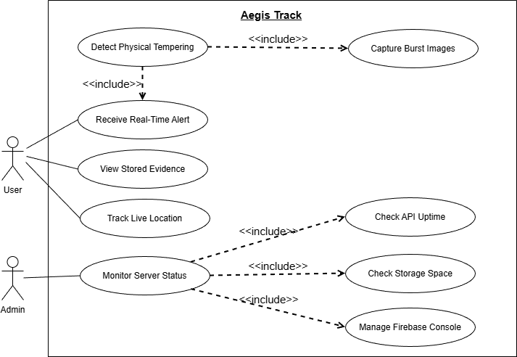
- Figure 1: Use Case Diagram for AEGIS TRACK Anti-Theft Monitoring System

- 5.1 Information Viewpoint
The Entity Relationship (ER) Diagram of the AEGIS TRACK Anti-Theft Monitoring System is illustrated below. The entities, relationships, and attributes represented in the ER diagram are explained in the sections Design Entities and Design Attributes.
This viewpoint provides a clear understanding of how user data, device data, alerts, notifications, GPS tracking information, and captured media evidence are structured and stored within the system database.
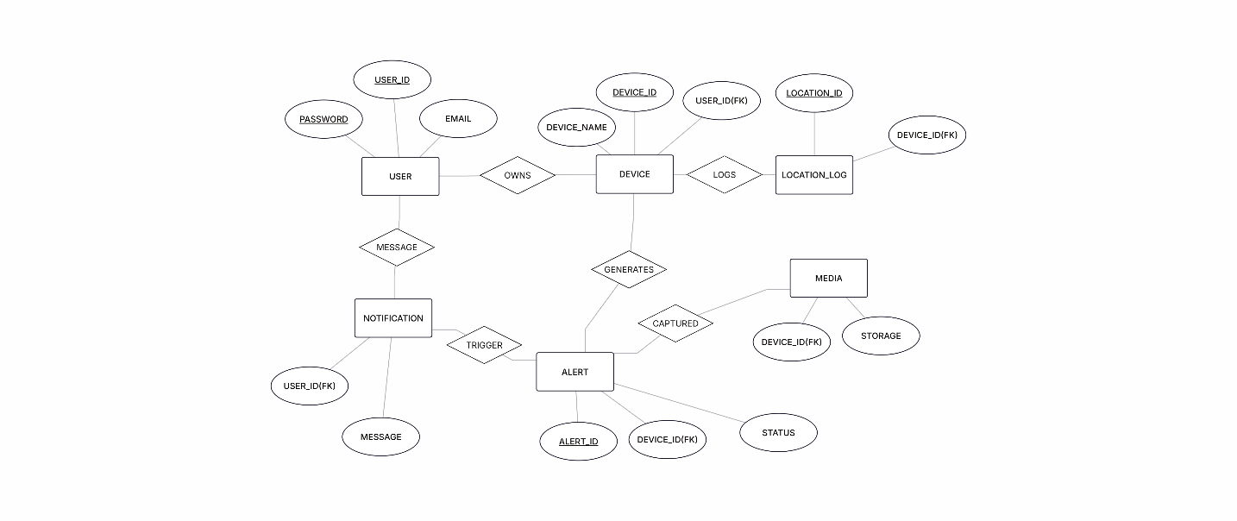
- Figure 2: Entity Relationship (ER) Diagram of AEGIS TRACK Anti-Theft Monitoring System

- 5.1 Interface Viewpoints
- 5.1.1 System Interface
This viewpoint describes the interaction between the main components of the AEGIS TRACK Anti-Theft Monitoring System. The system consists of three primary components:
• Firmware (ESP32-CAM + Sensors Module)
• Backend and Database (Python Server + Firebase Cloud Services)
• Mobile Application (Flutter App)
The Firmware component continuously monitors tampering activity using vibration sensors or micro-switch inputs. When a theft attempt is detected, the ESP32-CAM captures image evidence and gathers GPS location data. The collected sensor readings, media evidence, and location details are then transmitted to the Backend and Database layer through HTTP/HTTPS communication.
The Backend and Database layer processes incoming requests, stores alert logs and device tracking data in Firebase Cloud Firestore, and uploads captured images/videos into Firebase Storage. This layer also triggers real-time updates and notifications to the mobile application.
The Mobile Application component retrieves this synchronized data from Firestore in real time to display device status, GPS tracking map view, captured evidence, notifications, and alert history for the user.
The interaction between these components forms the complete system structure. The Component Diagram representing these interfaces is shown below.
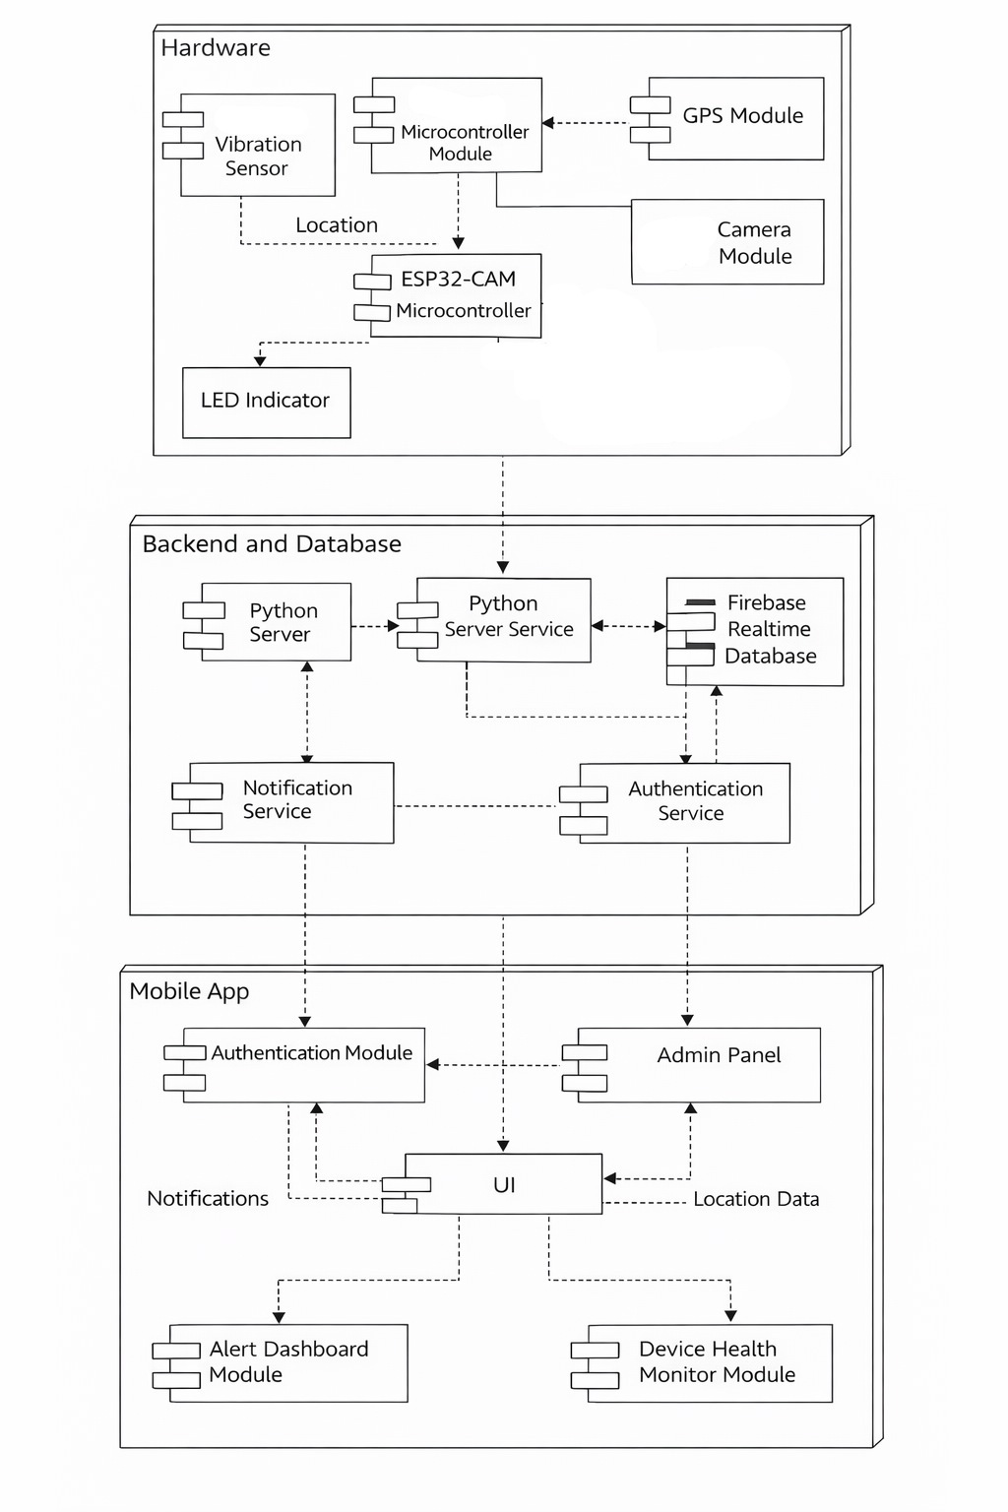
- Figure 3: Component Diagram of AEGIS TRACK Anti-Theft Monitoring System

- 5.1.1 Application Interface Viewpoint
- Dashboard Interface
The Dashboard Interface serves as the primary monitoring interface of the AEGIS TRACK Anti-Theft Monitoring System. It provides real-time visualization of the device security status, alerts, and tracking information.
The dashboard includes the following features:
• Live device status display (Armed / Disarmed)
• Tamper detection status indicator (Safe / Alert Triggered)
• Connectivity status indicator (Online / Offline)
• Real-time monitoring label
• Alert and notification icons
• Captured media evidence preview (Image/Video thumbnails)
• Live GPS tracking map shortcut
• Location history / movement path tracking option
• Alert history log for previous tamper events
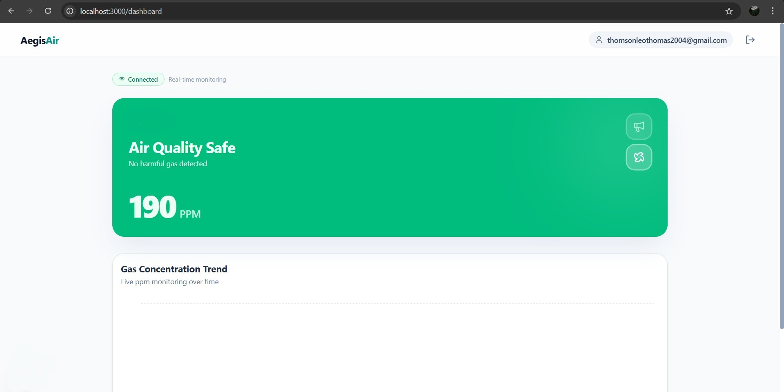
Figure 4: Dashboard Interface
Sign-In Interface The Sign-In Interface enables secure access to the system dashboard using Firebase Authentication.
- Email input field
- Password input field
- Show/Hide password option
- Forgot password link
- Sign-In button
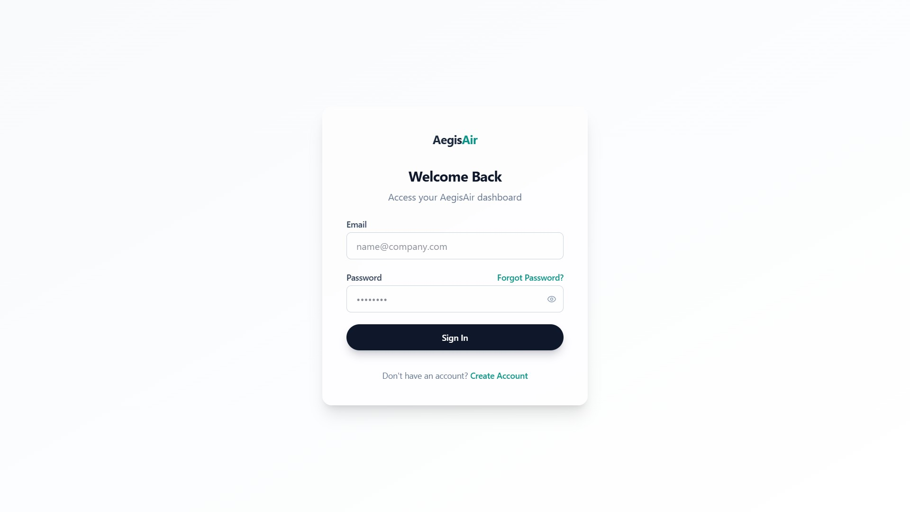
Figure 5: Sign-In Interface
Sign-Up Interface The Sign-Up Interface allows new users to register and create an account.
- Email input field
- Password field
- Confirm password field
- Sign-Up button
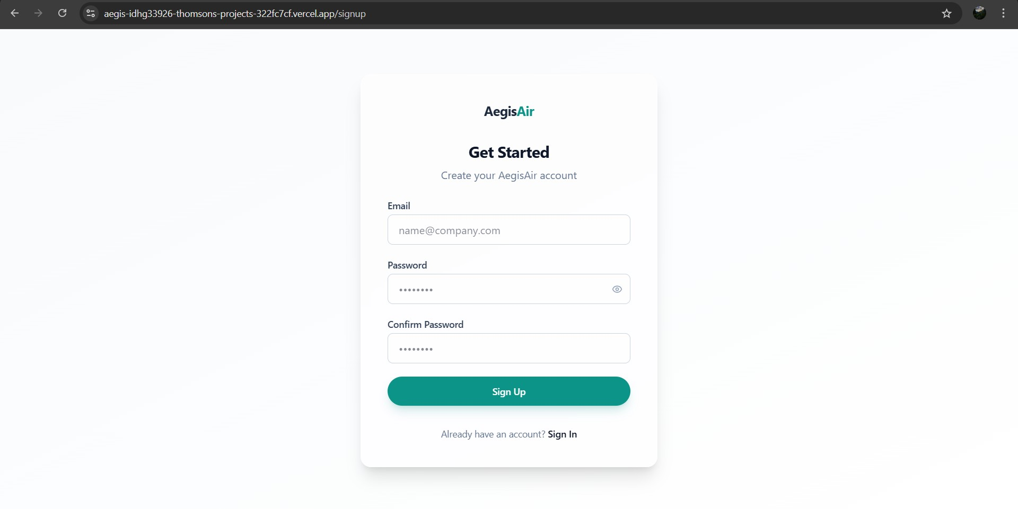
Figure 6: Sign-Up Interface

Interaction Viewpoint

Activity Diagram
The Activity Diagram illustrates the overall workflow of the Smart Gas Leak and Smoke Detection Alert System. It describes the interaction between the three major components: Firmware, Backend and Database, and Application.
The workflow begins when the ESP32 device is powered on. The firmware reads gas concentration values from the MQ-2 sensor and processes the data. The system then evaluates whether the gas level exceeds the predefined threshold. If the gas level exceeds the threshold:
- The buzzer and LED are activated.
- The severity level is set to HIGH.
If the gas level does not exceed the threshold:
- The severity level is set to Safe or Warning.
The processed sensor data is then transmitted to the cloud backend via an API. The backend stores the data in the Firebase Realtime Database. If the severity level is HIGH:
- The backend triggers the notification service.
- An alert event is generated and logged.
On the application side:
- The dashboard fetches data from the database.
- The user interface updates in real time.
- If a notification is received, an alert message is displayed.
The activity diagram of the system is shown below.
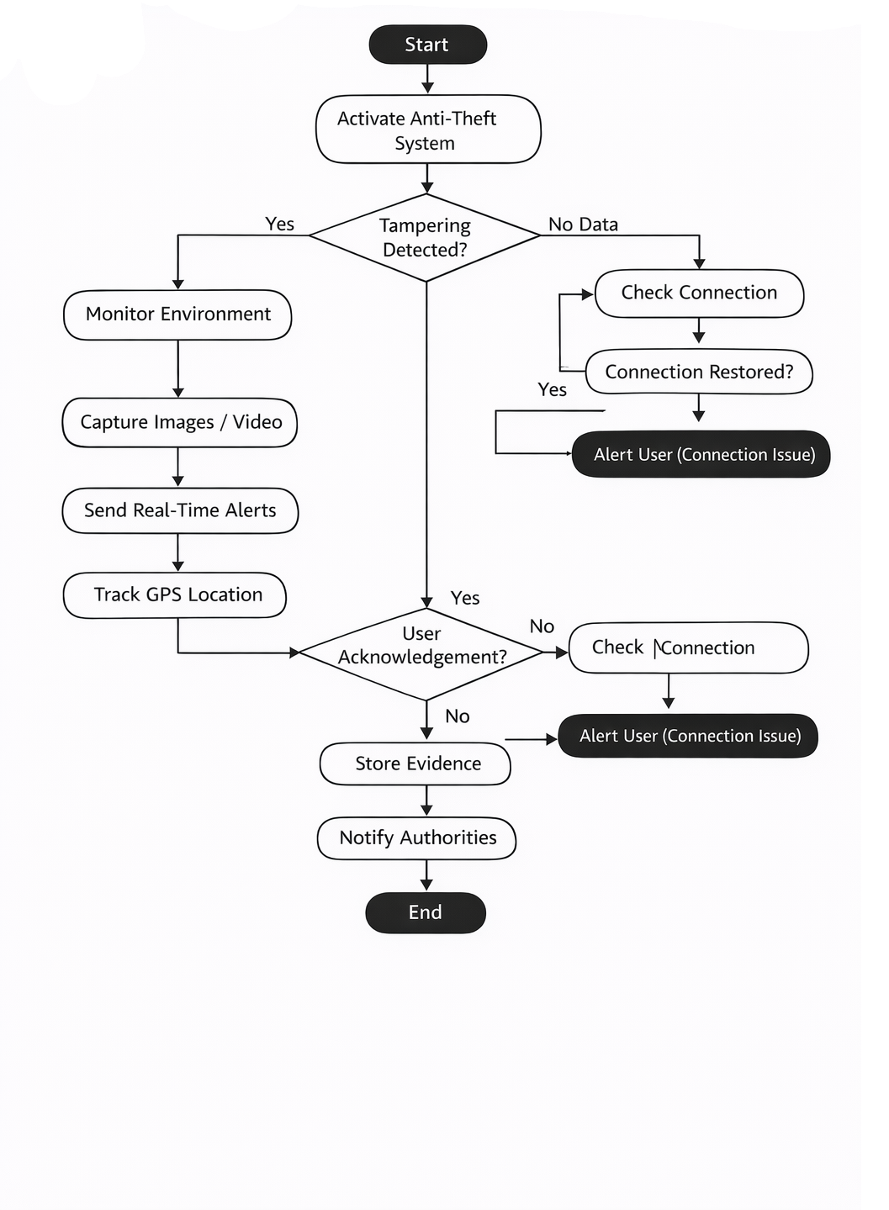
Figure 7: Activity Diagram of Smart Gas Leak and Smoke Detection System

TECHNOLOGY STACK

Programming Languages
- C/C++ (ESP32 Firmware)
- JavaScript
- HTML, CSS

Frameworks
- Arduino Framework
- Next.js
- Firebase Web SDK

Database
• Firebase Realtime Database (NoSQL, Cloud-based)

Tools / IDEs
- Arduino IDE
- Visual Studio Code
- GitHub
- Firebase Console
References
- Espressif Systems, “ESP32 Series Datasheet,” 2024. [Online]. Available: https://www.espressif.com/
- Espressif Systems, “ESP32 Technical Documentation,” 2024. [Online]. Available: https://docs.espressif.com/
- Google Firebase, “Firebase Realtime Database Documentation,” 2024. [Online]. Available: https://firebase.google.com/docs/database
- React Documentation Team, “React Official Documentation,” 2024. [Online]. Available: https://react.dev/
- Vercel, “Next.js Official Documentation,” 2024. [Online]. Available: https://nextjs.org/docs
- Components101, “MQ-2 Gas Sensor Datasheet,” 2023. [Online]. Available: https://components101.com/sensors/mq2-gas-sensor
- YouTube, “Next.js Tutorial for Beginners,” 2024. [Online]. Available:
https://youtu.be/ZVnjOPwW4ZA?si=EIqJROTmiU1FlB-k

