**SUNDAY SCHOOL PARENT RESOURCE**

This parent resource may be used as a tool for family devotions or discussions to help children apply the lessons they learned this Sunday throughout the rest of the week.



**November 4, 2018**

**Title:** God gives Solomon Wisdom.

**Passage:** IKings 2:1-4; 3:3-15.

**Principle:** We are unable to obey God without His help.

**Ask Your Child:** What did Solomon ask for, and how did God give it to him?

**Apply:** By asking God for the wisdom to obey Him.

**This Week:** As a family, read IKings 2:1-4; 3:3-15.

28 Arch Street, Keene, NH, 03431 • www.keenecrossway.org • 603.283.0041 Overseers/Pastors/Elders: Craig Johnson (staff) and Bill Calhoun

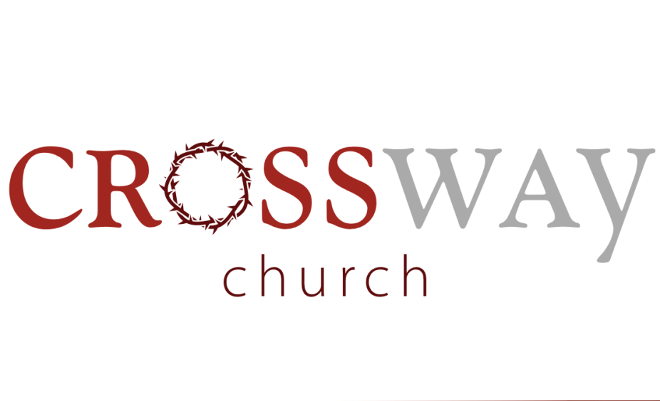

**INVOCATION**

Sing: *Oh For A Thousand Tongues To Sing*

**ADORATION**

Scripture Reading: Psalm 90 (Weldon Smith)

Sing: *O God, Our Help In Ages Past*

**CONFESSION**

Prayer of Confession: (Bill Calhoun)

Sunday, November 4, 2018 16, 2018

**COMMUNION** (Jason Bilby)

Sing: *Now Why This Fear*

**PREPARATION**

Sing: *Praise The Savior*

**PROCLAMATION**

Sermon: Sweet Fellowship Even When We Disagree, part 2

Romans 14:5-9(Craig Johnson)

**DEDICATION**

Sing: *And Can It Be (Amazing Love)*

**BENEDICTION**

**WORSHIP IN GIVING:** Consider the Gospel and give generously, humbly, and worshipfully in response to Christ’s

sacrifice for you (2 Cor. 8:9). Place offerings in foyer kiosk.

**Welcome to Crossway:** The welcome bag you received contains a visitor card. Please fill it out and put it in the offering kiosk so we can send our thanks and answer any questions you may have about Crossway.

**Children's Nursery:** For children through age 2 during Bible Fellowship (9:15am) and the worship service. Located at the far back of the church building.

**Children’s Sunday School:** 9:15-10:15am (during Adult Bible Fellowship). Children, age 3 (and potty trained) through grade 6.

**Children’s Church:** Age 3 through kindergarten. Children are dismissed after Communion to the upstairs classroom where they will be led in songs, activities, and a Bible story.

**Adult Bible Fellowship:** Topic of Study: The Person and Work of the Holy Spirit (Pneumatology).

**CCYG:** No Meeting today. Our next regular meeting will be Sunday, Nov 11.

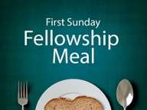**Fellowship Meal & Quarterly Meeting today:** Following the Fellowship Meal, we will have our quarterly meeting. Please make plans to be a part.

**Theology for Breakfast:** Men, join us on Tuesday mornings at 6am in the church library for our study through *Calvin’s Institutes*.

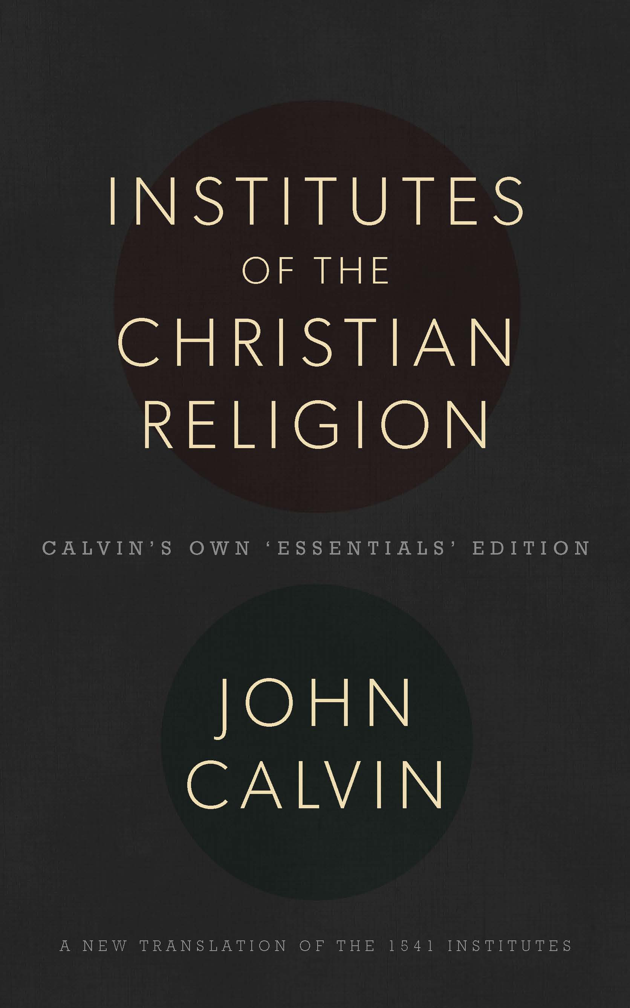

**Books . . . Books . . . Books** are available at a great discount for your spiritual edification, family uplifting, and on-going knowledge of Bible doctrines. Price is on the inside cover. Today only get ***Uprooting Anger*** for **$3** (Retail: $13.99; Amazon: $11.39).

**Home Fellowships:** 5 Home Fellowships meet weekly for a meal, singing, Bible study (the Book of Luke), & prayer.

**Johnson HF**

Host: Craig & Tiffany Johnson

Address: 23 Pleasant St, Keene

Leader: Craig Johnson

Meeting: Wednesdays, 6pm

**Russo HF**

Host: Aaron & Becky Russo

Address: 662 Rt. 12A, Surry

Leader: Bill Calhoun

Meeting: Wednesdays, 6pm

**Sage HF**

Host: Andrew & Cathy Sage

Address: 8 Erin Lane, Jaffrey

Leader: Jason Bilby

Meeting: Mondays, 6pm

**Burch HF**

Host: Dave & Laney Burch

Address: 42 Liberty Ln., Keene

Leader: Sam Wullbrandt

Meeting: Wednesdays, 6pm

**Wells HF**

Host: Chris & Karen Wells

Address: 664 County Road, Walpole

Leader: Richard Russell

Meeting: Thursdays, 6pm

**Special Need:** Help is needed, once again, for floor cleaning, which includes all hard floors and all carpeting. Average time spent doing this is 1x per week for +/- 2hrs.

**Giving Report Through November 21, 2018**

|  |  |  |  |
| --- | --- | --- | --- |
| Giving thru 11/21 | Budgeted thru 11/21 | Fiscal Year Budget | Projected Giving |
| $50,369 | $64,731 | $187,000 | $158,943 |

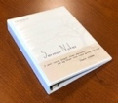**Sermon Notes Binders:** In the foyer, you may purchase for $6 a binder for keeping your sermon notes. Dividers are included.





**Mercy** and **Ruby Johnson** will be baptized and join the church next Sunday! Take a few minutes today to talk with each of them about their faith in Christ and their desire to be a part of the church.