REQUIREMENT 4

Complexity Comparison Report

Empirical comparison of time and space complexity: UCS vs A*

1. Objective
This report measures how Uniform Cost Search (UCS) and A* with the bipartite-matching heuristic (Requirement 2) behave as Sokoban maps become larger and harder. Time complexity is measured by execution time and the number of expanded nodes; space complexity by peak memory, the maximum frontier size and the maximum explored-set size. All numbers were produced by experiment.py; the raw data is in results/results.csv.

2. Test environment
Item | Value
Operating system | Windows 11 Home Single Language 26200
CPU | 13th Gen Intel(R) Core(TM) i7-13620H (2.40 GHz)
Memory | 32.0 GB
Python | 3.14.8.
Code under test | algorithms.py and heuristic.py from the team, unchanged
Time measurement | time.perf_counter (wall-clock search time)
Memory measurement | tracemalloc (peak Python allocation during the search)
Frontier measurement | heapq.heappush wrapped to record the largest heap size
Isolation | multiprocessing: every run starts in a fresh process
Note: Absolute times depend on the machine. Node counts, frontier sizes and solution costs are the same on every machine, and the UCS/A* ratios are what the comparison relies on.

3. Method

3.1 Test maps
Nine maps of increasing difficulty were used. Each map is a plain text file in maps/ using the assignment symbols (% wall, A agent, B box, D target, C box on target).

Map | Size | Boxes | Floor cells | Description
map1_basic | 7×5 | 1 | 15 | Small room, short path
map2_corridor | 12×3 | 1 | 10 | One-tile corridor
map3_two_boxes | 8×6 | 2 | 24 | Small room, 2 boxes
map4_open_room | 10×7 | 2 | 40 | Open room
map5_narrow_rooms | 10×6 | 2 | 25 | Narrow partitions
map6_three_boxes | 9×7 | 3 | 35 | 3 boxes, open room
map7_warehouse | 11×8 | 3 | 47 | Many walls, long detours
map8_hard | 12×7 | 4 | 46 | 4 boxes, hardest custom map
map9_example | 9×9 | 7 | 44 | Assignment example_map.txt layout
Note: If additional maps are needed, they can be added to the maps/ folder.

3.2 Metrics
- Execution time: search time only (map parsing excluded), median of repeated runs.
- Nodes expanded: number of states removed from the frontier and expanded.
- Max frontier: largest size of the priority queue during the search.
- Max explored set: the closed list only grows and each state is added exactly once, so its maximum size equals the number of expanded nodes.
- Peak memory: tracemalloc peak in MB, measured in a separate run so that tracing does not distort the timing.

4. Results

4.1 Time complexity
Map | Cost | Nodes UCS | Nodes A* | Ratio | Time UCS | Time A* | Ratio
1 basic | 4 | 13 | 7 | 1.86× | 0.06 ms | 0.09 ms | 0.62×
2 corridor | 8 | 19 | 8 | 2.38× | 0.07 ms | 0.09 ms | 0.73×
3 two_boxes | 8 | 441 | 74 | 5.96× | 1.38 ms | 1.04 ms | 1.33×
4 open_room | 14 | 6,314 | 1,021 | 6.18× | 24.00 ms | 14.85 ms | 1.62×
5 narrow_rooms | 16 | 2,656 | 451 | 5.89× | 9.42 ms | 4.48 ms | 2.10×
6 three_boxes | 15 | 18,925 | 1,445 | 13.10× | 74.06 ms | 31.02 ms | 2.39×
7 warehouse | 54 | 431,507 | 182,004 | 2.37× | 2.17 s | 2.81 s | 0.77×
8 hard | 32 | 2,537,871 | 81,713 | 31.06× | 27.24 s | 2.06 s | 13.22×
9 example | 34 | 2,736,902 | 50,170 | 54.55× | 32.06 s | 3.08 s | 10.42×
Table 1. Time complexity. Ratio = UCS / A*; a value above 1 means A* is better. Cost is identical for both algorithms on every map.

4.2 Space complexity
Map | Frontier UCS | Frontier A* | Explored UCS | Explored A* | Mem UCS (MB) | Mem A* (MB) | Ratio
1 basic | 13 | 8 | 13 | 7 | 0.008 | 0.009 | 0.88×
2 corridor | 5 | 7 | 19 | 8 | 0.010 | 0.011 | 0.97×
3 two_boxes | 437 | 96 | 441 | 74 | 0.296 | 0.064 | 4.59×
4 open_room | 4,023 | 885 | 6,314 | 1,021 | 3.41 | 0.615 | 5.54×
5 narrow_rooms | 904 | 195 | 2,656 | 451 | 0.993 | 0.210 | 4.73×
6 three_boxes | 13,567 | 1,391 | 18,925 | 1,445 | 10.34 | 1.03 | 10.01×
7 warehouse | 35,404 | 14,712 | 431,507 | 182,004 | 91.29 | 45.04 | 2.03×
8 hard | 698,889 | 45,989 | 2,537,871 | 81,713 | 1046.4 | 43.16 | 24.25×
9 example | 1,353,829 | 20,965 | 2,736,902 | 50,170 | 1486.7 | 22.88 | 64.99×
Table 2. Space complexity. Ratio = peak memory UCS / A*.

4.3 Charts
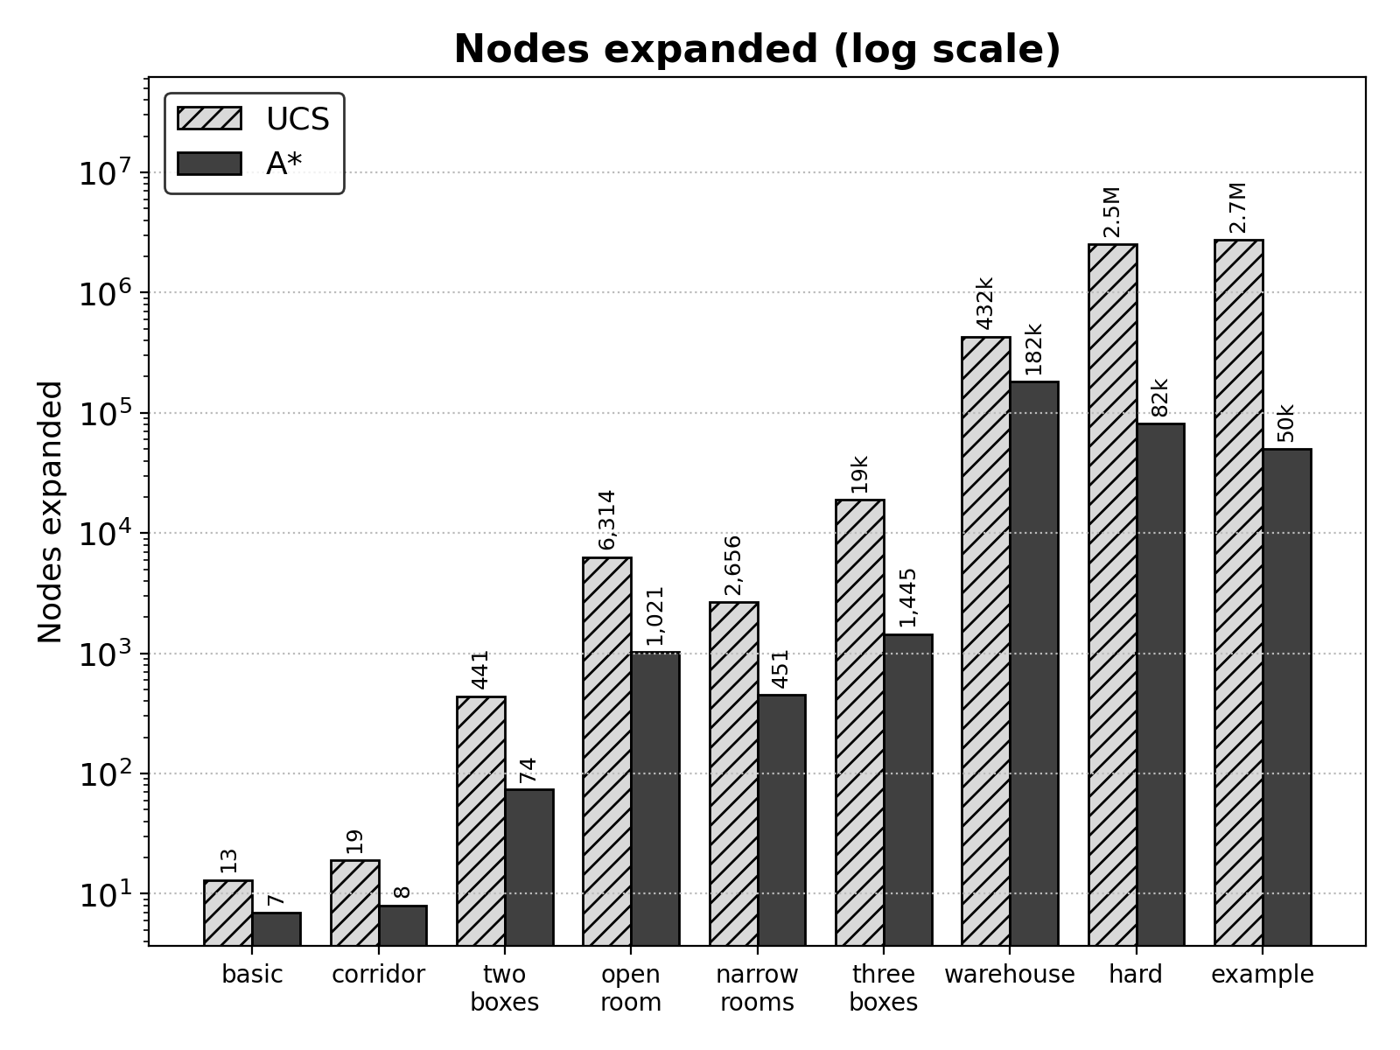
Figure 1. Nodes expanded per map (log scale).
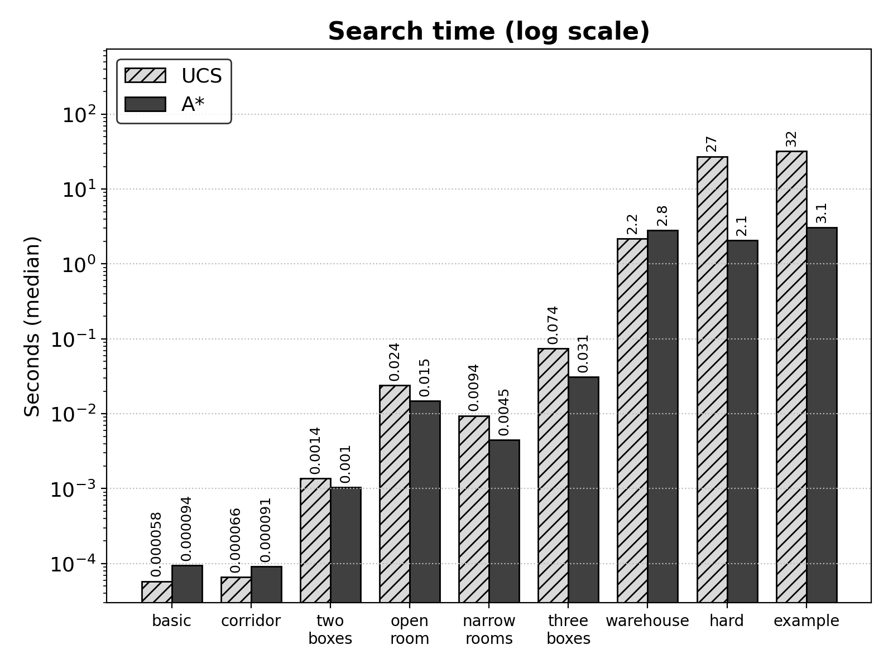
Figure 2. Search time per map (log scale).
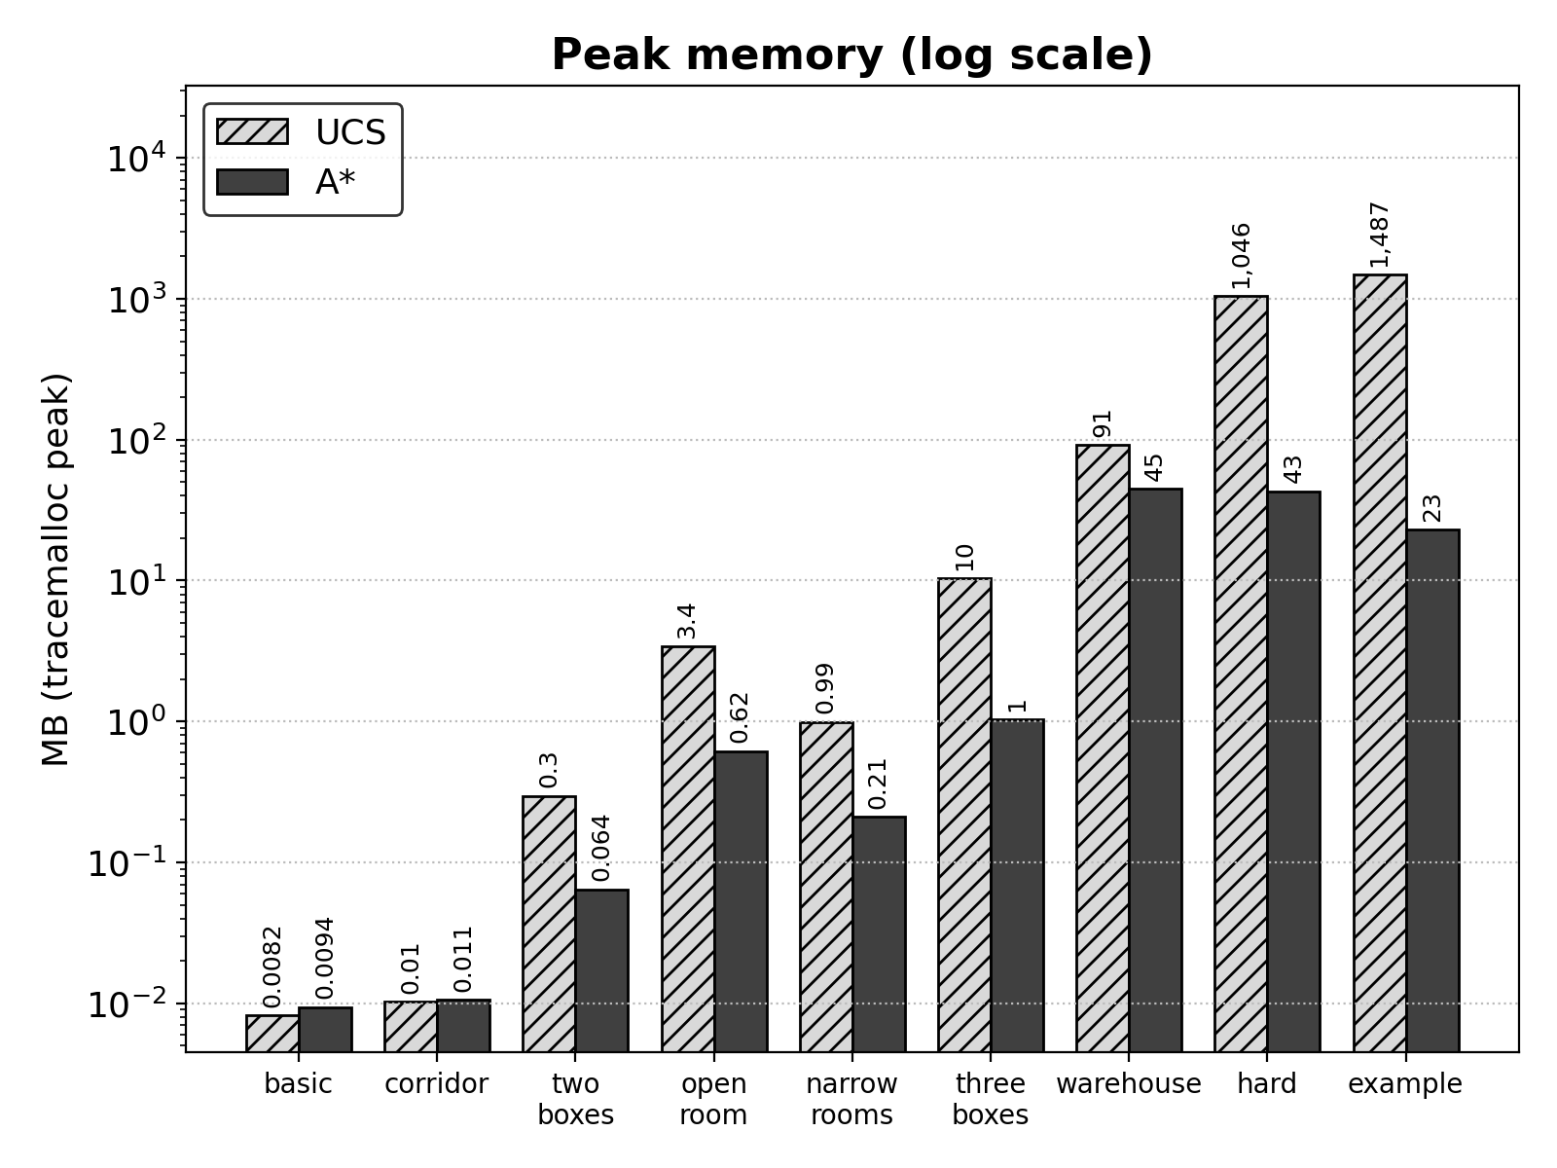
Figure 3. Peak memory per map (log scale).
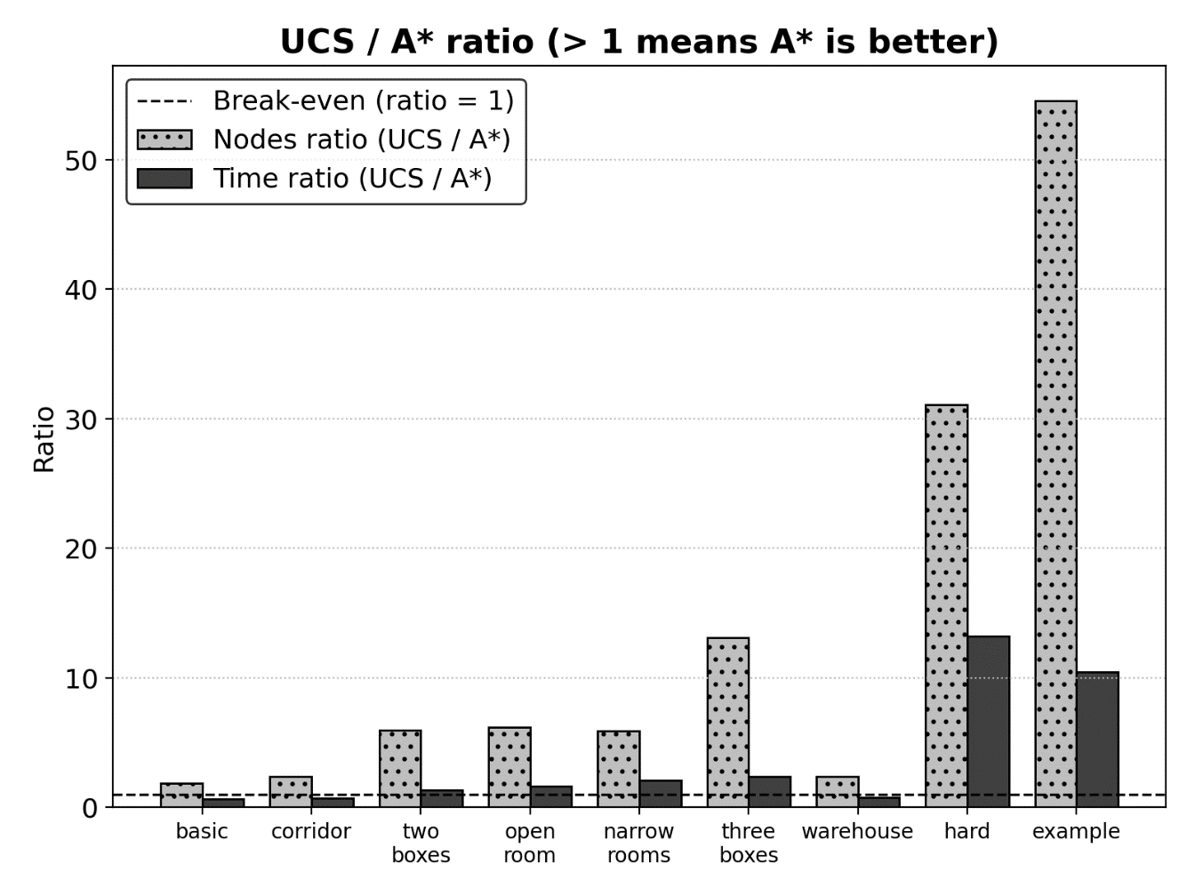
Figure 4. UCS / A* ratio for nodes and time. Bars above the dashed line mean A* wins.

5. Analysis and Conclusion
A* uses less time and memory because the heuristic focuses the search on the goal. UCS orders nodes by path cost g(n) only, so it spreads out evenly in every direction and expands every state that is cheaper than the optimal solution, whether or not it leads toward the targets. A* orders nodes by f(n) = g(n) + h(n): states whose boxes are already close to their targets are expanded first, and corner-deadlocked states are discarded immediately (h = ∞). On example_map.txt this means 50,170 expanded nodes instead of 2,736,902 (54.55× fewer), 3.08 s instead of 32.06 s, and 22.88 MB instead of 1486.7 MB of peak memory, with the same optimal cost of 34 steps.
Three further observations explain the variation between maps:
- The gap grows with difficulty. The saving in expanded nodes grows from about 2× on one-box maps to 31× (map8_hard) and 55× (example map). This matches the exponential form O(b^{d}) of uninformed search: every extra box multiplies the number of states UCS must visit.
- The heuristic has a cost. When between 52% and 84% of A*, the search time is spent computing h(s) (BFS lookups plus the Hungarian algorithm), so one A* expansion costs from 2.4 to 5.5 times as much as one UCS expansion. On the two one-box maps this overhead is larger than the saving and UCS is slightly faster (0.06 ms vs 0.09 ms on map1_basic).
- Constrained layouts can reverse the result. On map7_warehouse walls already restrict the reachable states and the solution is long (54 steps), so both algorithms explore a large part of the space. A* expands 2.37× fewer nodes and uses 2.03× less memory, yet UCS is faster (2.17 s vs 2.81 s) because every A* node costs more.

Conclusion:
Both algorithms always returned the optimal solution, confirming that the heuristic is admissible and consistent in practice. On every map with more than one box A* expanded fewer nodes and used less memory, and it was also faster on all of them except map7_warehouse; the larger and harder the map, the larger its advantage. UCS is competitive only on trivial maps and on tightly walled maps, and on the hardest maps its memory use (over 1 GB) becomes the limiting factor.

6. How to reproduce
- python experiment.py runs all maps (3 timing runs each) and writes results/.
- python experiment.py --maps map8_hard --repeats 1 --merge reruns one map and keeps the others.
- pip install matplotlib is needed for the charts; everything else uses the standard library.

