Module 2 Initial Results

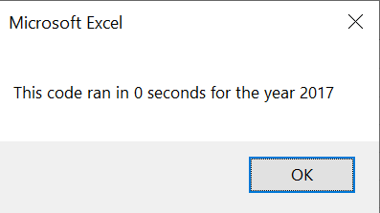

Refactored - VBA_Challenge_2017.png

