**15. Optocouplers**

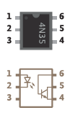Optocouplers are integrated circuits that allow you to control one circuit from a different one without any electrical connection between the two. Inside an optocoupler is an LED and a light detector. When the LED in the optocoupler is turned on by your Arduino, the light detector closes a switch internally. The switch is connected to two of the output pins (4 and 5) of the optocoupler.

When the internal switch is closed, the two output pins are connected. When the switch is open, they’re not connected. This way, it’s possible to close switches on other devices without connecting them to your Arduino.

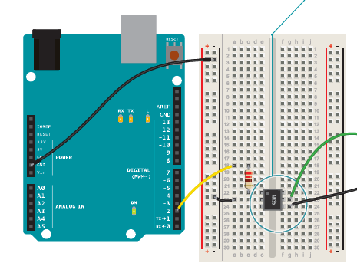

?

Use the octocoupler for controlling, turning on and off, at least an LED. Think of the circuit and calibrate it on the basis of the 9 V battery (!) that goes to self-power the LED.

Write your code.