**1_Get to know**

You’re going to use the Arduino in this project, but only as a source of power. When plugged into a USB port or a 9-volt battery, the Arduino will provide 5 volts between its 5V pin and its ground pin that you can use.

**Use a proper resistance to connect the power line to one side of the switch. The other side will be connected to the LED anode. Check and verify the technical sheet.**

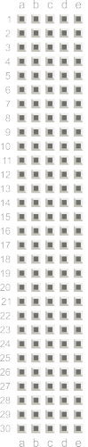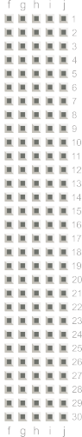

USB

Gnd-5V

Switch



Led



Series/Parallel circuits

**Once you’ve removed your power source** add a switch next to the one already on your breadboard. Wire them together in series and then in parallel.





 

 

 

 

