**Servo motor**

Servo motors are a special type of motor that don’t spin around in a circle, but move to a specific position and stay there until you tell them to move again.

Servos usually only rotate 180 degrees (one half of a circle). Similar to the way you used pulses to PWM an LED in the Color Mixing Lamp Project, servo motors expect a number of pulses that tell them what angle to move to. The pulses always come at the same time intervals, but the width varies between 1000 and 2000 microseconds. While it’s possible to write code to generate these pulses, the Arduino software comes with a library that allows you to easily control the motor. Because the servo only rotates 180 degrees, and your analog input goes from 0-1023, you’ll need to use a function called **map()** to change the scale of the values coming from the potentiometer

.

Gnd-5V

Place a potentiometer on the breadboard, and connect one side

to 5V, and the other to ground. As you turn the knob, you change the ratio of the voltage between the middle pin and power. You can read this change on an analog input. Connect the middle pin to analog pin A0

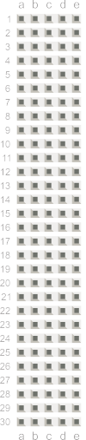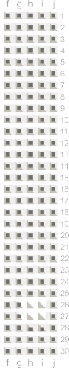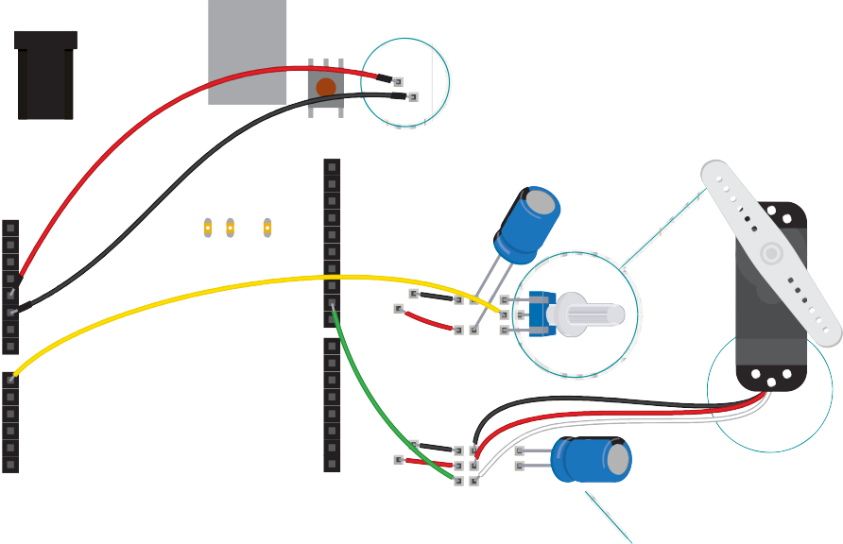

The servo has three wires coming out of it. One is power (red),

one is ground (black), and the third (white) is the control line that

will receive information from the Arduino( pin 9)

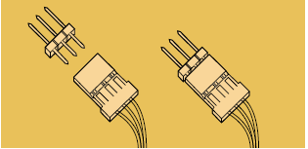

When a servo motor starts to move, it draws more current than if it were already in motion. This will cause a dip in the voltage on your board. By placing a 100uF capacitor across power and ground right next to the male headers, you can smooth out any voltage changes that may occur. You can also place a capacitor across the power and ground going into your potentiometer. These are called *decoupling capacitors* because they reduce, or decouple, changes caused by the components from the rest of the circuit. Be very careful to make sure you are connecting the cathode to ground (that’s the side with a black stripe down the side) and the anode to power.

If you put the capacitors in backwards, they can explode!

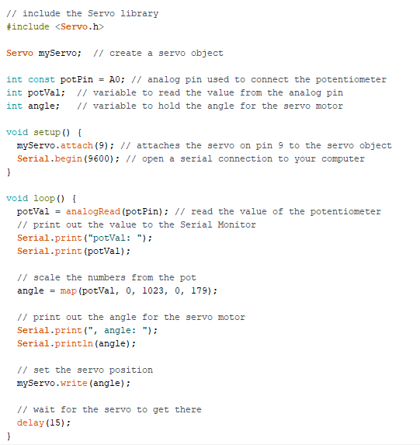

To use the servo library, you’ll first need to import it. This makes the additions from the library available to your sketch.

To refer to the servo, you’re going to need to create a named instance of the servo library in a variable. This is called an object.

When you do this, you’re making a unique name that will have all the functions and capabilities that the servo library offers. From this point on in the program, every time you refer to **myServo**, you’ll be talking to the servo object.

Set up a named constant for the pin the potentiometer is attached to, and variables to hold the analog input value and angle you want the servo to move to.

In the setup(), you’re going to need to tell the Arduino what pin your servo is attached to.

Include a serial connection so you can check the values from the potentiometer and see how they map to angles on the servo motor.

In the loop(), read the analog input and print out the value to the serial monitor.

To create a usable value for the servo motor from your analog input, it’s easiest to use the **map()** function. This handy function scales numbers for you. In this case it will change values between 0-1023 to values between 0-179. It takes five arguments: the number to be scaled (here it’s **potVal**), the minimum value of the input (0), the maximum value of the input (1023), the minimum value of the output (0), and the maximum value of the output (179). Store this new value in the angle variable.

Then, print out the mapped value to the serial monitor. Finally, it’s time to move the servo. The command **myServo.write()** moves the motor to the angle you specify.

At the end of the loop() put a delay so the servo has time to move to its new position. Decide if it necessary to increase the delay value.