**Thesis Outline**

**Title**

**BUILDING A DIGITAL TWIN FROM AN INTELLIGENT ELECTRONIC DEVICE**

**Student**

Prasath Manickam

**Thesis Advisor**

Prof. DI Dr. Marc Kurz

**Date and Time**

Hagenberg, 02.02.2021

Table of Contents

1. Overall Goal, Motivation, and Research Questions 3

2. State of the Art and Related Work 4

3. Approach and Methodology 5

4. Practical Realization 6

5. Planned Structure of the Thesis 7

6. Planned Schedule and Deliverables 8

7. Literature 9

# Overall Goal, Motivation, and Research Questions

< “What is the basic idea of your intended work and why do you find that work important, and which research questions should be answered with your intended work?” – about one page >

This thesis aims to present an approach for building a digital twin solution for the increasingly complex automation in the Energy Industry. As we all know, industry 4.0 accelerates digitalization, smart grid, and distributed mini-grids integration enabled automation, optimization, and energy efficiency. The distributed integration and massive data led to system inconsistency, non-availability, and protection issues. An additional infrastructure must be evaluated using expensive simulation devices. Operators must be at the local station to check how parameters react to protection trips can be safely validated and validated with the real device and interaction. The systems must be available as a playground for the user but limited due to the machine's modelling.

**Research Questions**:

1) Is it possible to avoid expensive simulation device?

2) Is it possible to bring the whole system online in the web browser to access from anywhere?

# State of the Art and Related Work

< “Which work (scientific, but also commercial work) has been done in this field (rough, but broad overview), that can be used by you to reach the goals formulated in section 1?” – about one page >

# Approach and Methodology

< “How do you intend to derive answers to the research questions, which artefacts (proof-of-concept implementations) do you intend to build for that purpose, and with which scenarios do you intend to use the artefact?” – about one page >

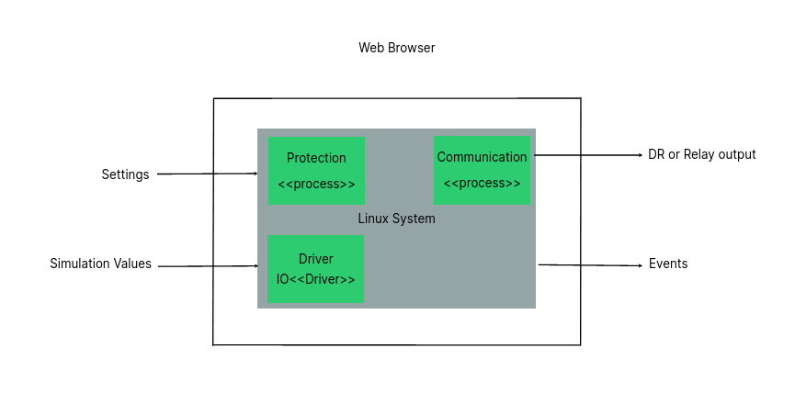

# Practical Realization

< “Which concrete functionalities are realized by the artefacts (proof-of-concept implementations)? Which internal interfaces are needed between these modules? Which external components collaborate with the intended artefacts and which external interfaces are needed for that purpose?” – about one page >

The solution is to create a digital twin of the system that can be used for training to test changes and simulations. This twin system will be integrated into the Web engineering replicates behavior model of the IED and executed on the web using WebAssembly. WebAssembly is a promising innovative approach that enables running machine code on the browser besides Javascript and HTML. The entire model consists of several C/C ++ programs based on RTOS and Linux. The digital twin facilitates the system as a playground in the browser and provides an intuitive experience to testers, developers, and operators. Therefore, it helps to reduce the cost of simulation devices and operators. Also, the complex infrastructure can be simulated and tested remotely available to integrate into production devices safely.

# Planned Structure of the Thesis

< “Which chapters, sections, and potentially subsections shall your thesis contain, how long shall they be, and what are the basic planned contents of these chapters?” – about one page >

1. Introduction

2. Related Work

3. Requirement analysis and Specification

4. Concept

5. Implementation

6. Result

7. Conclusion

# Planned Schedule and Deliverables

< “Which steps of work shall be done up to which deadlines, and which deliverables shall be provided at these times?” – about one page >

|  |  |  |  |
| --- | --- | --- | --- |
| **Milestone** | **Estimated date** | **Deliverable/Outputs** | **Standing** |
| Project proposal | Dec 2020 | Project topic acceptance | Completed |
| Project Specification  and Thesis outline | Jan 2021 | Project specification and Thesis outline | WIP |
| Data collection  and analysis | Jan 2021 | Access Data | WIP |
| Implementation | End of Feb 2021 | Developed and Working model | Not yet started |
| Evaluation and  research | End of Feb 2021 | Research on other best approach | Not yet started |
| Project Thesis Writing  and presentation  defence | 25.05.2021 | Final edition of thesis  written | Not yet started |
| 21.06.2021 | Final report  submission | Not yet started |
| 12.07.2021 | Defence | Not yet started |

# Literature

[SA21] Sprecher Automation GmbH: “SPRECON Protection Device website” [Online]. Available: https://www.sprecher-automation.com/en/products/sprecon-protection-devices/ [Accessed: 02-Feb-2021]

[WA21] WebAssembly: “WebAssembly open source community website” [Online]. Available: <https://webassembly.org/> [Accessed: 02-Feb-2021]

[EM21] Emscripten: “ Emscripten open source community website” [Online]. Available: https://emscripten.org/ [Accessed: 02-Feb-2021]