The protection relay testing procedure varies through its life-cycle of usage. The manufacturers performs type and production testing where as test engineers involved in commissioning and maintenance test of relays depends upon their role. The different method of testing used to determine and ensure performance of the relay while commissioning. The commissioning

carries function testing where installation of manual wiring, AC and DC control systems setup and relay testing where hardware tests carried (meter test, contact test, input/output circuitry), verification of hardware settings to avoid wrong operations. Then, automated testing evolved to fasten this process and generating a precise automated report for standard compliance. Also, it stopped manipulation of the results by the test engineers and established high standard relay schemes to settings. For instance, an automated test software namely OMICRON Test Universe provided an intuitive UI for controlling test parameters, creating,saving and playing test plans and generate automated report.

OMICRON TestUniverseTM

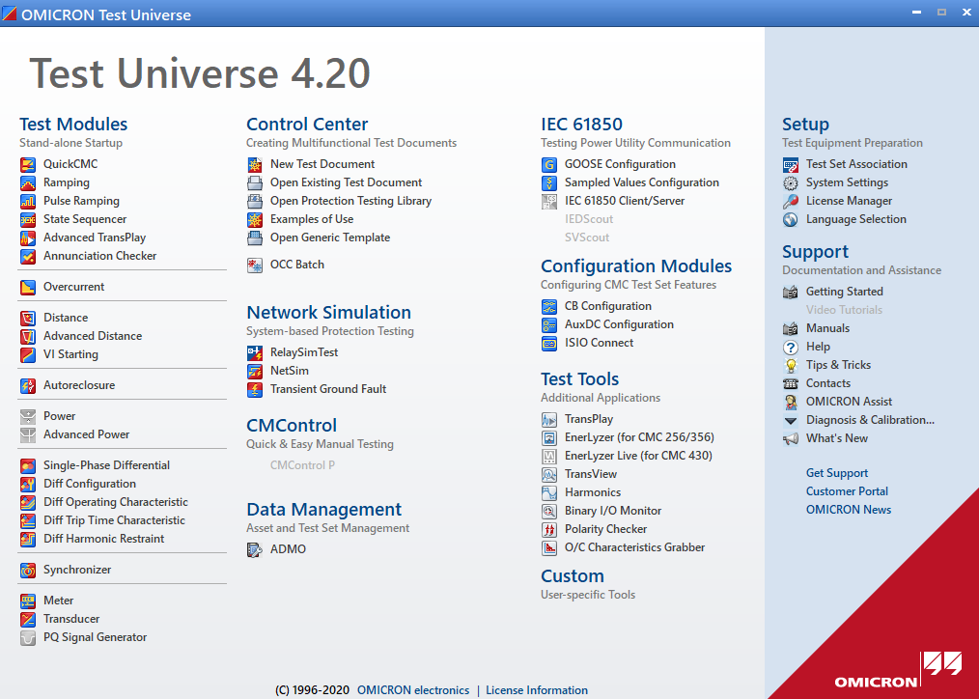

The OMICRON electronics GmbH created TestUniverse software as part of power system solutions. It provided varying sections and particularly test modules for different protection schemes. The test engineer choose desired module, enter nominal values for the relay in test, perform calculations, and limit test set outputs to the relay rated values.

In addition to that, the software TestUniverse enabled strong visualisation of test data’s in different views as time-signal plot, R-X complex diagram, and phasor diagram. The QuickCMC test module is the easiest and allowed manipulation of the test voltages (V) and currents (I). And Ramping is the most widely used module allows to ramp test quantities (magnitude, phase and frequency) up and down. The control center section enabled the faster and enhanced test automation where test engineers can create test plans using OCC files. The OCC files used to run a series of test modules, write a new setting for a test relay for the next test module and produced assessment reporting. As visible in the Figure Test Universe software facilitates many services namely network simulation, IEC 61850, configuration modules, test tools and so on. The entire setup and testing were physical dependent. Therefore, remote testing of protection relays were explored through research and following sections will explain in detail.

Hardware in the Loop Based

Plenty of researchers introduce the ‘remote testing of protection relays’ concept for

educational and distance learning purposes. R. Zivanovic in his paper “Remote pro-

tective Relay Testing” proposes remote protective relay test method that comprises

the use of SEL low level test module and Application Service Provider (ASP) to

enhance troubleshooting testing performed by engineers on remote locations [26].

The Application Service Provider architecture used includes Authentication, test

management, results management and queue management for remote user interac-

tion with online experiments. A block diagram of this implementation is shown in

Fig. 4.5. Another similar proposition by V. Fernão Pires in the School of Setúbal to

implement a remote laboratory [11].

SV Based Testing

Omicron has made a step towards functional testing using their product CMC 256

with NET- 1 option that allows the generation of sampled value test quantities. The

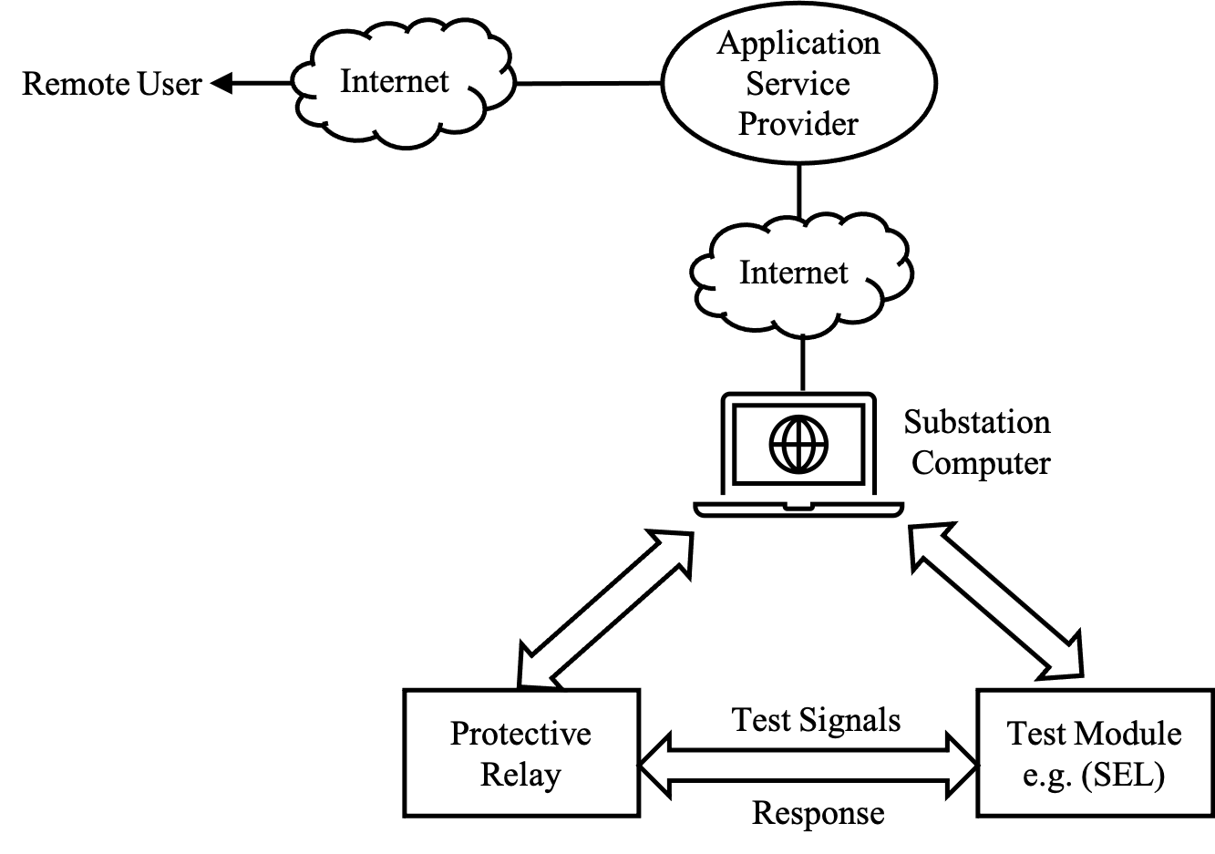

sampled values are generated according to the ”Implementation Guideline for Digi-

tal Interface to Instrument Transformers using IEC 61850-9-2”, which is published

by the UCA International Users Group [15]. This method is quite effective for con-

ventional wires reduction since the communication is established via ethernet based

communication link. Fig. 4.6 shows a simplified diagram of this testing philosophy.

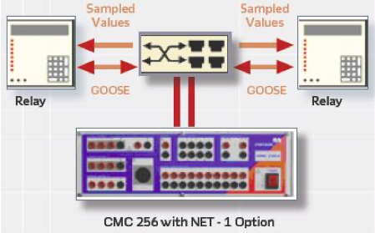

Web Based Remote Testing

Lately, Sprecher Automation developed a Web application The IED under test is

the server and the remote user pc is the client as shown in Fig. 6.1. Ideally, The

Server App runs the protection algorithm in the physical IED and data is sent and

retrieved using the https internet communication protocol. However, the Web app

is implemented for prototyping using WebAssembly technology [12]. WebAssemply

enables users to run native language applications in the web browser using the

Emscripten compiler. Emscripten compiles the C source code and generates 3 files

(.wasm, JavaScript and HTML) that can be loaded into the browser.

The user in the remote location is able to upload two files, an IED settings file

and a test file where the testing samples are stored. The user has two test file

formats possibilities to use. COMTRADE file format [1] or CSV file format. Most

disturbance recorders and automated test software store the data in COMTRADE

format, therefore, it was chosen in this approach.

The CSV format was chosen to make use of the OMICRON OCC files concept

where the user can store the data stored in an OCC file into a CSV file using

the ”OCCinterpreter”. ”OCCinterpreter” is a C++ based program written for this

approach by the author. Additional, a Windows desktop application was created

based on the Microsoft C# .Net Framework. The windows application is created to

generate 3 phase system samples. The samples are stored in a csv file the user can

download to be used fot the Web app.

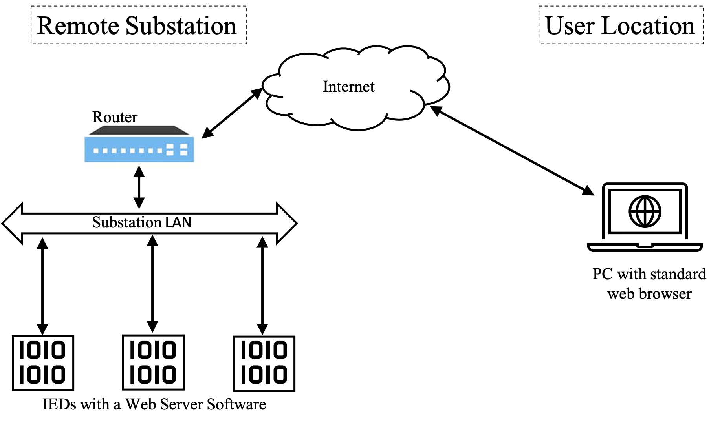

Test Setup

Test Procedure

Test Results