**Testing methods**

The protection relay testing procedure varied through its life-cycle of usage. The manufacturers performed a type and production testing where test engineers involved in commissioning and maintenance test of relays depended upon their role. The different method of testing used to determine and ensure performance of the relay while commissioning. The commissioning

carried function testing where installation of manual wiring, AC and DC control systems setup and relay testing where hardware tests carried (meter test, contact test, input/output circuitry), verification of hardware settings to avoid wrong operations. Then, automated testing evolved to fasten this process and generated a precise automated report for standard compliance. Also, it stopped manipulation of the results by the test engineers and established high standard relay schemes to settings. For instance, an automated test software namely OMICRON Test Universe provided an intuitive UI for controlling test parameters, creating,saving and playing test plans and generate automated report.

**SV Based Testing**

http://iec61850.ucaiug.org/implementation%20guidelines/digif_spec_9-2le_r2-1_040707-cb.pdf

The Sampled Value (SV) testing on the relay protection algorithm was achieved using OMICRON product CMC 256 with NET- 1 option that allowed generation of sampled value test quantities. The

sampled values generation followed the standard ”Implementation Guideline for Digital Interface to Instrument Transformers using IEC 61850-9-2”, published by the UCA International Users Group [1]. The approach used Ethernet based communication for exchanging data (SV) and signals (GOOSE), the OMICRON software Test Universe used to inject the digital file (SV) to the relay instead of traditional injection of analog low energy signals with ADC. Fig. 4.6 shows a simplified diagram of this testing philosophy.

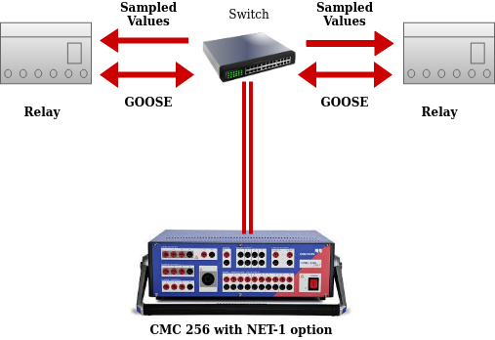

**OMICRON TestUniverseTM**

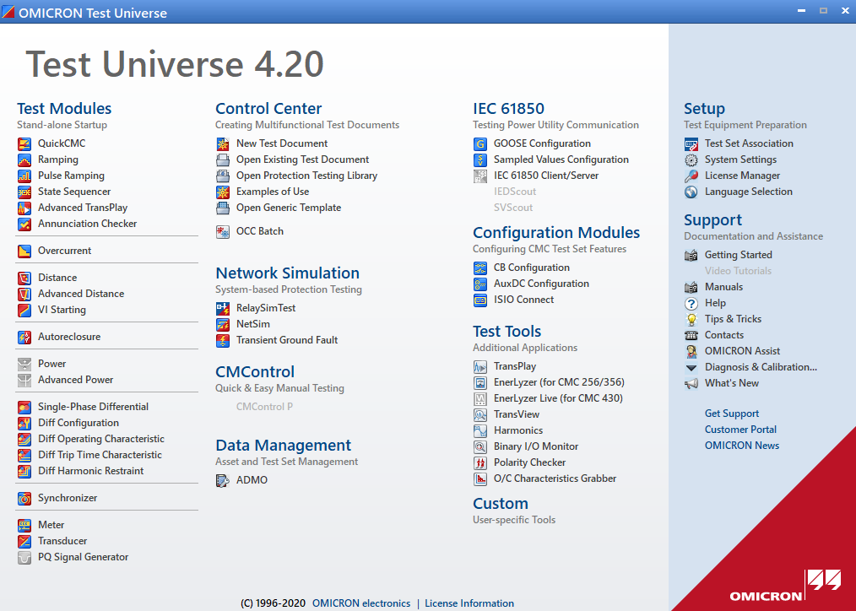

The OMICRON electronics GmbH developed a TestUniverse software suite as part of power system solutions. It provided varying sections and particularly test modules for different protection schemes. The test engineer chose desired module, entered nominal values for the relay in test, performed calculations, and limited test set outputs to the relay rated values.

In addition to that, the software TestUniverse enabled strong visualisation of test data’s in different views as time-signal plot, R-X complex diagram, and phasor diagram. The QuickCMC test module is the easiest and allowed manipulation of the test voltages (V) and currents (I). And Ramping is the most widely used module allows to ramp test quantities (magnitude, phase and frequency) up and down. The control center section enabled the faster and enhanced test automation where test engineers can create test plans using OCC files. The OCC files used to run a series of test modules, write a new setting for a test relay for the next test module and produced assessment reporting. As visible in the Figure Test Universe software facilitates many services namely network simulation, IEC 61850, configuration modules, test tools and so on. The entire setup and testing were physical dependent and constituted non-holistic test method as dis-advantage. The analog input channel influence the performance of the protection algorithm in input transformer and analog to digital conversion.

**Hardware in the Loop Based**

[**https://www.researchgate.net/publication/317415795_Developing_automated_Hardware-In-the-Loop_tests_with_RTDS_for_verifying_the_protective_relay_performance**](https://www.researchgate.net/publication/317415795_Developing_automated_Hardware-In-the-Loop_tests_with_RTDS_for_verifying_the_protective_relay_performance)

<https://ieeexplore.ieee.org/document/8107191>

<https://ieeexplore.ieee.org/document/9176775>

<https://www.semanticscholar.org/paper/Hardware-in-the-loop-design-and-optimal-setting-of-Papaspiliotopoulos-Korres/22feb703cf308419ee3bb7c6e71c09892dbfb83d>

<https://link.springer.com/chapter/10.1007/978-3-030-42274-5_4>

https://www.semanticscholar.org/paper/Real-time-Hardware-in-the-loop-Implementation-for-Avalos-Zamora/f54eb540ce59d7c5d505581284e4ab0a2f78e72b

An innovative approach for a time-domain protection approach must be tested in realistic before actual commissioning within the power substations to make sure reliability improvement implemented through hardware-in-the-loop (HIL) simulation. A HIL simulation testing enabled the possibility for reliability and flexibility without damaging physical equipments but usually hard to fully capture the real behaviour of the equipment. And real hardware testing required more time to configure for adaption and investments. HIL approach interfaced the simulation and real-hardware environment as efficient testing method for emerging distributed energy resource (DER), manufacturers to adapt, network operators and regulation authorities to establish new testing method from power system landscape. HIL allowed a real hardware setup to couple with real time simulator for testing hardware/software components under realistic conditions. It avoided simulation gaps in real-hardware as well as time consuming hardware reconfiguration with simulated values. A HIL tests with the distance relay Schweitzer Engineering Laboratories product SEL-421 in a simulated model of power network was performed and reported a improved performance of relay through a study from T. Iracheta-Cortez et al [1]. And an another study [2] from [Amir Saman Makhzani](https://ieeexplore.ieee.org/author/37086901970) et al. where operation of a real instantaneous overcurrent protection module of SEL-351S relay was investigated and verified through OPAL-RT digital simulator using HIL testing in a distribution feeder with varying distributed generation. Also an another study from Juan R. Camarillo-Peñaranda et al. used PSCAD software to do virtual relay testing in a HIL simulation of single-machine infinite bus system and virtual relay was implemented in LAUNCHXL-F28379D through commercial microcontroller.

<https://www.semanticscholar.org/paper/Remote-protective-relay-testing-Musaruddin-Zaporoshenko/6ec99d1c2fe4094622bd2be967ed515493fdc85d>

Futhermore, the remote testing possibility of protection relays was analyzed by numerous researches and specifically this experimental study from Mr. Musaruddin et al. introduced an approach via application server provider (ASP). The testing method categorized into three levels, first level where the substation had the SEL low level test module, protective relay and substation computer, the resulting data was passed from substation computer using a web server to Application Service Provider (ASP) through a WAN network. Then the test engineers access the data through ASP to do testing from remote locations. The ASP also featured authentication for remote users, test management, results management and queue management. A block diagram of this implementation is shown in Fig. 4.5.

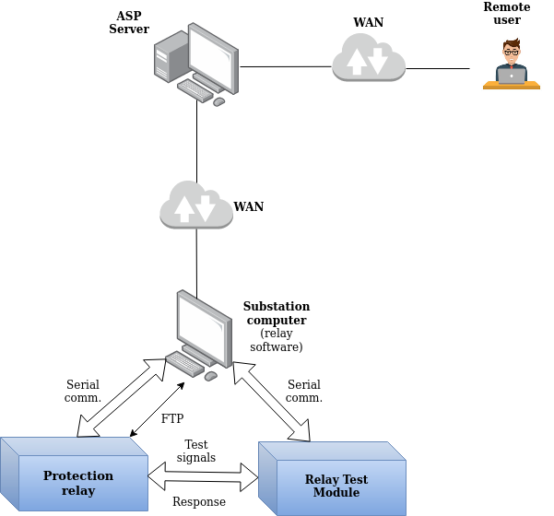

**Web Based Remote Testing**

Over and above approaches, Sprecher Automation developed a Web application for an intuitive and easy testing experimental to access remote substation. The physical IED (protection relay) with a web server ran the protection algorithm, the user pc with UI web application for testing and data are fetched through HTTP request as shown in Fig . The distinctive factor to earlier ASP approach, the web application was implemented for prototyping using WebAssembly. WebAssemply enabled users to run machine code in the web browser using the Emscripten compiler. The remote user uploaded two files, an IED settings file and a testing sample file (COMTRADE or CSV format). These files were chosen because of the following reasons.

- Major disturbance recorders and automated test softwares stored data in COMTRADE format.

- And to use OMICRON OCC files concept where the user stored the data in an OCC file into a CSV file using the ”OCCinterpreter”. OCCinterpreter was a windows desktop application with C++ libraries and front end designed using Microsoft C# .Net Framework. It helped to create three phase system samples.

The user had the flexibility to choose the format and upload the file to web application and do the testing on the relay using web requests and display the results in the web application UI.

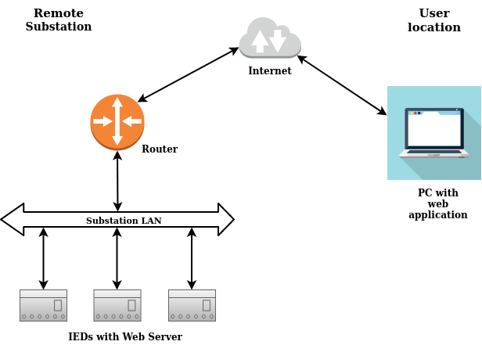

**Digital Twin testing setup, procedure and results**

Evaluation

**Requirement elicitation**

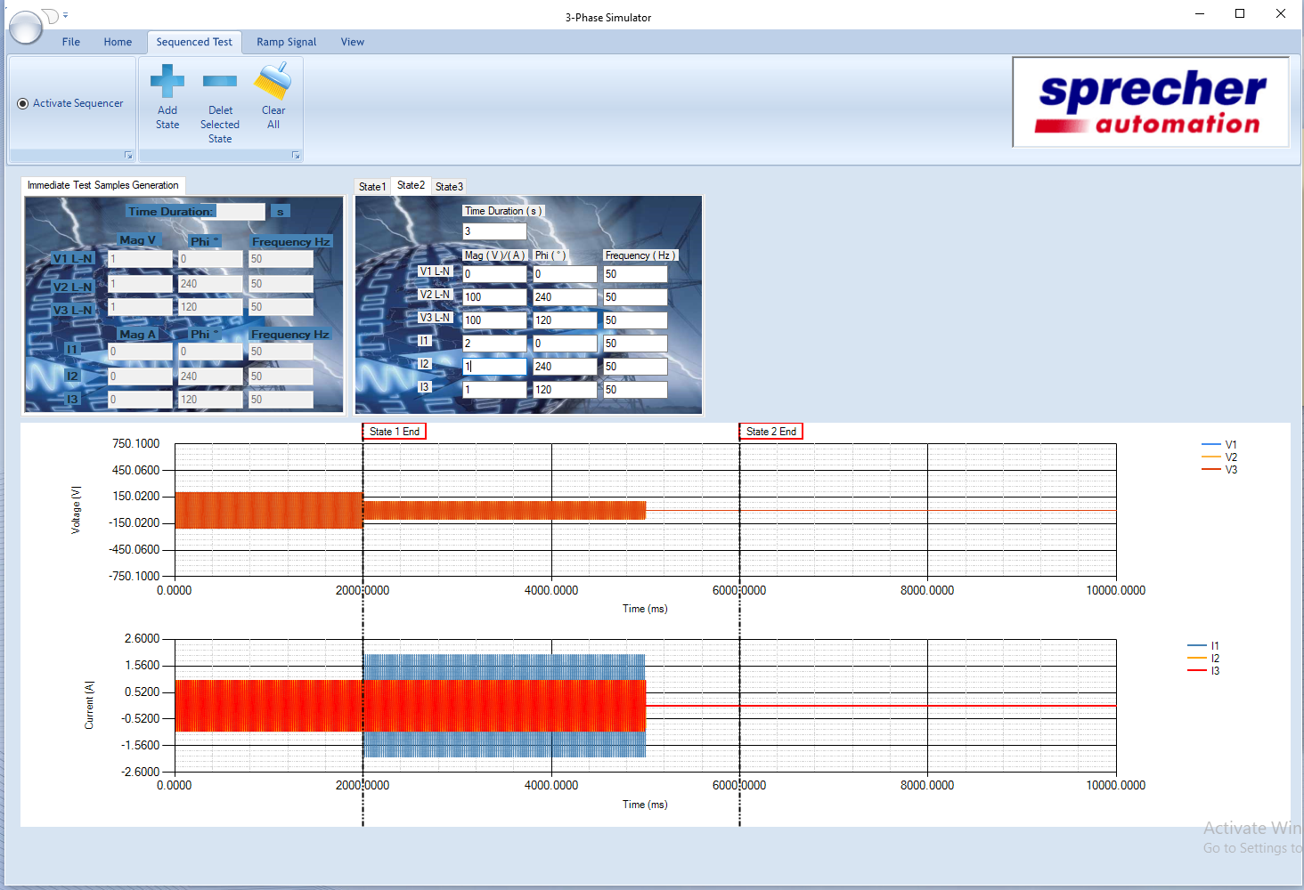

Single phase fault

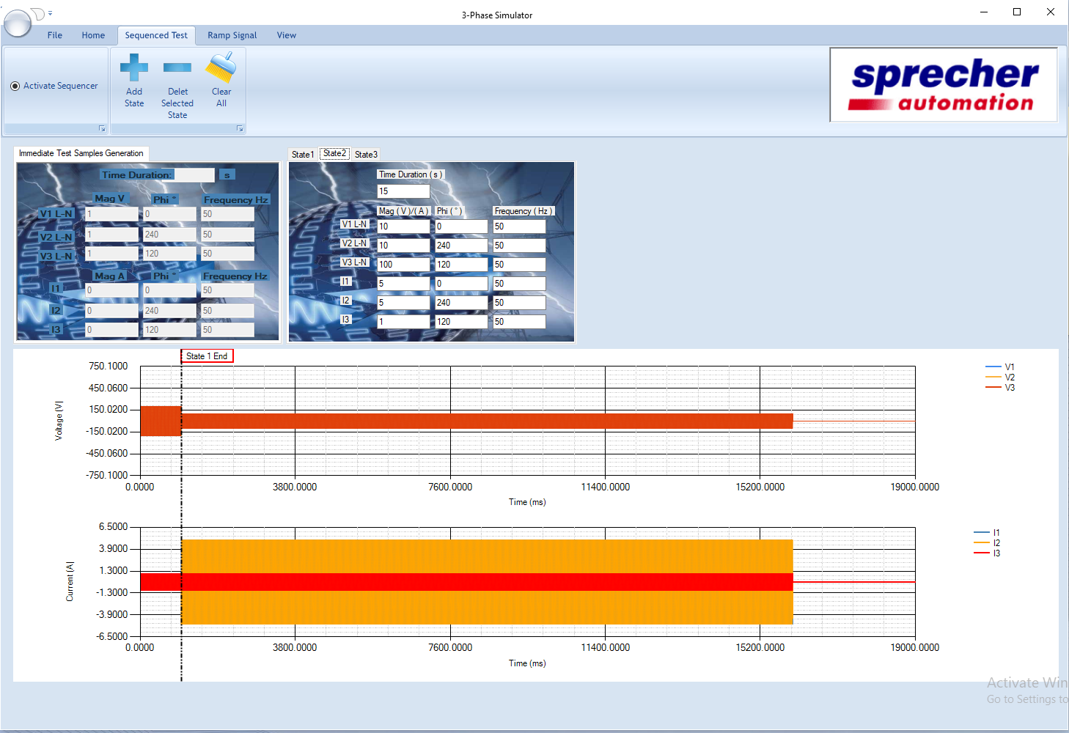

two phase fault

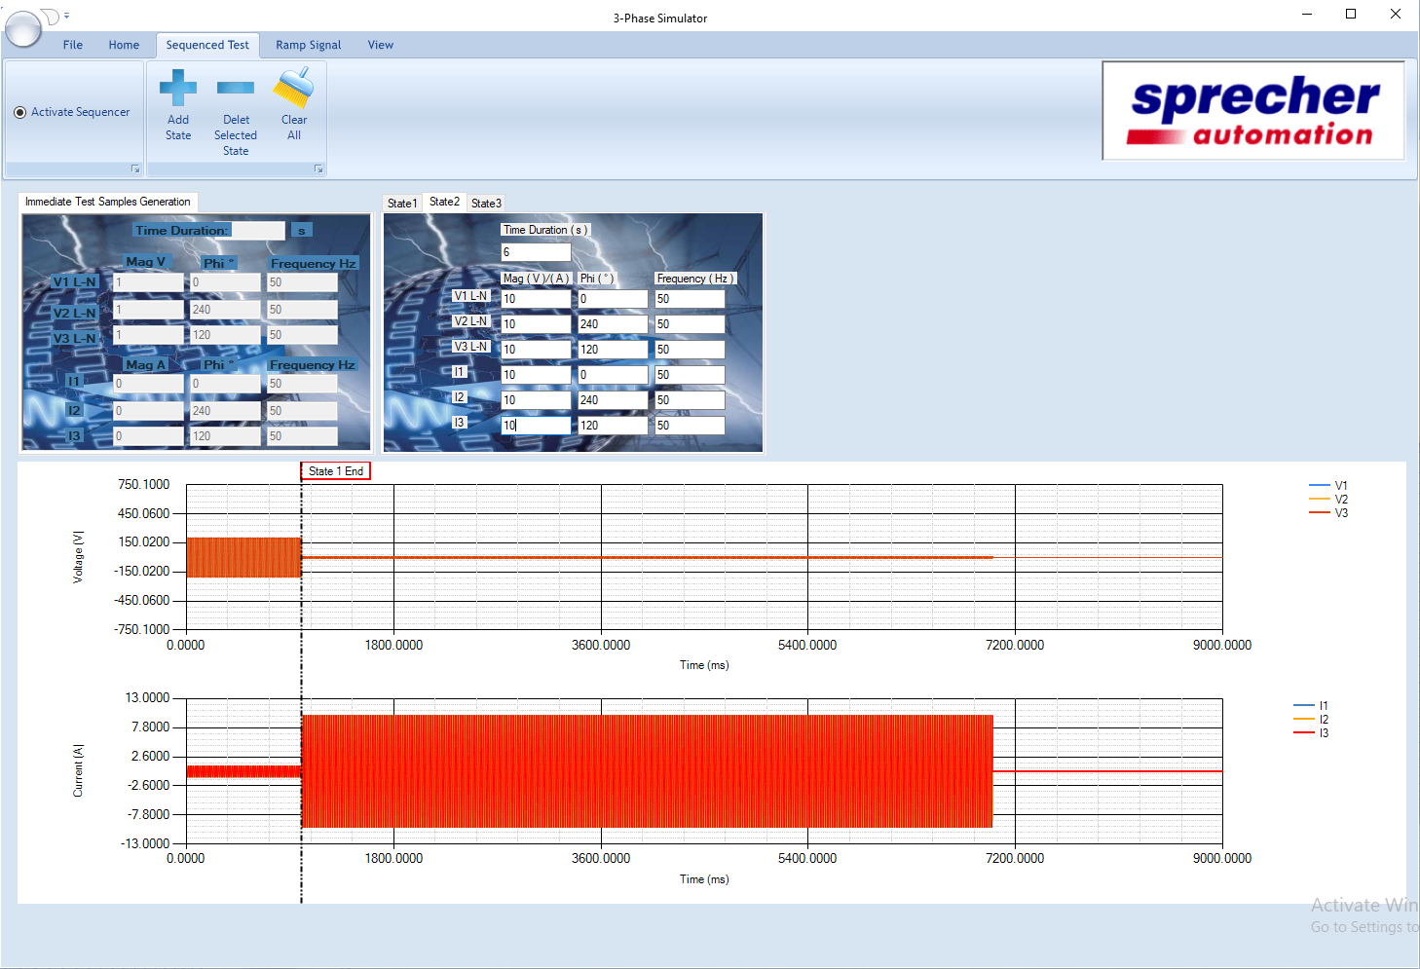

three phase fault

Data

|  |  |  |  |  |  |
| --- | --- | --- | --- | --- | --- |
| Sample | Time(s) | Frequency (Hz) | Phase ° | Magnitude(V) | Magnitude(I) |
| Healthy | 0, 2, 2 | 50 | 0, 240, 120 | 57.7 | 1 |
| Fault1  (single-phase) | 1 |  |  |  |  |
| Fault2  (two-phase) |  |  |  |  |  |
| Fault3  (three-phase) |  |  |  |  |  |

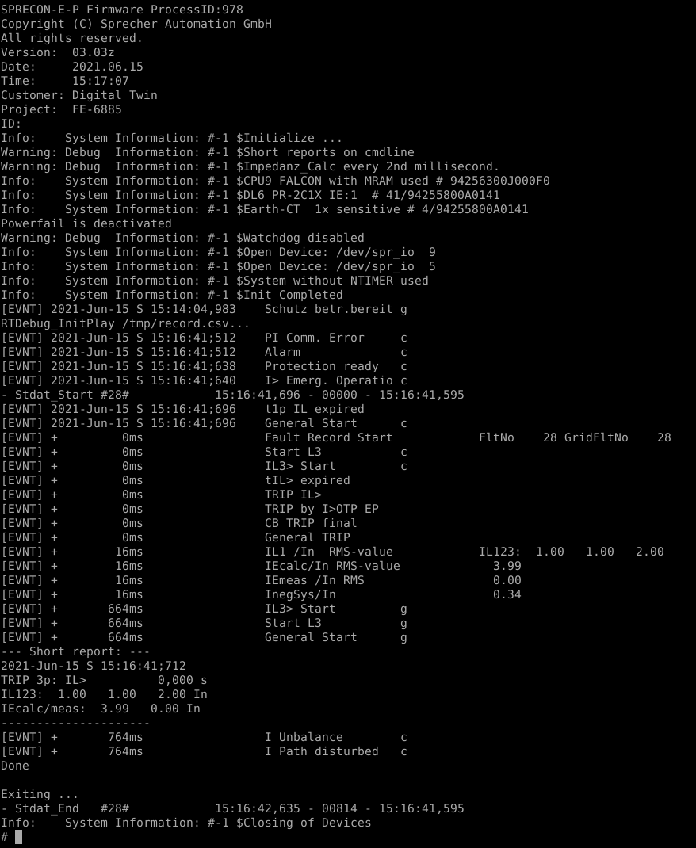

**Performance evaluation**

**Virtual machine**

Idle machine performance/per day and With protection/per day

Graphs separate for both

CPU, Memory, Network, and Disk IO

Reading and writing to virtual disks and virtual disk health

### VM Disk Read/Write IOPS and Throughput

<https://www.eginnovations.com/blog/top-10-vmware-performance-metrics/>

https://docs.snowsoftware.com/commander/service-portal/view_perform_details.htm

Virtual network traffic

https://www.dnsstuff.com/vm-performance-guide

**Load testing**

**Stress testing**

**Host machine**

CPU, Memory, Network, and Disk IO while a virtual machine loads

**Virtual vs Physical machine comparison**

Booting time

Processing time

Tools

dstat https://www.tecmint.com/dstat-monitor-linux-server-performance-process-memory-network/#:~:text=dstat%20is%20a%20powerful%2C%20flexible,can%20build%20their%20own%20plugins.

https://www.site24x7.com/help/virtualization-metrics/vmware-vm-monitor.html

https://www.golinuxcloud.com/check-top-memory-cpu-consuming-process-script/

<http://www.benjamincburns.com/2013/11/10/jor1k-ethmac-support.html>