1. I am using my MacBook Air, version macOS 13.4
2. My editor is TextEdit

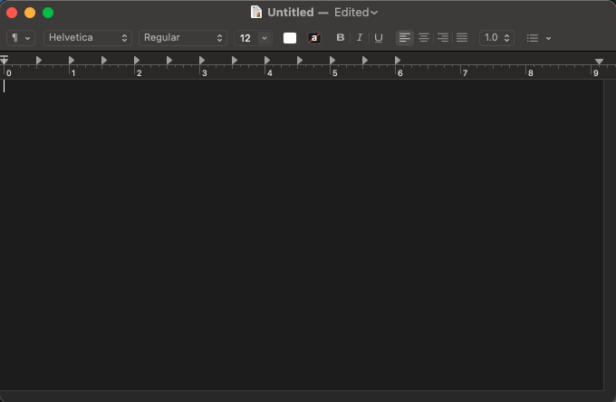

1. The compiler I am using is Terminal on a Mac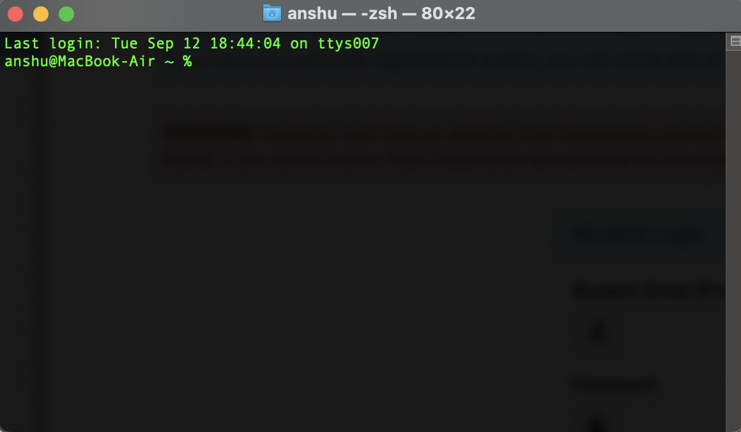
2. My working folder is called “COMSC110” in my iCloud Drive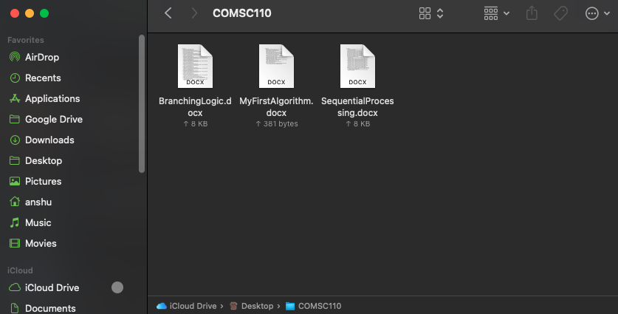
3. n/a