Recipe List

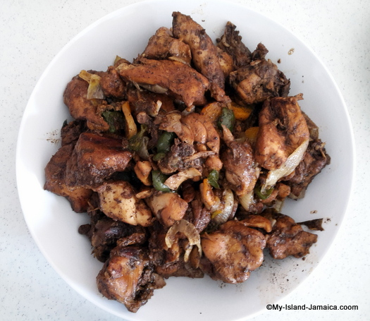

1. Jamaican Brown Stew Chicken

**Ingredients**

* 3 lb. chicken
* 1 stalk escallion
* 2 cloves garlic (chopped)
* 2 cups water
* 1 tsp. Salt
* 3 regular sized carrots
* 1 oz. soy sauce
* 1 sprig. thyme (chopped)
* 1.5 tablespoon vegetable oil
* 1 medium onion (Chopped)
* 2 tomatoes (diced)
* ½ oz lime juice
* 4 tablespoon ketchup

**Preparation**

1. Wash the chicken in water with the lime juice.
2. Clean & cut chicken into small pieces.
3. With the exception of the oil and ketchup, combine the chicken and all the other seasonings-including soy sauce.
4. Rub all the ingredients into the chicken and allow to marinate for a few hours (even overnight, if possible).
5. Remove the tomatoes,scallion and other easily removed seasonings from the chicken and place in a bowl.
6. Heat the vegetable oil- well hot, and fry all the chicken pieces until brown.
7. Add all the seasonings in the same saucepan along with the tomato ketchup and carrot.
8. Add water
9. Cover and cook over medium heat until tender.
10. Serve it up!

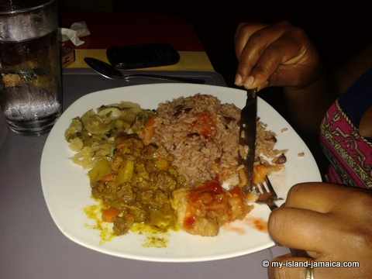

1. Jamaican Curried Goat

INGREDIENTS

* 3 lbs mutton (goat meat) -cut it into medium-sized chunks
* 2 teaspoons seasoning salt
* 1/2 teaspoon black pepper
* 3 medium potatoes (diced)- optional
* 1 large onion; diced
* 3 cloves garlic; minced
* 1 teaspoon fresh thyme leaves
* 1 bunch scallions; chopped
* 1 scotch bonnet, seeded & minced finely
* 2 tablespoons Jamaican curry powder.
* 2 tablespoons cooking oil

PROCEDURE

1. Season meat with the seasoning salt.
2. Heat the cooking oil in a large pot & add 1 tablespoon of the Jamaican curry powder.
3. Cook stirring constantly until the curry powder darkens quite a bit.
4. Put meat in pot along with onions, scallions, garlic & scotch bonnet pepper.
5. Fry a little (about 5 minutes) over medium heat.
6. Add thyme, remaining curry powder, black pepper & a little (1/2 teaspoon) of seasoning salt.
7. Cover with water & simmer uncovered until meat is very tender & sauce is thick.
8. Add diced potatoes to pot after meat is tender.
9. Simmer on very low heat until potatoes are tender.
10. Taste sauce & add more salt, if necessary.
11. Serve with white rice (or whatever you like)
12. Serve it up!