Name: _____Dawoo__________________________________ Date: _5/14/2024_______________

Your HTML file’s URL: <https://icatcare.org/advice/thinking-of-getting-a-cat/>

https://openverse.org/image/a6dd2414-7695-4f03-9723-a9dc6852e2b3?q=cats

https://icatcare.org/advice/what-is-a-cat/

**Image 1** 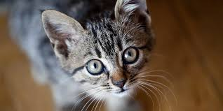

Source page URL: https://icatcare.org/advice/thinking-of-getting-a-cat/

Public domain or Creative Commons? (List any reserved rights) Public domain

**Image 2** 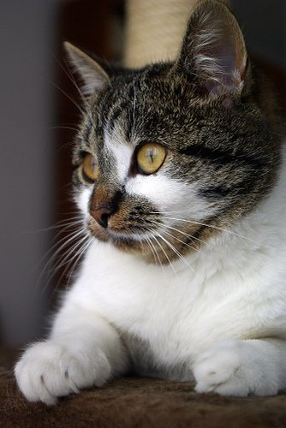

Source page URL: https://openverse.org/image/a6dd2414-7695-4f03-9723-a9dc6852e2b3?q=cats

Public domain or Creative Commons? (List any reserved rights)  "CAT" by Lilithis is licensed under CC BY-SA 2.0.

**Image 3** 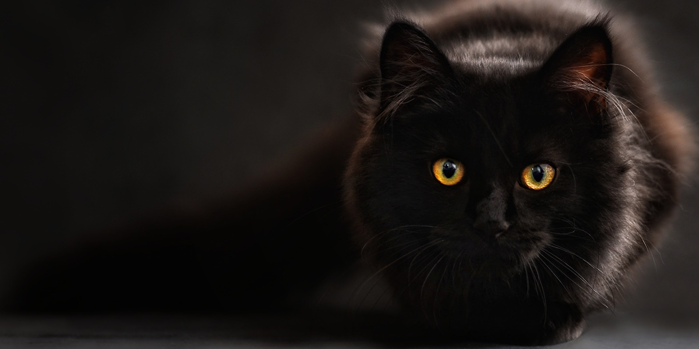

Source page URL: https://icatcare.org/advice/what-is-a-cat/

Public domain or Creative Commons? (List any reserved rights) Public domain