Project Report
Dizzy Walk — Professor's 2D Maze Adventure

1. Introduction
Dizzy Walk is a console-based 2D maze simulation written entirely in x86 Assembly Language
(MASM, Irvine32 library). The program models a dizzy professor navigating home from a Computer Science holiday party across a 100×150 cell maze filled with walls, buildings, lakes, pits, coins, and gems. The project demonstrates mastery of all major COAL topics including data structures, procedures, macros, file I/O, and console graphics.
The program supports four gameplay modes: keyboard-controlled with a fixed step limit, keyboardcontrolled with unlimited steps, random (automatic) movement with a fixed step limit, and random movement until a terminal condition is reached.

2. Project Files
- dizzy_walk_main.asm — Main entry point, game loop, all procedures
- dizzy_walk_structs.inc — Constants, cell types, structure definitions
- dizzy_walk_macros.inc — Reusable utility macros
- dizzy_walk_ui.inc — UI helper constants and panel procedures

3. Feature Descriptions

3.1 Maze Representation
The maze is a flat byte array of 15,000 elements (MAZE_ROWS=100, MAZE_COLS=150) stored in the .data segment. Each cell holds a type constant: CELL_EMPTY (0), CELL_WALL (1), CELL_BUILDING (2), CELL_LAKE (3), CELL_PIT (4), CELL_COIN (5), CELL_DEST (6), and CELL_GEM (8). The MAZE_INDEX macro converts (row, col) coordinates into the flat array index using the formula row × MAZE_COLS + col.
- Maze size: 100 rows × 150 columns (15,000 cells)
- Default start: row 50, col 75 (center)
- Destination: row 10, col 130 (top-right quadrant)
- 300 coins, 100 pits, 70 gems placed via PlaceMazeObjects

4.2 Professor Structure
The PROFESSOR struct holds all state for the protagonist including name (32-byte buffer), current and previous position (posRow, posCol, prevRow, prevCol), wallet (coin count), hasKey flag, stepCount, and moveMode (random vs keyboard). A single global instance prof is used throughout the program.

4.3 Movement Procedures
Four directional movement procedures handle UP, DOWN, LEFT, and RIGHT navigation. Each procedure validates the target cell before moving, preventing the professor from walking into walls, buildings, or lakes. Boundary checks prevent movement outside the 100×150 maze.
- MoveUp — decrements posRow
- MoveDown — increments posRow
- MoveLeft — decrements posCol
- MoveRight — increments posCol
- After each move, cell contents are checked (pit, coin, gem, destination)

4.4 Movement Types
Both required movement modes are implemented and selectable from the main menu:
- MODE_RANDOM — uses Irvine32 RandomRange to pick a direction each step; fully automatic
- MODE_KEYBOARD — uses Irvine32 ReadKey with arrow keys and W/A/S/D; ESC quits
- Four game modes combining movement type with fixed or unlimited step limit

4.5 Termination Criteria
The program tracks five distinct ending conditions, each setting an endReason byte and the gameOver flag:
- Pit Fall (reason 0) — professor steps on CELL_PIT
- Success with Key (reason 1) — professor reaches CELL_DEST with hasKey=1
- Reached Home Without Key (reason 2) — professor reaches CELL_DEST with hasKey=0
- Max Steps Reached (reason 3) — stepCount hits the configured step limit
- Player Quit (reason 4) — user presses ESC in keyboard mode

4.6 Obstacles
Three obstacle types are generated by PlaceMazeObjects using random positions:
- Walls — horizontal and vertical line segments (CELL_WALL) that block movement
- Buildings — dense rectangular blocks (CELL_BUILDING) that act as impassable areas
- Lakes — curved/irregular shapes (CELL_LAKE) that block movement
Stumble mechanic: each step has a 1-in-100 chance (STUMBLE_CHANCE) of the professor dropping the key (sets hasKey=KEY_LOST), triggering a beep and console message.

4.7 Record Keeping
Two log arrays track the professor's journey:
- pathLog — array of PATH_ENTRY structs (stepRow, stepCol) storing every step; capacity MAX_STEPS=10,000
- treasureLog — array of TREASURE_ENTRY structs (itemType, itemRow, itemCol) storing each pickup; capacity MAX_TREASURES=100
- pathCount and treasureCount track how many entries are used
A dedicated results screen displays the last 20 path steps and all treasure pickups with coordinates at the end of each game.

4.8 File Handling
An adventure log is written to adventure_log.txt at game end using Irvine32 CreateOutputFile and WriteToFile. The log includes:
- Professor name
- Total steps taken
- Coin count (wallet)
- Key status (lost or kept)
- End result (reason string)
- Final position (row, col)
- All treasure locations (coins and gems with row/col)
The WRITE_FILE_STR macro uses SCASB to compute string length before writing, avoiding hardcoded lengths.

5. Visual Simulation

5.1 Starting Maze State
After name entry, InitVisual clears the screen and renders the full starting maze through a scrollable viewport (VIEWPORT_ROWS=22, VIEWPORT_COLS=39). The professor's starting position is marked, the destination (home) is highlighted in bright green, and all obstacles, coins, pits, and gems are drawn using distinct ASCII characters and colors. A side panel shows the legend and professor stats
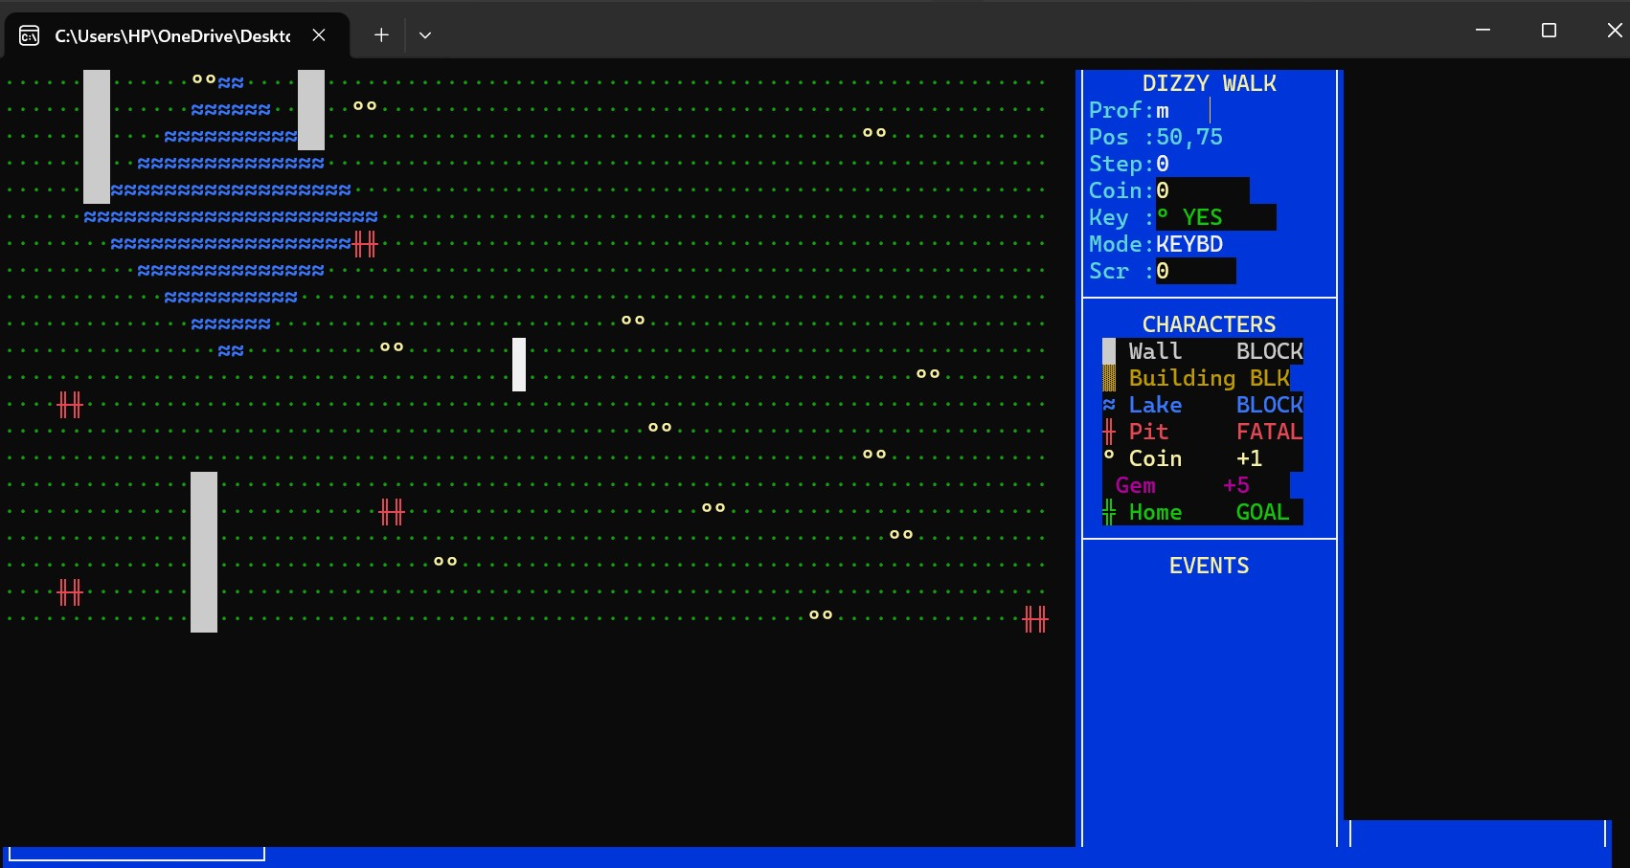
.

5.2 Intermediate Maze States
The DrawMaze procedure redraws the viewport after every step. The viewport auto-scrolls to keep the professor centered on screen. The side panel updates in real time showing current position, step count, wallet value, key status, and the last 10 events (coin pickups, key drops, etc.). Random mode uses a configurable Delay call so the animation is visible. Collected coins/gems are erased from the map.
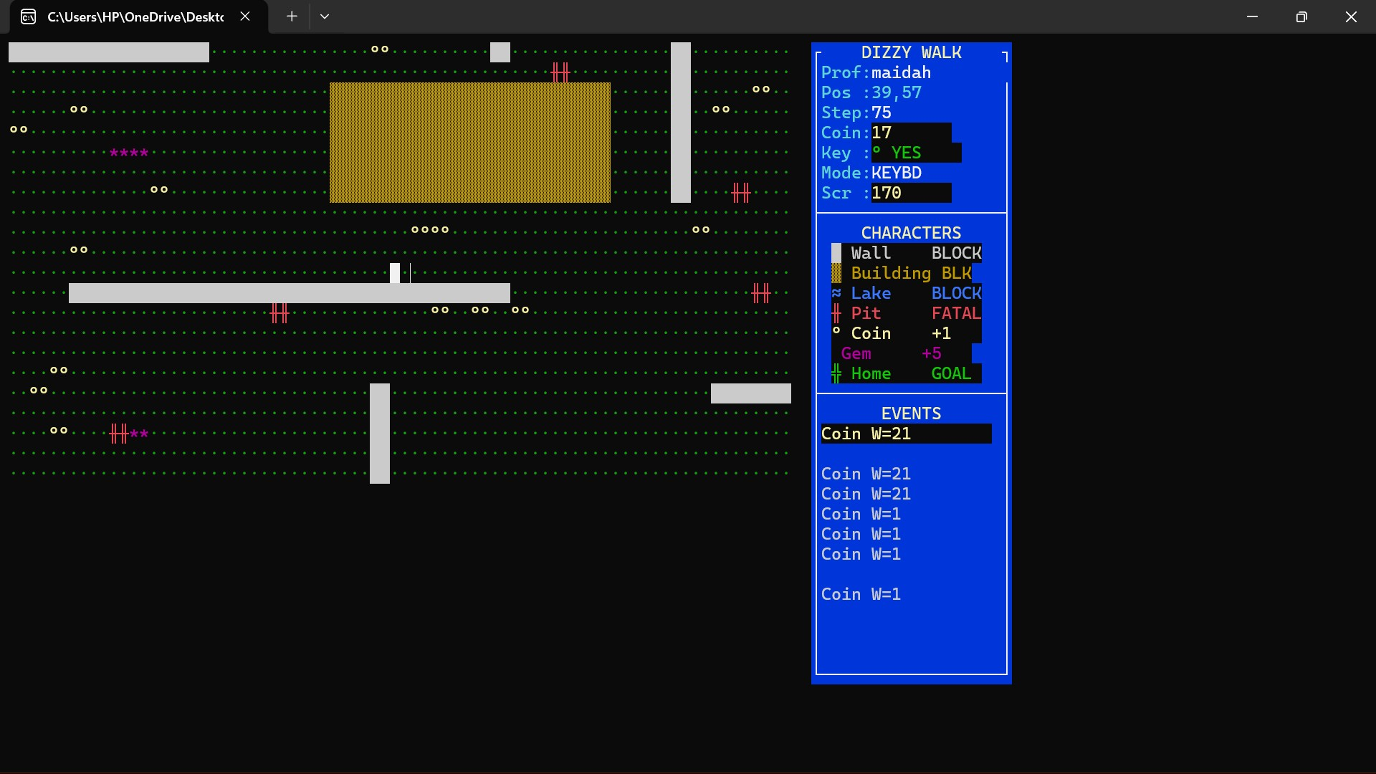

5.3 Final Maze State
When the game ends, DrawResultsScreen displays a dedicated full-screen results panel showing the professor's name, final step count, coins collected, key status, and the termination reason. A sound effect is played matching the outcome (success tone for home entry, low tone for pit, etc.). After pressing any key, the main menu is restored.
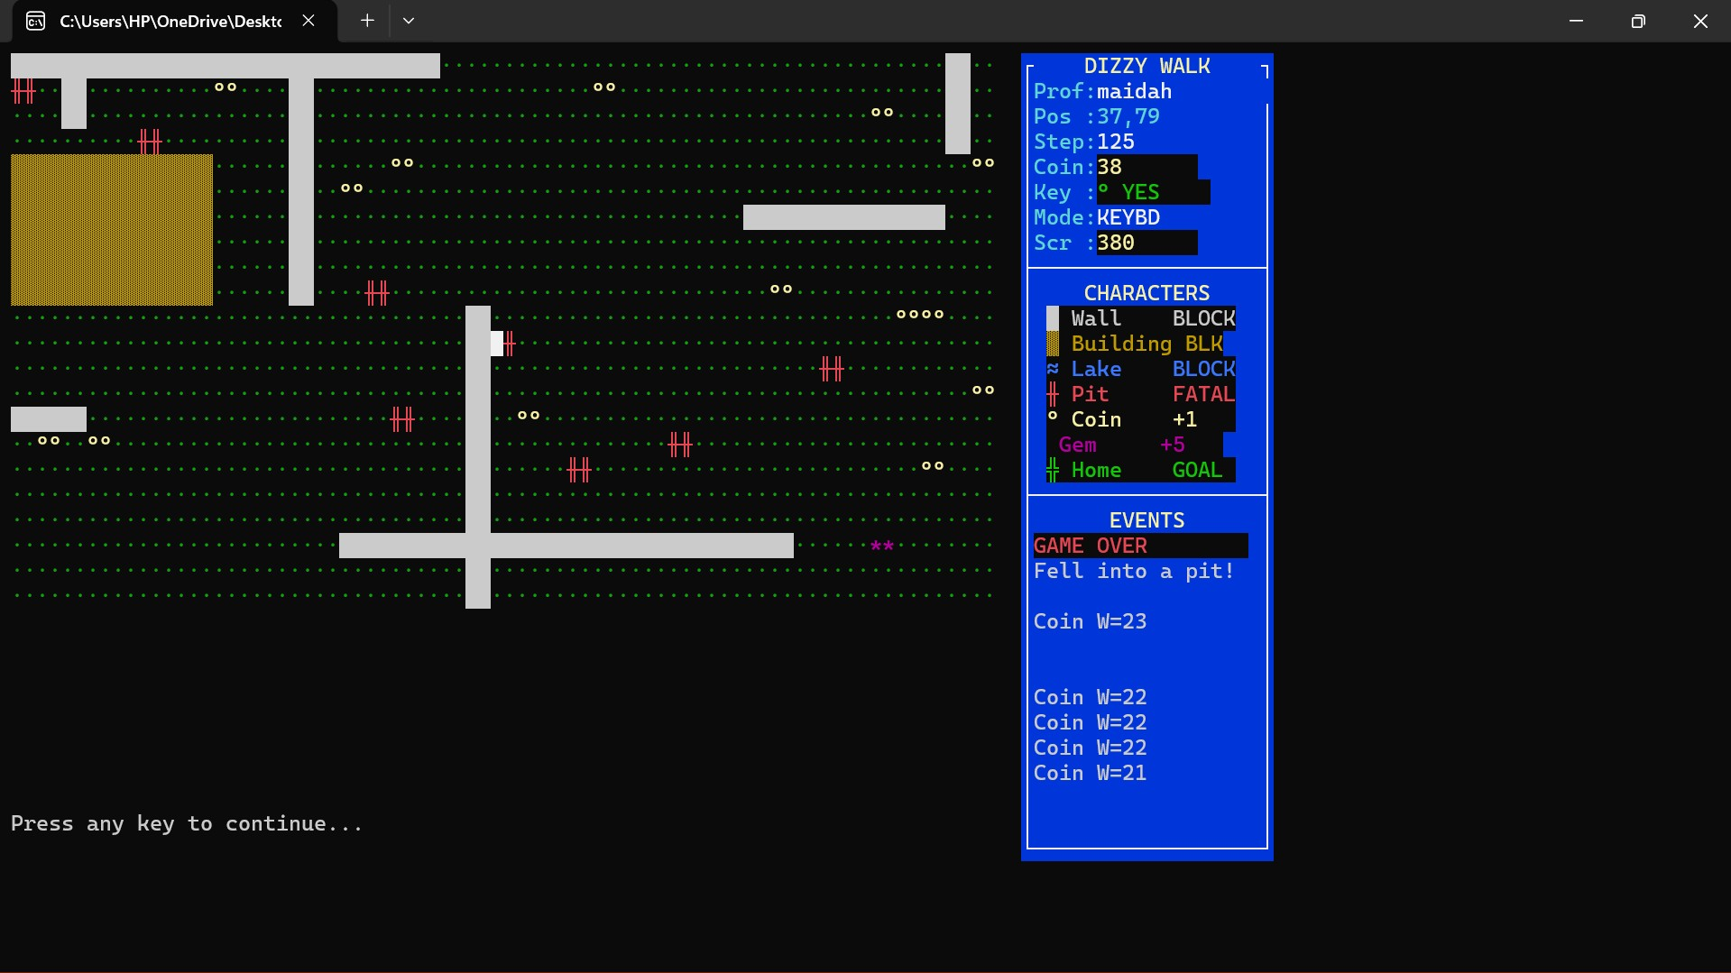

5.4 Visual Features
- Sound effects via Windows Beep API — distinct tones for coin (1200 Hz), gem (900 Hz), key drop (250 Hz), pit fall (120 Hz), and success (1600 Hz)
- Animated ASCII art welcome screen with game instructions and map legend
- Color-coded cell types (bright cyan=professor, green=home, yellow=coin, magenta=gem, red=pit)
- Scrollable viewport with smooth auto-pan tracking the professor
- Circular event log buffer in side panel showing last 10 in-game events
- Main menu with 6 options (4 game modes + instructions + exit

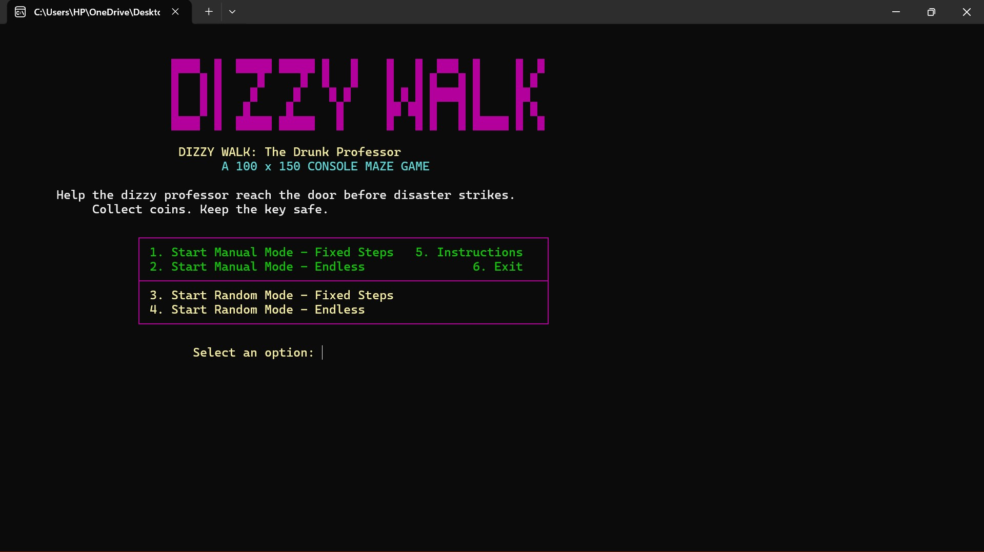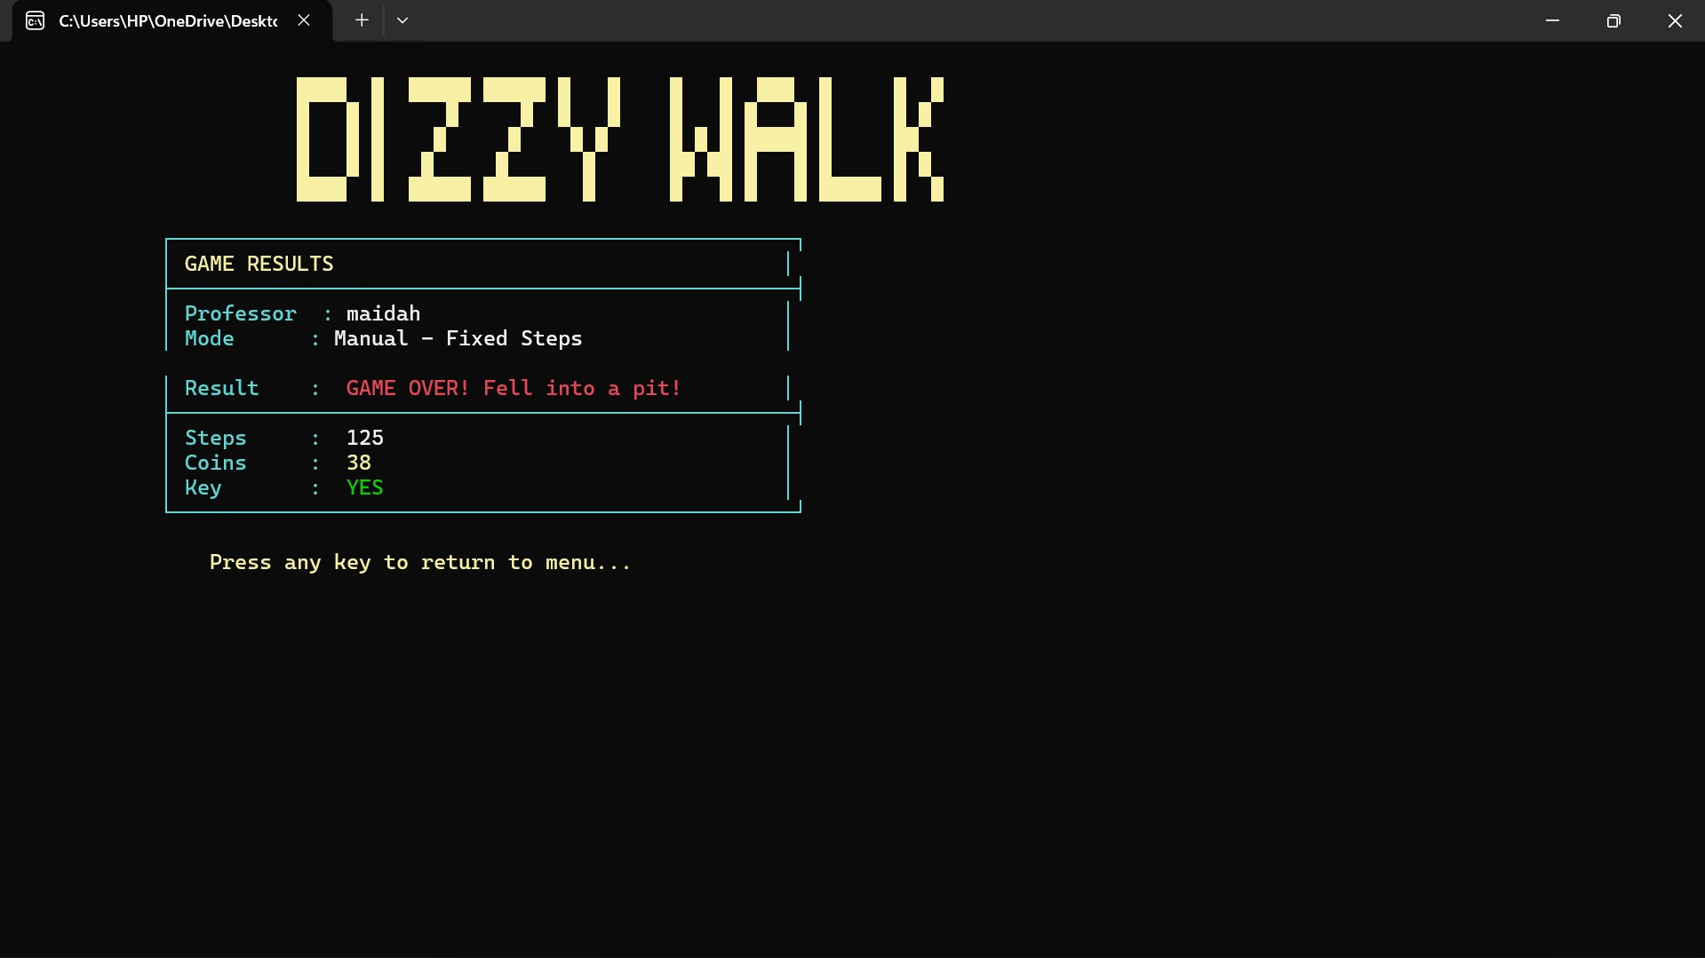

6.3 Identifiers
All identifiers use clear, descriptive naming:
- Constants — SCREAMING_SNAKE_CASE (e.g., MAZE_ROWS, CELL_WALL, SND_COIN)
- Structures — PascalCase (e.g., PROFESSOR, PATH_ENTRY, TREASURE_ENTRY)
- Procedures — PascalCase (e.g., InitMaze, PlaceMazeObjects, DrawResultsScreen)
- Variables — camelCase (e.g., pathCount, treasureLog, gameOver)
- Macros — ALL_CAPS (e.g., PRINT_MSG, DELAY_MS, MAZE_INDEX, WRITE_FILE_STR)

6.4 Modular Code Structure
Code is split across four files by concern. The main file is organized into clearly delineated phases (maze data, professor, path log, treasure log, UI strings, file I/O, visual simulation) using comment banners. Procedures are self-contained with explicit parameter passing via registers and memory. Structures are defined in the .inc file rather than scattered through the main file. Symbol definitions (EQU constants) are centralized in dizzy_walk_structs.inc.

6.5 Commented Code
Each instruction group is preceded by a purpose comment explaining what the block accomplishes
(e.g., '; compute flat index for maze cell', '; check boundary before moving', '; write professor name to log file'). Inline comments clarify non-obvious register usage. All magic numbers are replaced with named constants.

6.6 Indentation and Line Spacing
The source consistently uses 4-space indentation for instruction bodies, with procedure labels flushleft and local labels indented. Logical blocks are separated by blank lines. Comment banners (;=====) delimit major sections. Data definitions are aligned using tab stops for readability.

7. Known Gaps and Assumptions
The following items are noted for transparency. None are expected to result in deductions based on the project spec's allowance for assumptions.

7.1 Minor Gaps
- Lake representation — lakes are stored as CELL_LAKE (straight lines internally); curved rendering is approximated visually. The spec notes 'curved lines' but does not mandate a specific curve algorithm.
- Wall direction distinction — walls are placed as horizontal or vertical runs; the direction is implicit in placement but not stored as a separate attribute in the cell byte.
- PRINT_CHAR and SET_COLOR macros — defined as stubs in macros.inc with inline versions used directly in procedures. Functionality is present; macros are not the primary invocation path.
- Gem display character — defined as CHAR_GEM = '*'; the side panel uses the diamond character (0x04) for the legend. Consistent internally.

7.2 Assumptions Made
- The project spec's description of 'upward movement increases X coordinate' (item 4b) is interpreted as 'upward movement decreases posRow', which is the standard screen convention. The spec text appears to contain a typo (it lists both up and down as modifying X, and both left and right as modifying Y with conflicting descriptions).
- The maze is navigated through a scrollable viewport rather than rendering all 150 columns at once, since the console is typically 80 columns wide. This is noted as a valid alternative in the spec.
- File logging occurs at game end rather than after every step, for performance reasons.
- The step limit for 'fixed steps' mode is set to 1,000 (FIXED_STEP_LIM) and for 'unlimited' mode to 10,000 (MAX_STEPS). Both values are symbolic constants, not hard-coded.

8. Conclusion
The Dizzy Walk project fully implements all required components of the semester project specification. The program runs without errors across all four game modes and correctly handles every termination condition. The visual simulation provides a rich, color-coded, real-time console interface with bonus sound and animation features. All code is modular, documented, and follows the naming and formatting conventions specified in the rubric.
The four-file architecture (main, structs, macros, ui) demonstrates principled separation of concerns in assembly, and the use of structures, macros, procedures, file I/O, and the Irvine32 library reflects comprehensive application of all topics covered in COAL Spring 2026.

End of Report

