

Marble Dash

21.04.2024

**─**

David Wiggins

# 

# Contents

Contents 2

Client Meeting 4

Client Brief 4

Client Meeting Minutes 4

Project Description and Requirements 5

Terminology 5

Game Summery 5

Target Audience 5

Target Platform 5

Software Minimum and Maximum Requirements 5

Hardware Minimum and Maximum Requirements 6

Unique Selling Points 6

Events and Behaviours 6

Objectives 6

Rules 6

Gameplay Loop 6

Controls and actions 6

GUI Layout 7

GUI User Requirements 7

User Interface Design 7

GUI Events 7

Save System 7

Save Format 7

Save Data 7

Testing and Feedback 7

Errors and Bugs 7

Peer Feedback 8

Changes 8

Confirm Project Meets Requirements 8

Sign Off 8

Client approval 8

# Client Meeting

## Client Brief

*To make a mechanical prototype of a 3D platformer where the player controls a marble. The game will have a dash mechanic which will let the player dash into solid objects and causing the marble to bounce off the normal of the object.*

## Client Meeting Minutes

*/ Record the meeting with the client. /*

|  |  |
| --- | --- |
|  | **The programming language to use for the project** |
| Question Asked | What programming language should be used for this project? |
| Client Answer | We are familiar with the Unity engine. C# is the appropriate programming language for this project. |

|  |  |
| --- | --- |
|  | **Organizational/Legal standards and guidelines applicable to the project** |
| Question Asked | Are there any standards or guidelines which will need to be upheld during this project? |
| Client Answer |  |

|  |  |
| --- | --- |
|  | **Save file formats to use in the project** |
| Question Asked | How should data saving be handled in the project? |
| Client Answer | The quickest method is to use the player preferences. |

|  |  |
| --- | --- |
|  | **Clarify naming conventions of C#** |
| Question Asked | What naming conventions should be followed in the writing of C# code? |
| Client Answer | Camel Case for variable declarations. Pascal Case for class declarations. And interface declarations should start with an I followed by the interface name which should be an adverb. |

|  |  |
| --- | --- |
|  | **Clarify menu and options functionality** |
| Question Asked | What do you require in terms of UI functionality? |
| Client Answer | A main menu with the options of new game, options and quit game. New game should start the player at the first checkpoint. Options should open the options menu. Quit game should exit the application |

|  |  |
| --- | --- |
|  | **Clarify additional required functionality of the project** |
| Question Asked | Are there any features additionally required outside of the brief for this project? |
| Client Answer | There are no additional features outside of what has been given in the brief. |

# Project Description and Requirements

## Terminology

*Dash: Refers to a movement in which the player will move in a set direction ignoring any external forces for an amount of time.*

*Checkpoint: Refers to a place in which the players progression through the game is saved.*

*Kill zone: Refers to an area which will reset the player to the start of the game or to a previously unlocked checkpoint.*

## Game Summary

*The player is a ball, rolling and jumping and bouncing at a perilous height. You must reach the end as quickly as possible.*

## Target Audience

*People who like games such as super monkey ball and marble madness.*

## Target Platform

*Target platform is for PC. If the prototype works well then ports can be considered.*

## Software Used

*/ A list of all software being used for the project, their versions and any costs. /*

**Software Used:**

|  |  |  |
| --- | --- | --- |
| Software | Version | Pricing |
|  |  |  |
| Unity | 2022.3.18f1 | Free |
|  |  |  |

## Targeted Hardware Requirements

*/ Hardware constraints, research the minimum and preferred hardware requirements for developing the game. /*

**Targeted Minimum Hardware:**

|  |  |
| --- | --- |
| Targeted Hardware | |
| Processor: |  |
| Memory: |  |
| Graphics: |  |
| DirectX: |  |
| Storage: |  |
| Operating System: |  |

**Targeted Preferred Hardware:**

|  |  |
| --- | --- |
| Targeted Hardware | |
| Processor: |  |
| Memory: |  |
| Graphics: |  |
| DirectX: |  |
| Storage: |  |
| Operating System: |  |

## Unique Selling Points

*Dashing ability allowing the player to bounce off surfaces*

# Events and Behaviours

## Objectives

*To get to the end of a level as fast as possible. The quicker the player reaches the end goal the more points they receive. There are time stopping collectibles which stop the timer from counting up.*

## Rules

*The only rule is to not fall into the kill zone. The collectables allow the player to dash again even without touching the floor*

## Gameplay Loop

*Player will use their basic movement abilities (moving, jumping and dashing) to move from the start to the end in each level.*

## Controls and actions

*/ Brief description of how the controls will work (are they mappable or are they static?) /*

|  |  |
| --- | --- |
| **Control** | **Function/Action** |
| Move | WASD / Left Joystick / Dpad. Rolls ball. Not mappable |
| Jump | Space. Not mappable |
| Dash | Left mouse button. Not mappable |
|  |  |
|  |  |

# GUI Layout

## GUI User Requirements

*GUI will only be interactable in main menu / options menu.*

## User Interface Design

Main menu

*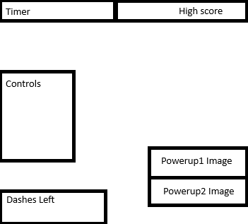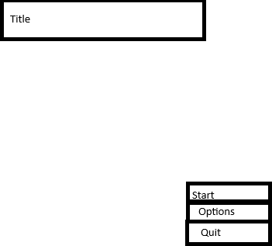In game*

*Button components, TextMeshPro components, Raw Image components.*

## GUI Events

*/ What type of events will the GUI elements have to trigger intractability? /*

*On click events for main menu buttons*

# Save System

## Save Format

*High score data will be saved to player preferences as a float*

## Save Data

*Save data will contain top time completion of the level*

# Testing and Feedback

## Errors and Bugs

/ Outline any classes that had errors during testing. Add rows to table as required. /

|  |  |  |  |
| --- | --- | --- | --- |
| **Class Name** | **Description of Error** | **Screenshots of testing** | **Solution** |
| *GameManager* | *Null reference exception* | *Did not screenshot* | *Assigning object in inspector* |
|  |  |  |  |
|  |  |  |  |
|  |  |  |  |

## Peer Feedback

*/Get two peers to test and provide feedback on the following. /*

1. User Interface Readability.
2. User Interface Functionality?
3. Overall User Experience?

Ava:

UI readability is bad because the text is white and most of the level is white.

Didn’t even notice there was a timer.

Overall experience: It was very enjoyable and challenging!

Fred:

Can’t really fault it on anything honestly. Felt like a CS surf map. The actual marble feels super sluggish to control.

## Changes

There was an issue where Ava would actually reach the end goal area but bounce back out of it without hitting the end goal trigger. So I made the end goal trigger cover the entrance of the goal area.

## Confirm Project Meets Requirements

Project meets the requirements. The dash functionality is implemented and the bouncing works and makes intuitive sense at least for a prototype. The end goal is added and the high score system works.

# Sign Off

## Client approval

Name

[Name of appropriate person approving the software]

Signature

Date

[Click/tap to select date]