Servlet Review

* Servlet
  + Servlets are a Java only thing
  + Java Class that is designed to handle incoming requests and responses
  + We use HttpServlet which is for handling http requests and responses
* Servlet Container
  + Holds our servlets
  + Holds multiple servlets
  + You can configure the servlet container using the **web.xml**

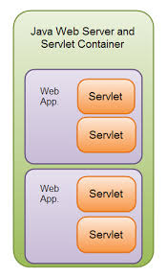

* Tomcat is a Java web server
  + It allows us to how our web applications
  + Because it serves as a servlet container

URL vs URI

URL (uniform resource locator)

Domain + uri

espn.com/football/panthers

URI (uniform resource identifier)

/football/panthers

web.xml

* Main configuration file for the servlet container
  + <servlet>
  + <display-name>
  + <servlet-class>
  + <servlet-mapping> (uri pattern)
  + <uri-pattern>
  + <servlet-name>
  + <init-param>
  + <context-param>
  + <load-on-startup>
    - Eager loading (Servlet is created as soon as you launch you web app)
    - Lazy loading (Servlet is not created until it receives its first request)

Front Controller

* Design pattern
* Hub for all requests and then gests shipped out
* All requests to an application go to a single servlet
* That servlet then dispatches those requests to different parts of the application as necessary
  + Dispatcher Servlet handled all requests and based on the uri sent requests to the appropriate controller

Important objects and methods

* HttpServletRequest
  + An object that stores all the information related to an http request
* HttpServletResponse
  + An object used to generated http responses
* PrintWriter
  + Object obtained from the HttpServletResponse
  + Allows me to send back character information
    - Could be json or plain text
* Request.getParameter()
  + Allows us to get a parameter that was sent in the uri
    - Something.com/people?name=adam
    - Can also be used to read the body if in form data format
* RequestDispathcer
  + Object that allows us to forward requests to other servlets

Maintaining the user session

* Client-side
  + Cookies
  + Hidden forms
  + url rewriting
* Server-side
  + HttpSession

Servlet Lifecycle

1. Servlet class is loaded into the servlet container
2. Servlet is instantiated (an instance is created)
3. Servlet is initialized init() (could be used to run some code that helps set up your servlet)
4. Servlet service() is called one per http request
   1. The service method just sends a request to either doGet,doPost,doDelete,doPut based on the http verb
   2. Usually you do not have to override this
5. Servlet destroy() is called only when the web application is turned off

Servlet Hierarchy

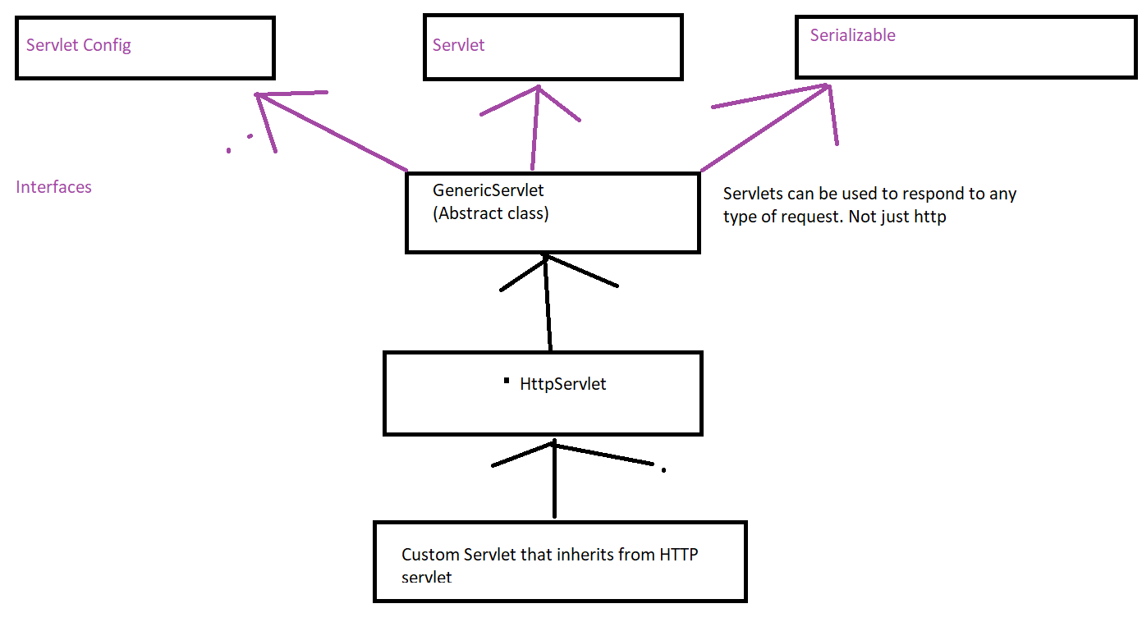

Forwards vs redirects

* Forward
  + Occurs when a request is sent to a servlet and the servlet sends the request to another servlet (same container)
  + The client will have no idea if this happens
* Redirect
  + Occurs when a request is made to a servlet and the servlet sends back a response
  + This response tells the client to make a 2nd request to a new location
  + Client is aware that a redirect occurs

SerletConfig vs Servlet Context

* ServletConfig
  + Stores parameters and information for a single servlet
* ServletContext
  + Stores parameters and information for the servlet container
  + All servlets can access and use the ServletContext