Boss Encounter Champion Document
  - Dungeon Crawler Carl
Sahadeep Kc | TL5 | Feature 6 | Unity and C#
This document defines the final boss encounter, its public contract, and the evidence needed to accept it. Shared system diagrams establish where TL5 connects to the team; detailed design and estimates cover only the boss feature.

Contents
1 Introduction
2 Use Case
3 Interface Contract
4 Data Flow Diagrams
5 Class Design Dynamic Binding and Patterns
6 Sequence Diagram
7 Testing and Acceptance Criteria
8 Dependencies and Integration Rules
9 Completion Criteria
10 Time Requirements

Document baseline
Feature 6 remains Process 6.0 throughout the DFD hierarchy. Process numbers follow feature numbers, not TL numbers: TL2+ owns Feature 3, TL5 owns Feature 6, and TL6 owns Feature 7. The three published TL5 API signatures remain unchanged.
Planning baseline: 52 hours. Proposed behavior policies and integration adapters are identified where they apply; they require agreement before implementation. This is a design and acceptance plan, not a report of completed tests.

1 Introduction
The Boss Encounter System implements the final fight in the map's BossRoom. It selects a phase from current boss health, runs that phase's attack pattern, and signals boss defeat so the Game State Manager can finish the run. The encounter must become visibly different as health falls without embedding every attack in one controller switch statement.

1.1 Responsibilities
- Validate and activate one boss encounter per run; own boss health and encounter lifecycle.
- Resolve the health-threshold chain and execute Ranged Barrage, Summon Minions, or Enrage behavior.
- Cancel the previous phase's scheduled work when the phase changes; prevent attacks after defeat or run cancellation.
- Publish a read-only phase snapshot and one defeat notification per encounter.

1.2 Exclusions
- TL5 does not generate rooms, manage the player's movement or health storage, implement generic enemy AI, or award economy points.
- TL5 does not own the HUD, final win screen, global run-state transitions, or persistence.
- Phase objects do not access the player's private fields or create a second player-stat model.

1.3 Proposed phase policy
Proposed tuning baseline: maximum boss health is 1,000 in acceptance fixtures. Production maximum health is configuration data. Let r = currentHealth / maximumHealth, computed using floating-point division. Maximum health must be positive.
Phase | Health range | Observable pattern
1 Ranged Barrage | 0.70 < r <= 1.00 | Three aimed projectile commands per ready tick; 1.5 s cooldown.
2 Summon Minions | 0.35 < r <= 0.70 | One request for two minions per ready tick; 4 s cooldown; live cap 6.
3 Enrage | 0 < r <= 0.35 | Six radial projectile commands per ready tick; 0.75 s cooldown.
Defeated | currentHealth <= 0 | No phase executes; publish defeat once.

These counts, cooldowns, caps, and thresholds are proposed values, not supplied requirements. Phase entry is immediately ready. Healing is outside this encounter baseline. A large hit selects the correct destination phase directly; it does not force an intermediate attack.

2 Use Case

2.1 Actors
Actor | Role at the TL5 boundary
Player via TL6 | Primary gameplay actor; attacks the boss and receives damage.
BossRoom / TL2 | Supporting system; supplies the room context for activation.
Game State Manager / TL1 | Supporting system; supplies run state and consumes defeat/phase status.
Enemy spawning / TL2+ | Supporting system; creates and reports the requested minions.
Point economy / TL4 | Supporting system; supplies boss-content availability when applicable.

2.2 Main use cases
Start Encounter, Fight Boss, Resolve Phase, Execute Pattern, Record Defeat, and Query Current Phase. Fight Boss includes phase resolution and attack execution for live combat ticks. Record Defeat extends the fight after a validated lethal hit.
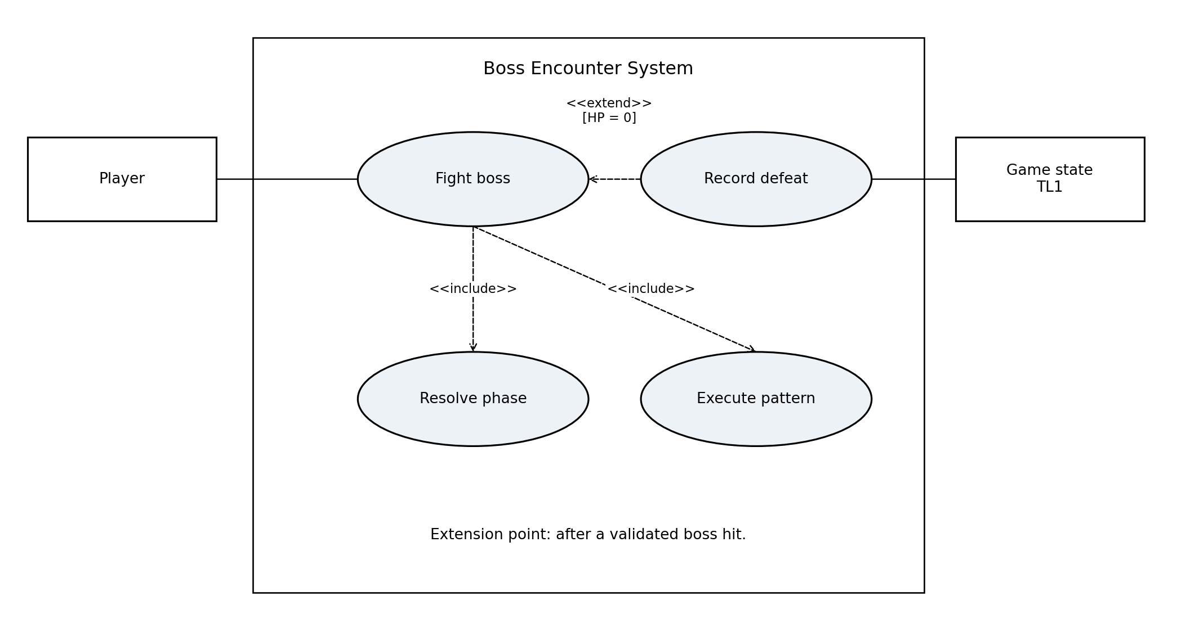
Figure 1. Boss combat use cases and conditional defeat behavior.
UML convention: actor associations have no arrowheads; include and extend use dashed open-arrow relationships. Include points to reused behavior; extend points from conditional behavior to the base use case. Supporting systems are labelled boxes rather than human actors.

2.3 Boss fight scenario
BE1 — Defeat the final boss. Priority: must have. Scope: the Boss Encounter System within an active game run. The Player reaches the final room and must survive the boss's changing attacks, reduce its health to zero, and receive the game's victory result.

Goal and participants
The Player is the primary actor. BossRoom integration (TL2) activates the encounter; Player Controller and Combat (TL6) supplies player state and hit data; Enemy AI and Spawning (TL2+) supplies minions; Game State Manager (TL1) displays status and owns victory. TL4 supplies content availability when the boss is gated.
Trigger: the Player enters the configured BossRoom during an active run. Preconditions: the Player is alive, the boss is available, a fresh BossController and required adapters are bound, maximum boss health is positive, and TL1 has subscribed to OnBossDefeated.
Scenario fixture: maximum boss health is 1,000, with phase boundaries at 700 and 350. These are the proposed values in Section 1.3. This success path assumes the Player survives and hits do not skip a phase; alternate paths appear below.

Main success scenario
1. The Player enters the BossRoom. TL2 supplies room context and invokes StartEncounter(). BossController begins validating this encounter.
2. BossController confirms the preconditions, sets health to 1,000, clears its defeat latch, and builds the Phase 1 → Phase 2 → Phase 3 chain. The encounter becomes Active.
3. The boss executes Phase 1 ranged barrages when ready. The Player moves, dodges, and attacks through TL6. Each accepted hit reduces boss health once; TL1 can read GetCurrentPhase() to display the current phase and health.
4. Accepted hits reduce boss health to 700. Phase 1 forwards the health-range request to Phase 2. BossController cancels old phase work, commits Summon Minions, and requests minions through the TL2+ adapter.
5. TL2+ reports the spawn result. The Player deals with the minions and keeps attacking the boss. At 350 health, the chain selects Phase 3; BossController cancels Phase 2 work and begins faster radial attacks.
6. The Player continues dodging and attacking during Enrage. TL6 applies validated boss damage to the Player; accepted player hits continue reducing boss health. Cooldowns and the live-minion cap remain enforced.
7. A validated lethal hit reduces boss health to zero. BossController records Defeated, stops attacks, and marks its notification latch before invoking OnBossDefeated exactly once.
8. TL1 receives the defeat notification, changes the global run state to its win state, and displays the victory result. Any point award is coordinated by TL1 with TL4. The scenario ends successfully.

2.3 Boss fight scenario continued

Exceptions and alternative paths
- Step 2a — Invalid room, unavailable boss, non-positive maximum health, or missing adapter: reject activation, remain Inactive, and record a diagnostic. No attacks or defeat notification occur. After correcting setup, retry from Step 1.
- Step 2b — Repeated activation while Active or Defeated: StartEncounter() does nothing. Continue the existing fight or retain its terminal state; a new run uses a fresh controller.
- Step 3a — At any hit-processing step, a negative, duplicate, or stale hit record is rejected without changing health. Resume the current combat step and wait for a valid hit.
- Step 4a — A nonlethal hit crosses both thresholds: select Enrage directly and continue at Step 6. Phase 2 does not execute merely because its health range was crossed. A lethal hit from any phase proceeds directly to Step 7.
- Step 4b — Minion spawning fails: record zero accepted spawns, retain Phase 2, and wait its normal cooldown before another request. Continue Step 5; do not retry repeatedly within one tick.
- Step 5a — The live-minion cap is reached: request only the remaining capacity, or no minions if capacity is zero. Continue the fight using reported live counts.
- Step 6a — The Player pauses during any combat step: suspend attack timing and resume that step with its remaining cooldown when the run resumes.
- Step 6b — The Player dies, exits, or resets before boss defeat: cancel encounter work and let TL1 apply its loss or reset policy. End without a boss-defeat notification or victory.
- Step 7a — Additional hits or callbacks arrive after defeat: retain Defeated and suppress further attacks, spawns, and defeat notifications. Continue to the already-issued victory handling.
- Step 8a — The victory listener is absent or fails: log an integration failure. The boss remains Defeated and the notification is not reissued. The end-to-end success condition is not met; retain evidence for the T16 integration test.

Postconditions and guarantees
Success: boss health is zero, encounter state is Defeated, no boss attack work remains active, exactly one defeat notification has been issued, and TL1 has displayed victory. GetCurrentPhase() returns a read-only Defeated snapshot with Phase=None.
Failure or cancellation: rejected activation leaves no active encounter; loss, exit, or reset cancels boss work without signaling victory. Validated health remains within 0..MaximumHealth. Duplicate hits cannot apply damage twice, and terminal callbacks cannot issue a second defeat notification. Pausing leaves the scenario suspended rather than completed.
Acceptance evidence: T01–T06 verify activation, thresholds, lethal hits and phase skipping; T07–T15 verify patterns and exceptions; T16–T19 verify victory, damage, visible phase changes and cleanup. This scenario specifies expected behavior; it does not claim that those tests have already passed.

2.4 Additional use case for encounter activation
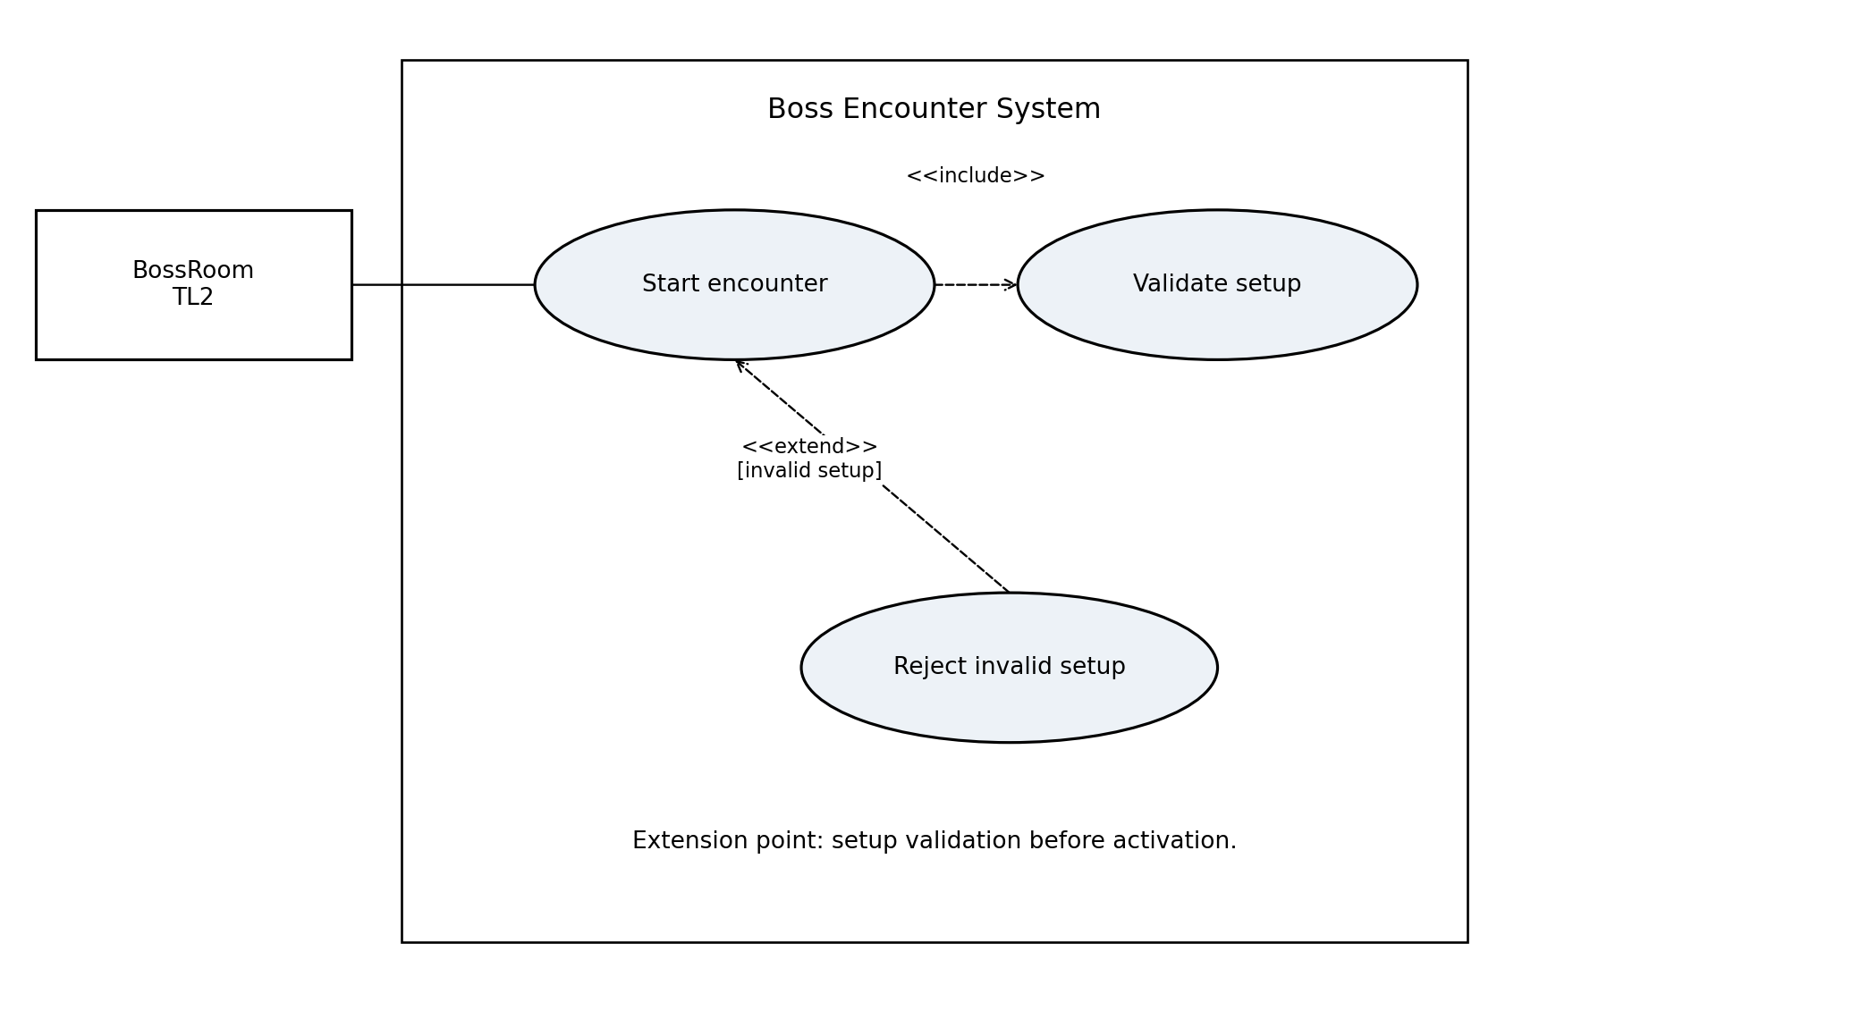
Figure 2. Encounter activation and invalid-setup extension.
ID: BE2. Priority: must have. Primary actor: BossRoom integration. Summary: prepare a single boss fight without allowing partial initialization to produce attacks. Preconditions: a new BossController exists and dependencies can be validated.
1. BossRoom integration binds the room context and the existing team adapters.
2. The integration calls StartEncounter().
3. BossController checks the current run, boss availability, maximum health, and adapter references.
4. BossController initializes health, timing, and the Phase 1 -> Phase 2 -> Phase 3 successor links.
5. The controller records the initial Phase 1 snapshot and becomes active.
Step 3a - Reject Invalid Setup: if validation fails, the extending use case leaves the controller inactive, reports a diagnostic, and ends this attempt. No damage, spawn, or defeat notification occurs. A corrected setup may be retried.
Postconditions: success yields one active Phase 1 encounter at full health. Failure leaves no active encounter. Calling GetCurrentPhase after either path is safe and does not initialize or advance combat.

3 Interface Contract

3.1 Published public boundary
Member and exact signature | Input and output | Testable contract
void StartEncounter() | No parameters; no return value. Reads bound context. | On valid inactive setup: full health, active Phase 1, unsent defeat latch. Repeated calls while active/defeated are no-ops. Invalid setup leaves inactive state.
event Action OnBossDefeated | No payload. Observer notification. | Invoked once when active boss health reaches zero. State is Defeated and attacks are stopped before invocation. Not invoked for pause, cancellation, or rejected start.
BossPhaseInfo GetCurrentPhase() | Returns a value snapshot. | No mutation, attacks, random draws, or phase advancement. Returns the lifecycle and most recently resolved phase/health; safe before start and after defeat.

3.2 Proposed snapshot schema
BossPhaseInfo is named in the specification but its fields are not defined. Freeze this value-type schema with TL1 before implementation; it does not change the method signature.
Field | Type | Invariant
Phase | BossPhaseId enum | None, RangedBarrage, SummonMinions, Enrage.
State | EncounterState enum | Inactive, Active, Paused, Defeated, Cancelled.
CurrentHealth | int | 0 <= value <= MaximumHealth.
MaximumHealth | int | Positive after valid initialization; 0 permitted only before setup.
HealthRatio | float | 0..1; use 0 when MaximumHealth is 0.

Inactive, Defeated, and Cancelled snapshots use Phase=None; Paused retains the live phase. No mutable references to BossPhase or player objects leave this boundary.

3.3 Notification semantics
OnBossDefeated has no payload: no encounter ID or health argument is silently added. The publisher instance identifies the encounter. TL1 subscribes before activation and unsubscribes during teardown. DFD defeat data is the logical fact conveyed by this notification, not a replacement event signature.

3.4 Cross feature data contracts
The following are proposed adapter records for the logical data flows. Names describe data, not extra published TL5 methods. Unit tests can inject these records through internal test seams. The team must agree on the receiving adapters before integration.
Packet | Proposed fields | Validation or meaning
Boss room | roomId:string; roomType:RoomType; origin:Vector2 | RoomType must be BossRoom; position must be finite.
Boss unlocks | available:bool | Availability is resolved by TL4; no balance logic in TL5.
Run state | state:GameState | Active / paused / terminal semantics agreed with TL1.
Player state and hits | position:Vector2; health:int; hits:HitRecord[] | HitRecord = encounterId:string, hitId:int, damage:int. Reject negative, duplicate, or stale hits; read player health, never mutate it.
Boss damage | amount:int; target:Player | Non-negative amount passed to TL6 ApplyDamage after hit validation.
Minion data | requestId:int; count:int; positions:Vector2[]; tier:int | Count 0..2 per proposed tick; enforce six-live-minion cap.
Spawn result | requestId:int; accepted:int; liveCount:int | Match a pending request. 0 <= accepted <= requested; liveCount >= 0; no duplicate accounting.
Boss status | phaseInfo:BossPhaseInfo; defeated:logical fact | Phase data uses the getter. Defeat fact uses Action with zero parameters; this is not a new combined event.

3.5 Interface gaps requiring agreement
- The player and enemy specifications describe damage consumption but do not publish a boss hit receiver. Bind an internal collision/combat adapter; do not assume TL6 ApplyDamage damages the boss.
- Feature 3 exposes SpawnEncounter(Room,int), not a minion-specific API or spawn-result event. A TL2+ adapter must provide the proposed minion records while reusing its enemy classes.
- TL4 describes unlock availability but supplies no unlock-state accessor. Agree on a read-only integration path without exposing its balance field.

4 Data Flow Diagrams

4.1 Context diagram
The whole Dungeon Crawler Carl game is Process 0. The Player is the external input source and feedback sink. Unity, room generation, enemies, the boss, and internal state all lie inside this boundary; local stores are not external agents. No internal processes or stores appear at context level.
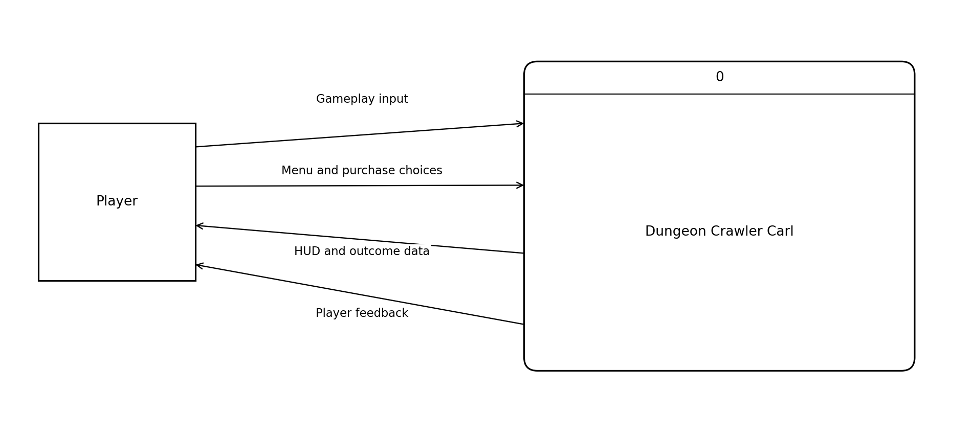
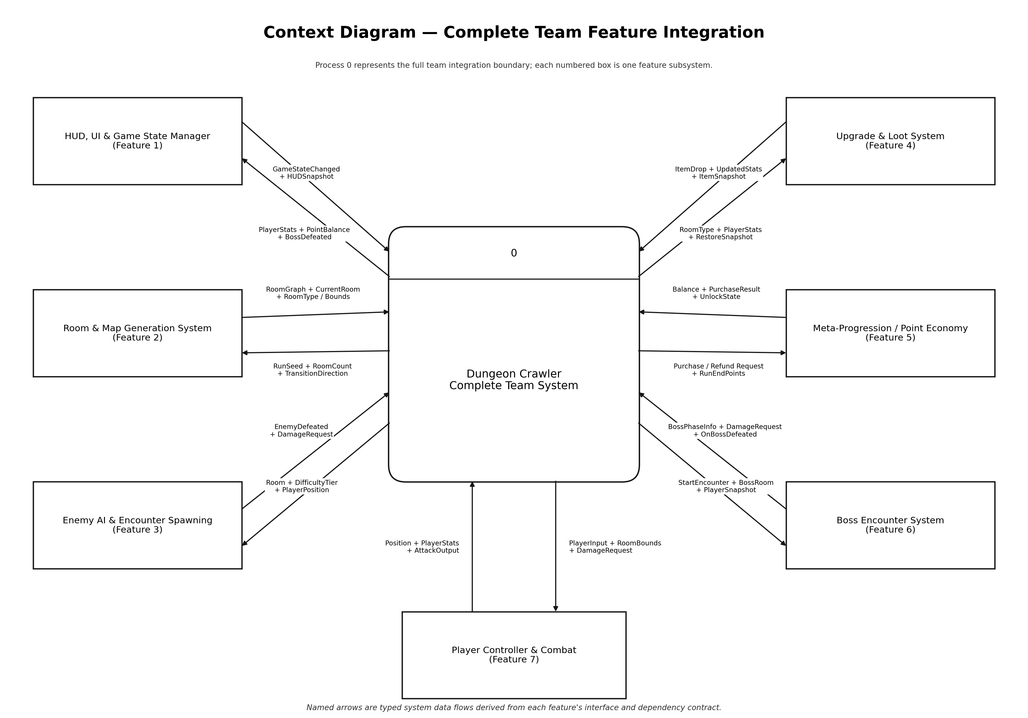
Figure 3. Whole-team context diagram.
Context flow | Diagram 0 endpoint | Data carried
Gameplay input | Player -> 7.0 | Movement axis, attack choice, dash choice.
Menu and purchase choices | Player -> 1.0 | Menu selection and requested UnlockID.
HUD and outcome data | 1.0 -> Player | Health, points, minimap, timer, run result.
Player feedback | 7.0 -> Player | Player presentation and haptic feedback.

The two diagrams use the same four external flows. Abbreviations in Diagram 0 (for example HUD / outcome) denote the same packets, not additional inputs or outputs. Arrows describe data transfers; API calls and execution order belong in Section 6.

Store ownership
D1 is TL4's persistent progression save. D2 is TL2's read-only preset room-template collection, shipped with the game rather than generated run persistence. D4 is TL3's in-memory loadout checkpoint; SaveState/RestoreState alone do not imply disk persistence. D3, introduced in the boss zoom, is transient TL5 encounter state. No boss save file or high-score service is required.

4.2 Diagram 0 system decomposition
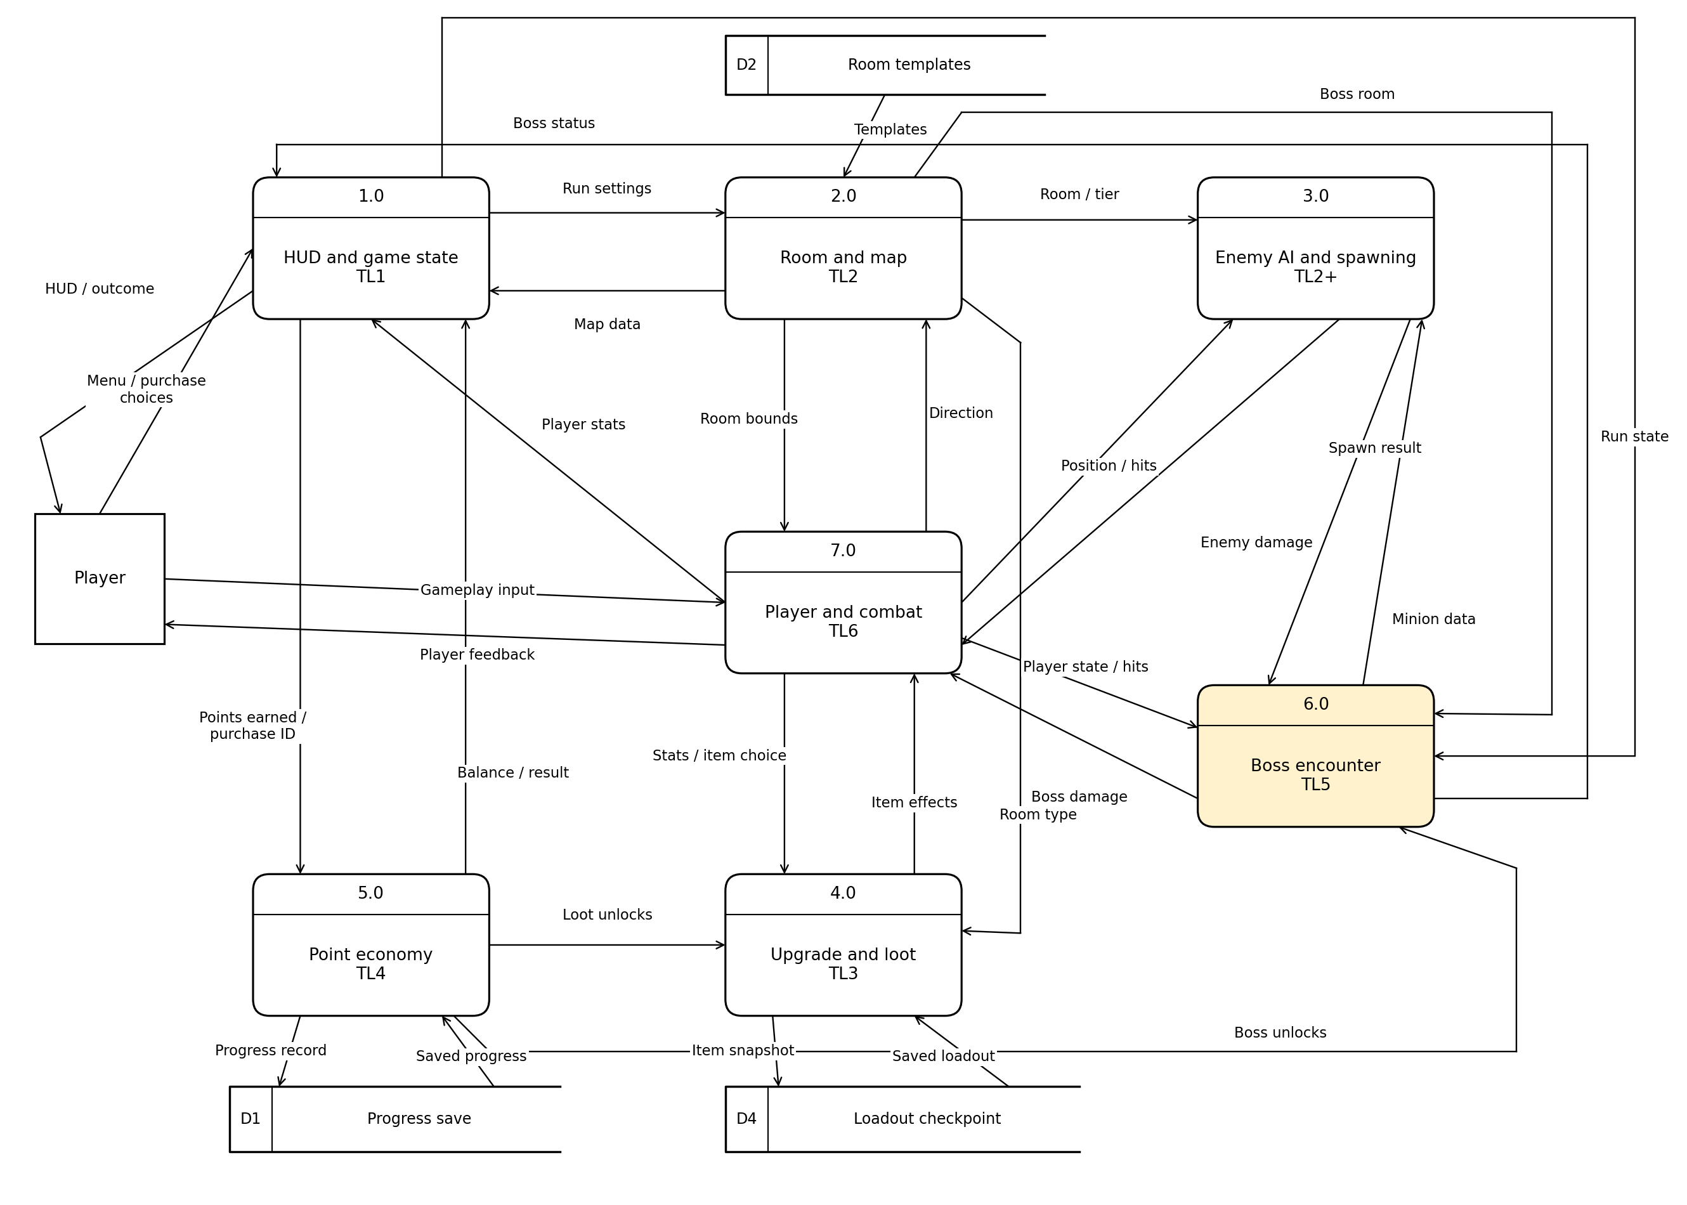
Figure 4. Diagram 0. Yellow Process 6.0 is expanded in Diagram 6.

4.2.1 Process responsibilities and ownership
Process | Owner and feature | Data transformation
1.0 | TL1 HUD, UI and Game State Manager | Menu choices plus map/player/boss/economy data become HUD/outcome data, run settings, run state, and payout/purchase data.
2.0 | TL2 Room and Map Generation | Run settings, templates, and movement direction become connected rooms, map data, bounds, room types, and encounter context.
3.0 | TL2+ Enemy AI and Encounter Spawning | Room/tier, player position/hits, and minion requests become enemy damage and spawn results. Ordinary enemy defeat reporting remains available through its existing event.
4.0 | TL3 Upgrade and Loot | Room type, unlocks, player stats/item choices, and saved loadout become item effects and checkpoint snapshots.
5.0 | TL4 Meta-Progression / Point Economy | Points earned, purchase ID, and saved progress become balance/purchase results, unlock availability, and saved progress records.
6.0 | TL5 Boss Encounter System | Room/run/unlock/player/minion data become phase-specific damage, minion requests, and phase/defeat status.
7.0 | TL6 Player Controller and Combat | Gameplay input, room bounds, damage, and item effects become player feedback, position, stats, attack hits, and transition direction.

Low coupling: direct flows follow existing dependencies. TL1 mediates run state and economy choices; TL5 does not query economy balance or write progression records. Room-based loot does not require an additional enemy-to-loot dependency in this baseline.

Numbering and boundary rules
TL5 is Process 6.0, so Diagram 6 expands 6.0; Diagram 6.2 expands its phase resolver. Neighboring processes in a zoom are boundary references, not new external agents for the whole game. Each parent packet is conserved when expanded; bundled status may split into phase information and a defeat fact.

4.3 Diagram 6 boss encounter decomposition
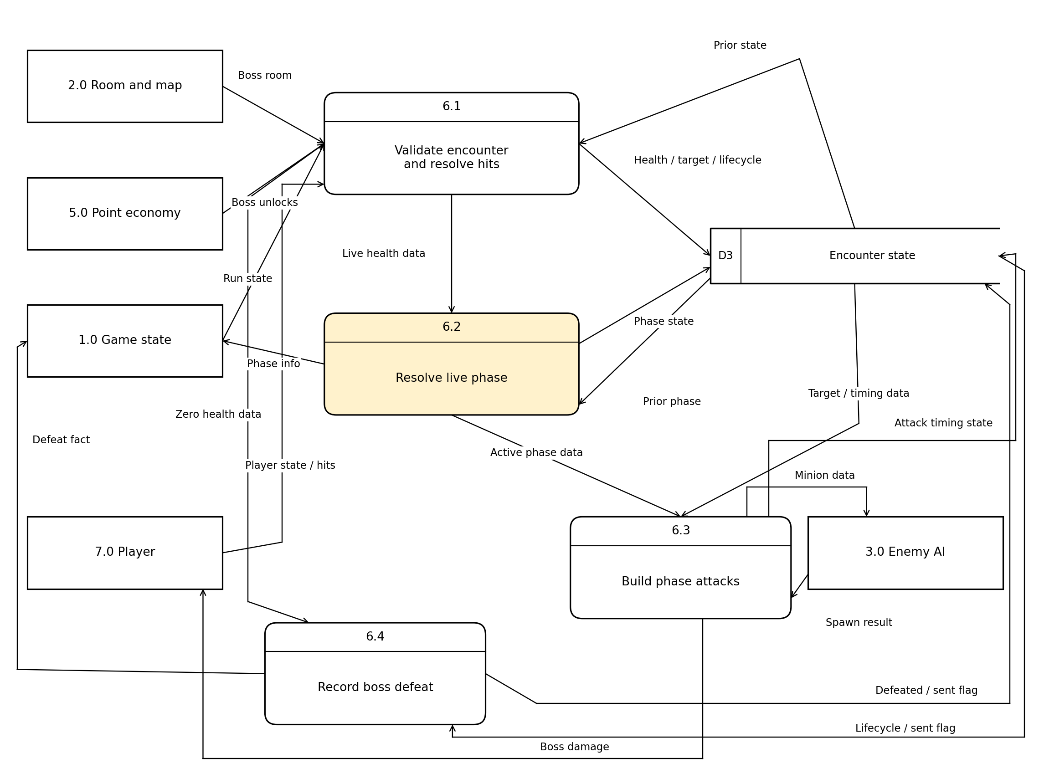
Figure 5. Diagram 6. Yellow Process 6.2 is expanded in Diagram 6.2.
6.1 validates encounter setup and hit records, reads prior D3 state, then writes current health, target, and lifecycle. It sends Live health data to 6.2 or Zero health data to 6.4. Cancelled/paused encounters produce no attack-ready data.
6.2 resolves a live phase using the handler chain, reads/writes D3 phase state, and produces Active phase data for 6.3 plus Phase info for TL1. 6.3 combines phase, target/timing, and spawn results to produce boss damage or minion data and update timing state. 6.4 reads the lifecycle/latch, records defeat, and produces at most one Defeat fact.
D3 is a single transient encounter record containing health, lifecycle, active phase, target, cooldown, pending minion request, live minion count, and the notification latch. Its phase fields are accessed in the 6.2 zoom; no second store is introduced.

4.3.1 Parent and child balance
Process 6.0 boundary flow | Diagram 0 neighbor | Diagram 6 destination or source
Boss room IN | 2.0 | 6.1 consumes room context.
Boss unlocks IN | 5.0 | 6.1 consumes content availability.
Run state IN | 1.0 | 6.1 consumes lifecycle state.
Player state / hits IN | 7.0 | 6.1 validates hit and target data.
Spawn result IN | 3.0 | 6.3 consumes results and live count.
Boss damage OUT | 7.0 | 6.3 produces player damage.
Minion data OUT | 3.0 | 6.3 produces spawn data.
Boss status OUT | 1.0 | 6.2 Phase info + 6.4 Defeat fact.

There are five inbound and three outbound parent packets. The child status split is a decomposition of Boss status, not two unrelated new external contracts. D3 is internal to the child and does not cross the Process 6.0 boundary.

4.4 Diagram 6 point 2 phase resolution
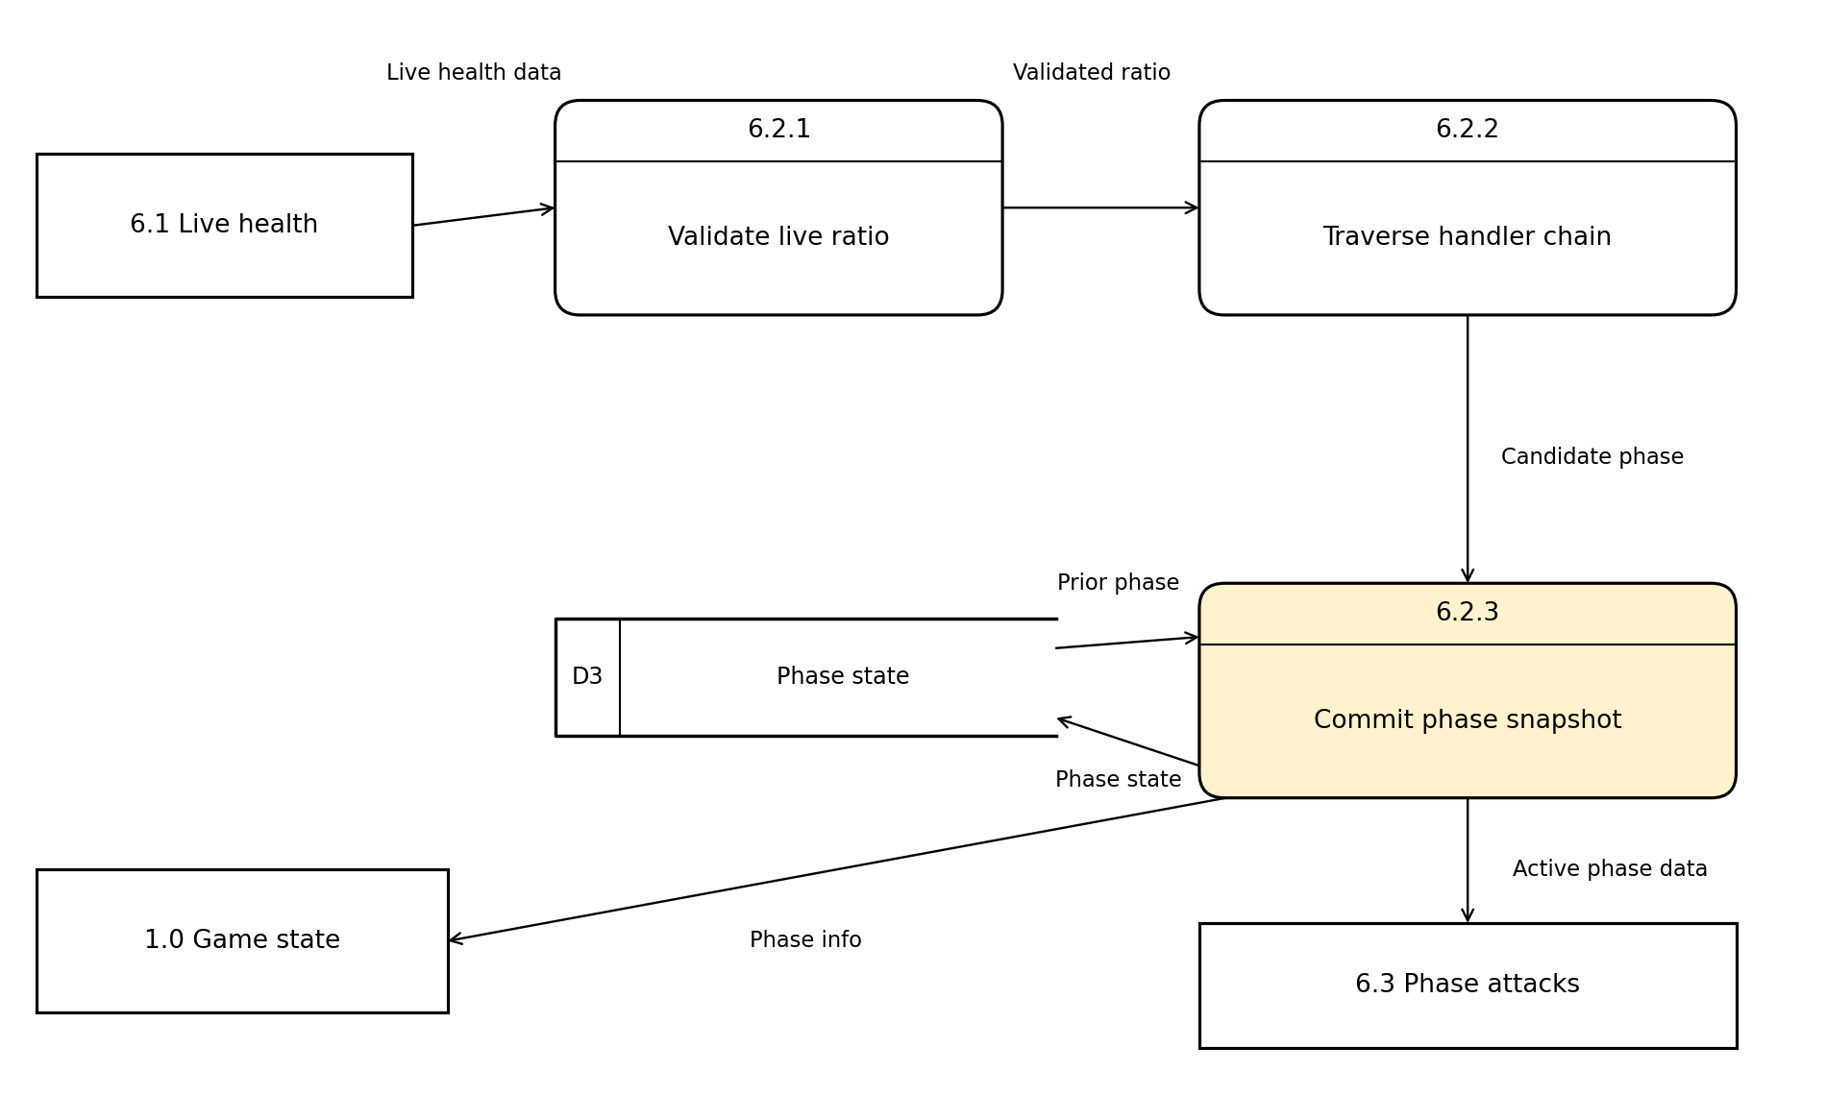
Figure 6. Diagram 6.2. Yellow Process 6.2.3 is specified in Section 4.4.1.
6.2.1 validates the positive live-health ratio. 6.2.2 walks Phase 1 -> Phase 2 -> Phase 3 until one range handles that ratio. 6.2.3 commits the selected phase to D3 and emits a value snapshot. The five parent connections are preserved: Live health data in, Prior phase in, Phase state out, Active phase data out, and Phase info out.

4.4.1 Primitive process description
Primitive 6.2.3 Commit Phase Snapshot. Preconditions: validated live health, a non-null selected handler, and an active encounter. The D3 prior phase determines whether the attack schedule must be reset. Phase behavior runs later in 6.3, not during this primitive update.
INPUT CandidatePhase, CurrentHealth, MaximumHealth
READ PriorPhase FROM D3
REQUIRE 0 < CurrentHealth <= MaximumHealth
REQUIRE CandidatePhase handles CurrentHealth / MaximumHealth
IF CandidatePhase != PriorPhase THEN
WRITE CandidatePhase, AttackReady = true TO D3
INVALIDATE prior phase work token
END IF
OUTPUT ActivePhaseData(CandidatePhase)
OUTPUT PhaseInfo(CandidatePhase, Active,
CurrentHealth, MaximumHealth)
END

4.4.2 DFD and implementation consistency
A data flow is not a scheduling command. For example, Live health data carries values used to select behavior; it does not mean "call the next function." The notification OnBossDefeated appears only in contracts and the sequence diagram, while its logical information appears as Defeat fact in the DFD.
A terminal hit bypasses live phase resolution. This prevents the primitive from committing a phase at zero health. Cancellation invalidates pending attack work without producing defeat data. All damage and spawn effects must check the same lifecycle/work token before execution.

5 Class Design Dynamic Binding and Patterns

5.1 Classes and relationships
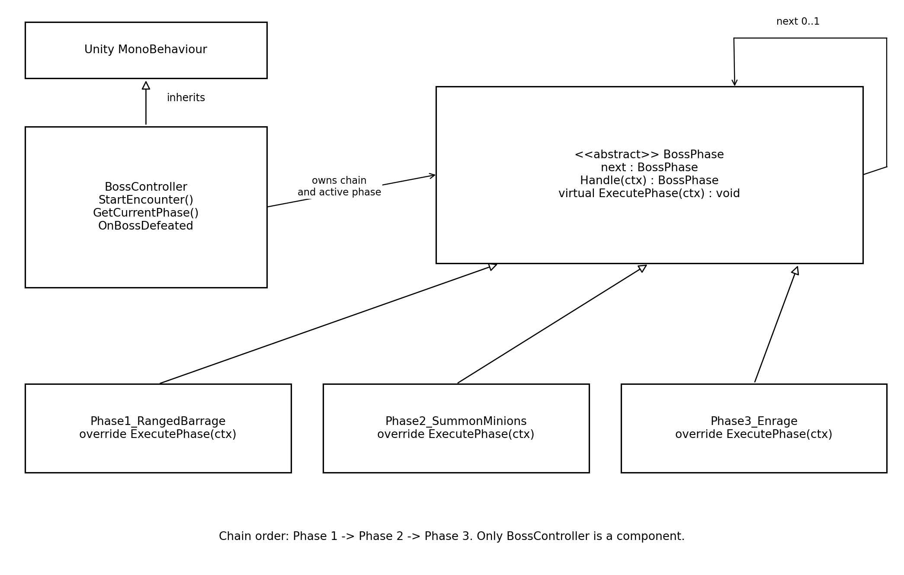
Figure 7. Boss controller, polymorphic phases, and successor relationship.
Class | Responsibility
BossController : MonoBehaviour | Unity-facing owner of health, lifecycle, active phase, chain, timing, and public API.
BossPhase (abstract C# class) | Holds a successor, forwards unmatched health ranges, and provides virtual ExecutePhase(BossController ctx).
Phase1_RangedBarrage | Handles health above 70%; overrides ranged barrage execution.
Phase2_SummonMinions | Handles health above 35% through 70%; overrides minion request execution.
Phase3_Enrage | Handles positive health through 35%; overrides accelerated radial attacks.
BossPhaseInfo | Immutable value snapshot; no phase or player internals exposed.

Handle(ctx), range checks, successor links, and timing/work tokens are internal design helpers. They are not additions to the published three-member BossController interface. Unity inheritance is shown separately from phase inheritance; hollow triangles point toward the base phase type.

5.2 Dynamic binding
Dynamic binding is declared in BossPhase.ExecutePhase and implemented by the three overrides. BossController calls activePhase.ExecutePhase(this) through a BossPhase reference. The runtime selects the derived implementation; the controller does not switch on concrete phase names to choose the attack.
BossPhase is not a MonoBehaviour. The phase objects are ordinary C# objects owned by the controller. Unity calls the controller's lifecycle hooks, but that does not replace the explicit base-reference and virtual/override design needed for this feature. ExecutePhase is a method; a method cannot inherit from MonoBehaviour.

5.3 Chain of Responsibility
BossController is the client. BossPhase is the handler abstraction and owns nextPhase. The three derived phases are concrete handlers. Each handler checks its health range, returns itself if it matches, or forwards to its successor. Selection starts at Phase 1 on each live resolution; a zero-health check occurs before the chain.
BossPhase selected = chainHead.Handle(this);
if (selected != activePhase) CancelPreviousPhaseWork();
activePhase = selected;
activePhase.ExecutePhase(this);
Returning the matching handler and then executing it separates threshold selection from attack effects. Only the selected handler executes. The chain ends with Enrage for valid live ratios; an unmatched ratio is a configuration error, not a silent fallback attack.

5.4 Demonstrating removal of dynamic binding
Simply deleting virtual while leaving derived override declarations causes a C# compile error. A controlled static-dispatch demonstration must also replace override with new and provide a non-virtual base implementation that performs the Phase 1 pattern. Calls through BossPhase then execute that base pattern even when the selected object is Phase 2 or Phase 3. The visible symptom is ranged barrage throughout the fight, not proof that health thresholds stopped changing.
Principle | Application and reason
GoF Chain of Responsibility | Health-range handling is passed along successors instead of centralizing all phase selection.
GRASP Polymorphism | Each override owns its phase-specific attacks; base-reference calls select behavior at runtime.
GRASP Low Coupling | Phases use the controller's narrow query/effect services; no player private fields, economy balance, or room generation logic.
Observer-style event usage | TL1 subscribes to Action. This supports integration but is not claimed as a second required GoF pattern.

6 Sequence Diagram
The main sequence shows activation, live phase execution, a status query, and defeat delivery. Solid arrows are calls/notifications; dashed arrows are returns. These control interactions are intentionally not used as DFD labels.
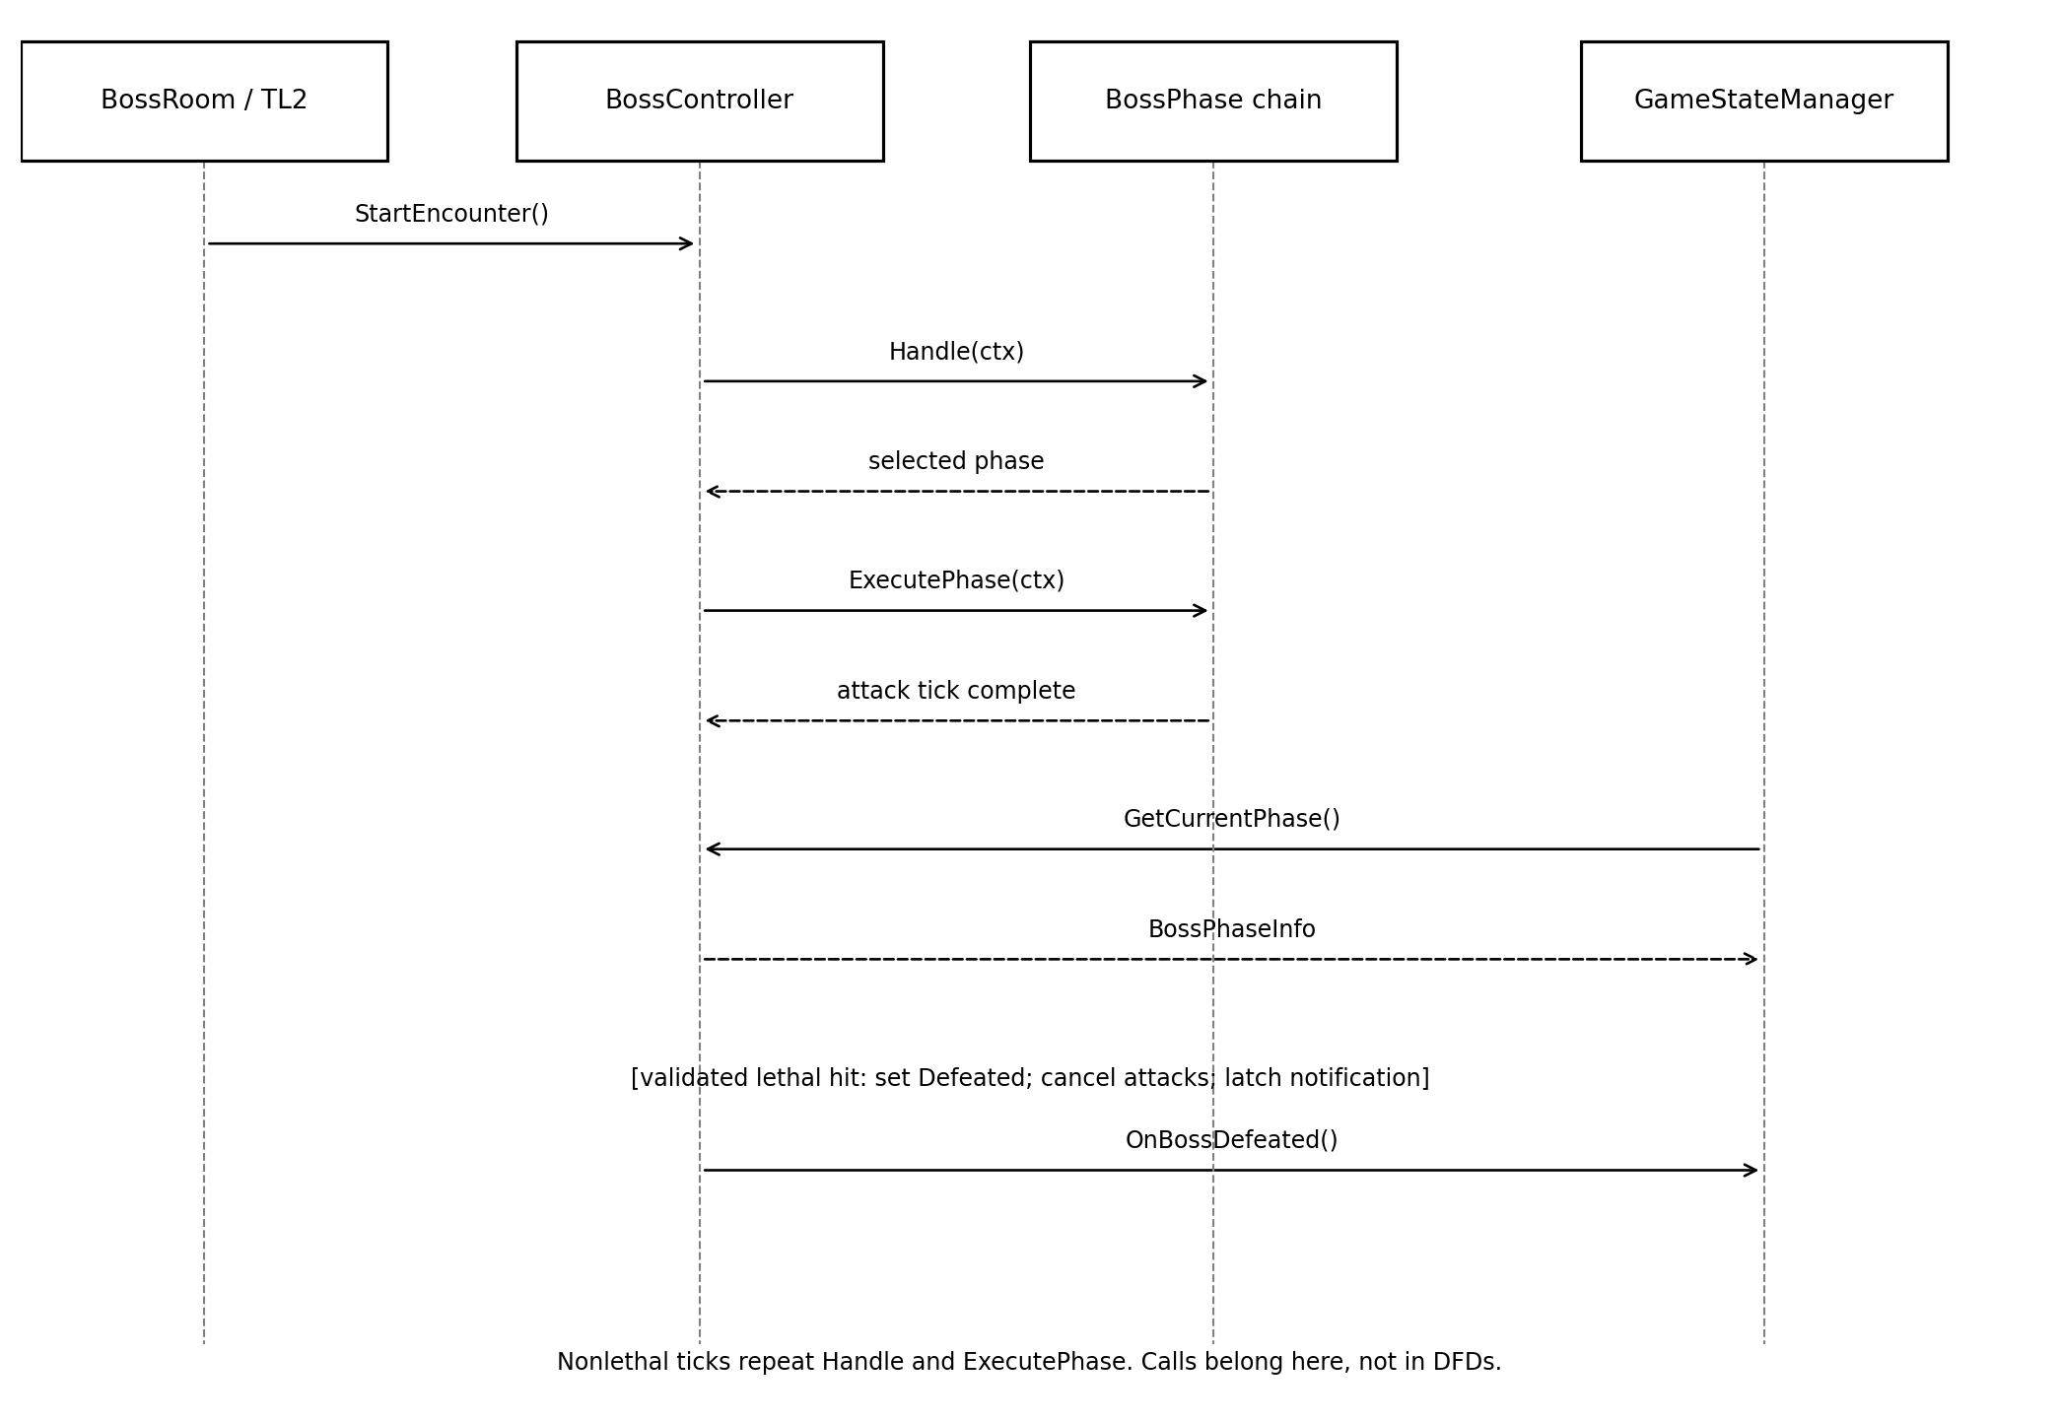
Figure 8. Boss activation, virtual dispatch, status read, and defeat notification.

6.1 Sequence description
1. BossRoom integration calls StartEncounter after binding dependencies.
2. BossController initializes and asks the chain for a matching live handler.
3. The selected handler returns; the controller cancels old work if necessary, then invokes ExecutePhase through the base reference.
4. TL1 may query GetCurrentPhase; the controller returns a value snapshot without advancing the fight.
5. For a lethal validated hit, the controller stores Defeated, invalidates attacks and marks the latch, then invokes OnBossDefeated. TL1 changes the global run state.
Minion requests and player damage leave through the adapters in Section 3.4. They are omitted from this sequence to keep the main dispatch path readable. Listener failures are logged without reissuing defeat; a missed/unsubscribed listener is an integration test failure, not a reason to emit the event twice.

7 Testing and Acceptance Criteria
Edit-mode tests exercise pure range selection and attack logic using a fake clock, deterministic targets, and recording damage/projectile/minion services. Phase tests may use an in-memory controller fixture; they do not need a loaded gameplay scene. Play-mode checks verify physics, presentation, and team wiring.
Test | Fixture or action | Required result
T01 Activation | Valid setup; start twice | Full health and Phase 1 once; no second reset.
T02 Invalid setup | Missing adapter; max health 0 | Inactive, no attacks, local diagnostic.
T03 Thresholds | HP 1000, 701, 700, 351, 350, 1 | Phases 1, 1, 2, 2, 3, 3 respectively.
T04 Lethal hit | HP 1; damage 1 or more | Health clamps to 0; Phase=None; event count 1.
T05 Repeated terminal work | Repeat hits and ticks after T04 | No more attacks, spawns, or events.
T06 Threshold skipping | HP 800; damage 500 | Enrage selected directly; no Phase 2 attack.
T07 Ranged Barrage | Ready Phase 1 with fake target | Exactly three aimed commands; none before 1.5 s.
T08 Summon Minions | Ready Phase 2, live count 0 | One request of count 2; none before 4 s; cap enforced.
T09 Enrage | Ready Phase 3 | Six evenly spaced radial commands; none before 0.75 s.
T10 Invalid hits | Negative, duplicate or stale hit | Health unchanged; accepted unique hit applies once.
T11 Snapshot purity | Read before, during, after fight | Correct value snapshot; no side effects.
T12 Virtual dispatch | Base reference to each subtype | Each subtype records only its own attack pattern.

At each threshold, test r just above, exactly at, and just below the boundary. The integer fixtures use MaximumHealth=1000 to avoid ambiguity. Repeat with another positive maximum to verify ratio-based rather than hard-coded HP selection.

7.1 Integration and resilience tests
Test | Scenario | Pass criterion
T13 Phase transition | Switch while old projectile work is scheduled | Old work token cannot create further attacks; new phase starts once.
T14 Spawn failure | Zero accepted spawns or duplicate result | No tight retry; duplicate result ignored; accepted/live counts stay valid.
T15 Pause and loss | Pause mid-cooldown; resume; then lose run | No pause-time effects; cooldown resumes; loss cancels without victory.
T16 Victory integration | TL1 subscribed before lethal hit | Exactly one observed event and one win transition.
T17 Player damage | Known hit with damage amount 12 | TL6 ApplyDamage receives exactly 12 once.
T18 Visual smoke test | Controlled descent through all three ranges | Aimed barrage, summoned enemies, and faster radial fire visibly distinct.
T19 Cleanup | Unload/reload BossRoom with fresh controller | No stale listeners, work tokens, projectiles, or minion ownership leaks.

7.2 Evidence to retain
- Automated test report with threshold fixtures and assertion failures, if any.
- Short play-mode recording showing phase changes and a single win result.
- Recording-service logs proving counts, cooldowns, selected handler type, and one notification.
- Interface sign-off from TL1, TL2, TL2+, TL4 and TL6 for the agreed adapter records.
Acceptance is not established by this document alone. TL5 will attach actual results during handoff. Failure of any required phase, duplicate defeat, or damage after cancellation blocks completion.

8 Dependencies and Integration Rules
Owner | Required integration | Constraint
TL2 / Feature 2 | BossRoom context and room placement | TL2 generates the map. TL5 validates room type; it does not generate a second room.
TL6 / Feature 7 | GetPosition, GetStats, ApplyDamage; agreed hit adapter | Player health remains TL6-owned. Incoming boss-hit data has a separate path from outgoing player damage.
TL2+ / Feature 3 | Enemy classes and proposed minion adapter | Reuse enemy behavior. Agree count/result/live-count contract before Phase 2 integration.
TL1 / Feature 1 | Run state, phase snapshot, defeat subscription | TL1 owns global win/loss. Subscribe before start, unsubscribe on teardown.
TL4 / Feature 5 | Boss unlock availability if content is gated | TL4 decides availability; TL5 performs no purchase, refund, or payout.
TL3 / Feature 4 | Indirect player-stat changes through TL6 | No direct loot-to-boss dependency is required.

8.1 Ownership and lifecycle rules
- Treat references to player stats under Feature 2 as Feature 7, and boss-triggered win state under Feature 7 as TL1's Game State Manager responsibility. Preserve the published API signatures.
- Keep callbacks, collision handling, and state mutations on the Unity main thread. If workers are later added, marshal results back before touching the controller.
- Apply lethal damage and mark the one-shot latch before invoking observers to prevent reentrant duplicate notifications.
- TL2+ manages minion instances; TL5 tags encounter ownership and requests cleanup through its adapter. Reset uses a fresh BossController, not repeated start on a defeated instance.
- Agree on hit IDs, spawn-result accounting, and cancellation before combining features. Do not access or serialize private fields across owners.

9 Completion Criteria
- A valid BossRoom activation creates one active fight; invalid activation creates none.
- All three phases select at the agreed health ranges; boundary and large-hit tests pass.
- Each phase executes its distinct pattern through BossPhase virtual dispatch and the health-handler chain.
- Outgoing player damage uses TL6's public boundary; minions reuse TL2+ enemy classes.
- Lethal damage produces exactly one OnBossDefeated notification and one TL1 win transition.
- Paused, cancelled, or defeated encounters cannot create unintended attacks or spawns.
- GetCurrentPhase is safe, typed, read-only, and correct for every lifecycle state.
- Whole-team and boss DFDs balance; use-case relationships and sequence arrows use their own correct notation.
- Automated results, visual evidence, interface agreements, and actual hours are attached to the handoff.

9.1 Scope of the demonstration
Use a controlled nonlethal health descent to show all three attack patterns. Separately demonstrate a large hit that skips Phase 2, a failed minion request, cancellation, and repeated hits after defeat. Showing every phase in the first demonstration does not require every possible playthrough to visit every phase.

9.2 Approval checklist
Decision | Proposed baseline | Owner agreement
Thresholds and tuning | 70% / 35%; counts and cooldowns in Section 1.3 | TL5 plus team gameplay review
Incoming hit contract | Unique hit and encounter IDs; non-negative damage | TL5 and TL6
Minion contract | Count 2, cap 6, result and live-count reporting | TL5 and TL2+
Terminal ownership | TL5 emits defeat; TL1 sets win | TL5 and TL1

10 Time Requirements
The baseline is 52 TL5 work hours: Design 11, Coding 26, Testing 10, Documentation 5. Estimates are planned effort, not elapsed calendar time or completed work. TL4 tracks actual hours against these task IDs. No hidden contingency has been added.

10.1 Work breakdown and effort estimates
ID | Category | Work item | Depends | Hours
D1 | Design | Freeze API semantics and adapter records | - | 3
D2 | Design | Define health ranges and attack tuning | D1 | 3
D3 | Design | Design chain and lifecycle/cancellation | D2 | 3
D4 | Design | Define fixtures and integration acceptance | D3 | 2
C1 | Coding | Controller initialization and hit validation | D4 | 4
C2 | Coding | BossPhase chain and range selection | C1 | 4
C3 | Coding | Ranged barrage and effect adapter | C2 | 4
C4 | Coding | Minion behavior and spawn accounting | C3 | 5
C5 | Coding | Enrage pattern and timing | C4 | 4
C6 | Coding | Defeat latch, pause and cleanup wiring | C5 | 5
T1 | Testing | Thresholds and lifecycle unit tests | C6 | 3
T2 | Testing | Headless pattern and timing tests | T1 | 3
T3 | Testing | Team integration, visual checks, fixes | T2 | 4
H1 | Documentation | Finalize contracts and diagrams | T3 | 3
H2 | Documentation | Evidence, demo and handoff notes | H1 | 2

Category reconciliation
Design | Coding | Testing | Documentation | Total
11 | 26 | 10 | 5 | 52

10.2 Suggested schedule timeline
Work week | Task IDs | Exit criteria | Hours
1 | D1-D4 | Contracts, thresholds, chain and acceptance baseline agreed. | 11
2 | C1-C2 | Active controller and deterministic health chain work. | 8
3 | C3-C4 | Barrage and minion behavior record correct commands. | 9
4 | C5-C6 | Enrage, pause, cleanup and one-shot defeat are wired. | 9
5 | T1-T3 | Boundary, headless and integration evidence passes. | 10
6 | H1-H2 | Diagrams and handoff match verified implementation. | 5

10.3 Critical path and assumptions
This schedule assumes one TL5 developer and deliberately serializes the task dependencies. Its resource-constrained baseline chain is D1 -> D2 -> D3 -> D4 -> C1 -> C2 -> C3 -> C4 -> C5 -> C6 -> T1 -> T2 -> T3 -> H1 -> H2, totaling 52 hours. Some design, documentation, and test drafting can overlap later; no shorter critical path is claimed before that dependency plan is revised.
The calendar assumes roughly 8-11 available work hours in the heavier weeks. The six weeks are relative work periods, not promised course dates. TL4 should map them to the actual submission schedule and record interruptions separately from hands-on effort.
- C4 assumes TL2+ provides a usable minion adapter; otherwise record blocked time and revise its integration estimate.
- C6 and T3 require TL1 run-state/defeat wiring and TL6 hit/damage agreement. Mocks allow isolated coding but do not substitute for integration evidence.
- Existing projectile assets and basic enemy classes are available. New art, audio production, large refactors of other features, and unrelated Unity troubleshooting are excluded.
- Testing includes a limited fix allowance inside T3. Substantial defects require an explicit re-estimate rather than silently consuming documentation hours.
- After each week, report task ID, estimated hours, actual hours, remaining effort, and blocker. Keep the original 52-hour baseline alongside any approved revision.
Basis: team Feature Specifications, Features 1-7. The section organization follows the revised Escape the 90s Champion example; its feature ownership, APIs, persistence policy, and time estimates do not transfer to this boss feature.

