Champion Document — Upgrade & Loot System
Name: Kaleb Dillon Feature: Upgrade & Loot System (Dungeon Crawler Carl) Mark: ____ / 30
This Champion covers Feature 4 (TL3). Exceptions reference the exact basic-sequence steps they branch from, DFDs use Gane–Sarson process rectangles and data stores, and every interface entry is typed with numeric pass/fail bounds.
1. Brief Introduction
My feature for Dungeon Crawler Carl is Feature 4 — the upgrade and loot system (TL3). When a room becomes eligible for loot, my code looks up the LootTable for that RoomType, rolls a drop, and clones an Item prototype rather than constructing a new definition from scratch (GoF Prototype). The internal classes are abstract Item (non-MonoBehaviour), WeaponUpgradeItem, ArmorUpgradeItem, ConsumableItem, RelicItem, LootTable, and ItemMemento. Each item subclass overrides virtual void ApplyEffect(PlayerStats stats). If that virtual is removed, every pickup applies the no-op default and the HUD stops changing — the spec’s visible failure mode. Item is the Information Expert for its own effect; loot logic stays out of combat and map code (GRASP High Cohesion).
The spec public interface is exactly four methods: ApplyItem(Item, PlayerStats), RollDrop(RoomType), SaveState() → ItemSnapshot, and RestoreState(ItemSnapshot). ApplyItem writes documented deltas into the live PlayerStats instance owned by Feature 7. ConsumableItem is temporary: Attack +8 for exactly 10.0 seconds, then the effect reverts. Weapon, armor, and relic effects last for the run unless RestoreState replays an ItemMemento (GoF Memento) taken at a checkpoint or before death. SaveState captures equipped item ids, remaining consumable timers, and the stat baseline so a round-trip restore is equal on every numeric field.
My feature deliberately does not own combat, movement, ApplyDamage, GetPosition, or the PlayerStats type — those belong to Feature 7; I only mutate a PlayerStats instance I am given. It does not generate runs, pick room templates, or implement TryTransition — Feature 2’s MapManager / RoomFactory own CombatRoom, TreasureRoom, CorridorRoom, and BossRoom; I only accept that RoomType as RollDrop input. It does not spawn encounters or raise OnEnemyDefeated (Feature 3). It does not run boss phases or OnBossDefeated (Feature 6); BossRoom is only a drop-weighting key. It does not render HUD elements or broadcast GameState — Feature 1 observes GameStateManager.OnStateChanged and reads stats via Feature 7 GetStats() after my mutation. It does not implement EconomyManager, TryPurchase, or point balance (Feature 5). Feature 5’s spec says purchases may later gate Feature 4 templates; that unlock set is not on my public interface and is out of scope for this Champion.
2. Use Case Diagram with Scenario
Use Case Diagrams
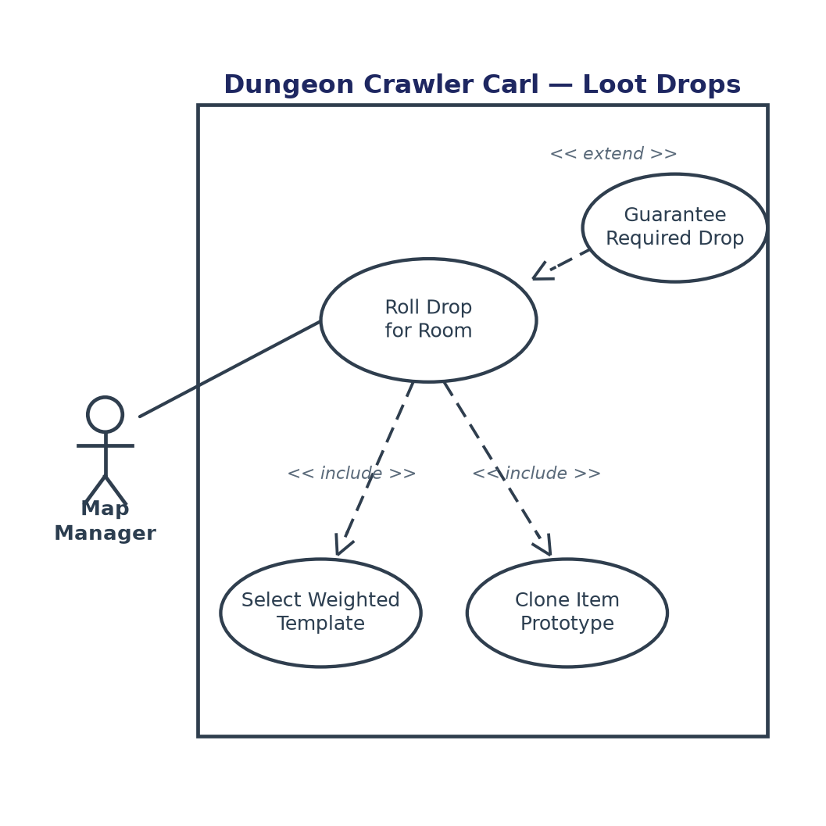
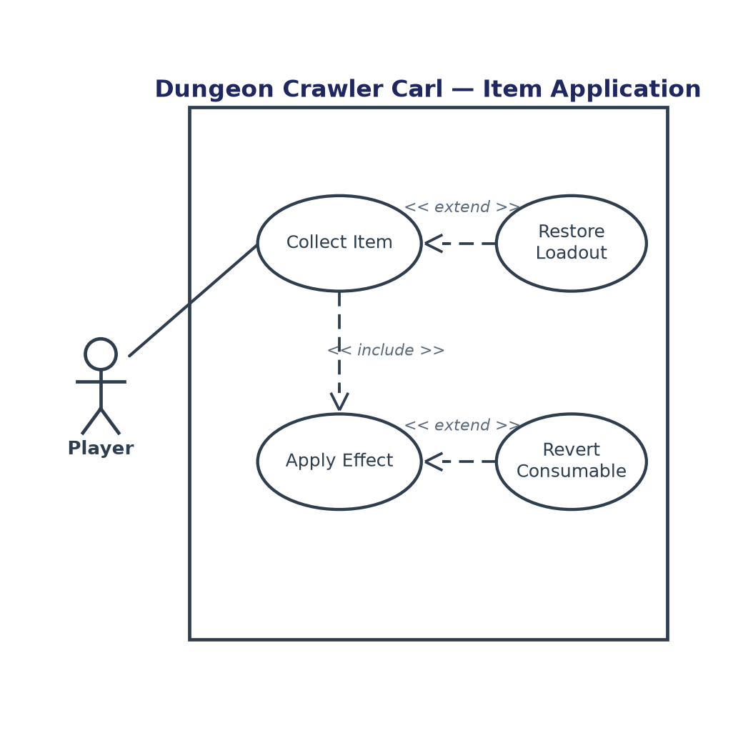
Scenarios
Scenario 1 (first use case diagram)
Name: Roll Drop for Room
Summary: When a room becomes eligible for loot, Feature 2’s MapManager (or Feature 3/6 passing the current room’s type after a clear) requests a drop; a weighted template is selected from that RoomType’s LootTable and cloned via Prototype.
Actors: MapManager (Feature 2); Feature 3 EncounterSpawner / Feature 6 BossController may call the same method with the current RoomType
Preconditions: The Item catalog and per-RoomType LootTable entries are loaded; RoomType is one of Feature 2’s four kinds: CombatRoom, TreasureRoom, CorridorRoom, BossRoom.
Basic sequence:
Step 1: The caller passes RoomType (and the run seed used by the loot RNG).
Step 2: LootTable for that RoomType is retrieved from the catalog.
Step 3: A drop-chance roll in [0.0, 1.0) is compared to the room’s drop rate.
Step 4: A weighted template is selected from the table (weights are positive integers that sum to 100).
Step 5: The template is cloned with Item.Clone() into a new Item instance (Prototype).
Step 6: RollDrop returns that Item (Null Object if the chance roll failed).
Exceptions:
Step 2a: RoomType has no table. RollDrop throws InvalidRoomTypeException and does not continue. Unit tests assert the exception type; production map code never passes an undefined enum value.
Step 3a: The drop-chance roll is ≥ the room’s drop rate (CombatRoom 0.35, CorridorRoom 0.10). Sequence skips to Step 6 with NullItem (ItemId = "NULL", Kind = None) — a Null Object implementing Item, not a fifth item subclass. TreasureRoom and BossRoom never take this branch (drop rate 1.00).
Step 4a: Weighted selection yields an unknown template id — the <<extend>> Guarantee Required Drop case for TreasureRoom and BossRoom only. Selection is retried up to 5 times; if still invalid, the test harness fails. CombatRoom/CorridorRoom return NullItem after one failure and log a warning. The sequence resumes at Step 6.
Post conditions: The caller holds either a cloned Item whose Kind is one of the four types, or NullItem. Catalog templates are unchanged.
Priority: 1 (must have)
ID: LD1
Scenario 2 (second use case diagram)
Name: Collect Item
Summary: The player collects a dropped item; ApplyItem mutates PlayerStats by the item’s documented deltas. Consumables later revert; death/checkpoint restores an ItemMemento.
Actors: Player
Preconditions: A non-null Item exists to collect (or RestoreState is invoked with a previously saved ItemSnapshot); PlayerStats is the live Feature 7 instance.
Basic sequence:
Step 1: The player collects the item (pickup input).
Step 2: ApplyItem(item, stats) is called with non-null arguments.
Step 3: item.ApplyEffect(stats) applies the typed delta for that subclass.
Step 4: Permanent items are appended to the loadout; a ConsumableItem starts a 10.0 s timer.
Step 5: ApplyItem returns; Feature 7 GetStats() now reflects the new fields. Feature 1 HUD updates via GameStateManager.OnStateChanged — it does not subscribe to Feature 4.
Step 6: SaveState() writes an ItemSnapshot into ItemMemento (equipped ids, timers, stat baseline).
Exceptions:
Step 2a: item is NullItem. ApplyItem is a no-op: no loadout change, every PlayerStats field unchanged.
Step 3a: RelicItem whose RelicId is already in the loadout. ApplyEffect is skipped; MoveSpeed and CritChancePercent stay at their pre-call values.
Step 4a: A ConsumableItem with the same ConsumableId is already active — the <<extend>> Revert Consumable / refresh case. Attack is not increased a second time; remaining duration is reset to 10.0 s.
Step 6a: Player HP reaches 0 or a checkpoint fires — the <<extend>> Restore Loadout case. RestoreState(snap) replaces the live loadout with the snapshot; remaining consumable timers are restored; each PlayerStats field equals the snapshot baseline after re-applying saved items.
Post conditions: PlayerStats matches the documented deltas (or the restored snapshot). HUD-visible fields have changed only when an effect actually applied.
Priority: 1 (must have)
ID: CI1
3. Interface Contract
The spec public interface is the four methods below — not events. Feature 1 already uses Observer on GameStateManager; the HUD must not subscribe here. Every input is an enum, a named type, or a numeric field. Every output is asserted in headless unit tests against the exact bounds in the tables below. No scene is required.
void ApplyItem(Item item, PlayerStats stats) Item RollDrop(RoomType roomType) ItemSnapshot SaveState() void RestoreState(ItemSnapshot snap)
Types
RoomType matches Feature 2’s four room kinds: enum { CombatRoom, TreasureRoom, CorridorRoom, BossRoom }. ItemKind: enum { None, WeaponUpgrade, ArmorUpgrade, Consumable, Relic }. PlayerStats is Feature 7’s type; Feature 4 requires these fields and run defaults: int MaxHealth = 100, int CurrentHealth = 100, int Attack = 10, int Defense = 0, float MoveSpeed = 1.00f, int CritChancePercent = 0. ItemSnapshot: EquippedItemIds : ItemId[], ConsumableTimers : (ItemId, RemainingSeconds : float)[], StatBaseline : PlayerStats, SchemaVersion : int = 1.
Inputs
Input | Type | Accepted values / bounds | On violation
ApplyItem.item | Item | Non-null. NullItem allowed (no-op). | ArgumentNullException if null
ApplyItem.stats | PlayerStats | Non-null live stats instance. | ArgumentNullException if null
RollDrop.roomType | RoomType | CombatRoom | TreasureRoom | CorridorRoom | BossRoom | InvalidRoomTypeException
RestoreState.snap | ItemSnapshot | Non-null; SchemaVersion == 1 | ArgumentNullException / SnapshotVersionException
Loot RNG seed | int | Same seed + table version ⇒ identical ItemId sequence | Test fail if two runs diverge

Outputs
Output | Type | Pass bound | Fail if
RollDrop → CombatRoom | Item | NullItem with p = 0.65 ± 0.04 over 2,000 rolls; else one of WEAPON_COMMON, ARMOR_COMMON, CONSUMABLE_RAGE | Any other ItemId, or NullItem rate outside 0.61–0.69
RollDrop → TreasureRoom | Item | Never NullItem. ItemId ∈ {WEAPON_RARE, ARMOR_RARE, RELIC_SWIFT, RELIC_LUCKY} | NullItem or unknown id
RollDrop → CorridorRoom | Item | NullItem with p = 0.90 ± 0.03 over 2,000 rolls; else CONSUMABLE_RAGE or ARMOR_COMMON | NullItem rate outside 0.87–0.93
RollDrop → BossRoom | Item | Never NullItem. ItemId ∈ {RELIC_SWIFT, RELIC_LUCKY} | NullItem or non-relic
WeaponUpgrade Apply | void / stats | Attack += 5; all other fields unchanged | Any other field differs
ArmorUpgrade Apply | void / stats | Defense += 3; MaxHealth += 10; CurrentHealth += 10, then clamp to MaxHealth | Attack/MoveSpeed/Crit change, or HP not clamped
Consumable Apply | void / stats | Attack += 8; DurationRemaining = 10.0 ± 0.0 s at t=0 | Stack beyond +8, or duration ≠ 10.0
Consumable Revert | void / stats | At t = 10.0 s, Attack returns to pre-apply value (± 0) | Revert early (< 9.99 s) or late with Attack still buffed at 10.05 s
Relic Apply | void / stats | MoveSpeed += 0.15f (± 0.0001); CritChancePercent += 10; duplicate RelicId is a no-op | Second copy changes stats
SaveState / RestoreState | ItemSnapshot | RestoreState(SaveState()) ⇒ every PlayerStats field equal; timers within 0.01 s | Any field mismatch
Item.Clone() | Item | Clone.Kind == template.Kind; clone is not reference-equal to template; mutating clone does not mutate template | Shared mutation or Kind mismatch

Test-only notifications (not on the spec public interface)
Feature 4’s published API is the four methods. These notifications exist so headless tests can observe side effects without a scene. Feature 1 must keep using GameStateManager.OnStateChanged; it must not subscribe here.
Notification | Payload type | Raised when | Testable assertion
OnDropRolled | DropRolledEvent { RoomType roomType; string itemId; int rngSeed } | End of every RollDrop call, including NullItem | Exactly 1 notification per call; itemId matches return value
OnItemApplied | ItemAppliedEvent { string itemId; ItemKind kind; StatDelta delta } | ApplyEffect actually mutated stats | Not raised for NullItem or duplicate relic
OnItemReverted | ItemRevertedEvent { string itemId; StatDelta delta } | Consumable duration reaches 0.0 s | Raised once; Attack restored; not raised for permanent items
OnLoadoutRestored | ItemSnapshot | RestoreState completes | Payload equals the snap argument; stats match

Loot table weights (sum to 100 per RoomType)
RoomType | Drop rate | Template id | Weight
CombatRoom | 0.35 | WEAPON_COMMON | 40
CombatRoom | 0.35 | ARMOR_COMMON | 40
CombatRoom | 0.35 | CONSUMABLE_RAGE | 20
TreasureRoom | 1.00 | WEAPON_RARE | 25
TreasureRoom | 1.00 | ARMOR_RARE | 25
TreasureRoom | 1.00 | RELIC_SWIFT | 25
TreasureRoom | 1.00 | RELIC_LUCKY | 25
CorridorRoom | 0.10 | CONSUMABLE_RAGE | 70
CorridorRoom | 0.10 | ARMOR_COMMON | 30
BossRoom | 1.00 | RELIC_SWIFT | 50
BossRoom | 1.00 | RELIC_LUCKY | 50

StatDelta is { int attack; int defense; int maxHealth; int currentHealth; float moveSpeed; int critChancePercent }. COMMON templates use the deltas in the table; RARE weapon/armor templates are the same subclasses with AttackDelta = 8, DefenseDelta = 5, MaxHealthDelta = 20. Unit tests apply each of the four item types (common and rare where they exist) to a mock PlayerStats and assert the exact field-by-field delta. Distribution tests use a fixed seed and 2,000 rolls per RoomType. Memento tests save, mutate stats with a second item, restore, and require equality with the snapshot.
4. Data Flow Diagrams
Diagram 0 shows the whole game: one numbered process for each feature in the Feature Specifications (1 HUD & game state, 2 dungeon map, 3 encounters, 4 upgrade & loot, 5 point economy, 6 boss, 7 player combat). Process 4 is highlighted as this Champion’s feature. I then zoom into Process 4 and give a decision-tree description for primitive process 4.2. Processes are Gane–Sarson rounded rectangles with a numbered band; data stores are open rectangles with a left-hand identifier. Every process has at least one incoming and one outgoing flow (no black holes or miracles). D1 and D2 belong to Process 4 (catalog and loadout). D3 Player Stats, D4 Dungeon Layout, and D5 Point Balance are the stores the other features need.
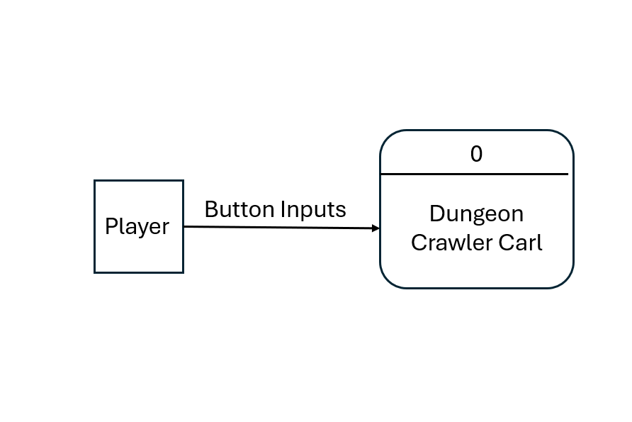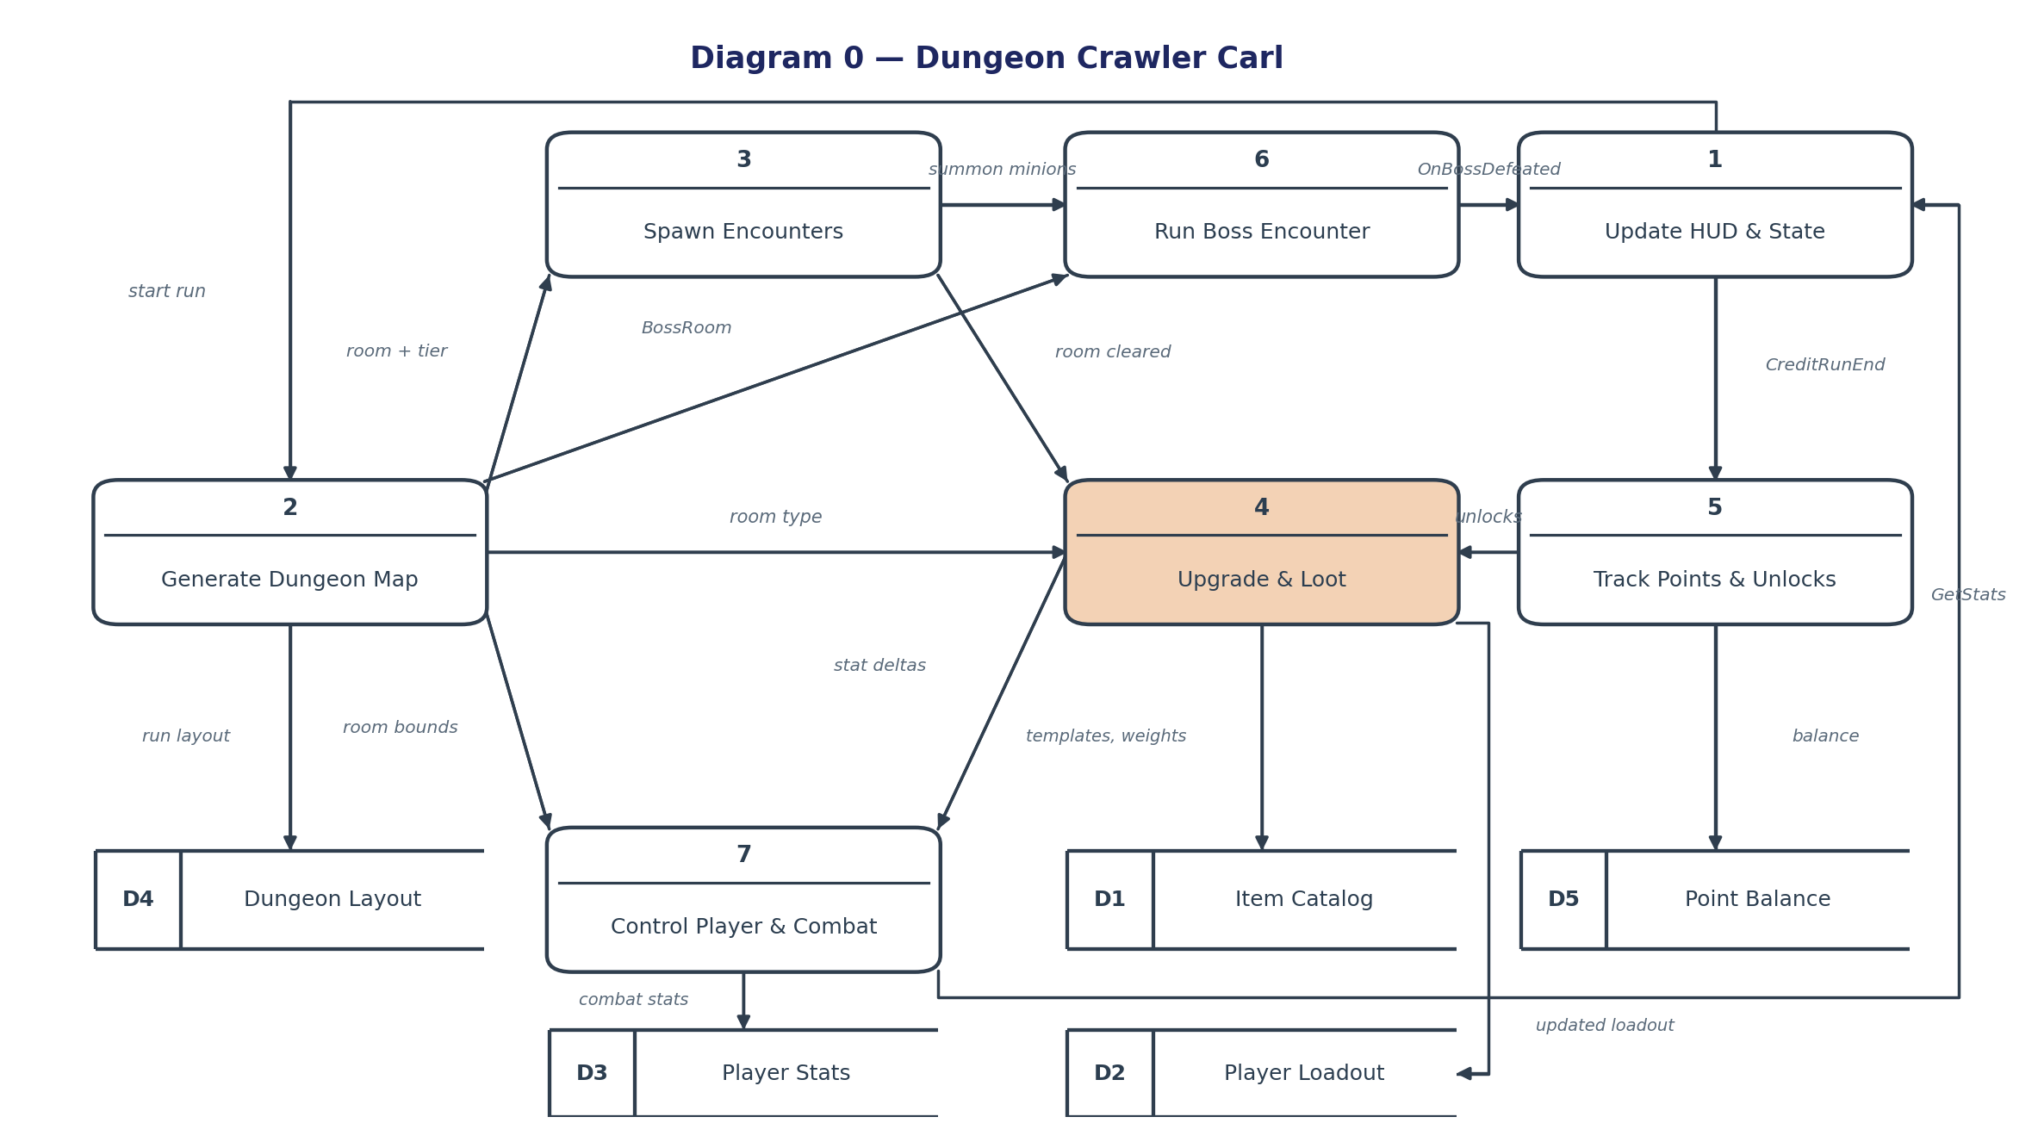
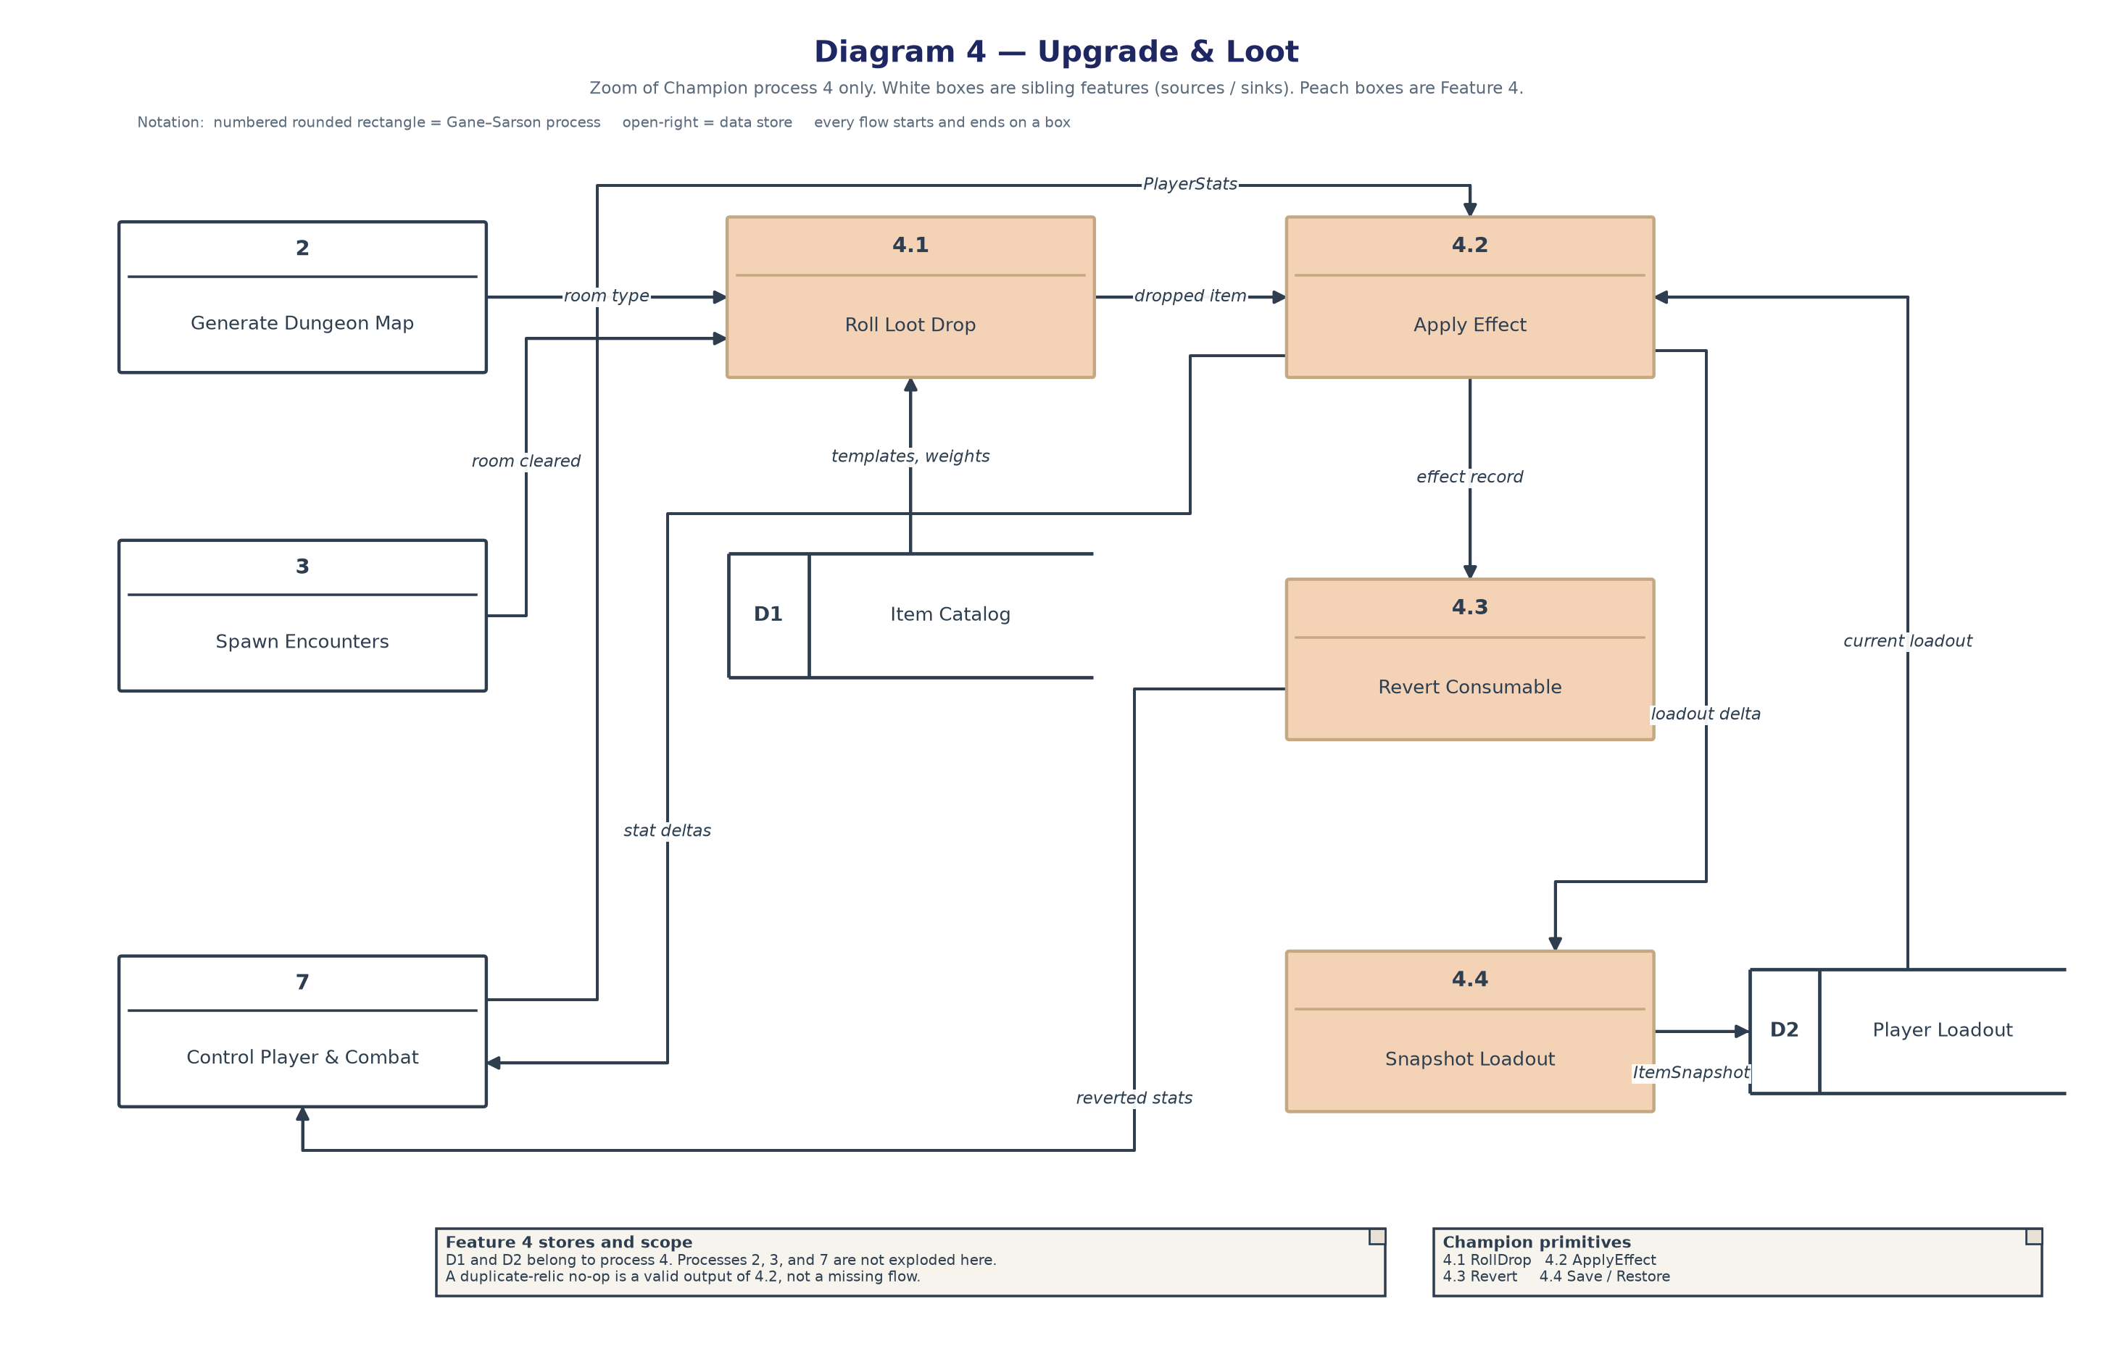
Process Description — 4.2 Apply Effect
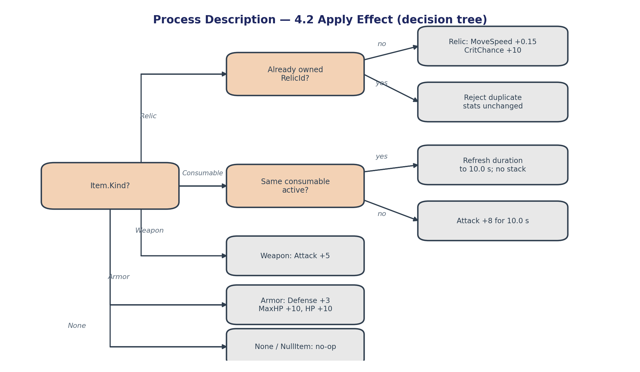
4.2 is a primitive: it does not decompose further. It reads Item.Kind and the current loadout from D2, writes mutated PlayerStats out to Process 7, snapshots the loadout to D2, and emits an effect record to 4.3 (consumables) and 4.4 (every successful apply). A duplicate relic is a valid output of 4.2 (no-op), not a missing output. Completion criteria from the spec: all four item types apply correct, reversible effects, and every RoomType’s LootTable produces a valid Item when a drop occurs.
5. Timeline (Feature 4 only)
This schedule is my Feature 4 work only — not the seven-feature project calendar. Hours match the Feature 4 spec budget: Design 10 hrs, Coding 27 hrs, Testing 10 hrs, Documentation 5 hrs (52 hrs of my work). Because several of my coding tasks run in parallel, calendar time on the critical path is 31 hours. TL4 tracks actuals against these Feature 4 rows. Features 1, 2, 3, 5, 6, and 7 keep their own champions and hour budgets.
Feature 4 work items
Feature 4 task | Duration (hours) | Predecessor task(s)
1. Item class hierarchy & effect matrix | 5 | —
2. Loot table design (per RoomType) | 5 | —
3. Abstract Item + Prototype Clone() | 4 | 1
4. WeaponUpgradeItem + ArmorUpgradeItem | 5 | 3
5. ConsumableItem + RelicItem | 5 | 3
6. LootTable.RollDrop(RoomType) | 6 | 2, 3
7. ApplyItem / revert on PlayerStats | 4 | 4, 5
8. ItemMemento SaveState/RestoreState | 3 | 7
9. Unit tests (deltas, drops, restore) | 10 | 6, 7, 8
10. Feature 4 documentation | 5 | 6, 8

PERT diagram (Feature 4 tasks)
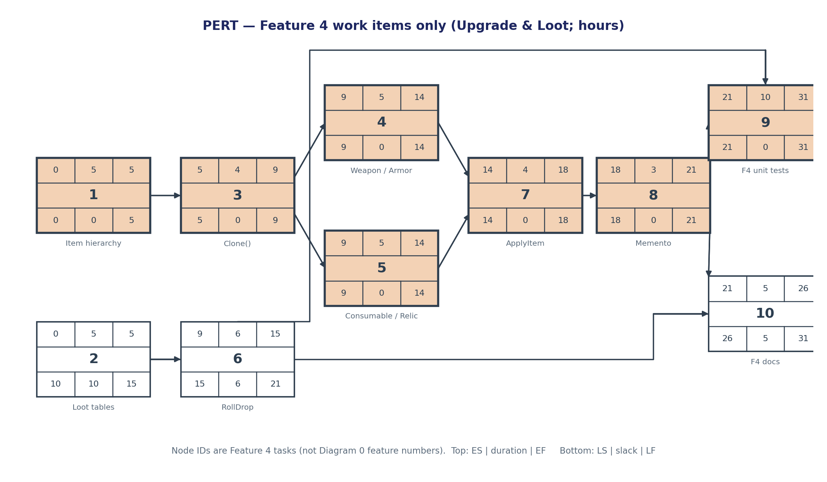
PERT nodes are the Feature 4 tasks in the table, not Diagram 0’s feature numbers. The critical path is 1 → 3 → 4 → 7 → 8 → 9 (equivalently 1 → 3 → 5 → 7 → 8 → 9), totaling 31 hours of my calendar time. Tasks 4 and 5 are both critical because either one finishing late delays ApplyItem. Task 2 carries 10 hours of slack; task 6 carries 6; documentation (task 10) carries 5. Design of the loot tables can slip without moving my finish, but the Item hierarchy cannot.
Gantt timeline (Feature 4 only)
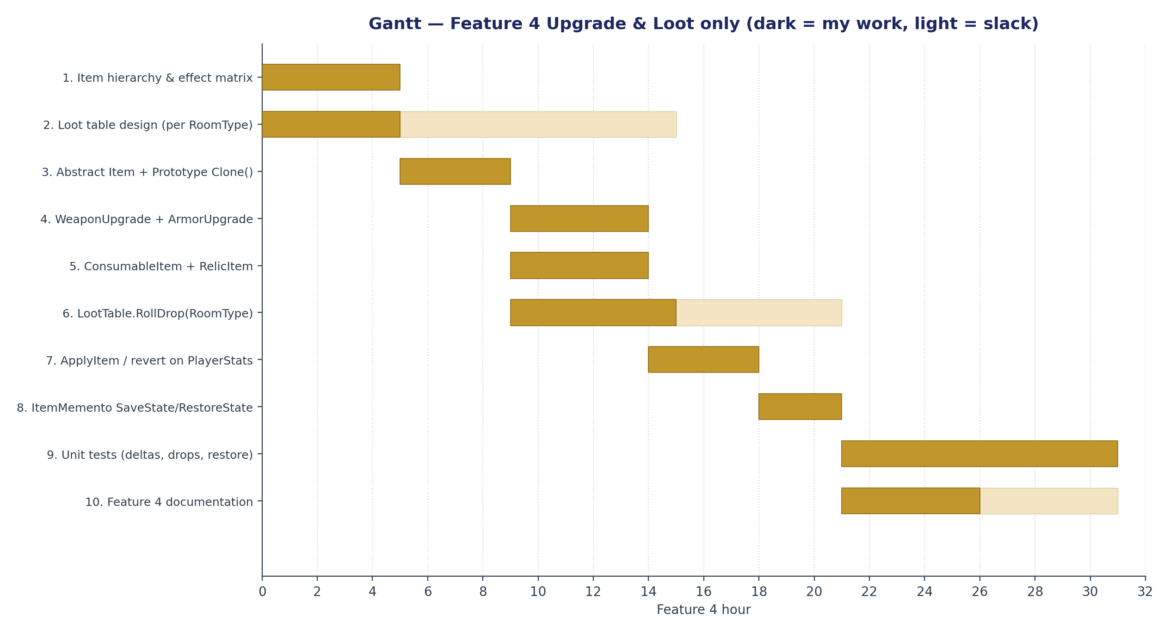
AI Question Log — Summary
The full question record is docs/TL3_Kaleb/AI_Interaction_Log.md (Entries 1–8, questions 1–24). Numbers in this Champion (stat deltas, drop rates, hours, PERT values) come from the Feature 4 specification and the sample’s grading notes, not from accepting a first AI draft.
I drafted the five required sections from the Feature 4 spec using the Enemy Spawning sample as the structural template, then checked the three things the sample warns about. First, exceptions are branches of numbered steps (Step 3a, 4a, 6a), not separate stories. Second, DFDs use Gane–Sarson process rectangles and D-numbered stores, not flowchart circles. Third, the timeline is my Feature 4 budget only — Design 10 + Coding 27 + Testing 10 + Documentation 5 = 52 hours of work / 31 hours on the critical path — not a collapsed “coding only” guess and not the seven-feature project calendar. Interface bounds (drop rates, +5 Attack, 10.0 s consumable, 0.15 MoveSpeed) are the testable contract for TL4.
After reading all seven Feature Specifications, RoomType names match Feature 2 (CombatRoom / TreasureRoom / CorridorRoom / BossRoom), the public API is only ApplyItem, RollDrop, SaveState, and RestoreState (events are test-only), and HUD updates stay on Feature 1’s Observer. Feature 5 unlocks and Feature 6 boss phases stay out of this interface. Feature 1’s spec slip (“player stats (Feature 2)”) is not copied: GetStats() is Feature 7.
Later passes corrected diagrams against instructor examples. Use-case lines follow the Pearson legend: Communicates is a solid line with no heads; << include >> and << extend >> are dashed with an open arrowhead (include points at the common use case; extend points from the exception to the basic use case). Diagram 0 has one process per spec feature (1–7) with process 4 highlighted; stores D1–D5 are the open-right Gane–Sarson symbol (ID band on the left). Every flow starts and ends on a box — dead-end arrows on Diagram 0 and Diagram 4 were rejected. Diagram 4 explodes process 4 (4.1 Roll Drop, 4.2 Apply Effect, 4.3 Revert, 4.4 Snapshot). PERT node numbers are Feature 4 work items, not Diagram 0 feature IDs; the Gantt axis is Feature 4 hour.

