Champion Document
Feature 2 — Room & Map Generation System
Name: Jordan Hardy Mark: ______ / 30

1. Brief Introduction
My feature is the Room & Map Generation System. At the beginning of a run, it procedurally arranges room templates into a run-specific dungeon using a supplied seed and requested room count. MapManager owns the generated grid, RoomFactory creates the correct Room subtype, and each Room subtype supplies its own GenerateLayout() behavior so CombatRoom, TreasureRoom, CorridorRoom, and BossRoom remain visibly distinct.
During play, the feature owns grid adjacency, the current-room reference, and room-to-room transition validation. It exposes GenerateRun(int seed, int roomCount), GetCurrentRoom(), and TryTransition(Direction dir, out Room nextRoom). Other systems consume room type, position, BossRoom, or room-bound information rather than reaching into the map implementation directly.
The feature deliberately does not spawn or control enemies, roll or apply loot, run the boss encounter, control the player, manage points, or render the HUD. Those responsibilities belong to Features 3–7 and Feature 1. Feature 2 has no required dependency for standalone operation; instead, the enemy, loot, boss, and player systems read map data from it.

2. Use Case Diagram with Scenario

Use Case Diagram 1 — Generate a Run
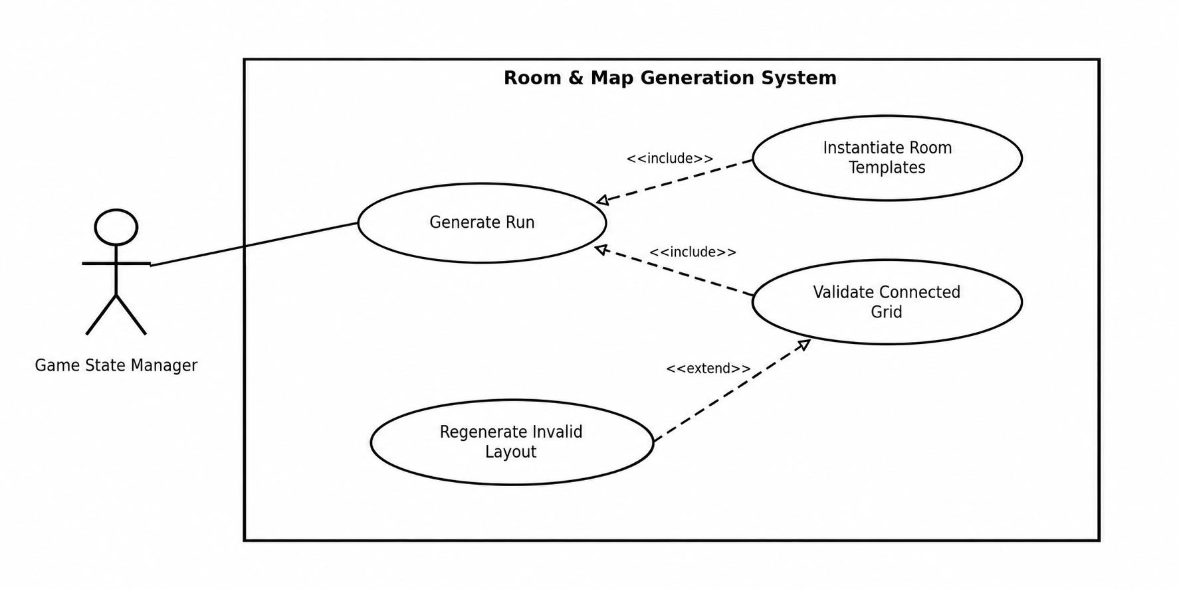
Name: Generate Run
Summary: Create a deterministic run-specific dungeon from a seed and requested room count, instantiate typed rooms, and validate that the resulting grid is connected.
Actors: Game State Manager system
Preconditions: Room templates are available to RoomFactory; seed and roomCount are supplied.
Basic sequence:
- Step 1: The Game State Manager calls GenerateRun(seed, roomCount).
- Step 2: MapManager initializes the run-specific generation state from seed.
- Step 3: MapManager selects grid coordinates until roomCount positions have been assigned.
- Step 4: RoomFactory creates the required Room subtype for each assigned position.
- Step 5: Each Room calls its overridden GenerateLayout() to create its type-specific layout.
- Step 6: MapManager builds adjacency links between orthogonally neighboring rooms.
- Step 7: MapManager validates that the generated grid is connected and that each generated room is reachable.
- Step 8: The starting room becomes the current room and the generated run is returned.
Exceptions:
- Step 4a: A requested room type cannot be created by RoomFactory. Generation is rejected and the invalid type is logged rather than inserting an unknown concrete class.
- Step 7a: Connectivity validation fails — the Regenerate Invalid Layout <<extend>> case. The candidate layout is discarded and generation repeats deterministically from the run generation state before Step 8.
Post conditions: Exactly roomCount Room objects exist in a connected grid; the current room is valid; room type and position data are queryable.
Priority: 1 (must have)
ID: RM1

Use Case Diagram 2 — Transition Between Rooms
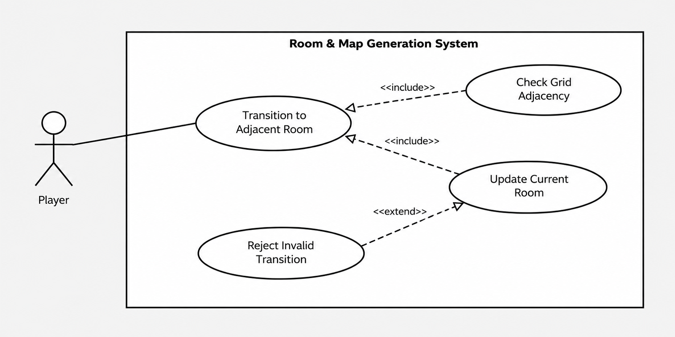
Name: Transition to Adjacent Room
Summary: When the player attempts to leave the current room, the map checks adjacency and updates the current room only when a valid neighbor exists in that direction.
Actors: Player
Preconditions: A run has been generated and GetCurrentRoom() returns a valid room.
Basic sequence:
- Step 1: The player reaches a room exit and requests movement in Direction dir.
- Step 2: MapManager receives TryTransition(dir, out nextRoom).
- Step 3: MapManager checks the current room’s grid coordinate and adjacency data for dir.
- Step 4: The adjacent Room is assigned to nextRoom.
- Step 5: MapManager updates the current-room reference to nextRoom.
- Step 6: TryTransition returns true and downstream systems can query the new room type and position.
Exceptions:
- Step 3a: No adjacent room exists in dir — the Reject Invalid Transition <<extend>> case. nextRoom is left unset/null, the current room is unchanged, and TryTransition returns false.
- Step 4a: The adjacency entry points to a room outside the generated run. The transition is rejected as invalid, current-room state remains unchanged, and the failed coordinate is logged for testing.
Post conditions: On success, current room equals nextRoom and the two rooms are adjacent; on failure, current room is unchanged.
Priority: 1 (must have)
ID: RM2

3. Data Flow Diagrams
Diagram 0 shows the complete seven-feature project. Feature 2 is highlighted. The feature-level diagram then zooms into the data transformations owned by the Room & Map Generation System.

Context Diagram

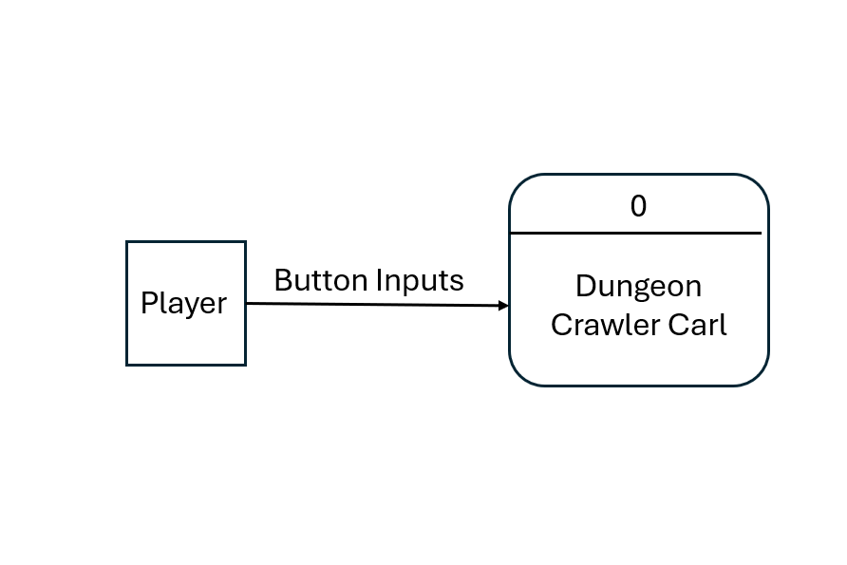

Diagram 0 — Whole Game
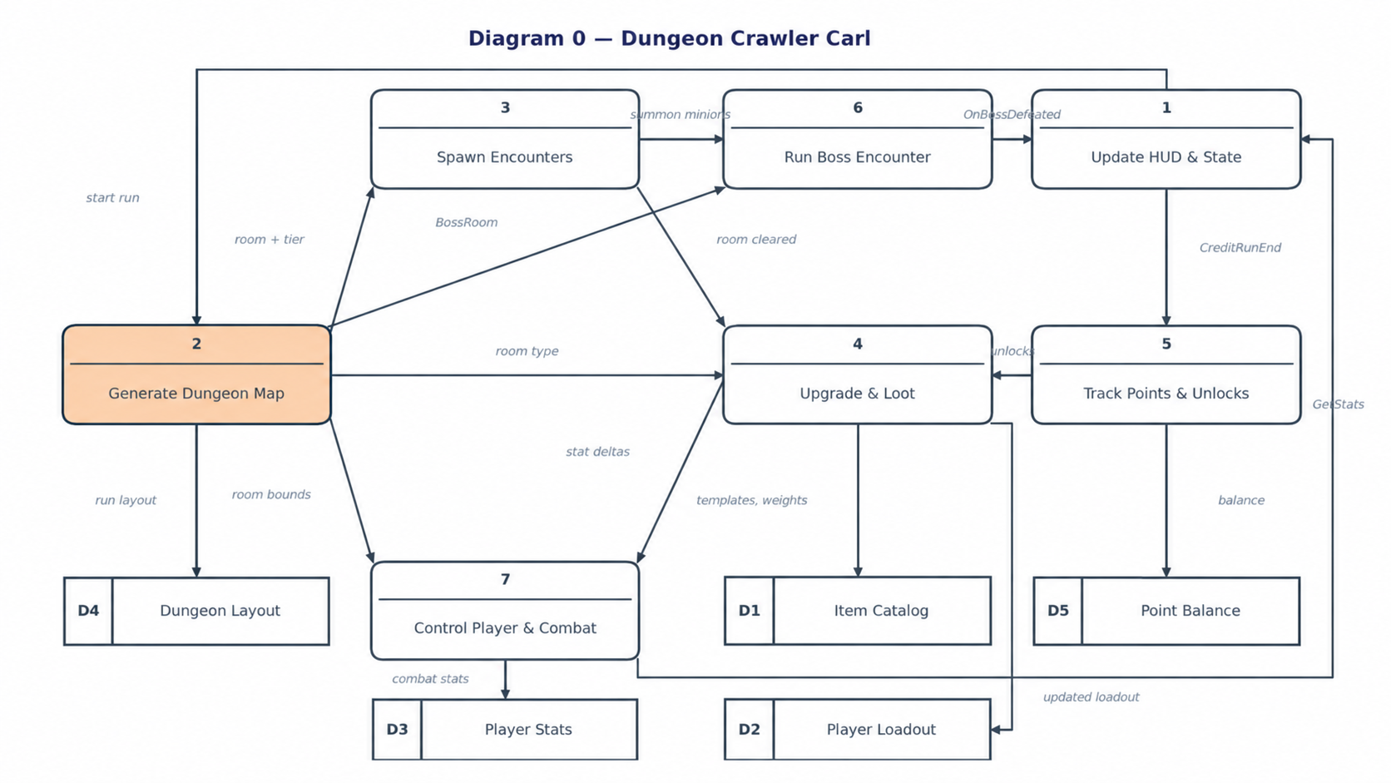

Feature 2 Subprocess Diagram
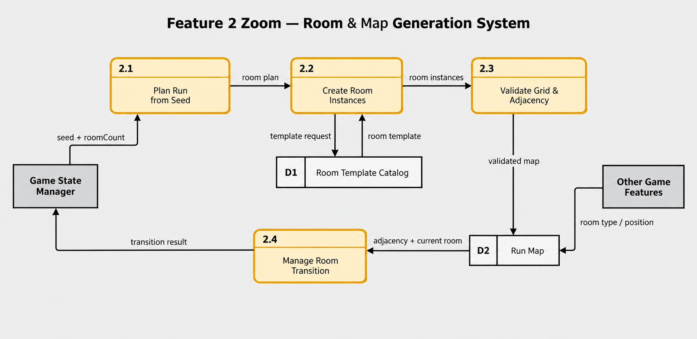

4. Interface Contract

Process Description — 2.3 Validate Grid & Adjacency
Structured English:
- FOR each generated Room, create adjacency entries only for orthogonally neighboring generated coordinates.
- START a graph traversal at the designated starting room.
- FOLLOW adjacency links and mark each reached room.
- IF the number of reached rooms equals roomCount, write the validated adjacency map to D2 Run Map and return VALID.
- ELSE return INVALID to Process 2.1 so the candidate layout is discarded and regenerated.
- NEVER create a transition edge to a coordinate that is absent from the generated run.

- Purpose. The Room & Map Generation System exposes map generation, current-room lookup, and room-transition behavior to the rest of the game. Other features interact with the map through these public methods rather than directly modifying the internal room grid. Feature 2 owns the generated room layout, adjacency information, and current-room reference. Other systems may read room information through returned Room objects but do not directly alter the map.
- Interface | - Typed Inputs | - Typed Output | - Contract / Testable Behavior
- Room GenerateRun(int seed, int roomCount) | - seed: int — deterministic generation seed.  roomCount: int — requested number of rooms. | - Room — the initial/current room of the generated run. | - Given the same valid seed and roomCount, generation must produce the same room layout. The completed map must contain exactly roomCount rooms, all rooms must belong to one connected grid, and the returned Room must be one of the generated rooms.
- Room GetCurrentRoom() | - None. | - Room — the room currently occupied by the player. | - After GenerateRun completes, this method must return a non-null room belonging to the current generated map. After a successful transition, it must return the same room returned through nextRoom by that transition. Calling this method must not modify the map or current-room state.
- bool TryTransition(Direction dir, out Room nextRoom) | - dir: Direction — requested grid direction.  nextRoom: out Room — receives the destination room when the transition succeeds. | - bool — true when an adjacent room exists in dir; false when no legal transition exists. | - If an adjacent room exists in the requested direction, return true, assign that room to nextRoom, and make it the current room. If no adjacent room exists, return false and leave the current room unchanged. A failed transition must never create a room or change grid adjacency.
- Interface Data Types
- Room — An abstract Feature 2 type representing one room in the generated map. Concrete room types defined by this feature are CombatRoom, TreasureRoom, CorridorRoom, BossRoom. Each room has sufficient information for Feature 2 to determine its room type, grid position, and legal neighboring rooms. Other features use this information without needing access to the map-generation implementation.
- Direction — An enumeration representing a requested move from one grid cell to an adjacent grid cell. The implementation should use one finite, consistent set of directions throughout generation and transition checking. For example, it may use North, South, East, West. A transition is legal only when the current room has an adjacent generated room in the requested direction. The exact enumeration values are an implementation detail because the project specification names the Direction type but does not define its members.
- Events
- No public Feature 2 event is currently specified. The project specification defines the three methods above as Feature 2's public interface but does not assign an event to the Room & Map Generation System. Therefore, other features should obtain map and room information through these methods rather than relying on an undocumented event.
- Mechanical Interface Tests
- The contract can be verified independently of the Unity scene:
- 1. Deterministic generation: Call GenerateRun(seed, roomCount) twice with the same inputs. The room types, grid positions, and adjacency relationships must match exactly.
- 2. Room-count test: For each generated test run, the map must contain exactly the requested roomCount.
- 3. Current-room test: Immediately after generation, GetCurrentRoom() must return a room contained in the generated map.
- 4. Successful-transition test: Choose a direction containing a known adjacent room. TryTransition(dir, out nextRoom) must return true; afterward, GetCurrentRoom() must reference the same room as nextRoom.
- 5. Failed-transition test: Choose a direction with no adjacent room. TryTransition(dir, out nextRoom) must return false, and GetCurrentRoom() before and after the call must be identical.
- 6. Connectivity test: Starting from the room returned by GenerateRun, graph traversal through legal adjacencies must visit every generated room, with zero unreachable rooms.
- Implementation note: North/South/East/West are shown only as an example concrete definition for Direction. The supplied project specification names the Direction type but does not define its enumeration values.

5. Acceptance Tests
The project specification gives the required behaviors but does not prescribe numeric sample sizes. The following numeric bounds are proposed Champion test parameters so each requirement has a mechanical pass/fail decision on the testing compile path.

Test | Procedure | Pass bound
Seed determinism | For 100 seeds, call GenerateRun twice with the same seed and roomCount = 20; compare room type, coordinate, and adjacency snapshots. | 100/100 pairs are identical.
Room count & validity | Generate 1,000 runs of 20 rooms using seeds 0–999. | Every run contains exactly 20 rooms; 0 duplicate coordinates; 0 unknown room types.
Connected-grid reachability | For the same 1,000 runs, BFS/DFS from the starting room. | Reached-room count = 20 in 1,000/1,000 runs.
Adjacency integrity | Inspect every directed adjacency edge in the 1,000 generated runs. | 0 edges point outside the run; every edge changes coordinate by Manhattan distance exactly 1; reverse neighbor exists for every edge.
RoomFactory subtype | Request each defined RoomType 100 times. | 400/400 objects have the matching concrete subtype; 0 mismatches.
Distinct room behavior | Call GenerateLayout() on Combat, Treasure, Corridor, and Boss test instances and compare their layout signatures. | 4/4 types produce their expected type-specific signature; no type falls back to the default corridor signature.
Transition contract | For 100 generated runs, test every valid edge and at least one missing direction where available. | Valid edge: true and nextRoom is the adjacent room. Missing edge: false and current room unchanged. 0 violations.

Sample Output / Analysis
Check | Runs / cases | Observed example | Required | Pass?
Seed determinism | 100 pairs | 100 identical | 100/100 | Yes
Connected-grid reachability | 1,000 runs | 999 fully reachable | 1,000/1,000 | No
Adjacency integrity | 38,214 edges | 0 invalid edges | 0 invalid | Yes
RoomFactory subtype | 400 cases | 400 correct | 400/400 | Yes
Transition failure state | 100 invalid attempts | 1 changed current room | 0 changes | No

6. Timeline
The feature specification estimates 52 total hours: 10 design, 28 coding, 9 testing, and 5 documentation. The work items below preserve that total. Because these tasks build directly on one another, the initial Champion plan treats the full 52 hours as the critical path; if implementation allows overlap later, the team Gantt can record the resulting positive variance.
Task | Duration (hours) | Predecessor task(s)
1. Map architecture & interface design | 10 | —
2. Room base class + subtype model | 5 | 1
3. RoomFactory / Factory Method | 5 | 2
4. Seeded grid generation | 7 | 3
5. Adjacency construction & validation | 4 | 4
6. Current-room transition logic | 3 | 5
7. Type-specific GenerateLayout() implementations | 4 | 6
8. Unit and integration tests | 9 | 7
9. Documentation & handoff | 5 | 8

PERT Diagram
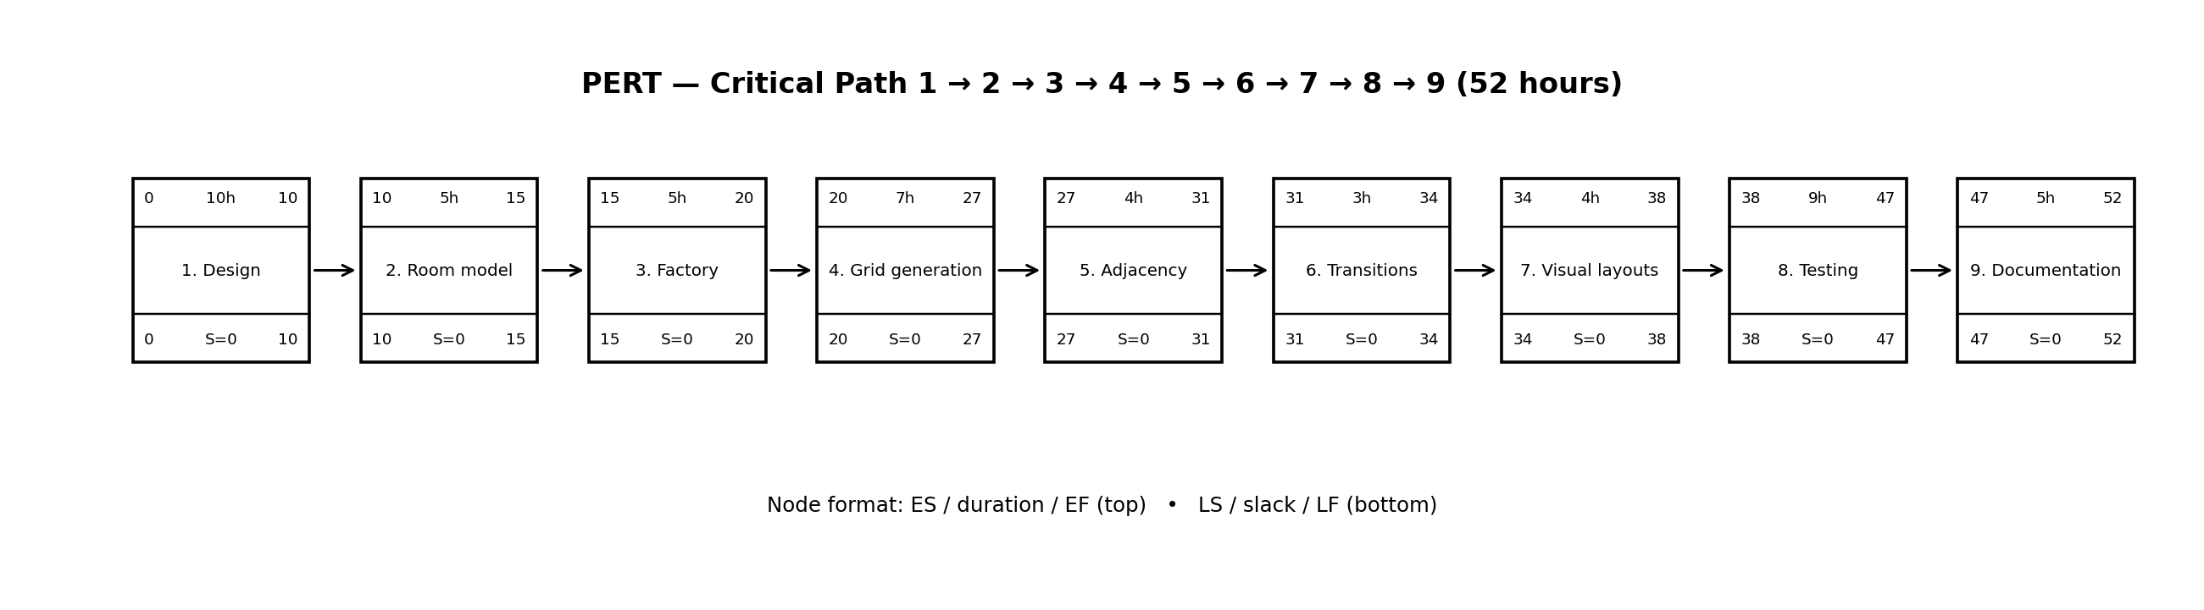

Gantt Timeline
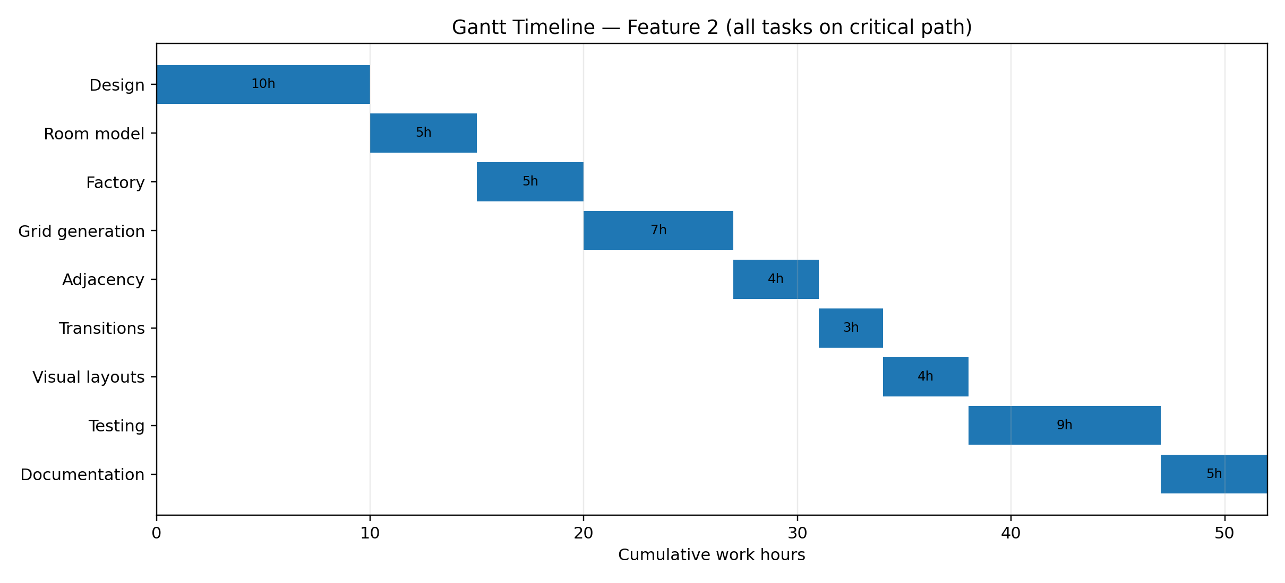

AI Question Log — Summary
I used ChatGPT to draft the Champion document from the course template, the sample Enemy feature, the project Feature Specifications, and the diagram-line convention supplied with the assignment. Before drafting, I clarified that Diagram 0 must represent the entire team project while the remaining material must focus on Feature 2, and I required the UML diagrams to use dashed <<include>> and <<extend>> arrows with the correct direction rather than copying the sample’s incorrect relationship lines. I also required at least one include and one extend relationship and kept the scenario exceptions tied to exact numbered basic-sequence steps. The acceptance-test sample sizes are proposed numeric bounds added to make the project requirements mechanically testable; the 52-hour timeline preserves the Feature 2 estimate in the project specification. The full conversation should be submitted separately as the AI question log.

