Champion Document — Feature 1
HUD, UI & Game State Manager (TL1)
Mark: ____ / 30
This document follows the supplied Champion sample's structure and level of specificity. The sample emphasizes step-linked exceptions, Gane–Sarson DFDs, and numeric acceptance bounds.
Feature scope: live HUD rendering, run/win/loss/reset flow, and state-change broadcasting.

1. Brief Introduction
My feature for Dungeon Crawler Carl is the HUD, UI & Game State Manager. At runtime, it owns the single game-state representation used by the HUD and coordinates the overall run lifecycle: run start, active play, win/loss game-over, and reset. When relevant state changes, the manager broadcasts the new GameState so registered HUD elements immediately refresh their own displayed portion.
The HUD renders four live elements: health, points, minimap, and run timer. The implementation uses an abstract HUDElement base class with virtual Refresh(GameState state). HealthBarElement, PointsCounterElement, MinimapElement, and RunTimerElement override Refresh so each element owns its presentation logic.
The feature deliberately does not calculate player stats, award points, or decide boss outcomes. Feature 2 provides player-stat information, Feature 5 provides point-balance information, and Feature 6 provides boss/win events. Feature 1 mediates those inputs into UI/state changes rather than replacing those systems.
Design rationale:
- GOF Observer: HUD elements react to OnStateChanged instead of polling the game state.
- GRASP Indirection: GameStateManager mediates between state-producing gameplay systems and the UI.
- GRASP Protected Variations: new HUD elements can be registered without changing state-producing code.
- Removing virtual from HUDElement.Refresh() would leave derived HUD elements at their default/placeholder rendering rather than updating when health, points, or time change.

Scope and completion
In scope | Explicitly not in scope
Register HUD elements; validate/apply GameState; broadcast OnStateChanged; refresh HUD; manage run start, game-over, win/loss, and reset transitions. | Computing combat damage; calculating player stats; awarding points; deciding boss victory; creating the minimap/world layout.
Unit-test Refresh() with mock GameState objects without requiring a scene. | Scene-specific art production or gameplay rules owned by Features 2, 5, and 6.

2. Use Case Diagram with Scenarios
The scenarios below use the sample's convention: actors are explicit, the basic sequence is numbered, and every exception branches from the exact step that can trigger it.

Use Case Diagram 1 — Run lifecycle
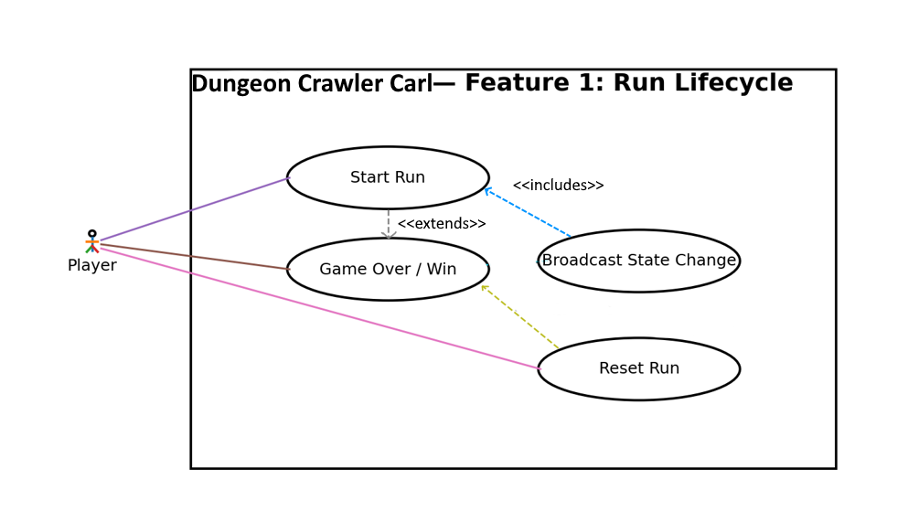
Figure 1. Use case diagram for start, game-over/win, and reset flow.

Scenario 1 — Start and Run the Game
Summary: The player starts a run; the manager establishes Running state and publishes the first live state to the HUD.
Actors: Player; gameplay systems supplying initial state.
Preconditions: GameStateManager exists; HUD elements have been registered; the initial GameState is available.
Basic sequence:
- Step 1: The player starts a run through the game's run-start action.
- Step 2: GameStateManager receives the initial GameState with RunStatus = Running.
- Step 3: GameStateManager stores the accepted state and identifies it as a state change.
- Step 4: GameStateManager invokes OnStateChanged with the new GameState.
- Step 5: Each registered HUDElement receives Refresh(newState) and renders its portion of health, points, minimap, or timer.
- Step 6: The game continues with the HUD reflecting the active run.
Exceptions:
- Step 2a: The supplied GameState is null. The manager rejects the update; no state-change event is raised and the previous valid state remains active.
- Step 5a: A registered HUD element is null or unavailable. The manager skips that registration and continues refreshing the remaining valid elements; the state-change event still represents the accepted state.
Post conditions: RunStatus = Running; the current GameState is stored; registered HUD elements have been offered the new state.

Use Case Diagram 2 — Live HUD update
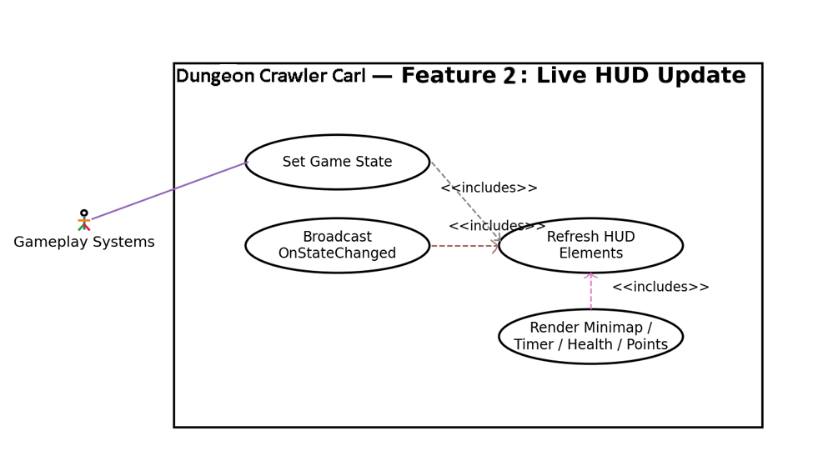
Figure 2. Use case diagram for state publication and HUD refresh.

Scenario 2 — Update Live HUD
Summary: A state-producing system sends a new GameState; the manager broadcasts it and every registered HUD element refreshes.
Actors: Feature 2 Player Stats; Feature 5 Point Balance; Feature 6 Boss/Win Events; HUD/player presentation.
Preconditions: GameStateManager exists and has at least one registered HUD element.
Basic sequence:
- Step 1: A gameplay system produces a new typed GameState containing the changed values.
- Step 2: The gameplay system calls SetGameState(state).
- Step 3: GameStateManager compares the incoming state with its current state.
- Step 4: If the state changed, GameStateManager invokes OnStateChanged(state).
- Step 5: Each registered HUD element executes its overridden Refresh(state).
- Step 6: Health, points, minimap, and timer presentation reflect the corresponding GameState values.
Exceptions:
- Step 3a: The incoming state is identical to the current state. The manager does not broadcast a redundant state-change event; the stored state remains unchanged.
- Step 5a: One element throws during Refresh(). The failure is isolated to that element; the manager continues processing the remaining registered elements and records the failed element for debugging.
Post conditions: Every successfully registered HUD element has been refreshed for each accepted changed state.
Priority: 1 (must have) ID: HU1

3. Data Flow Diagrams
Diagram 0 places Feature 1 in the whole game; Diagram 1 zooms into the relevant HUD and State feature. Diagram 1.2 is also expanded to display the decision tree for broadcasting the state change.
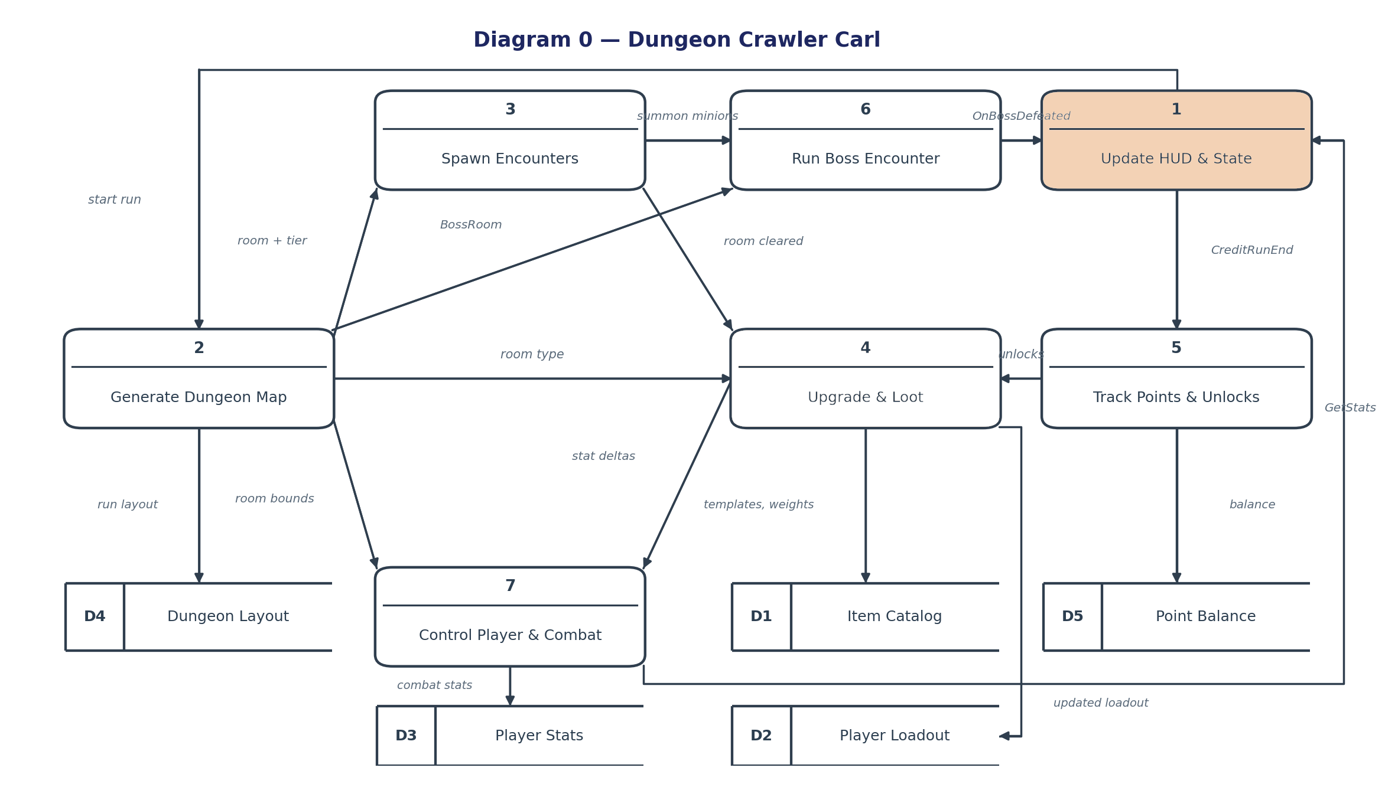
Figure 3. Context-level Gane–Sarson DFD. Feature 1 is the highlighted process.
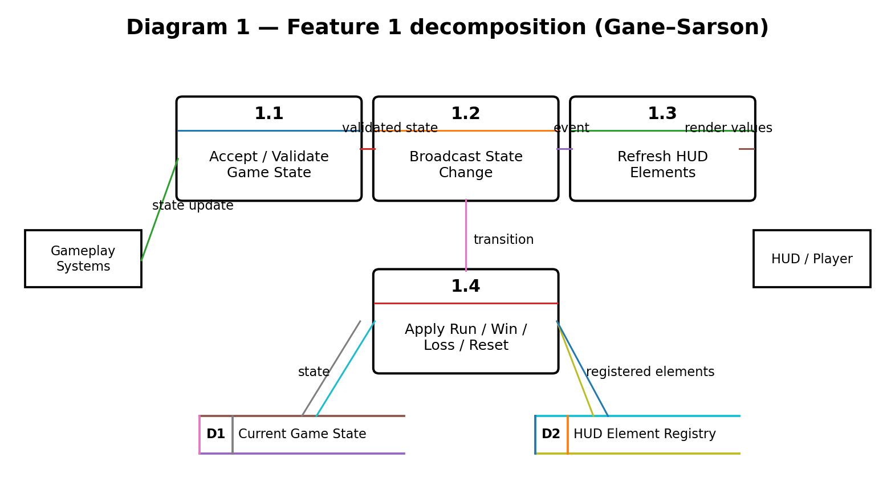
Figure 4. Feature-level Gane–Sarson DFD. Data stores D1 and D2 are explicit.

Process Description — 1.2 Broadcast State Change
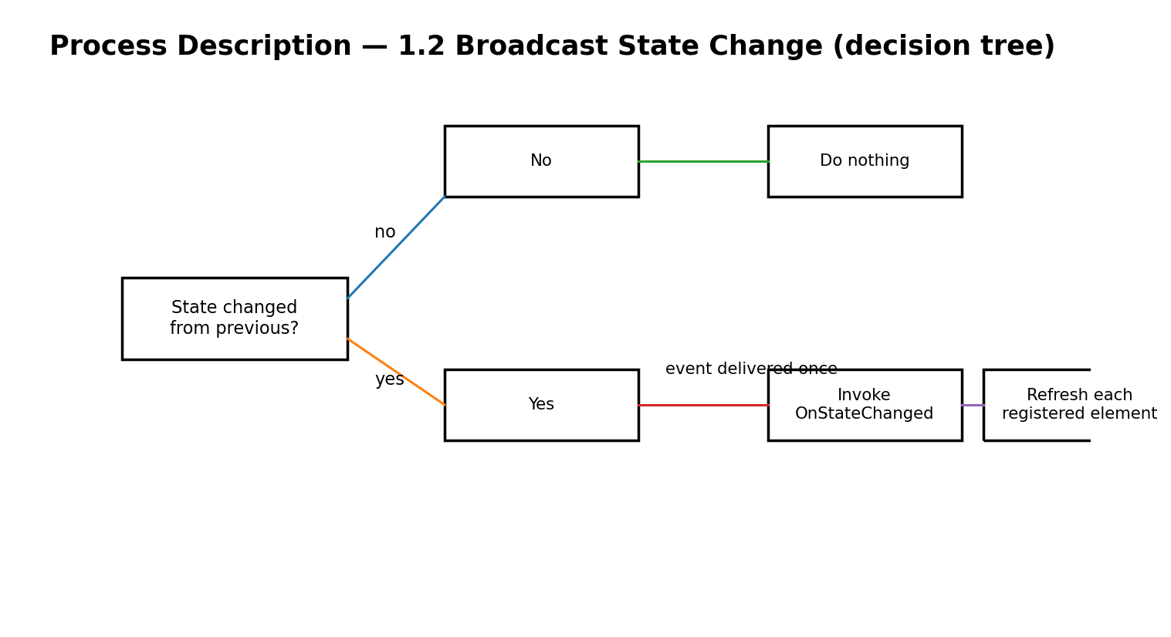

4. Acceptance Tests
HUD failure isolation test.
One hundred scripted runs exercise start, active play, win, loss, and reset transitions. Pass requires: 100% of runs reach Running after a valid start, every win/loss transition produces the corresponding GameState, every reset returns the manager to the documented reset state, and 0 invalid transitions are accepted.
Run lifecycle test.
With the four required HUD elements registered, 1,000 accepted changed states are published. Pass requires: each accepted changed state results in exactly one Refresh(state) call for each registered element, for 4,000 total refresh calls, with 0 missed refreshes.
HUD refresh test.
A scripted test submits 1,000 GameState updates: valid changed states, duplicate states, and null inputs. Pass requires: 100% of valid changed states are stored and broadcast; 0 duplicate states produce a redundant OnStateChanged event; 0 null states replace the previous valid state.
State acceptance test.
My feature has deterministic state transitions and bounded event/refresh behavior. The tests below run on the testing compile path and exercise state validation, state-change broadcasting, HUD refresh, and run lifecycle handling.

Test | Runs | Pass criterion
State acceptance | 1,000 updates | 0 null accepted; 0 redundant events; 100% valid changed states broadcast
HUD refresh | 1,000 state changes | 4,000 refresh calls; 0 missed
Run lifecycle | 100 runs | 100% valid transitions; 0 invalid transitions accepted
Failure isolation | 500 batches | Remaining 3 elements continue; 500 failure records; 0 batch interruptions

5. Timeline
The total estimate is 52 hours, matching the requested effort split: Design 8 hours, Coding 29 hours, Testing 10 hours, Documentation 5 hours.
Task | Work item | Hours | Predecessor task(s) | Category
1 | State contract & architecture | 8 | — | Design
2 | GameStateManager core | 7 | 1 | Coding
3 | HUDElement hierarchy & virtual Refresh | 6 | 1 | Coding
4 | HUD concrete elements | 7 | 3 | Coding
5 | Run/game-over/reset transitions | 5 | 2 | Coding
6 | Feature 2/5/6 integration | 4 | 2, 5 | Coding
7 | Unit & integration testing | 10 | 4, 6 | Testing
8 | Documentation & diagrams | 5 | 7 | Documentation
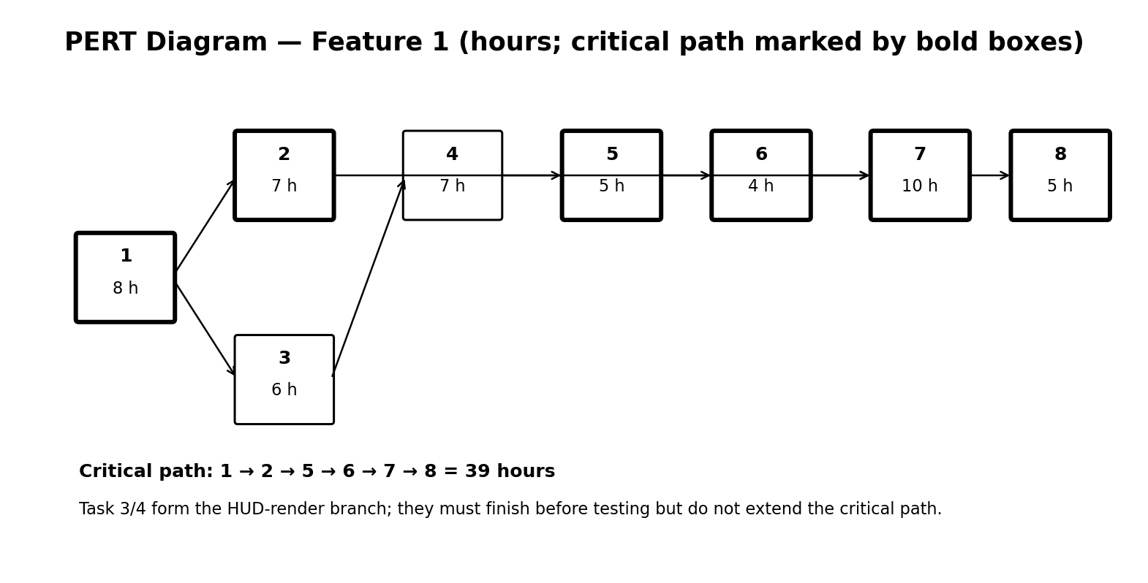
Figure 6. PERT network. Bold boxes mark the planned critical path.
Critical path: 1 → 2 → 5 → 6 → 7 → 8 = 39 hours. The HUD-render branch 1 → 3 → 4 → 7 → 8 is 36 hours, leaving 3 hours of schedule slack relative to the critical path.
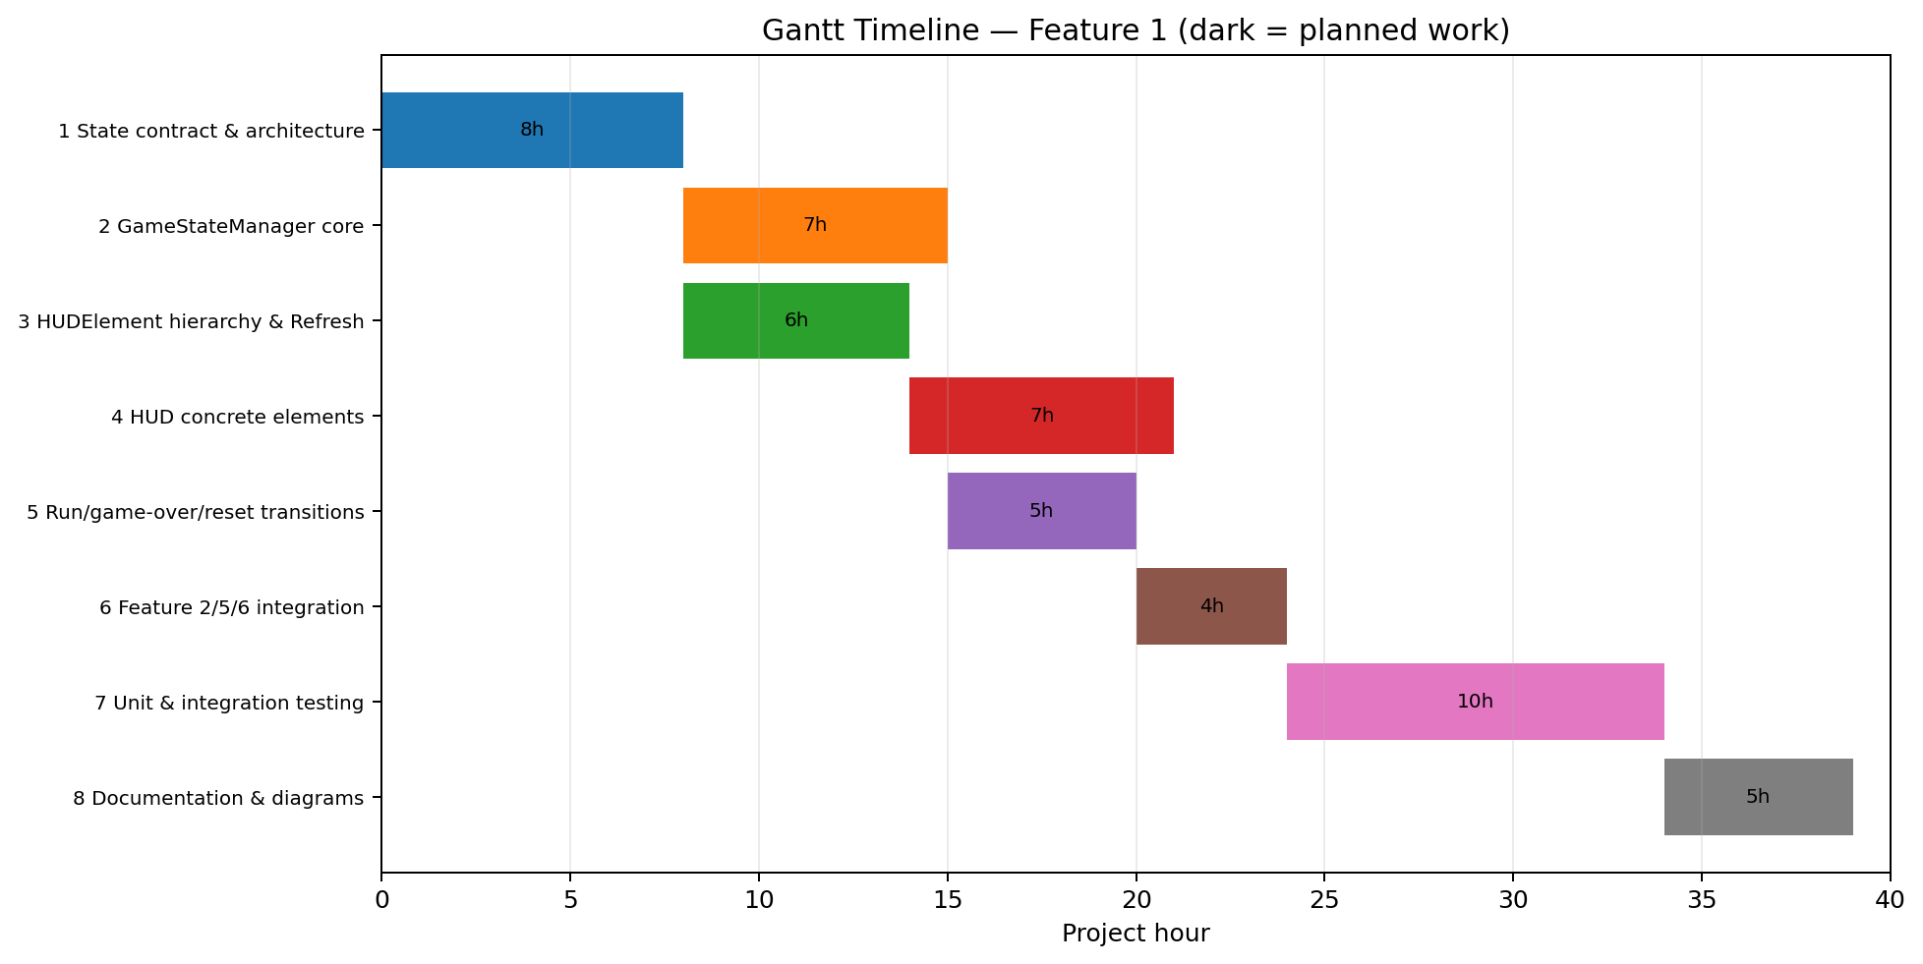
Figure 7. Gantt timeline — planned work by project hour.

AI Question Log — Summary
I drafted the full document as specified in class before going in and making revisions. Most edits were in diagrams containing incorrect formatting or incorrect names. I also removed additional elements ChatGPT decided to add that were not in the example document. It contained an extra section specifying data types and variables that was not in the example, and unnecessary elaboration on the timeline section that bloated the document. It also failed to add section 4 initially, which was added on a re-prompt. After this I had to alter the formatting of section 4 to be consistent with the rest of the document.

