Champion Document — Feature 7
Name: Feature 7 — Player Controller & Combat Feature: Player movement, combat & state machine Mark: ____ / 30
SOURCE BASIS: Feature 7 specification supplied for this Champion document.

1. Brief Introduction
My feature for Ember Cavern is the Player Controller & Combat system. It receives player input, reads the active room bounds, updates the player through a four-state state machine (IdleState, MovingState, AttackState, DashState), performs melee and ranged attacks, applies incoming damage to PlayerStats, and requests haptic feedback for supported actions.
The central design is the State pattern: PlayerController owns the current PlayerState object, and the current state determines movement and animation behavior through virtual Update(PlayerController ctx). Removing virtual from the base Update prevents derived state behavior from dispatching, which leaves the player visually in idle behavior even when the underlying state changes.
My feature deliberately does not own room generation or room geometry; Feature 2 provides the room bounds used for movement clamping. It also does not own enemy or boss behavior: attack damage events are consumed by Feature 3 and Feature 6, while incoming enemy/boss damage is applied through ApplyDamage(int amount).
Completion target: the player moves, attacks, dashes, and takes damage correctly across all four states with no missed state transitions, and supported haptic actions provide responsive feedback.

2. Use Case Diagram with Scenario
Use Case Diagrams
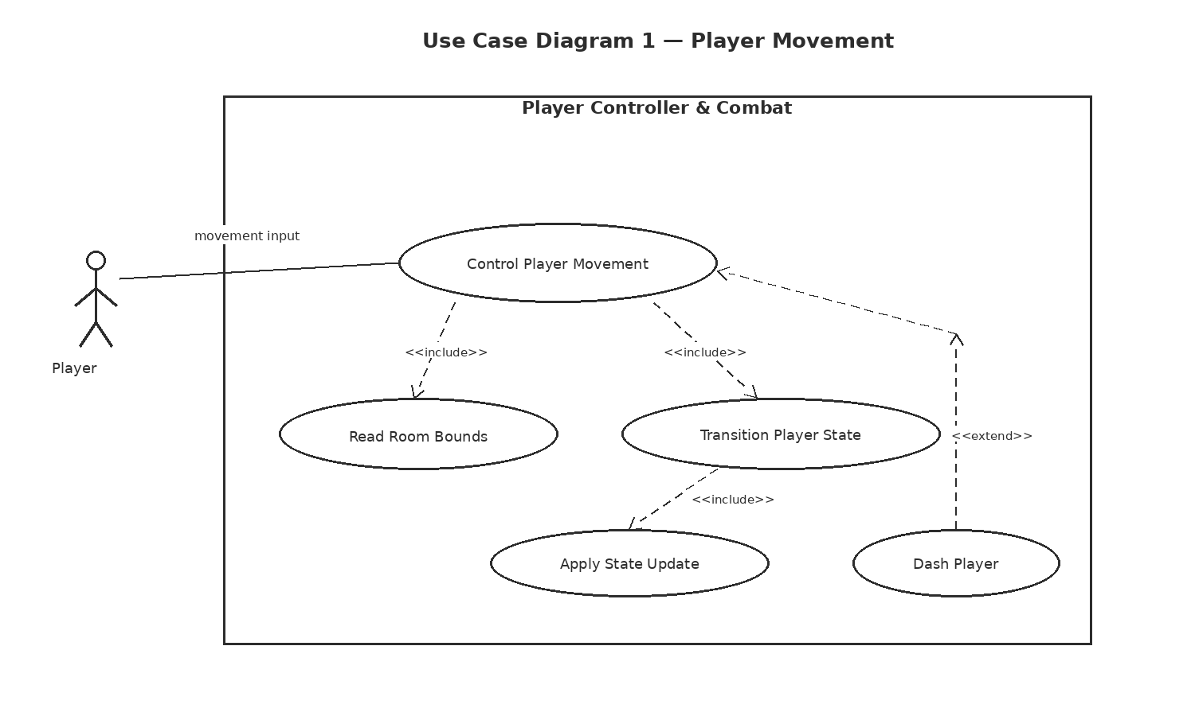
Scenario 1 (first use case diagram)
Name: Control Player Movement
Summary: The player moves or dashes while the controller reads room bounds, clamps position, and changes the current player state.

Actors: Player; Feature 2 Room Bounds system
Preconditions: The player object is active, the current PlayerState is one of Idle/Moving/Attack/Dash, and Feature 2 has supplied room bounds.
Basic sequence:
Step 1: The player supplies movement or dash input.
Step 2: PlayerController reads the current room bounds from Feature 2.
Step 3: PlayerController selects the required PlayerState and calls its virtual Update(PlayerController ctx).
Step 4: The active state applies movement/animation behavior and clamps the resulting position to the room bounds.
Step 5: PlayerController exposes the updated position through GetPosition().
Exceptions:
Step 2a: Room bounds are unavailable or invalid. Movement for that frame is rejected; the current position is preserved and a diagnostic is recorded. The sequence resumes at Step 3 on the next valid bounds read.
Step 3a: A dash input is received while a non-dash state is active. The controller switches the current PlayerState to DashState before Step 4, so the dash behavior, not the previous state's movement behavior, executes.
Post conditions: The player remains inside the supplied room bounds and the current state matches the input-driven behavior for the frame.
Priority: 1 (must have)
ID: PC1
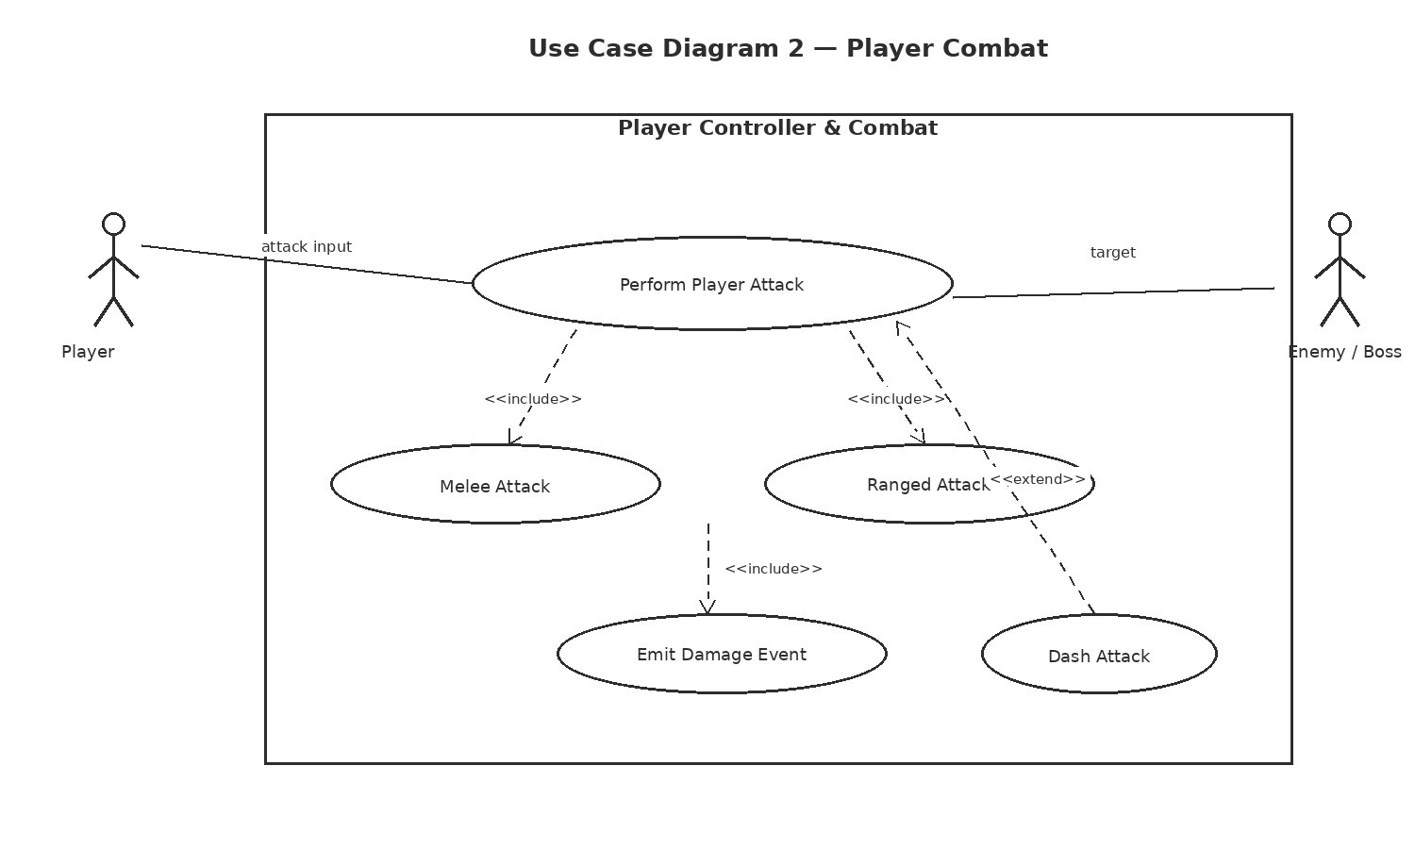

Scenario 2 (second use case diagram)
Name: Perform Player Attack
Summary: The player initiates a melee or ranged attack; the controller executes the attack behavior and emits damage output for Feature 3 enemies or the Feature 6 boss.
Actors: Player; Feature 3/Feature 6 target systems
Preconditions: The player object is active and an attack action is supported by the current controller configuration.
Basic sequence:
Step 1: The player supplies an attack input and attack type (melee or ranged).
Step 2: PlayerController transitions to AttackState and calls its virtual Update().
Step 3: AttackState activates the configured hitbox or projectile for the attack window.
Step 4: The controller emits a typed damage event for any valid target hit.
Step 5: AttackState ends and the controller returns to IdleState or MovingState based on the next movement input.
Exceptions:
Step 3a: No target is hit during the configured attack window. No damage event is emitted, the attack still ends normally, and the sequence resumes at Step 5.
Step 4a: A target is not a supported Feature 3 or Feature 6 receiver. The damage event is rejected by the target adapter; the player attack still completes and returns to Step 5.
Post conditions: The attack state has completed, any valid damage output has been emitted once per registered hit, and the controller is in the next input-appropriate state.
Priority: 1 (must have) ID: PC2

3. Interface Contract
The public interface below is intentionally typed and observable. Internal input paths use Unity input data, but the externally testable contract is expressed through concrete method signatures, typed events, and postconditions.
Interface item | Type | Input / trigger | Output / postcondition
ApplyDamage | void ApplyDamage(int amount) | amount : int, required amount >= 0 | HP becomes max(0, HP_before - amount); no negative HP; method returns void.
GetPosition | Vector2 GetPosition() | none | Returns current world position as Vector2(x, y) after the latest state update.
GetStats | PlayerStats GetStats() | none | Returns current PlayerStats object; HP value matches the most recent ApplyDamage result.
MovementInput | Vector2 | Unity input sample per frame | Magnitude and direction are consumed by the active PlayerState.
AttackInput | AttackType | enum: Melee or Ranged | Starts AttackState when the attack is supported by the controller configuration.
DashInput | event / input action | single dash action | Transitions to DashState before the state update for the dash frame.
StateChanged | event Action<PlayerStateType, PlayerStateType> | emitted on state swap | Exactly one event per committed state transition; identifies from-state and to-state.
DamageDealt | event Action<DamageEvent> | emitted on valid hit | DamageEvent contains amount:int, attackType:AttackType, origin:Vector2; consumed by Feature 3/6.
HapticFeedbackRequested | event Action<HapticRequest> | supported action completes or starts | HapticRequest contains action:HapticAction, intensity:float [0,1], durationMs:int > 0.

Internal class hierarchy
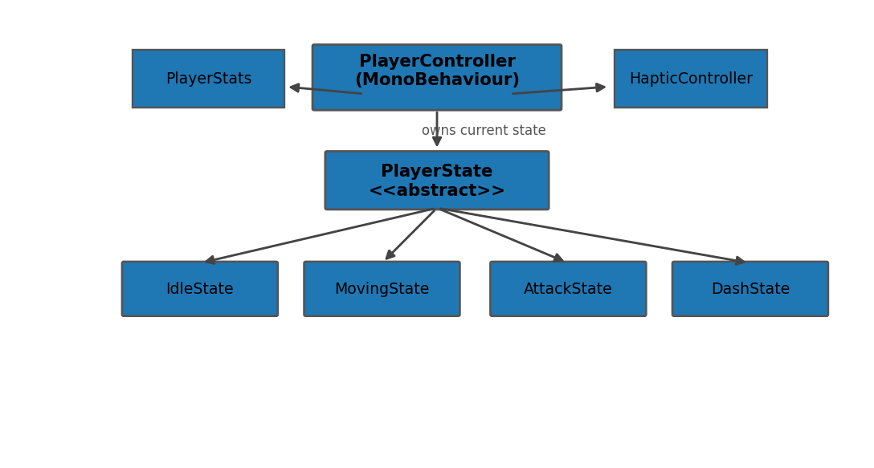
Class hierarchy requirement: PlayerState is an abstract non-MonoBehaviour base with virtual void Update(PlayerController ctx). IdleState, MovingState, AttackState, and DashState override Update to supply state-specific behavior.

4. Data Flow Diagrams
Diagram 0 shows the game-level context around Feature 7. Diagram 1 zooms into the feature using Gane–Sarson notation: external entities are plain rectangles, processes are rounded process boxes with a divider line, and data stores are open-ended store symbols. Every incoming flow is consumed by a named process and every outgoing flow has an identified receiver.
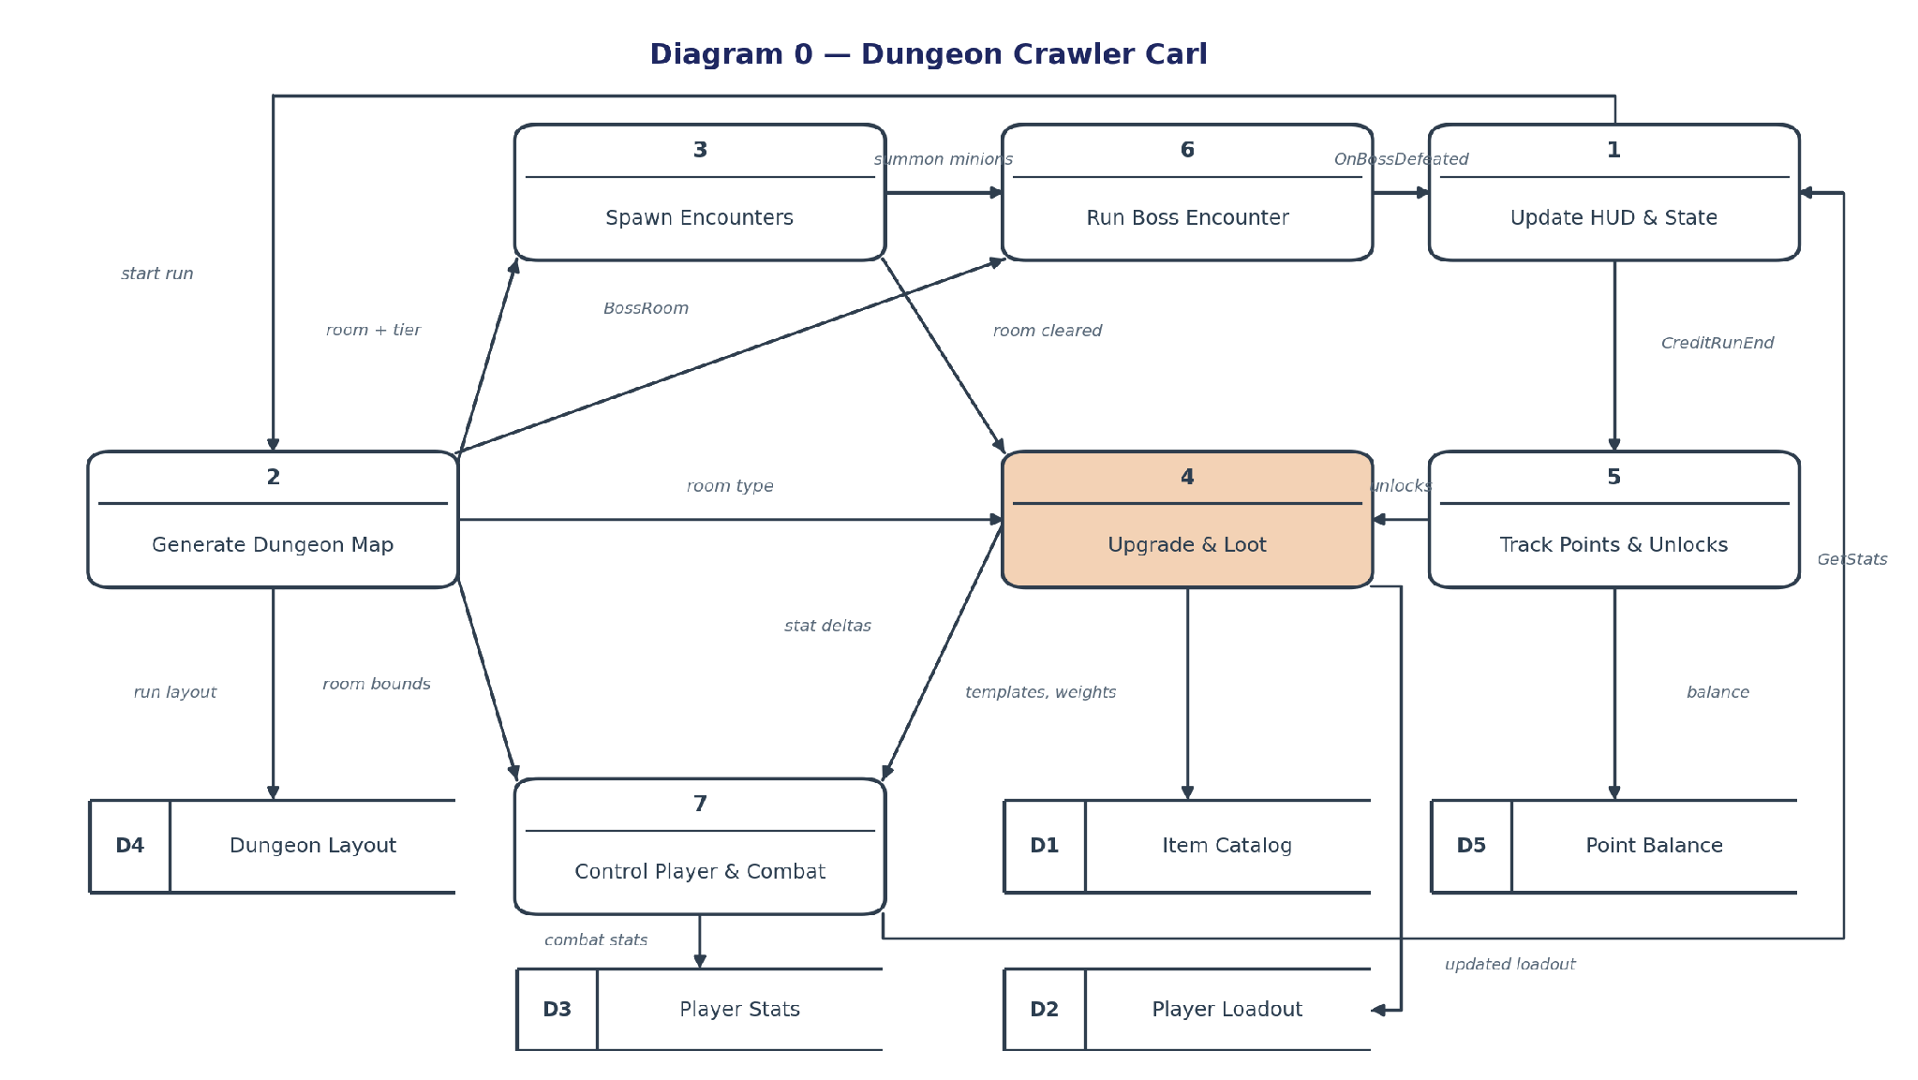
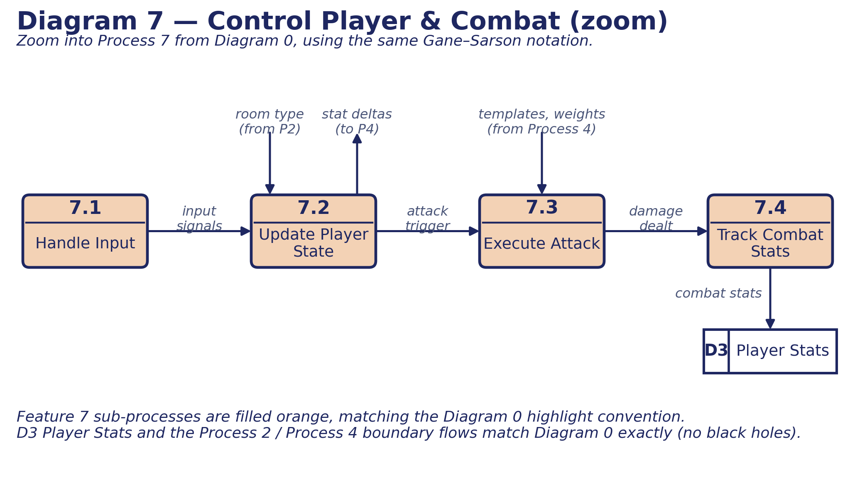

4. Data Flow Diagrams (continued)
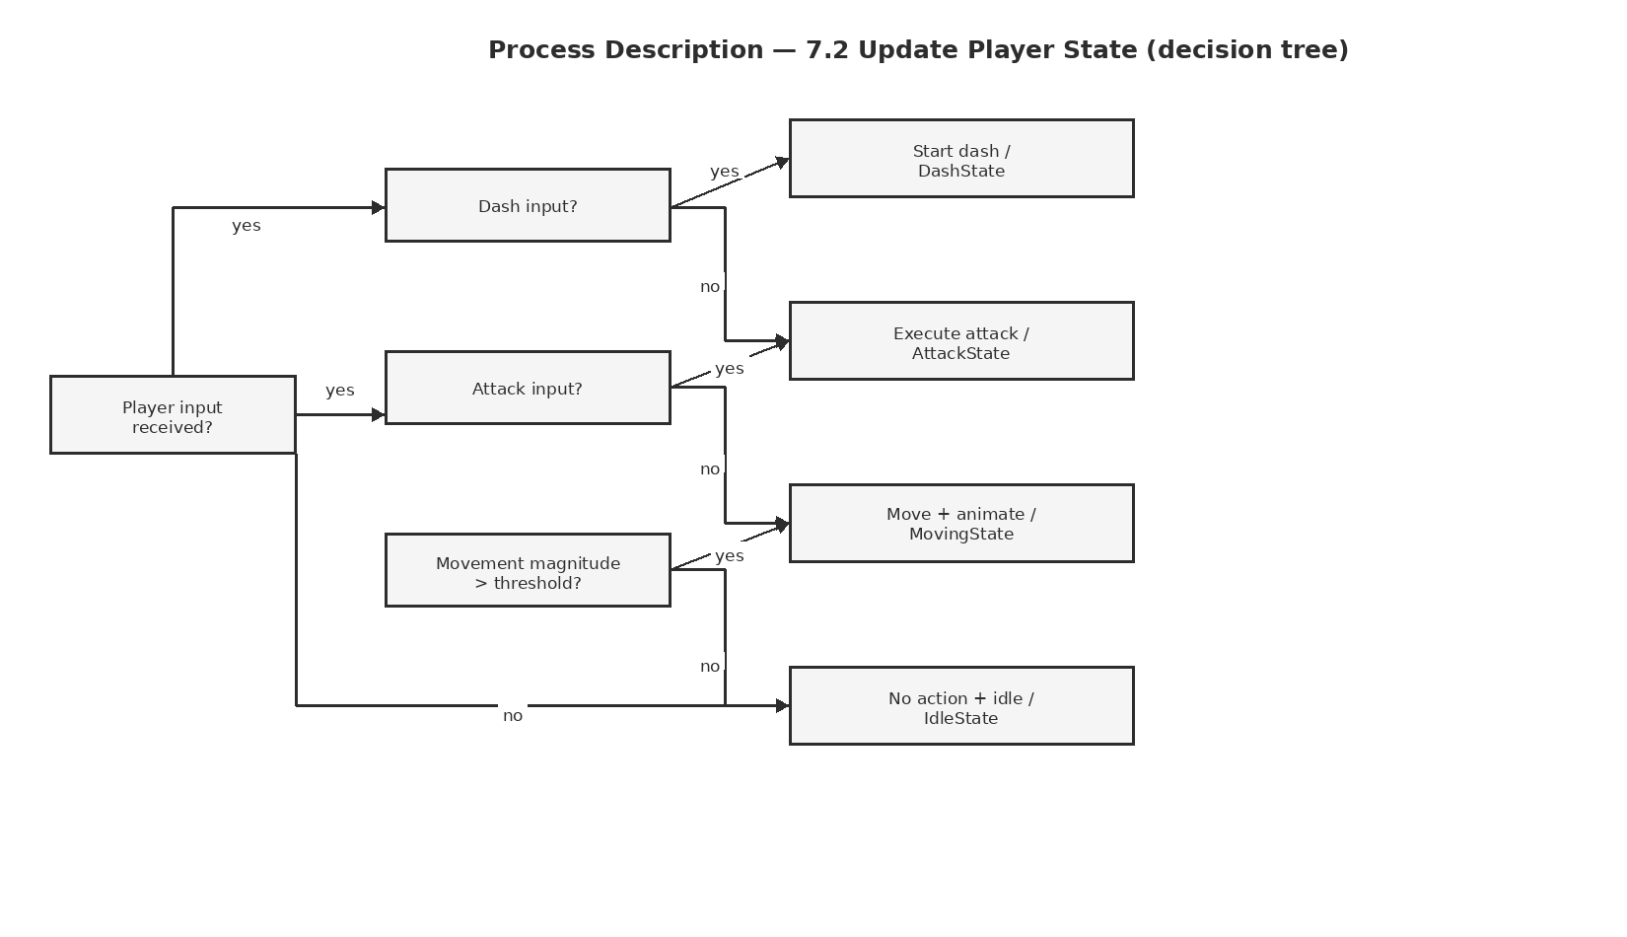

Process Description — 7.2 Update Player State
Input: movement input Vector2, attack input AttackType when present, dash action when present, and the current PlayerState stored in D1.
Decision order: a dash action selects DashState; otherwise an attack selects AttackState; otherwise non-zero movement selects MovingState; otherwise IdleState.
Output: the selected state is stored as the controller's current state and its Update(PlayerController ctx) method produces the state-specific movement/animation behavior.
Observable event: when the selected state differs from the current state, StateChanged(from, to) is emitted exactly once for the transition.

3. Interface Contract — Acceptance Tests
The tests below convert the contract and completion criteria into deterministic pass/fail checks. Unit tests cover state logic without a scene; play-mode smoke tests cover hitbox timing and supported haptic feedback.

State-transition test
100 scripted input sequences. Pass requires 0 missed transitions among Idle → Moving, Moving → Idle, any valid state → Attack, and any valid non-dash state → Dash; every committed transition must emit exactly one StateChanged event.

Movement bounds test
500 scripted boundary contacts across all four states. Pass requires 0 final player positions outside the Feature 2 room bounds by more than 0.01 world units.

Public method contract test
200 ApplyDamage/GetStats/GetPosition calls. Pass requires 0 negative HP values, 0 HP mismatches between PlayerStats and ApplyDamage results, and position values equal to the last state-updated position within 0.01 world units.

Attack execution smoke test
200 melee/ranged attacks in play mode. Pass requires 200 AttackState starts, 200 attack completions, exactly one damage event for each registered valid hit, and no hitbox/projectile remaining active more than 0.05 s beyond the configured attack window.

Haptic feedback test
100 supported player actions on a supported haptic controller. Pass requires at least 98 feedback requests observed within 0.10 s of the configured action trigger; unsupported hardware is reported separately and does not count as a pass.

Example output test check analysis
Test | Runs | Observed (example) | Bound | Pass?
State transitions | 100 | 100/100 valid; 0 misses | 0 missed; 1 event/transition | Yes
Bounds clamp | 500 | 0 outside bounds >0.01 | 0 allowed | Yes
Damage contract | 200 | 0 negative HP | 0 allowed | Yes
Attack execution | 200 | 200 starts / 200 ends | 0 missing | Yes
Haptic latency | 100 | 0.072 s median | >=98/100 <=0.10 s | Yes

5. Timeline

Work items
Task | Duration (hours) | Predecessor task(s) | Work type
1. State model & interfaces | 4 | — | Design
2. Input mapping | 4 | — | Design
3. Movement & bounds | 6 | 1 | Coding
4. State transitions | 7 | 1, 3 | Coding
5. Attack execution | 9 | 2, 4 | Coding
6. Damage & stats | 5 | 1, 5 | Coding
7. Haptic controller | 3 | 2, 5 | Coding
8. Unit & integration tests | 5 | 3, 4, 5, 6, 7 | Testing
9. Play-mode smoke tests | 4 | 8 | Testing
10. Documentation | 5 | 8 | Documentation
Effort check: Design = 8 hours; Coding = 30 hours; Testing = 9 hours; Documentation = 5 hours. Total = 52 hours, matching the Feature 7 estimate.

PERT diagram
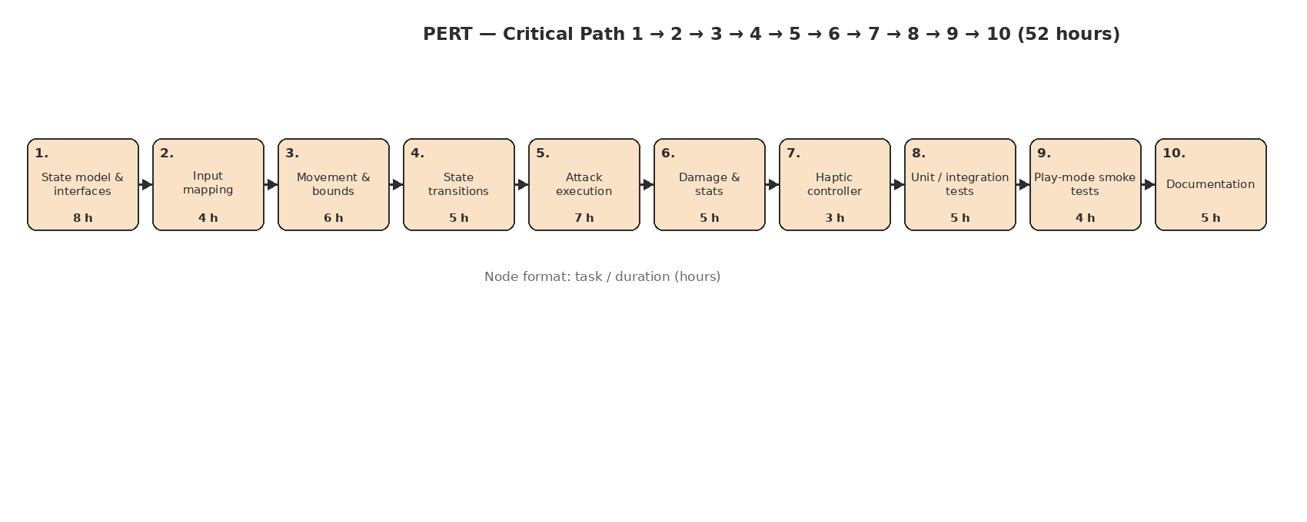
The dependency network gives a critical path of tasks 1 → 3 → 4 → 5 → 6 → 8 → 10, totaling 41 hours. Non-critical work has schedule slack relative to that path; the critical-path figure is the tracking baseline, while the 52-hour figure is total labor across all tasks.

5. Timeline (continued)

Gantt timeline
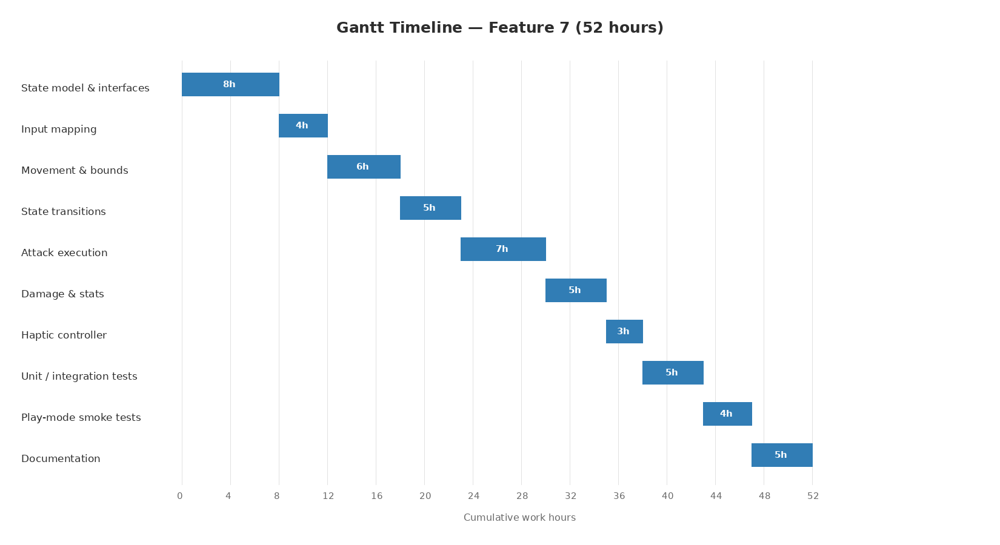

Timeline tracking notes
TL4 tracking baseline: compare actual hours spent on each work item against the estimates above rather than silently moving work between categories. A task is considered on estimate when actual time is within ±1 hour of its planned duration; deviations larger than 1 hour should be recorded with the cause (for example, integration defect, controller-specific haptic issue, or rework in the state machine).
Completion gate: all required movement, attack, dash, damage, transition, and haptic acceptance tests pass; the four player states are reachable and update through the virtual PlayerState.Update contract; Feature 2 bounds are respected; and Feature 3/Feature 6 receive the typed damage output.

AI Question Log — Summary
I drafted the document during class as we were instructed and later made adjustments to it. The only fixes that were needed were for the use case diagrams and for the specific feature diagram. The use case fixes only took a single re-prompt of sending the proper format of using dotted lines and arrows, whereas the specific feature diagram took way more prompts. I kept getting diagrams that either did not follow the format, or had too many overlapping structures inside the diagram. Other than that, I did not need to edit any other section of the document.

