Class Diagram — Feature 1
HUD, UI & Game State Manager (TL1)

1. CLASS LIST
Bracketed attributes are assumptions because the specification does not define stored fields explicitly.
Class | Responsibility | Key public operations | Role / markings
GameStateManager | Registers HUD elements, accepts GameState, broadcasts state changes, and manages run start/game-over/reset flow. | void RegisterElement(HUDElement element)  void SetGameState(GameState state) | «MonoBehaviour»; Observer publisher / subject
HUDElement | Abstract non-MonoBehaviour base for HUD elements; defines Refresh for rendering a portion of GameState. | virtual void Refresh(GameState state) | Required hierarchy base; dynamic-binding declaration; Observer participant
HealthBarElement | Renders the health portion of GameState. | override void Refresh(GameState state) | Derived hierarchy class; «override» dynamic-binding point; Observer participant
PointsCounterElement | Renders the points portion of GameState. | override void Refresh(GameState state) | Derived hierarchy class; «override»; Observer participant
MinimapElement | Renders the minimap portion of GameState. | override void Refresh(GameState state) | Derived hierarchy class; «override»; Observer participant
RunTimerElement | Renders the run-timer portion of GameState. | override void Refresh(GameState state) | Derived hierarchy class; «override»; Observer participant
Required hierarchy: HUDElement → HealthBarElement, PointsCounterElement, MinimapElement, RunTimerElement. All are non-MonoBehaviour because the base is specified as non-MonoBehaviour and the concrete classes derive from it.
Dynamic-binding pair: HUDElement declares virtual void Refresh(GameState state); each concrete HUD element overrides that method.
GOF pattern: Observer — GameStateManager publishes OnStateChanged, and the HUD elements are the reacting participants.

2. RELATIONSHIP LIST
Only relationships among the six feature classes are shown. External types such as GameState, HUDElement collections, and Action<GameState> are represented as types in signatures rather than added as extra classes.
- GameStateManager --navigable association--> HUDElement [registered elements; 1 to 0..*]
- HealthBarElement --generalization (inherits from)--> HUDElement
- PointsCounterElement --generalization (inherits from)--> HUDElement
- MinimapElement --generalization (inherits from)--> HUDElement
- RunTimerElement --generalization (inherits from)--> HUDElement
Notation used in the diagram: association = solid line with open arrowhead for navigability; generalization = solid line with hollow triangle pointing to the parent. No include/extend relationships are used.

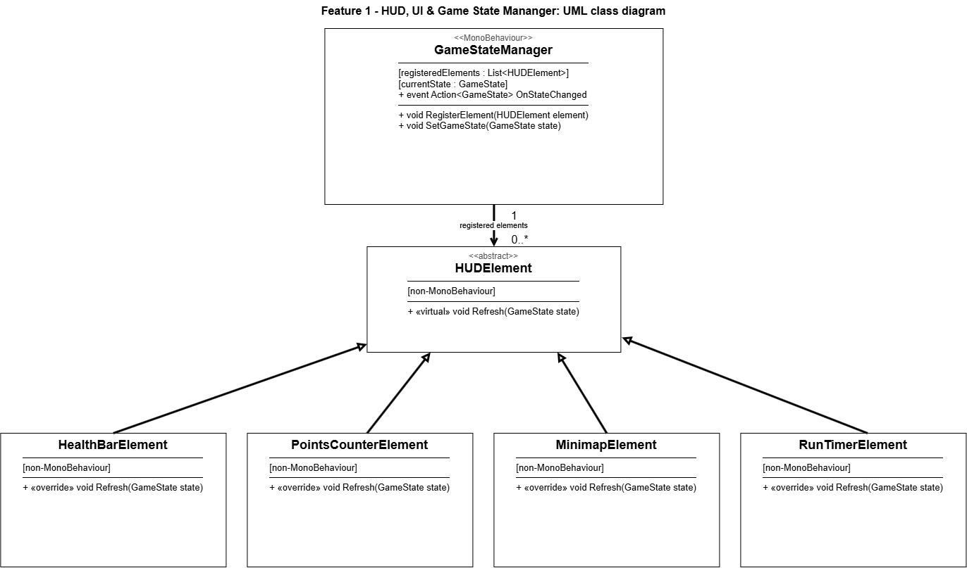
3. CLASS DIAGRAM (draw.io master)

Figure 1. Feature 1 UML class diagram.

4. REQUIREMENTS MAP
Oral-exam requirement | How the diagram satisfies it
Non-MonoBehaviour inheritance-and-polymorphism hierarchy | HUDElement is the abstract non-MonoBehaviour base; HealthBarElement, PointsCounterElement, MinimapElement, and RunTimerElement generalize from it and therefore supply the concrete polymorphic behavior.
Dynamic-binding virtual/override pair | HUDElement::Refresh(GameState state) is marked «virtual»; each derived HUD element marks Refresh(GameState state) as «override». Removing virtual would leave derived HUD elements at their default/placeholder rendering instead of updating when health, points, or time change.
One large GOF pattern | Observer — GameStateManager is the publisher/subject through OnStateChanged, while HealthBarElement, PointsCounterElement, MinimapElement, RunTimerElement, and the HUDElement abstraction are the HUD-side participants that react to state changes.
Bracketed items to confirm: [registeredElements : List<HUDElement>] and [currentState : GameState] are reasonable inferred fields needed to represent registration and stored current state, but those fields are not explicitly declared in the supplied specification.

