**The University of Newcastle**

**School of Electrical Engineering and Computing**

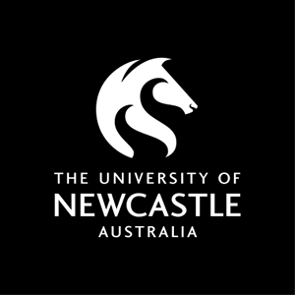

**Work Integrated Learning**

**COMP3850 / COMP3851A – Semester 1, 2020**

**Team 12 Project Plan:**

**UONOW(University Of Newcastle Orientation Web)**

***Authors:***

Jared Okeno

Yunting Chen

Weijie Lee

Haotian Sun

(September 6th, 2020)

1. **Title**

**UONOW(University Of Newcastle Orientation Web)**

The purpose of this project is to develop an orientation website for first-year students.

**2. Background**

For most first-year students, in addition to excitement and curiosity, they are more anxious and confused. AIS (2019) suggests anxiety and depression are the two most common reasons that students seek mental health services, according to the Centre for Collegiate Mental Health 2017 Annual Report from Penn State University. Many freshmen have symptoms of anxiety or depression when they first enter college. They will feel confused and do not understand the various basic services and curriculum evaluation rules of the university. It is often the sixth week when they understand these. Although UON has provided a lot of information on the official website to help first-year students, the information is very diverse and complicated. Students often feel more anxious when faced with complex information, which is also one of the reasons that affect their performance and mental health.

The goal of our team is to develop an orientation website for 1st year students that is easy to use, has good interactivity, and guides. Because the information on the university’s official website is not targeted and is too dazzling, this website is only for first-year students. It will introduce the university to the target students in detail through text and multimedia content, so that they can spend the first year of university smoothly and solve their anxiety and confusion. We believe that our team can successfully complete this project and deliver the results within the specified time. We will use the traditional waterfall model development method, namely requirements analysis, design, coding, testing, delivery, and regular meetings. Our team members have multiple professional backgrounds such as computer science, system development, and interactive media, which greatly enhances our self-confidence and motivation.