Deep Learning‐Based Approach for Automated Biometric Identification of Mugger Crocodiles

RCNN - Daksh Shah, Shalvi Modi, Sloka Thakkar

***Abstract-* Biometric identification of Mugger crocodiles (*Crocodylus palustris*) is essential for conservation and ecological research. Traditional identification methods are time-consuming and error-prone, necessitating an automated, deep learning-based approach. This study presents a two-stage framework leveraging YOLOv11 for object detection and ResNet18 for feature extraction. YOLOv11 first generates bounding boxes around crocodile faces, which are then processed by ResNet18 to extract 512-dimensional feature vectors. These features are classified using a FeatureNet module to identify individual crocodiles. The model is trained and evaluated on a dataset collected across different seasons to analyze the impact of environmental variations on performance. Metrics such as accuracy, True Positive Rate (TPR), and True Negative Rate (TNR) are computed to assess effectiveness. Preliminary results demonstrate high identification accuracy, showcasing the robustness of deep learning for wildlife monitoring. This approach enhances automated species identification, improving efficiency in conservation efforts.**

***Key Words—Biometric Identification, Mugger Crocodiles, Deep Learning, UAV Imagery, Feature Extraction.***

# Introduction

Biometric identification plays a vital role in wildlife monitoring and conservation. Traditional methods such as tagging can be invasive and stressful for animals. With the advent of UAV technology and advanced machine learning techniques, non-invasive biometric identification has become increasingly feasible. This work addresses the challenge of identifying individual mugger crocodiles in free-ranging environments using a classical machine learning approach. The motivation is to reduce human intervention and improve monitoring accuracy without the high computational costs often associated with deep learning models.

# Literature review

Recent studies have demonstrated the benefits of combining deep learning and machine learning for biometric applications. For instance, Kokal et al. [1] reviewed integrated deep learning frameworks for biometric mobile authentication, while Khan and Bhatt [2] explored hybrid recognition systems using stacked autoencoders and Random Forest classifiers. More specifically, Ghosal et al. [3] applied a UAV-based CNN model (YOLO-v5l) to identify mugger crocodiles with an accuracy of 89.2%. Additional work [4]–[6] has extended these methodologies to other wildlife species, highlighting the potential of aerial imagery in automated species recognition. However, there remains a gap in exploring classical feature extraction and machine learning methods for such applications.

# Dataset description

The dataset consists of 88,000 UAV-captured frames obtained using a DJI Mavic 2 Zoom drone. The captured dataset includes 143 free-ranging mugger crocodiles (approx. 1.5 m in length). It is collected from across 19 distinct sites in Gujarat, India.

Imaging Specifications:

* Frame resolution: 3840 × 2160 pixels at 96 DPI
* Optical zoom: 24–48 mm
* Flight height: 8–10 meters
* Recording duration: 30 seconds to 1 minute per session

Capture Protocol: When a crocodile was spotted ,the UAV was moved closer in order to obtain high-resolution images of the dorsal scute patterns. The OpenCV-Python package was used to process the captured video footage and extract individual frames for analysis.

# Methodology

##### 

##### Fig 2. Model Merging Approach

In this work, we present a deep learning-based, robust pipeline for the detection and categorization of mugger crocodiles in drone-captured photos. Figure [X] shows the several sequential stages that make up the approach. The following is a description of our approach's main steps:

* YOLO-Based Object Detection: A pre-trained YOLO model is used to process an image that was taken by a drone at the start of the pipeline. This model creates bounding boxes around items it detects in order to locate and identify possible crocodile instances. Only the pertinent region of interest (ROI) is extracted for additional processing thanks to the bounding box generating stage.
* ResNet18 Feature Extraction: A pretrained ResNet18 model is then used to extract features from the extracted ROIs. In particular, we make use of the last convolutional layer's output, which records high-level feature representations of the crocodiles that were found. Robust classification requires the acquisition of discriminative characteristics, which this step guarantees.
* FeatureNet for refinement:After the features have been retrieved, they are passed into the FeatureNet module, which processes and refines the feature representations to increase classification accuracy. FeatureNet analyzes the retrieved feature vectors and produces classification results by utilizing a trained deep learning model.
* Test Image Evaluation: The same object detection and feature extraction pipeline is used to input images during the testing phase. The trained FeatureNet model receives the extracted features and uses them to predict the detected object's class.
* Final Classification: The test image is finally classified using the FeatureNet output. The observed crocodile is reliably predicted by the trained model, which assigns the most likely class label.

This methodology ensures an efficient and accurate pipeline for detecting and classifying mugger crocodiles from drone imagery. By integrating object detection, deep feature extraction, and classification into a unified framework, the proposed system aims to enhance automated wildlife monitoring and conservation efforts.

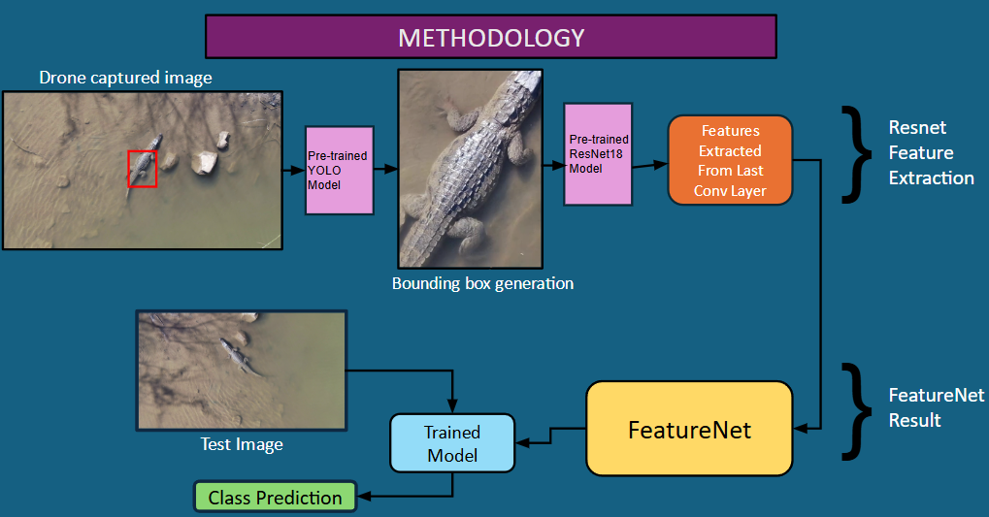

Fig 1. Flowchart of Approach

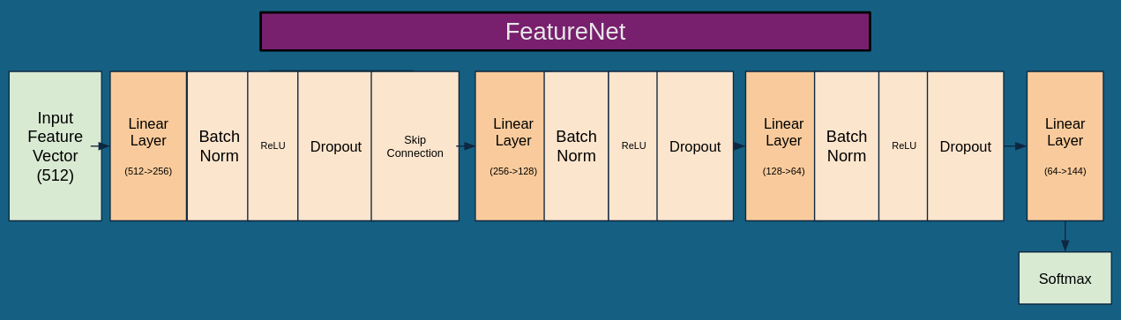

Fig 2. Steps of FeatureNet

We tested the classification with two different FeatureNet architectures. The first approach has fully connected (FC) layers in the following order: 512 -> 256 -> 128 -> 64-> 144. To improve generalization, Batch Normalization, ReLU activation, and Dropout come after each intermediate FC layer. In order to maintain high-level features and enhance gradient flow, a skip connection was added after the initial FC layer.

In the second, more straightforward method, we connected the output layer (128→144) and the 128-dimensional representation directly by removing the last FC block (128→64). This change decreased the model's depth, which could increase training effectiveness and aid in evaluating the trade-off between classification accuracy and model complexity.

Inference Time

Inference time is the time a model takes to make a prediction on a single input. It is crucial for evaluating real-time performance. In our case, FeatureNet (64 → 144) had an average inference time of 0.003944 s, while FeatureNet (128 → 144) took 0.004143 s per image.

# Experimental Results

#### Preliminary evaluations indicate that integrating ResNet-18 with FeatureNet effectively predicts data for a single season. Initial testing on new-season data will determine the model’s generalization ability. While detailed quantitative metrics are still being refined, early observations suggest that if the model struggles with new-season data, a model merging approach—combining YOLO, ResNet, and FeatureNet into a unified framework—may enhance performance across varying environmental conditions.

*Comparing performances of two architecture of FeatureNet:*

The first approach utilizes the full architecture of FeatureNet, progressing through successive linear layers from 512 to 256, 128, 64, and finally to 144 dimensions. Each block is followed by batch normalization, ReLU activation, and dropout to ensure regularization and stability during training. This deep configuration allows the network to capture intricate patterns in the dorsal scute features. The model achieved a Cumulative TPR of 0.9799 and a TNR of 0.9998, reflecting high accuracy in both positive and negative classifications. The prediction samples consistently show high confidence scores (around 0.97 to 1.00) and accurate label identification, demonstrating the network's robustness. Moreover, the average inference time was relatively low at 0.003944 seconds, making it efficient in real-time scenarios.

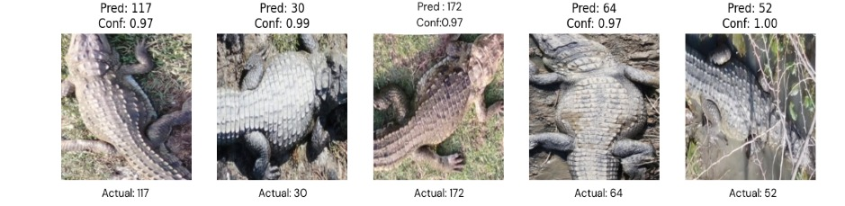

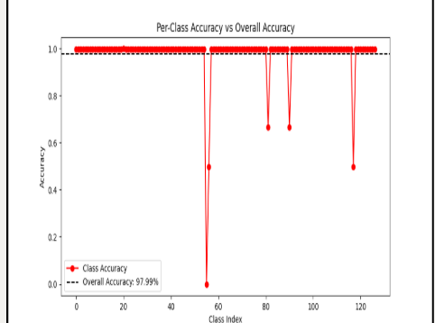

Fig 1. Results of FeatureNet - Method 1

*Comparing performances of two architecture of FeatureNet:*

In the second approach, the architecture was made more compact by removing the final intermediate block, effectively skipping the 64-dimensional layer and directly projecting from 128 to 144. This simplification reduces model complexity and parameter count, which could be beneficial for deployment on resource-constrained systems. Surprisingly, this lighter variant maintained the same TPR (0.9799) and TNR (0.9998) as the deeper model, indicating that it still retained enough representational capacity to correctly distinguish individual crocodiles. However, a slight dip in prediction confidence was observed in a few cases (e.g., confidence of 0.69), suggesting reduced certainty in edge-case classifications. The inference time was marginally higher at 0.004143 seconds, possibly due to execution variations despite the simpler architecture.

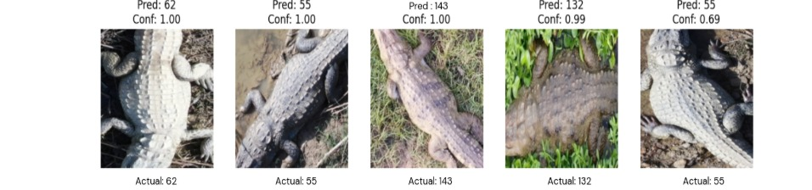

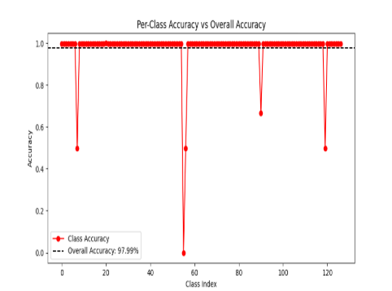

Fig 2. Results of FeatureNet - Method 2

Both architectural variations of FeatureNet demonstrated equivalent classification performance, achieving identical TPR and TNR scores. However, the full model (64 → 144) showed more consistent confidence in its predictions, with fewer low-confidence outputs. Additionally, it performed slightly faster during inference, despite being deeper—an indication that its architecture may be more optimized for forward-pass execution. On the other hand, the reduced model (128 → 144) offers the advantage of simplified structure and fewer parameters, making it attractive for scenarios where model size is a constraint. Overall, the full FeatureNet is preferable when prediction stability and speed are priorities, while the reduced version remains a strong contender for lighter applications.

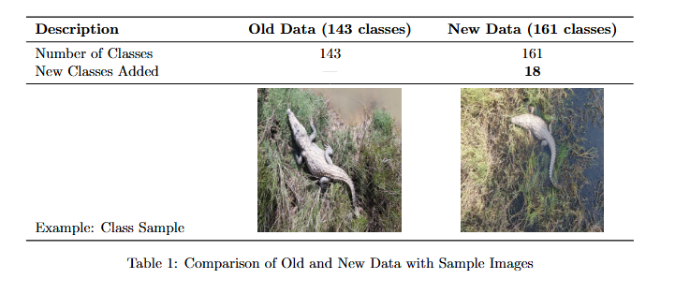

The model was trained on old data consisting of 143 crocodile classes from a specific season. When tested on new season data with 18 additional classes (total 161), visual and environmental differences led to new challenges. This shift highlights the need for continual model updates to maintain accuracy across changing conditions.

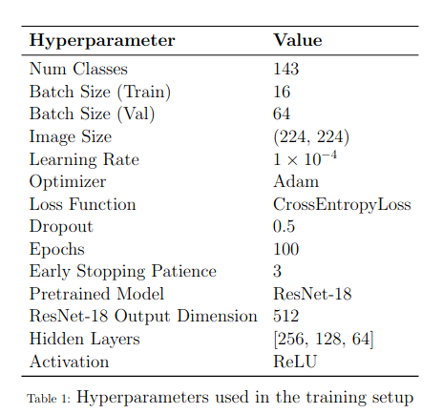

# Results

Train Confusion Matrix

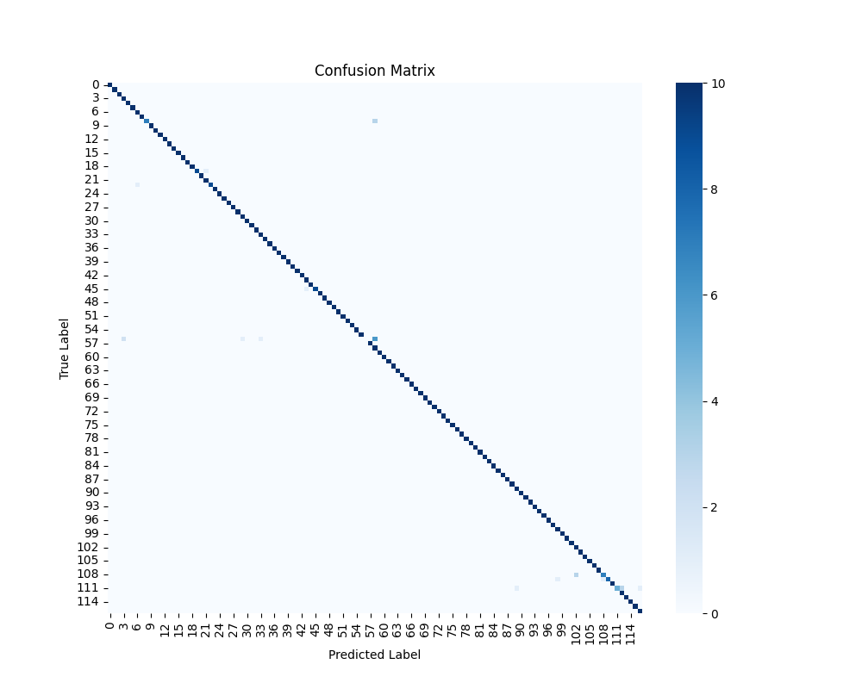

Fig. 3 Train confusion matrix

Figure 3 shows a strong diagonal pattern in the training confusion matrix, which indicates high classification accuracy for all labels. The majority of the projected labels match the actual labels, with very little misclassification. as the values in diagonal approaches to 10, it shows the highest frequency of accurate predictions across diagonals. Although they indicate rare misclassifications, sparse off-diagonal values have minimal impact. This suggests that the model has successfully picked up on the characteristics and trends found in the training set.

Test Confusion Matrix

The test confusion matrix (in Figure 4) maintains a similar diagonal dominance, confirming strong generalization performance. The highest frequency of correct classifications in the test dataset is lower (maximum of 4) compared to the training dataset. However, the minimal presence of off-diagonal elements indicates there are hardly any misclassifications.

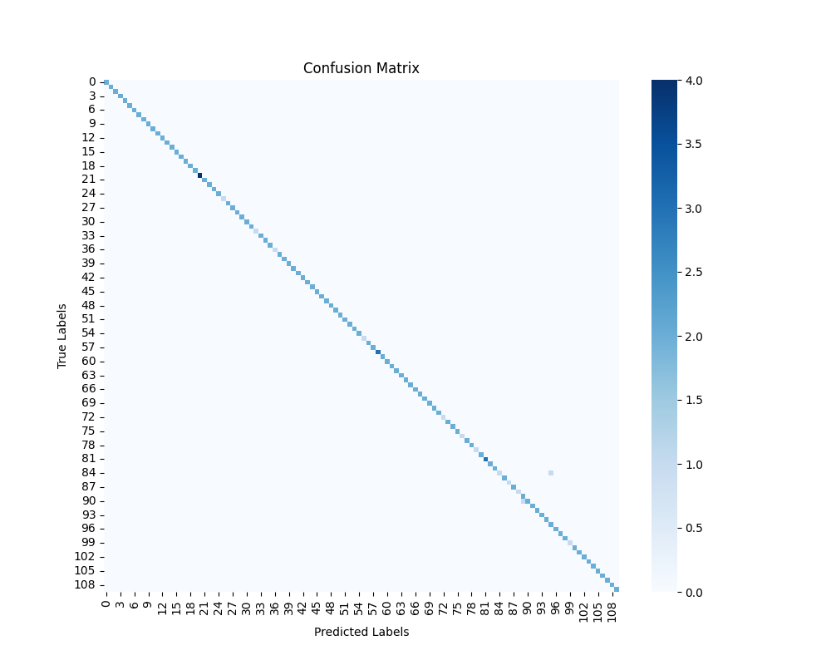

Fig 4. Test confusion matrix

##### Discussion

* Prediction confidence is higher in the training confusion matrix, as would be predicted given exposure to the training set.
* The model's capacity for generalization is demonstrated by the test confusion matrix, which shows somewhat lower confidence yet continuing to show a similar trend.
* Both matrices' sparse misclassifications imply that the model successfully separates labels in some classes with just slight confusion.

The model's strong classification accuracy and encouraging generalization to test data that hasn't been seen yet are confirmed by the confusion matrices overall. The remaining categorization mistakes can be reduced with more fine-tuning.

##### Conclusion

The confusion matrix analysis confirms that our model demonstrates strong classification performance with minimal misclassifications. The training results indicate a high level of learning, while the test results validate its generalization capability. Moving forward, we plan to implement a deep learning approach for further optimization. Our project will focus on two key aspects: (1) benchmarking results on the old single-season dataset and (2) improving the True Positive Rate (TPR) by incorporating multi-season data to enhance identification performance across various environmental conditions. Additionally, we will explore a model merging approach for future predictions to further refine classification accuracy.

##### References

[1] S. Kokal, M. Vanamala, and R. Dave, “Deep Learning and Machine Learning, Better Together Than Apart: A Review on Biometrics Mobile Authentication,” Journal of Cybersecurity and Privacy, vol. 3, no. 2, pp. 227–258, 2023, doi: 10.3390/jcp3020013.

[2] A. Khan and A. Bhatt, “Hybrid Biometric Recognition using Stacked Auto Encoder with Random Forest Classifier,” aging, vol. 4, p. 5.

[3] R. Ghosal, S. Shah, A. Patel, V. Patel, M. Raval, and B. Desai, “Identification of free-ranging mugger crocodiles by applying deep learning methods on UAV imagery,” Dryad, 2022, doi: 10.5061/dryad.s4mw6m98n.

[4] A. Delplanque, S. Foucher, J. Théau, E. Bussière, C. Vermeulen, and P. Lejeune, “From crowd to herd counting: How to precisely detect and count African mammals using aerial imagery and deep learning?,” ISPRS Journal of Photogrammetry and Remote Sensing.

[5] M. Moreni, J. Theau, and S. Foucher, “Do you get what you see? Insights of using mAP to select architectures of pretrained neural networks for automated aerial animal detection,” PLOS ONE, doi: 10.1371/journal.pone.0284449.

[6] A. Delplanque, “Multispecies detection and identification of African mammals in aerial imagery using convolutional neural networks,” Remote Sensing in Ecology and Conservation, Wiley Online Library, 2022, doi: 10.1002/rse2.234.