HomeGroup Windows

Student Name: David Saldaña Castaño

# Date of delivery: 15/11/2017

521-David-PARP302-HomeGroupWIN.docx

# Objetives

In this exercise, We are going to learn how to create a HomeGroup.

How to do basic network configurations.

How to add a system into the HomeGroup.

# Loot and material needed

VMWare Workstation or another virtualization tools, in my case: VMWare.

Cutting tool.

Microsoft Word.

ISOS of Windows 7 and Windows 10.

PDF sent by the teacher as guide.

# SETUP

These are the hardware configurations of both systems.

## W7

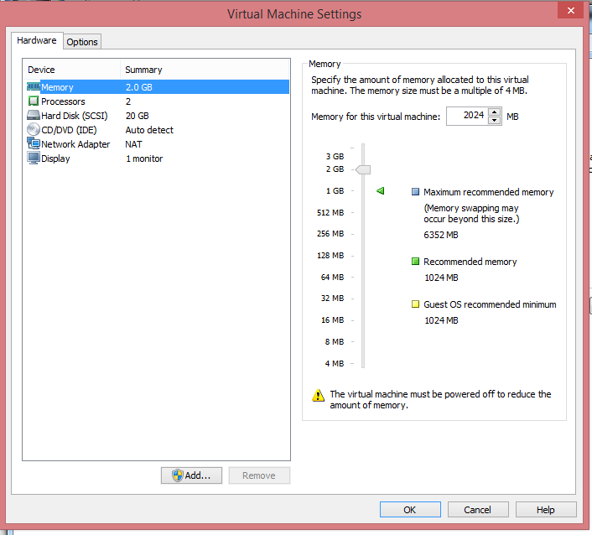

## W10

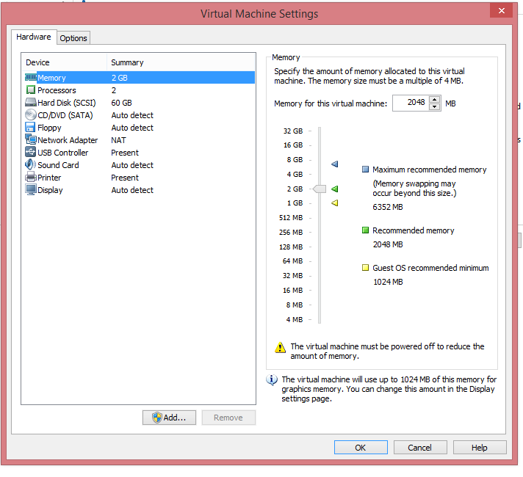

# NETWORK ADAPTER

In this practice we need to connect both systems, so we need to put the **network adapter in NAT mode**.

## W10

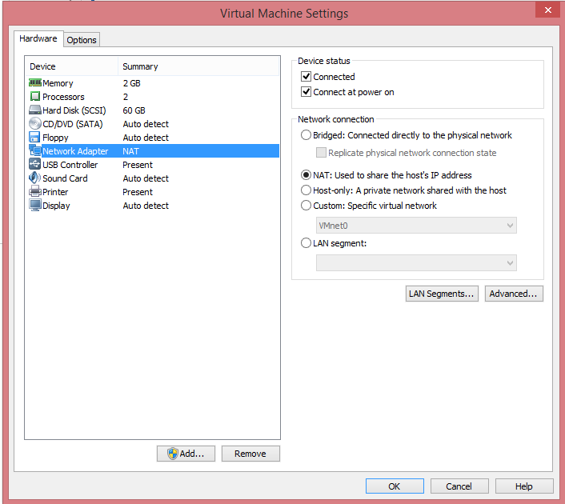

## W7

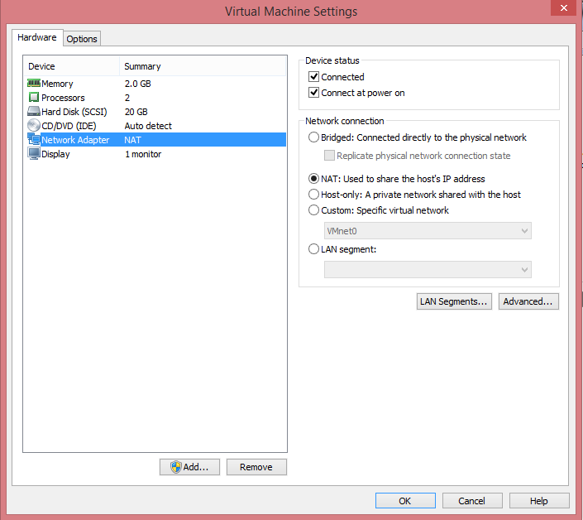

# NETWORK TEST

To check if both systems are connected, we need to see the IP address and then, with the command **Ping**, test if they the systems are seen between them.

## W7 IP ADDRESS

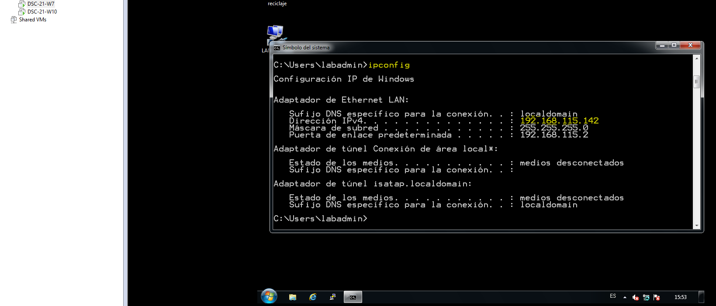

## W10 IP ADDRESS

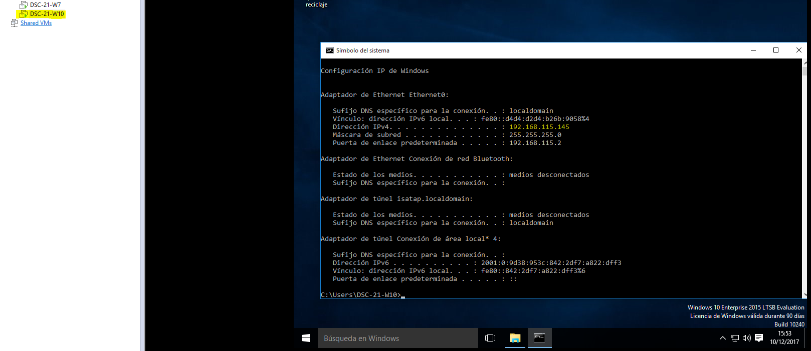

# CONNECTION TEST

## Connection test from W7 to W10.

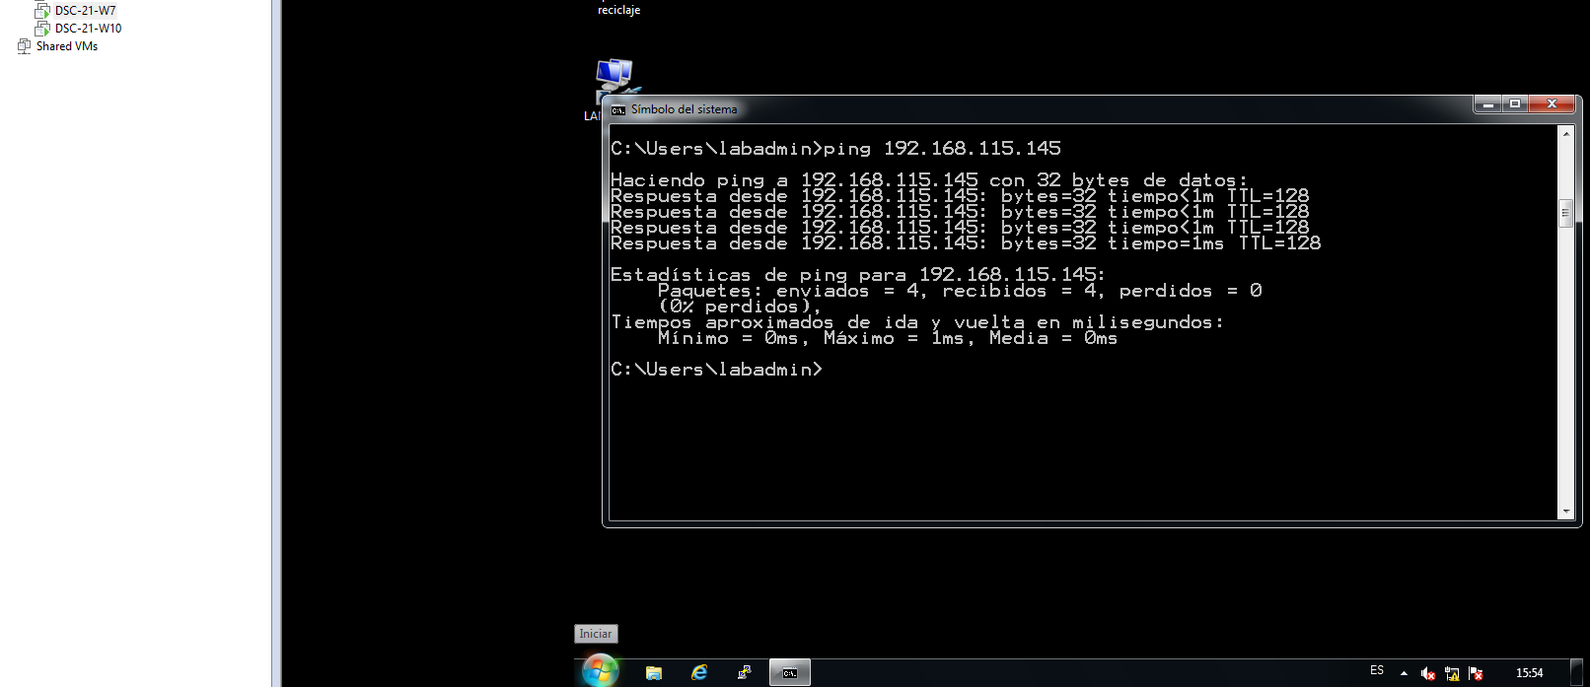

## Connection test from W10 to W7.

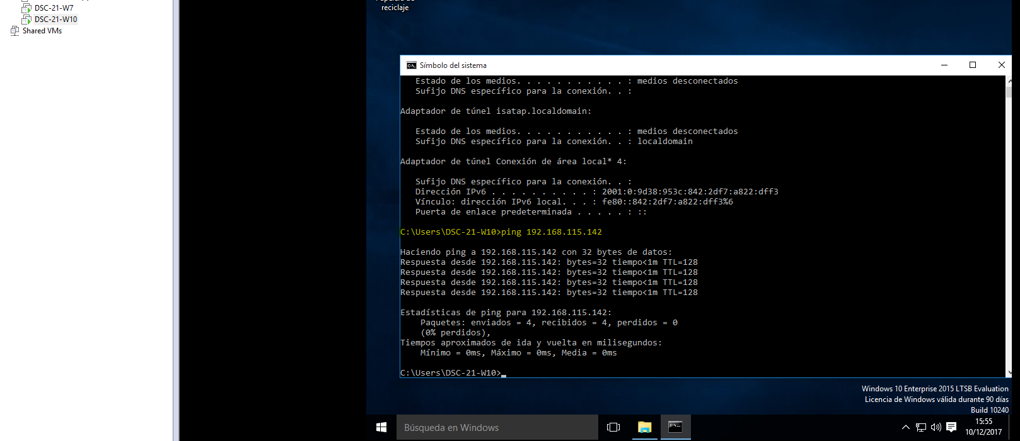

# HOMEGROUP CREATION

The path to Access to the Homegroup is: Control Panel - Networks – Homegroup.

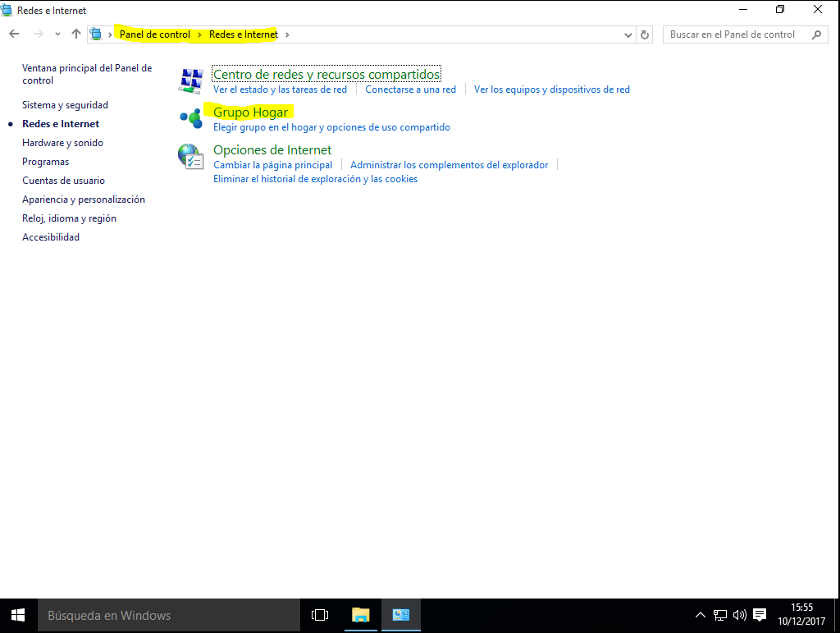

We select the option to create a homegroup and start the assistant.

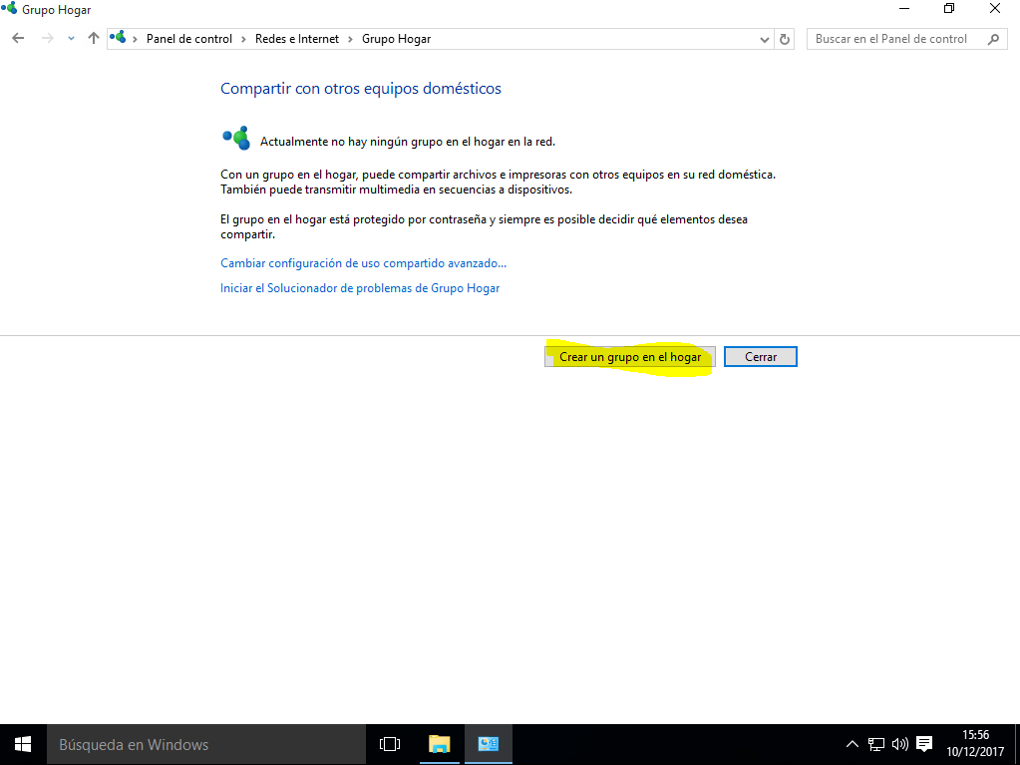

In this step, we can **select the folders that are going to share** with the W7 system.

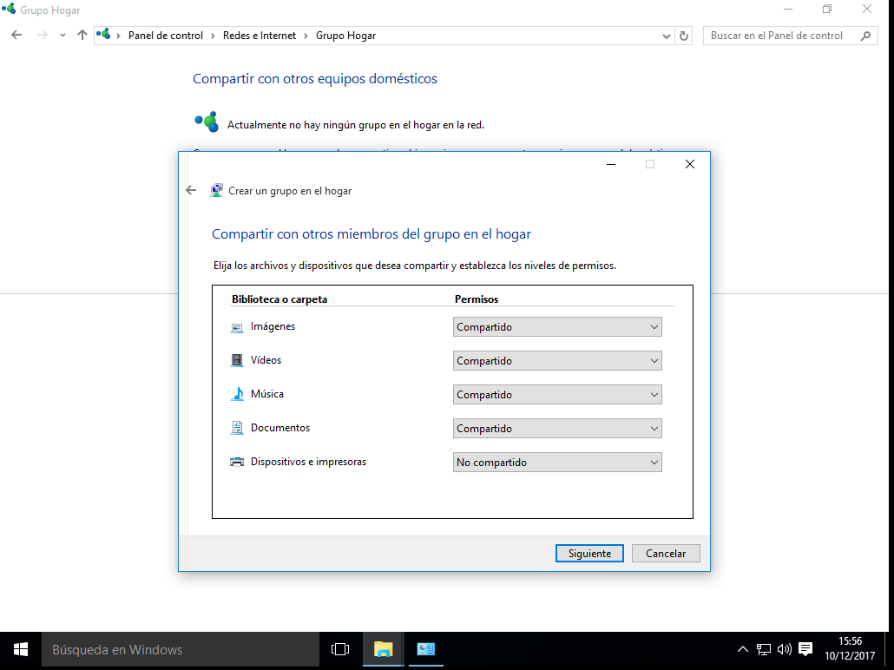

As a security method, we need to **copy this password** and then paste it into the w7 system.

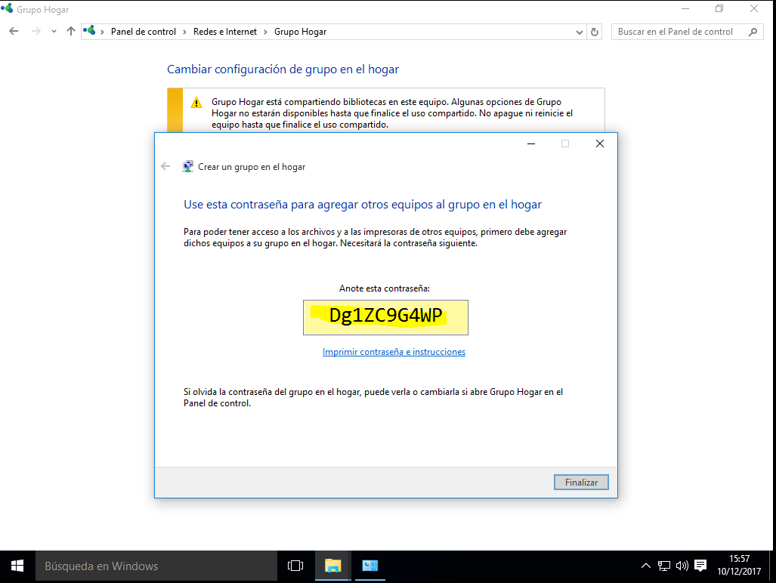

# JOINNING W7 INTO THE HOMEGROUP

**The path to Access to the homegroup in W7 is: Control panel – Networks – Homegroup.**

Now we select: Join now.

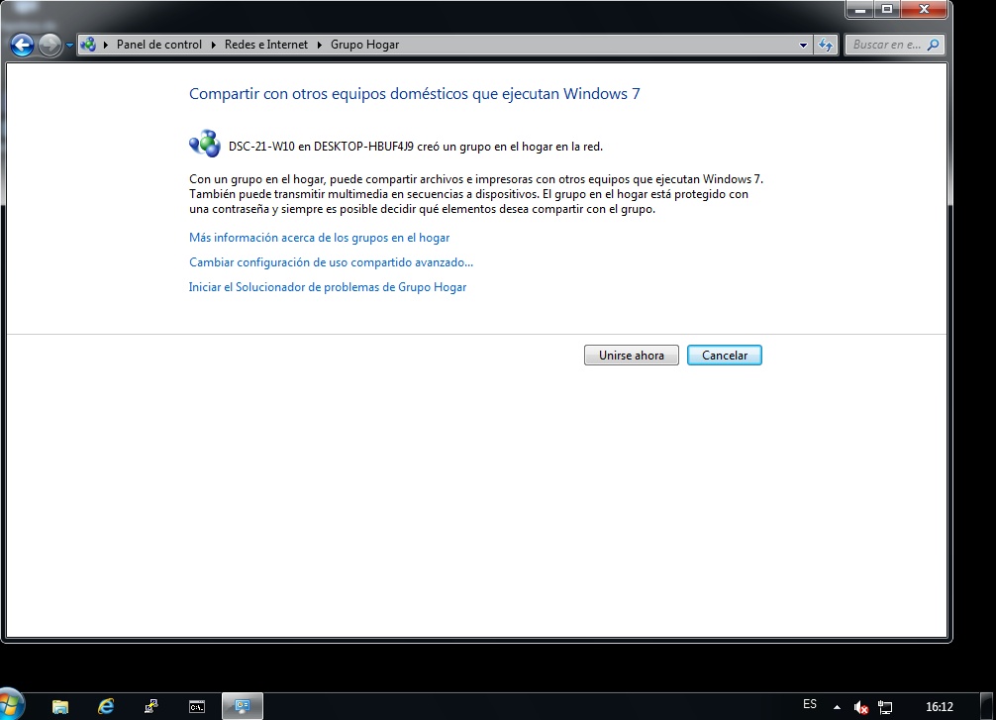

These are the folders that we can share with Windows 10 in the Homegroup.

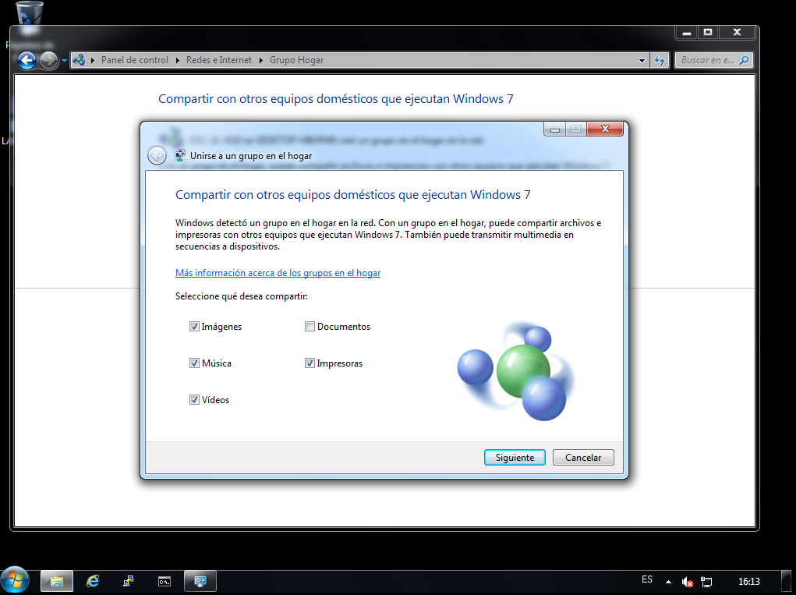

And now, To Access to the Homegroup, we should **paste the password** that we have copied in the Windows 10 system.

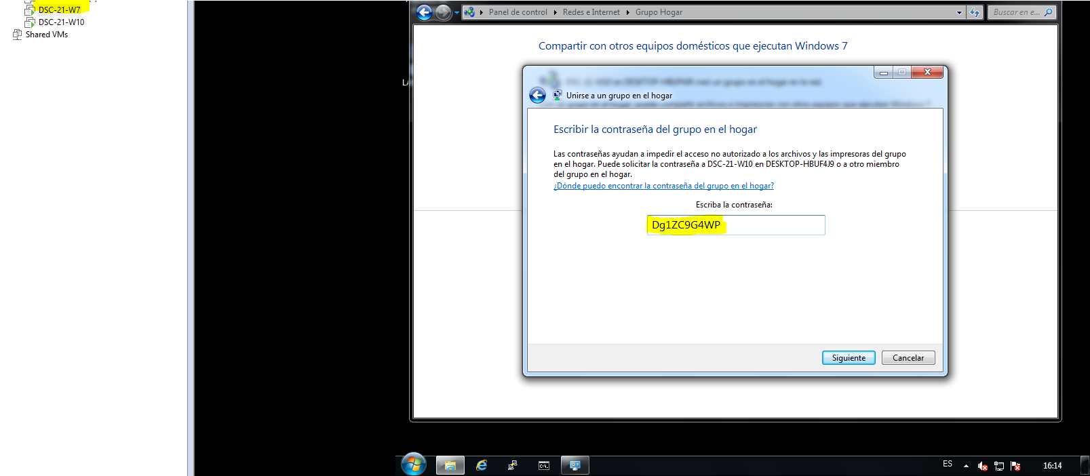

**I had a problem trying to join the w7** due to I had disabled the IPv6 protocol, so we have to enable it in the network adapter configuration.

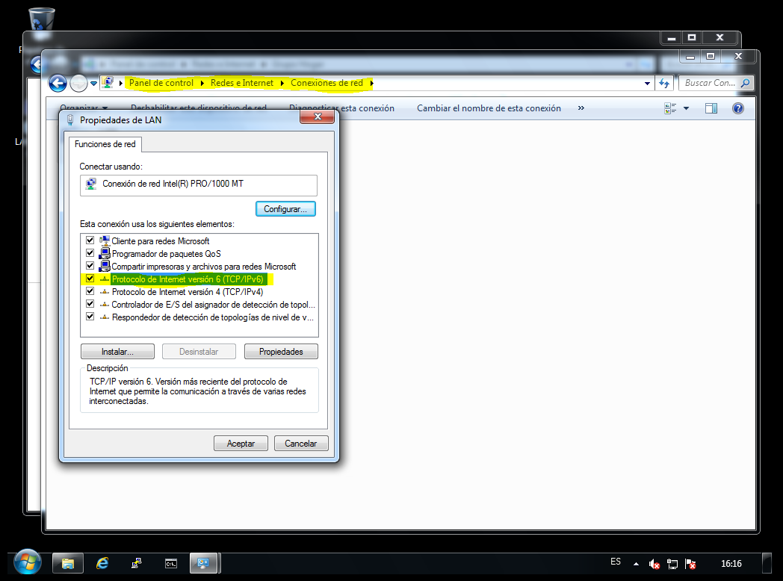

Finally, we have joined the w7 system into the HomeGroup.

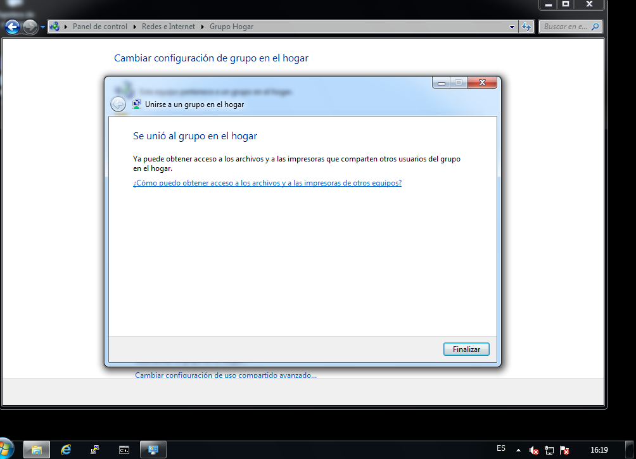

# HOMEGROUP TEST

To check if we can share the folders, I have created a txt file in the Pictures folder in the Windows 10 system, and now we are going to see if the w7 system can see the file throught the Homegroup.

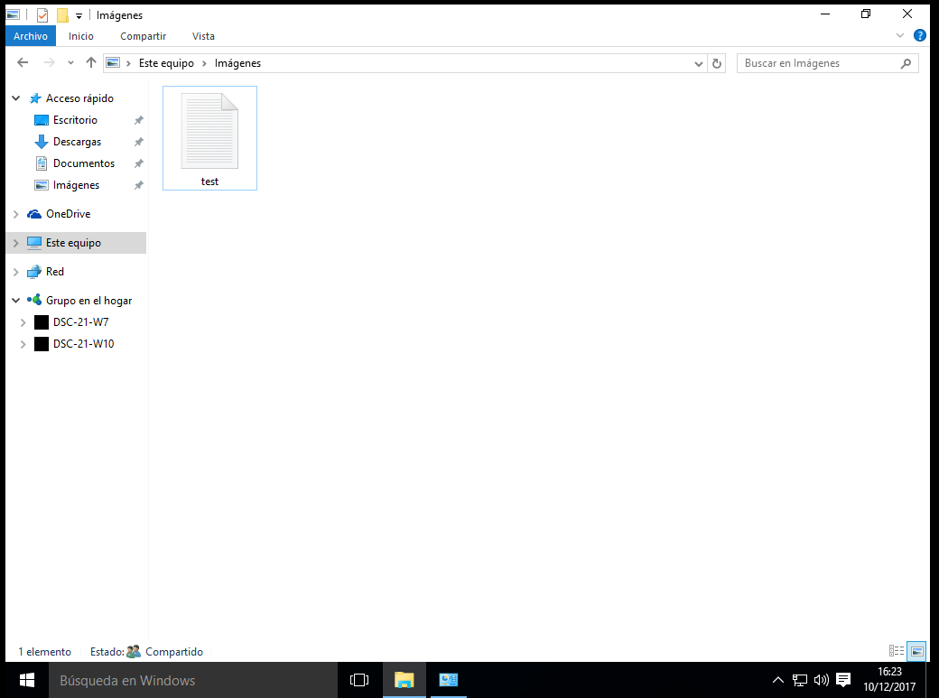

As we can see, the file has been shared successfully.

