ReactOS Proyect

Student Name: David Saldaña Castaño

# Date of delivery: 04/01/2018

521-David-ISOP211-CambiarIdiomaWIN.docx

# Objetives

In this exercise, we are going to learn how to install reactOS

# Loot and material needed

VMWare Workstation or another virtualization tools, in my case: VMWare.

Cutting tool.

Microsoft Word.

ISO of Windows 10.

PDF sent by the teacher as guide.

Content

Date of delivery: 22/12/2017 1

Objetives 1

Loot and material needed 1

Execution, researching and development. 3

SETUP 3

Final considerations and metacognition 8

# Execution, researching and development.

# SETUP

# 

# 

# 

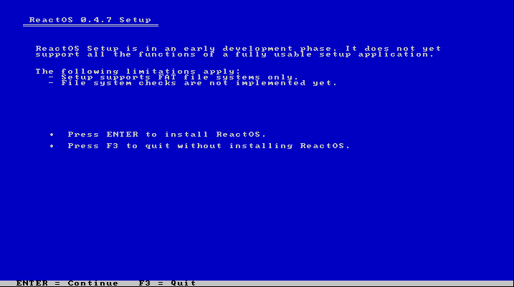

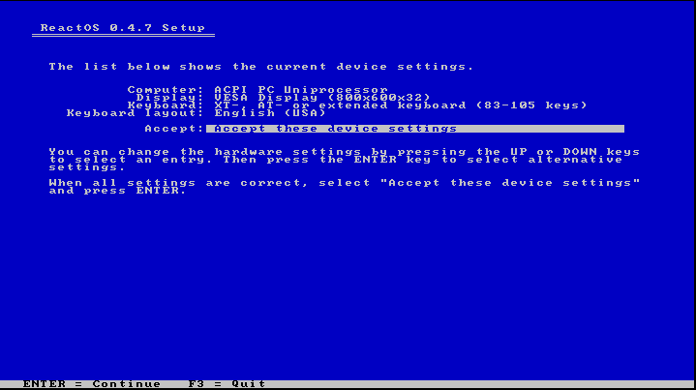

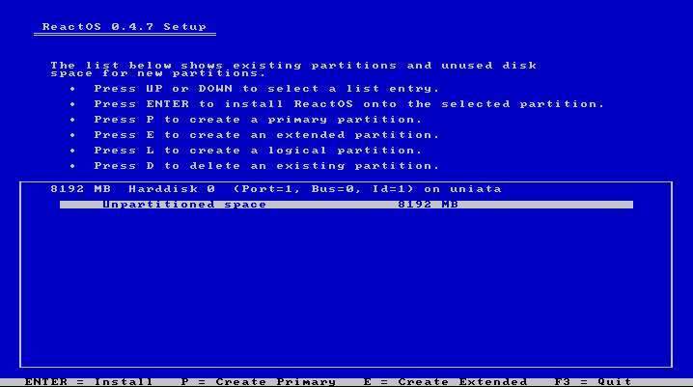

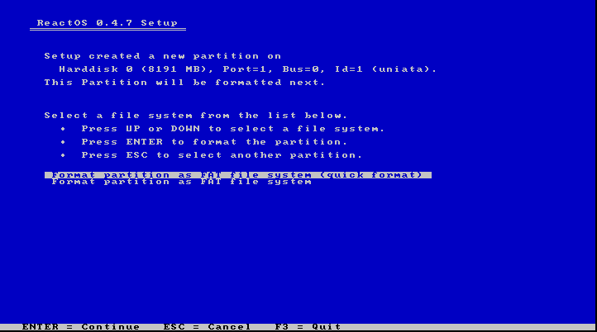

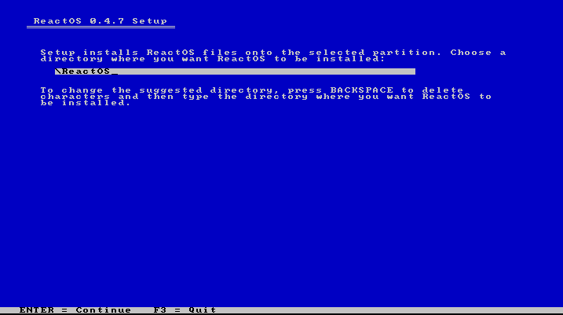

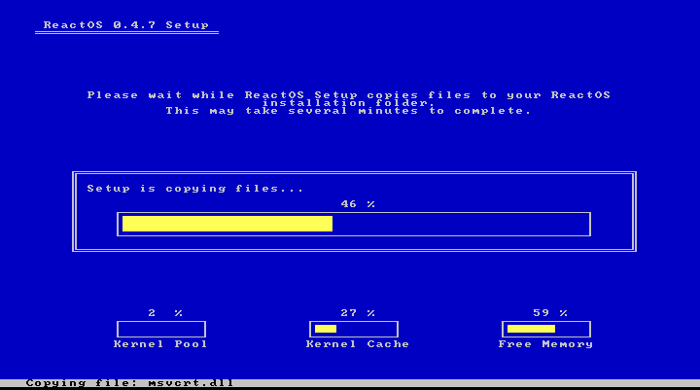

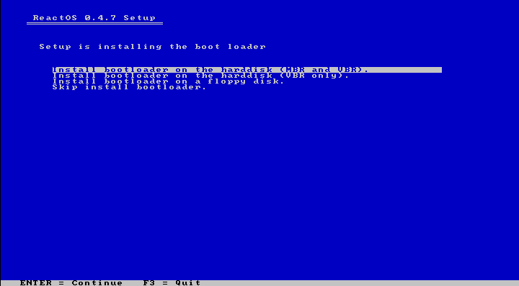

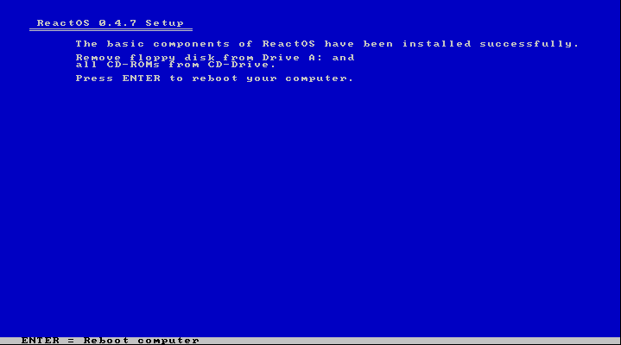

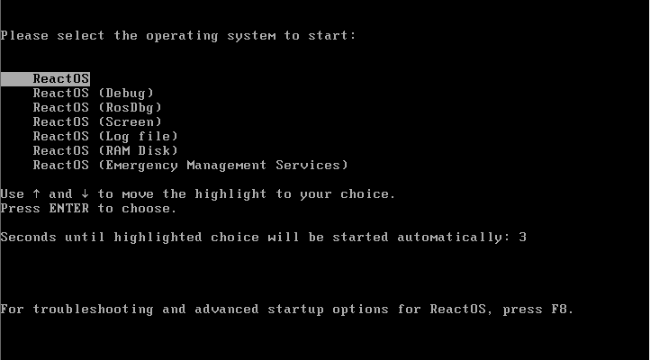

# 

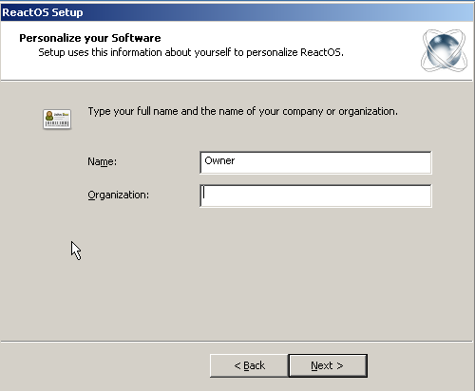

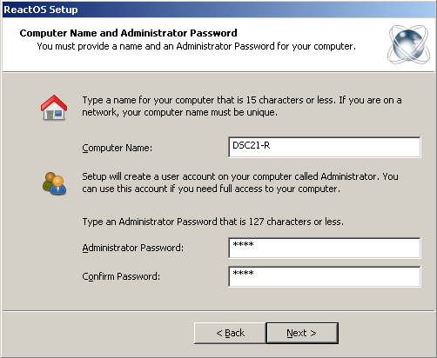

# 

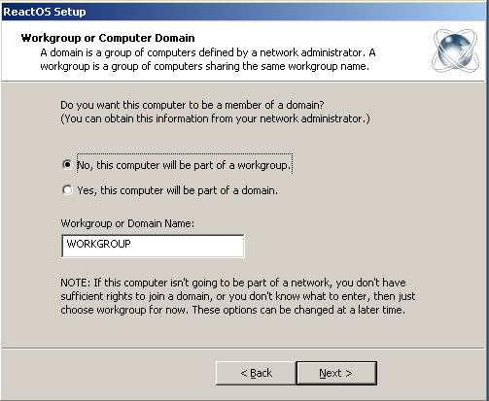

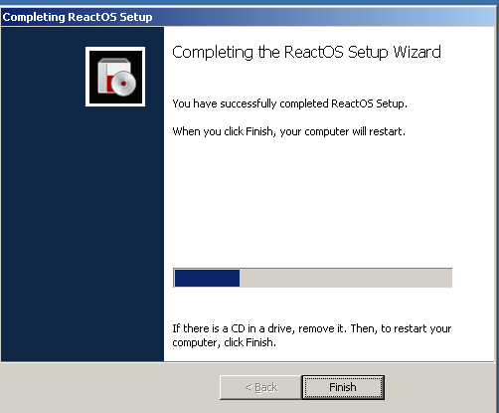

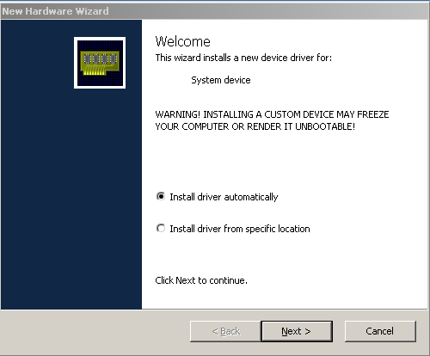

# Final considerations and metacognition

On the one hand, this practice has been very interesting for me because I have learnt how to change the idiom, just in case I need to change it.

On the other hand, I didnt find any issue during the installation so, the practice has been very easy for me.

I am looking forward to do the next one.