MEDIA CENTER

Student Name: David Saldaña Castaño

# Date of delivery: 22/12/2017

521-David-ISOP212-MediaCenterWIN.docx

# Objetives

In this exercise, we are going to learn how to install a Media center in Windows 10, even thinking that in Windows 10 version, Microsoft stop installing Media Center.

# Loot and material needed

VMWare Workstation or another virtualization tools, in my case: VMWare.

Cutting tool.

Microsoft Word.

ISO of Windows 10.

WMC

PDF sent by the teacher as guide.

Content

Date of delivery: 22/12/2017 1

Objetives 1

Loot and material needed 1

Execution, researching and development. 3

SETUP 3

Final considerations and metacognition 8

# Execution, researching and development.

# SETUP

We need a simple w10 with 64 bits.

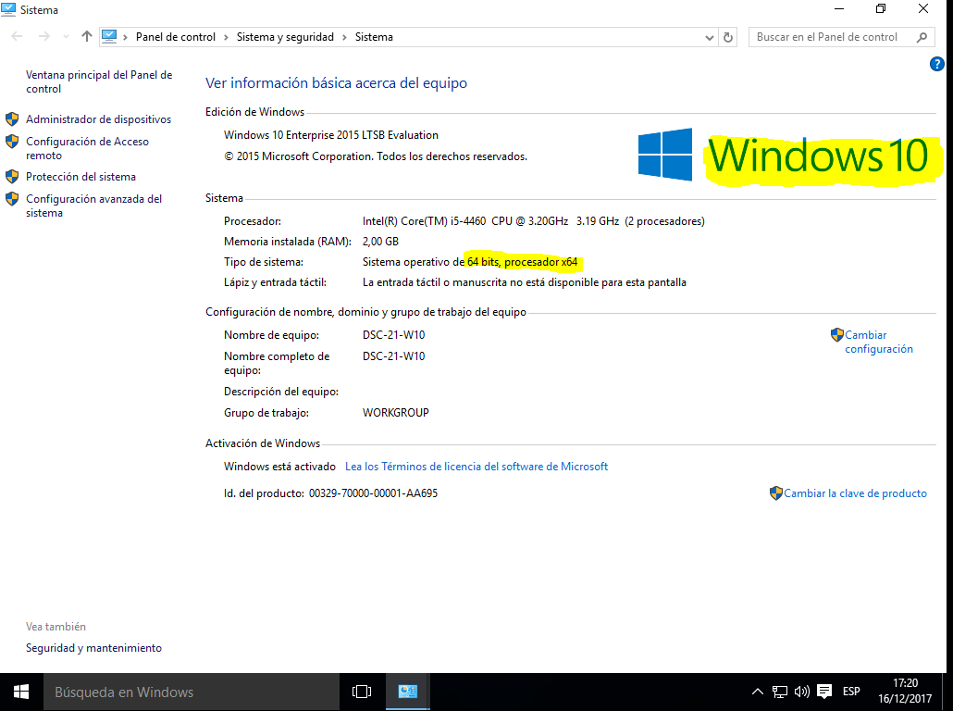

We need to **download the Windows Media Center from the Internet** and now, we are going to proceed with the installation

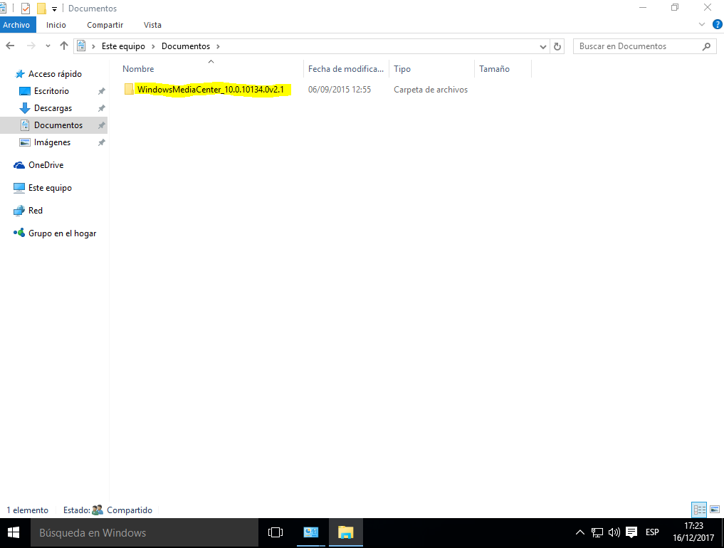

We need to run the _**TestRights.cmd as administrator**.

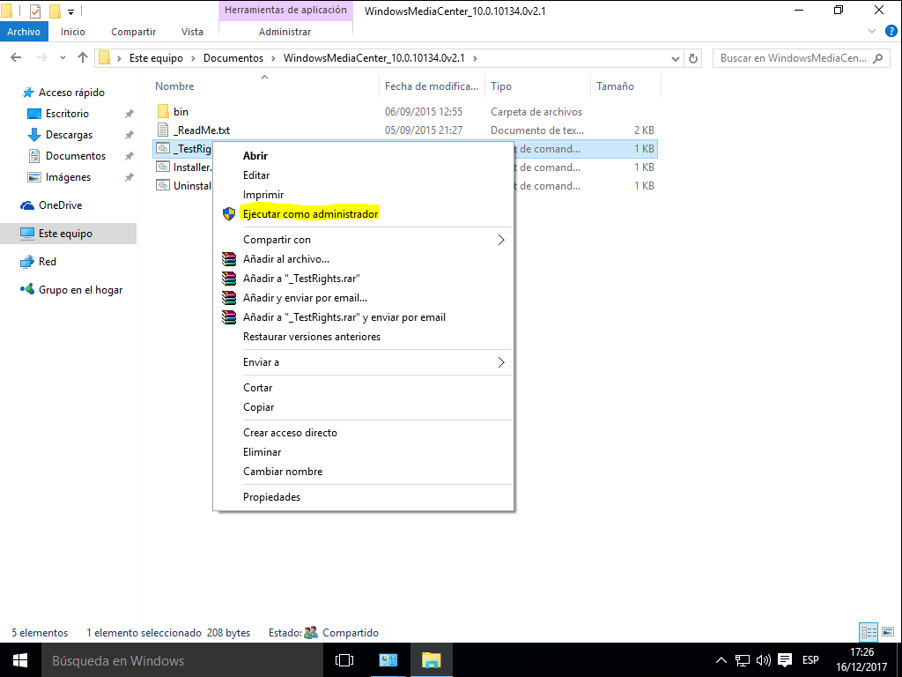

We need to run the **Installer.cmd as administrator.**

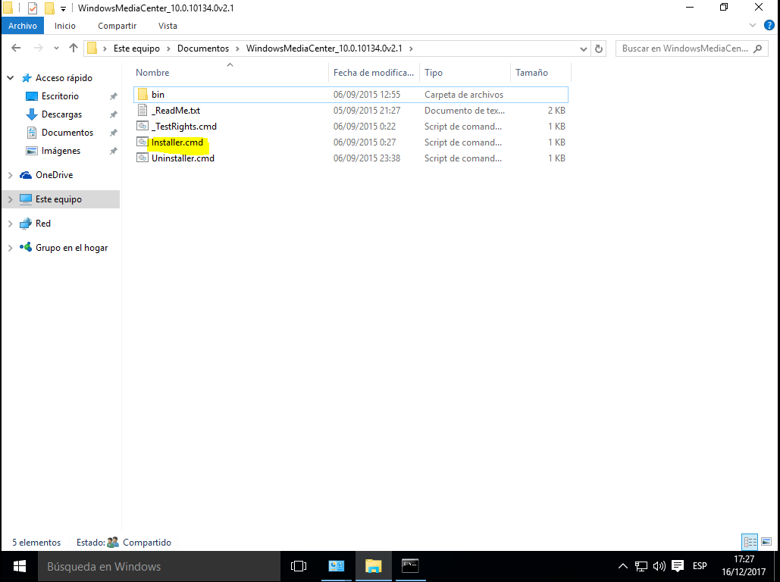

The services has been installed successfull.

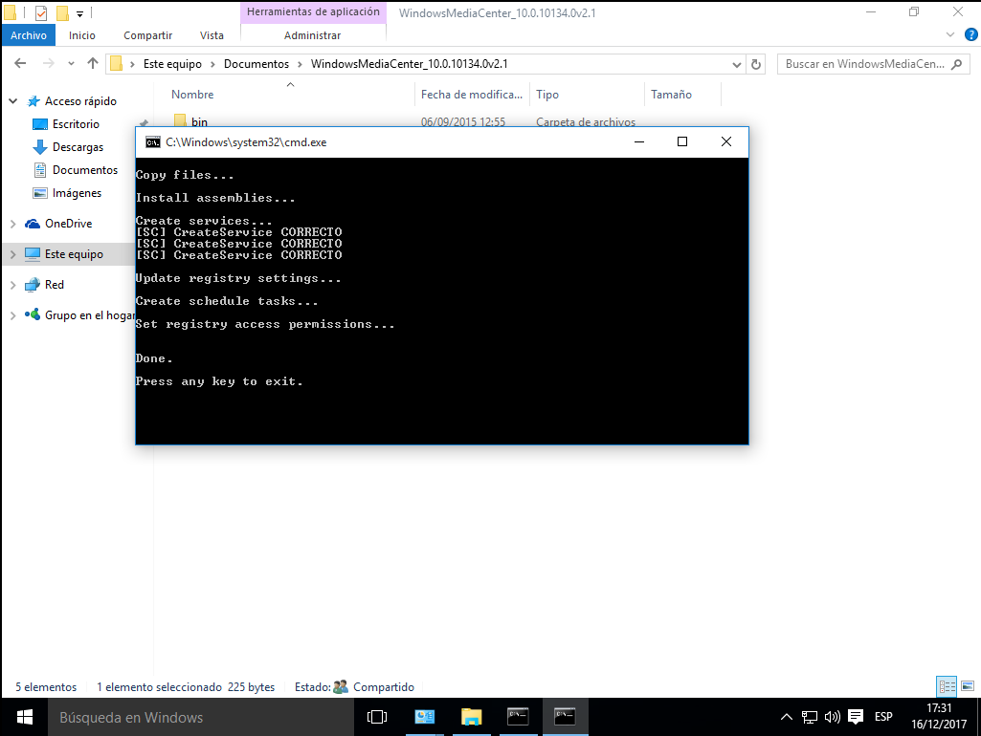

As we can see, we have a new program: Windows Media Center, let´s run it.

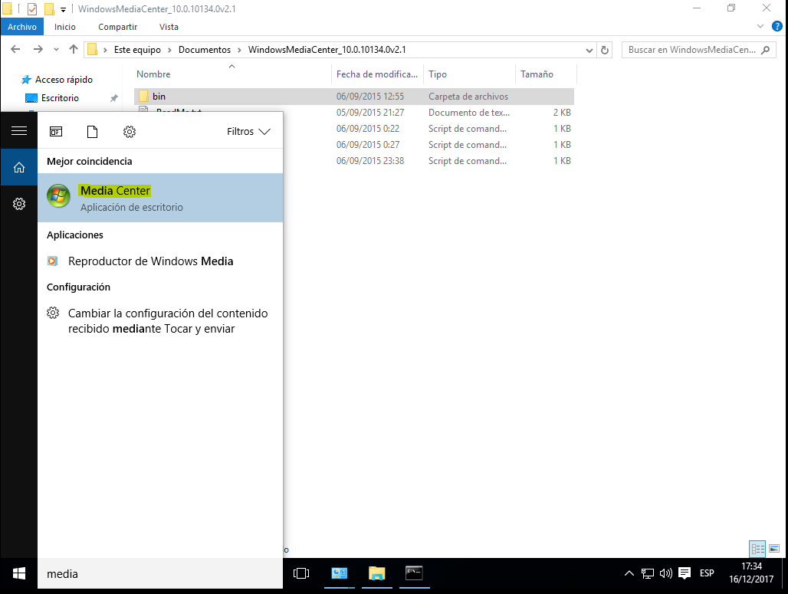

It runs successfully and now we can enjoy the advantages of the Windows media center service.

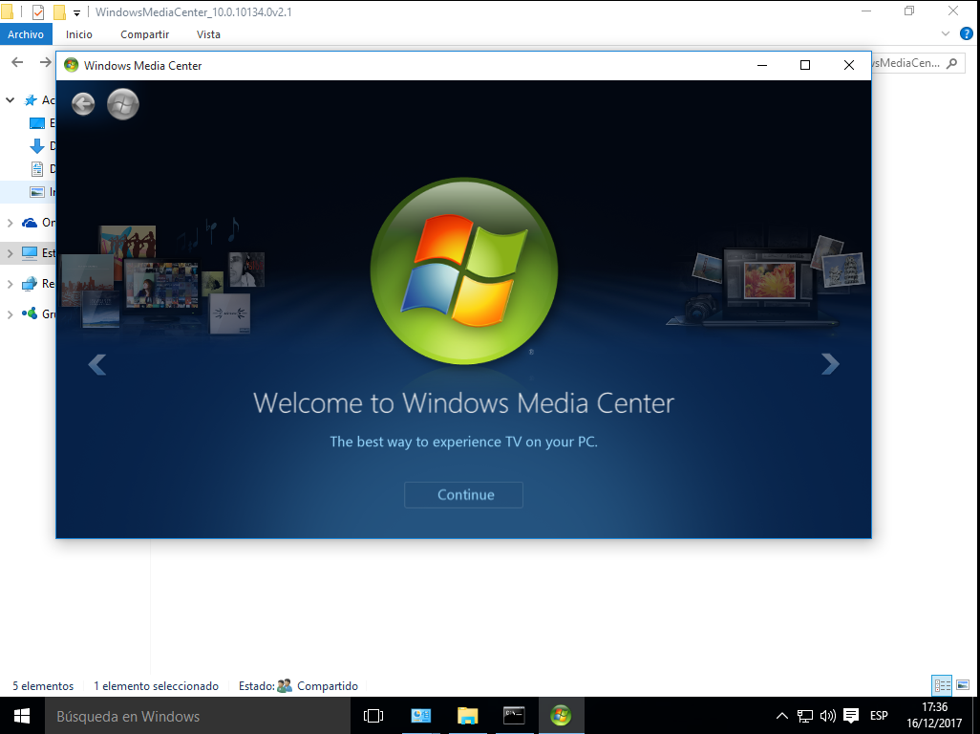

# 

# Final considerations and metacognition

On the one hand, this practice has been very interesting for me because I have learnt how install Media Center even thinking that Microsoft didn´t add it in the Windows 10 version.

On the other hand, I didnt find any issue during the installation so, the practice has been very easy for me.

I am looking forward to do the next one.