MEDIA CENTER

Student Name: David Saldaña Castaño

# Date of delivery: 22/12/2017

521-David-ISOP304-WinLinux-Multiboot.docx

# Objetives

In this exercise, we are going to learn how to install two different OS in the same disk.

# Loot and material needed

VMWare Workstation or another virtualization tools, in my case: VMWare.

Cutting tool.

Microsoft Word.

ISO of Windows 10.

WMC

PDF sent by the teacher as guide.

Content

Date of delivery: 22/12/2017 1

Objetives 1

Loot and material needed 1

Execution, researching and development. 3

SETUP 3

Final considerations and metacognition 8

# SETUP

Creation of a disk with 24GB splitted in: 14 for Windows + 10 for Ubuntu.

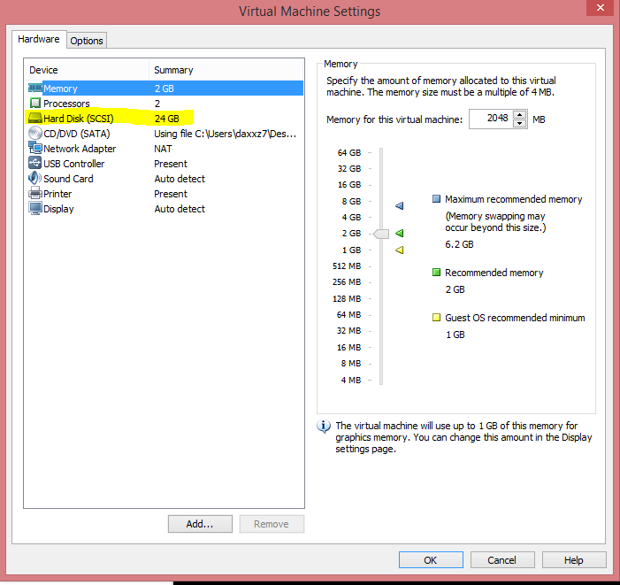

# Windows Installation

As we can see, W10 is successfully installed…

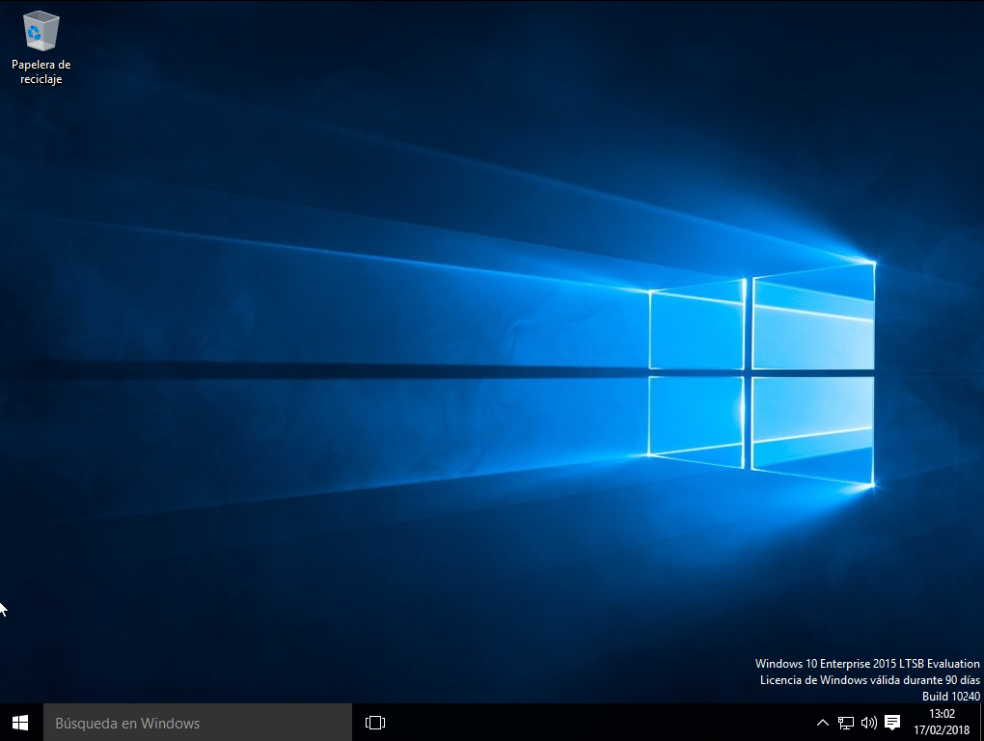

Inside of the disk management we can see that the Ubuntu live cd is enable and is where we are going to boot the system once is restarted.

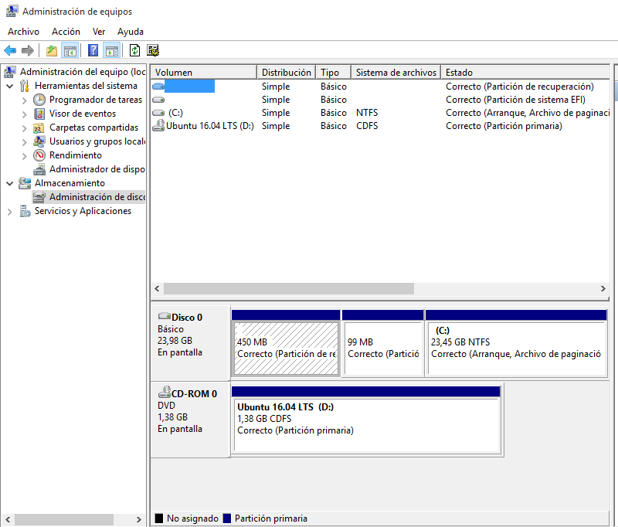

# BIOS

In the BIOS we select to boot from the disk where the Ubuntu live cd is located

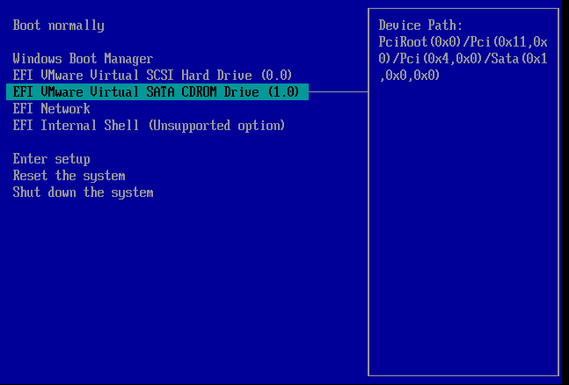

# UBUNTU

We select the option “Install Ubuntu” to install the operative system.

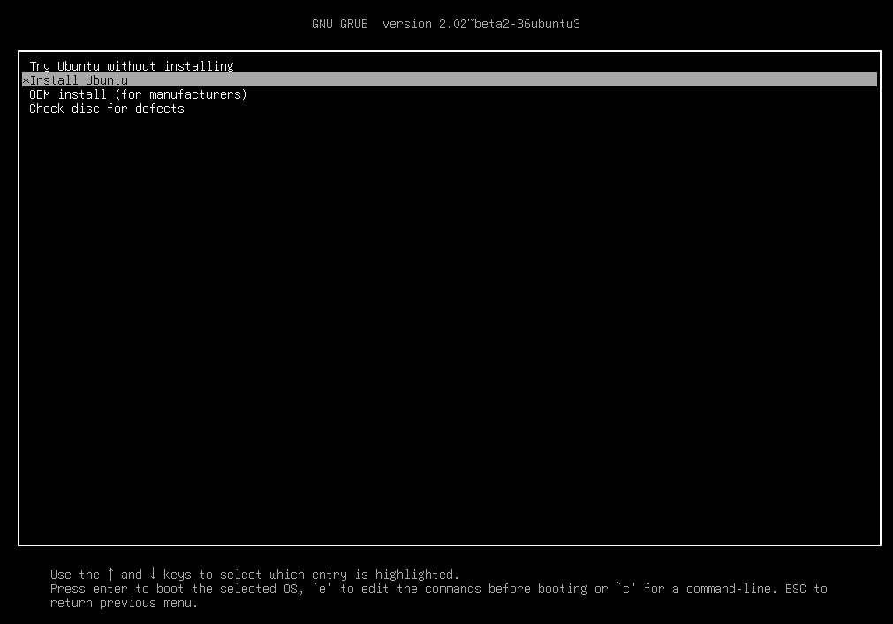

We follow the instructions to continue with the installation.

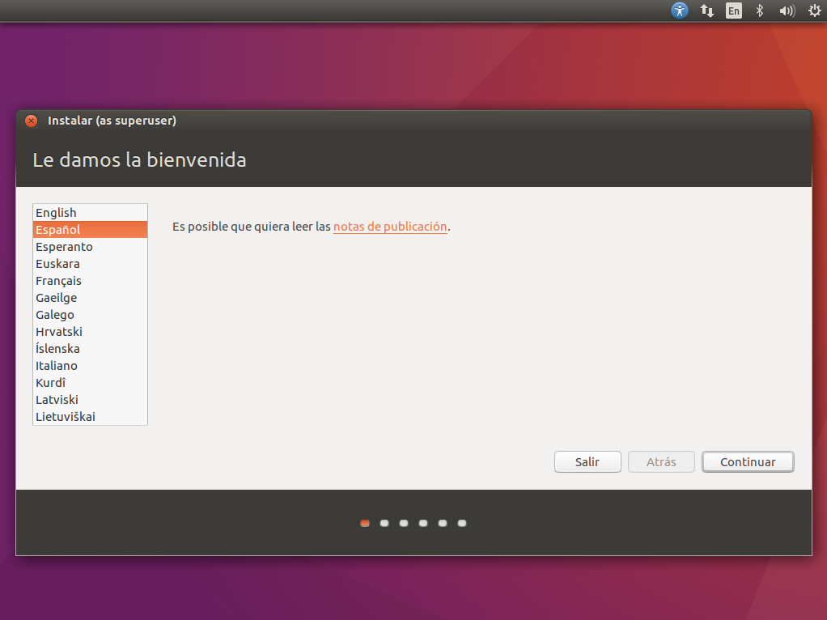

As we want both OS, we need to select the first option to have them located in the same disk.

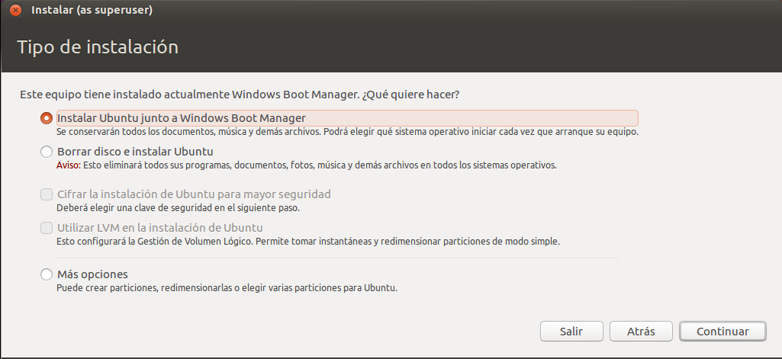

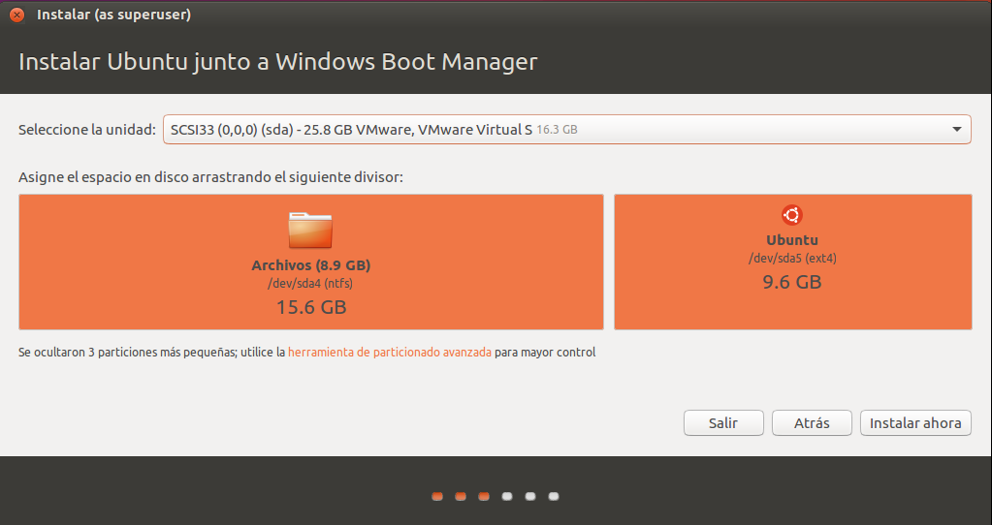

To do this, we need to formate the partitions, creating one to locate the OS and the grub and the other one to house the swap.

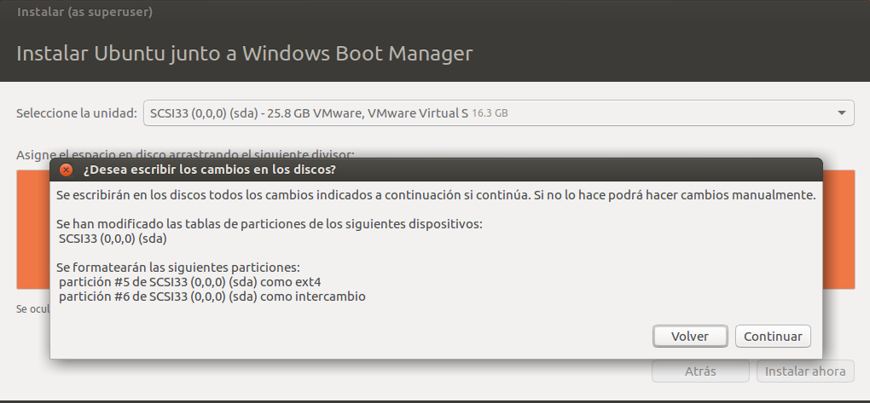

# DUAL BOOT

Once it is installed, now we can select the OS that we want to run, having the compatibility that they need.

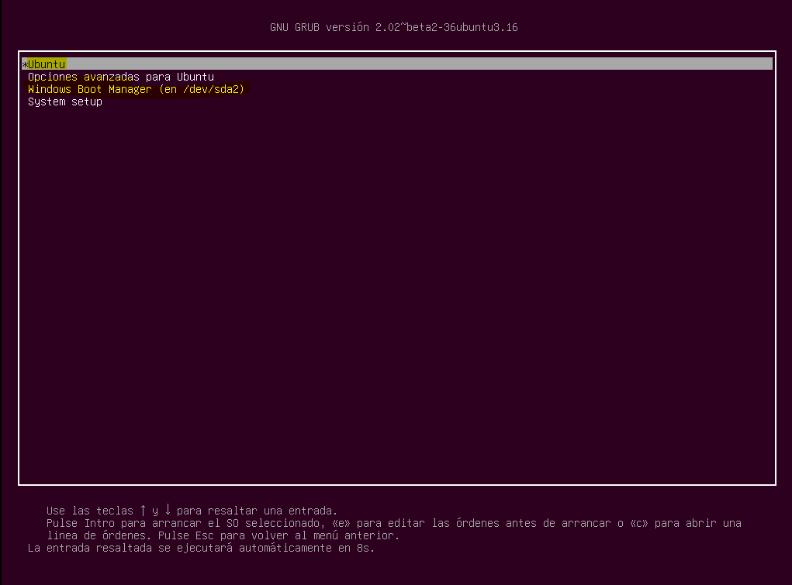

# Why do we install Windows before Ubuntu?

This is due to the compatibility, the boot manager of Ubuntu, can run other OS and the boot manager from Windows can not.

# Final considerations and metacognition

On the one hand, this practice has been very interesting for me because I have learnt how to do a Dual boot using the same disk.

To sum up, I am looking forward to do the next one.