Wireshark

Student Name: David Saldaña Castaño

# Date of delivery: 15/02/2018

521-David-PARP401A-Sniffers-Wireshark.docx

# Objetives

In this exercise, we are going to learn how to install and use wireshark and network miner.

# Loot and material needed

VMWare Workstation or another virtualization tools, in my case: VMWare.

Cutting tool.

Microsoft Word.

ISO of Windows 10.

PDF sent by the teacher as guide.

Content

Date of delivery: 15/02/2018 1

Objetives 1

Loot and material needed 1

First of all we are going to download the three programs that the practice requires. 2

Proofs of use. 3

In Microsoft Network Monitor, we have captured a ping request. 3

In Wireshark, we have captured a DNS request to Google.es 3

Wireshark in Ubuntu 3

Installing Network Miner in Ubuntu 4

Executing Network Miner 4

As we can see, Network miner has been installed successfully 5

Execution, researching and development. 6

SETUP 6

Final considerations and metacognition 6

# First of all we are going to download the three programs that the practice requires.

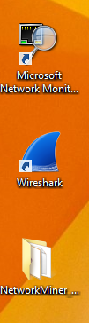

# Proofs of use.

## In Microsoft Network Monitor, we have captured a ping request.

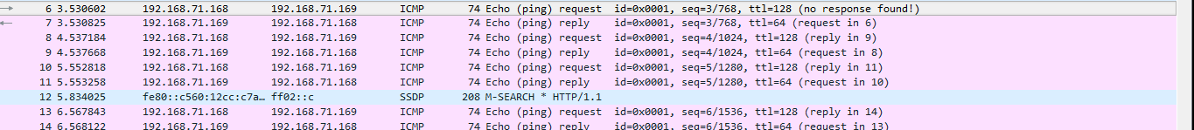

## In Wireshark, we have captured a DNS request to Google.es

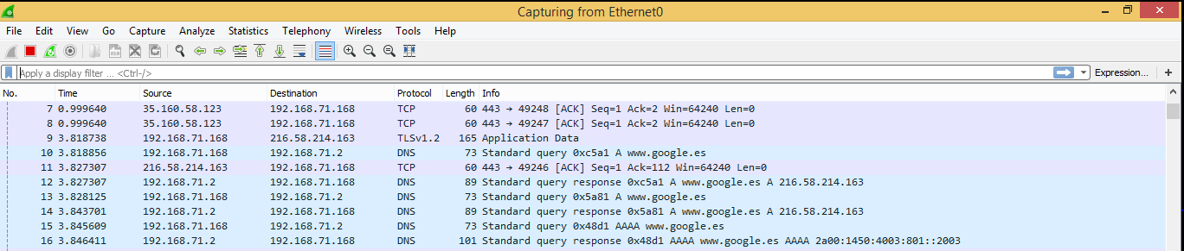

# Wireshark in Ubuntu

With the command **“apt-get install wireshark”** we can install this program.

Let’s analyze a DNS request to www.tajamar.es

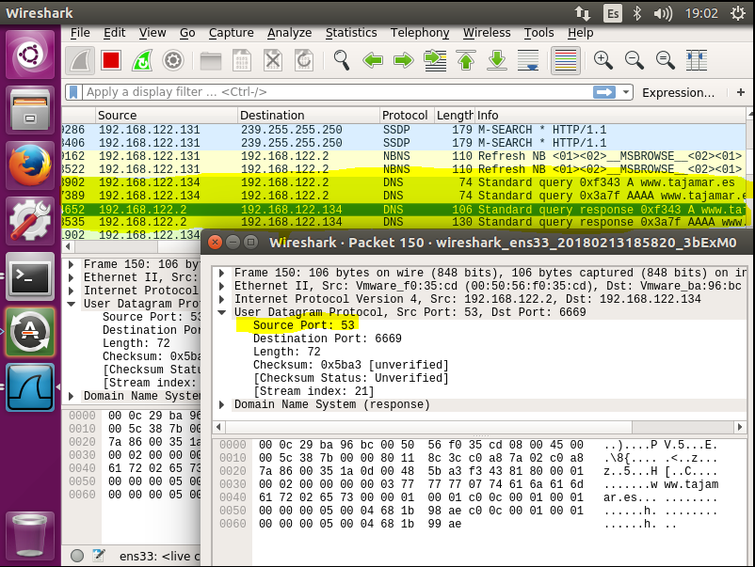

# Installing Network Miner in Ubuntu

With the command **“sudo apt-get install mono-reference-assemblies-2.0 mono-devel”** we add the repository of network monitor into our system.

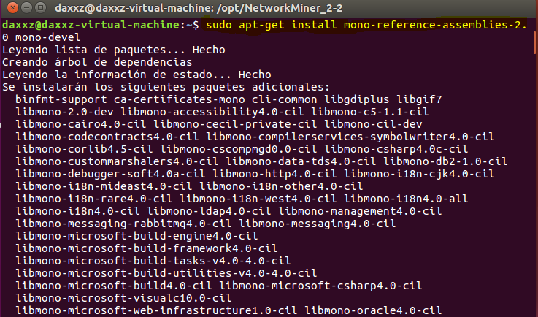

# Executing Network Miner

With the command **“cd /opt/NetworkMiner_*”** we access to the folder of Network miner.

With **“sudo chmod +x Networkminer.exe”** we give permission of execution to this file.

Now we give permissions of Reading to the folder, and we execute the .exe file.

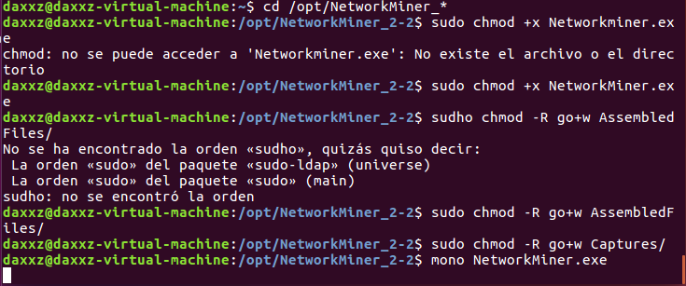

# As we can see, Network miner has been installed successfully

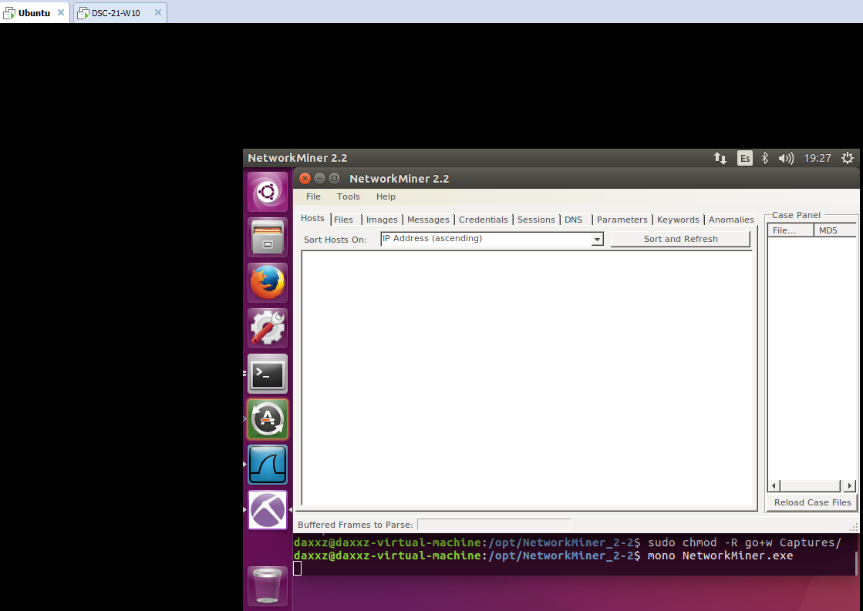

# Final considerations and metacognition

On the one hand, this practice has been very interesting for me because I have learnt how to use wireshark and network miner and how to install them in Ubuntu.

To sump up, this practice has been very useful for me and I am looking forward to do the next one.