Laboratory Practice

TCPDUMP

Student´s Name: David Saldaña

# Date of delivery: 05/11/2017

521-David-PARP411-Maltego.docx

# Objetives

* We are going to learn what is maltego.

# Loot and material needed

* VMWare Workstation or another virtualization tools, in my case: VMWare.
* Cutting tool.
* Microsoft Word.
* PDF sent by the teacher as guide.

# Execution, investigation and development

Content

Date of delivery: 05/11/2017 1

Objetives 1

Loot and material needed 1

Execution, investigation and development 1

Sniffing by the primary interface 1

Sniffing by the primary interface and source IP 2

Sniffing by the mac address as a destination. 2

Sniffing by protocol and port 2

Sniffing by protocol and port as destination 3

Final consideration and Metacognition 3

# ¿What is maltego?

It’s a service that has the potential to find information about people and companies on the Internet, allowing to cross data to obtain profiles in social networks, mail servers and so on.

To access to the program, we need to be logged in. In our case we have downloaded the Community edition 4.1.0

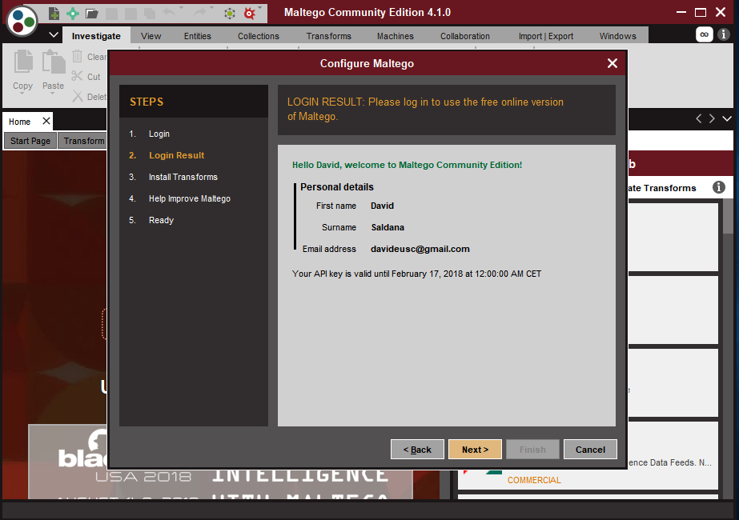

# Let’s try what maltego can do.

In this picture we can see that adding the DNS Name we can put the we page to analyze what IP is associated to that dns name.

For instance [www.tajamar.es](http://www.tajamar.es) is associated to the IP address 104.27.153.174 and 104.27.152.174

Therefore, we can see where is this server located (US)

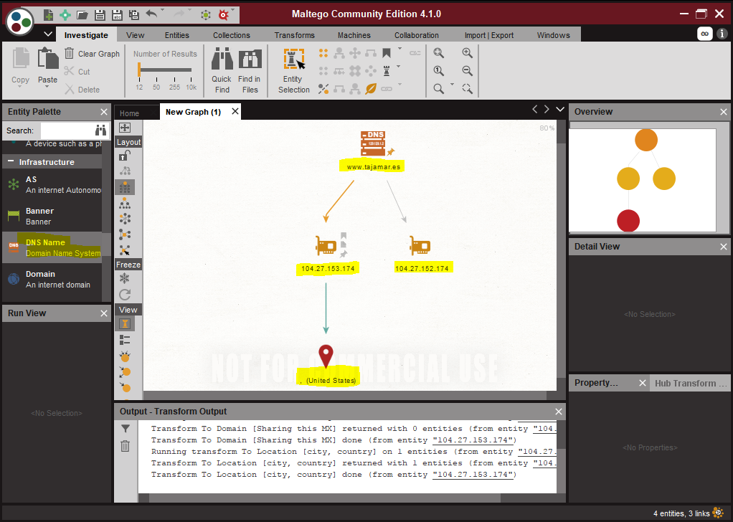

The tool works as follows:

• Maltego sends the request to the seed servers in XML format through HTTPS.  
• The seed server request is given to the TAS servers that are transmitted to the service providers.  
• The results are sent to the Maltego client.

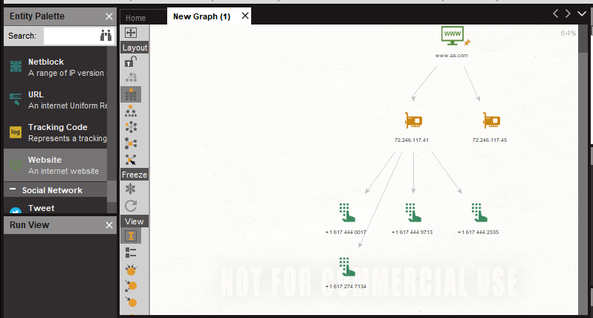

# In this area we can create new projects.



# In this section we can select the tool that we are going to analyze and use to obtain the data that we need.

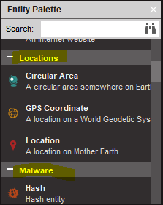

# If we press the right button of the mouse we can see all the options that we can look for in the tool



# Final consideration and Metacognition

On the one hand, I have to say that the practice has been very useful for me, because I’ve never used a Big data program before.

To sump up, this practice has been very interesting, I am looking forward to do the next one.