ACKNOWLEDGEMENTS

I would like to express my sincere gratitude to my project guide, Dr. Khyati Rami and Prof. Nairutvi, for their valuable guidance, support, and encouragement throughout the development of my project, "AI-Based Threat Detection and Automatic Response System". Their insights and suggestions greatly contributed to the successful completion of this work.I would also like to thank the Department of Computer Application, SAL Institute of Technology and Engineering Research, Ahmedabad, for providing the necessary resources and a supportive environment to carry out this project.This project has been developed independently by me, and it has been a valuable learning experience that enhanced my understanding of artificial intelligence, machine learning, and real-world problem-solving.Finally, I would like to acknowledge the authors, researchers, and online resources whose work in the field of AI and machine learning provided valuable references and guidance during the development of this project.

Name of the students
Satyam

ABSTRACT
In today’s rapidly evolving digital landscape, cyber threats are becoming increasingly sophisticated, making traditional rule-based security systems insufficient for real-time threat detection and response. This project presents an AI-based Threat Detection and Automatic Incident Response System designed to enhance cybersecurity operations through intelligent analysis and automation.
The system leverages machine learning techniques, particularly anomaly detection models, to identify suspicious patterns in system and network logs. By processing real-time event data such as login attempts, IP behavior, and access patterns, the model distinguishes between normal and malicious activities with high efficiency. A feature engineering pipeline is implemented to transform raw logs into meaningful inputs for the model, ensuring accurate detection.
In addition to detection, the system incorporates an automated incident response mechanism that dynamically reacts to identified threats. Based on severity levels, predefined actions such as alert generation, logging, or blocking suspicious IP addresses are executed without human intervention. This reduces response time and minimizes potential damage.
Furthermore, a real-time monitoring dashboard is integrated to visualize system activity, attack trends, and threat distribution, enabling better situational awareness for security analysts.
The proposed system aims to bridge the gap between traditional security monitoring and intelligent, autonomous defense systems by combining machine learning with automated response strategies. It provides a scalable and efficient solution for modern cybersecurity challenges, particularly in environments requiring continuous monitoring and rapid threat mitigation

Keywords:
Cybersecurity, Threat Detection, Machine Learning, Anomaly detection, Incident Response Automation, Log Analysis , Real time Monitoring, Intrusion Detection System(IDS), Feature Engineering, Security Analytics.
LIST OF ABBREVIATIONS
Abbreviation | Description
AI | Artificial Intelligence
ML | Machine Learning
NLP | Natural Language Processing
PDF | Portable Document Format
DOCX | Microsoft Word Document
TXT | Plain Text File
UI | User Interface
API | Application Programming Interface
OCR | Optical Character Recognition
CLIP | Contrastive Language–Image Pretraining
GPU | Graphics Processing Unit

LIST OF FIGURES

Sr. No Figure Name Page No.

1 System Flow Diagram …….……………………06

2 Use Case Diagram ………………………………..07

3 Class Diagram……………………………………..08

4 Interaction Diagram……………………….……….09

5 Activity Diagram………………………………….10

6 Screen Short………………………………………..17

INDEX

ACKNOWLEDGEMENTS i
ABSTRACT ii
LIST OF ABBREVIATIONS iii
1: Introduction 1
1.1 Existing System 1
1.2 Objective 1
1.3 Problem Statement 1
1.4 Core Components 2
1.5 Project Profile 3
1.6 Scope of the work 3
1.7 Advantages and Limitations 4
2: Requirement Determination & Analysis 5
2.1Requirement Determination 5
2.2 Targeted Users 6
3: System Design 6
3.1 System Flow Diagram 7
3.2 Use Case Diagram 8
3.3 Class Diagram 9
3.4 Interaction Diagram 10
3.5 Activity Diagram 11
3.6 Data Dictionary 14
4: Development Progress / Implementation 17
4.1 Coding standards 17
4.2 Screen Shots 18
5: Agile Documentation 26
5.1 Agile Project Charter 26
5.2 Agile Roadmap / Schedule 26
5.3 Agile Project Plan 27
5.4 Agile User Story 28
5.5 Agile Release Plan 28
5.6 Agile Sprint Backlog 29
5.7 Agile Test Plan 29
5.8 Earned-value and burn charts 30
6: Proposed Enhancements 32
7 : Conclusion 33
8: Bibliography 34

Chapter 1: Introduction

1.1Existing System
Existing cybersecurity systems mainly rely on traditional mechanisms such as firewalls, signature-based intrusion detection systems (IDS), and rule-based monitoring tools. These systems detect threats using predefined rules and known attack signatures.
While effective for known threats, they have significant limitations. They cannot detect new or unknown (zero-day) attacks and often generate a high number of false alerts. Additionally, most systems require manual intervention for response, leading to delayed action and increased risk. As a result, traditional approaches are insufficient for handling modern, evolving cyber threats.

1.2 Objective
The primary objective of this project is to develop an intelligent threat detection system using machine learning techniques to identify anomalous activities in system and network logs. It aims to design an effective feature engineering pipeline that transforms raw log data into meaningful inputs for accurate analysis. The system focuses on implementing real-time monitoring to detect suspicious events based on behavioral patterns. Additionally, it seeks to automate incident response actions, such as generating alerts and blocking malicious entities, thereby reducing dependency on manual intervention. Another key objective is to minimize false positives and enhance detection accuracy compared to traditional rule-based systems. Furthermore, the project intends to provide a dashboard for visualizing security events, attack trends, and overall system status for better decision-making..

1.3 Problem Statement
With the increasing complexity and frequency of cyberattacks, traditional security systems such as firewalls and rule-based intrusion detection systems are no longer sufficient to ensure effective protection. These systems rely heavily on predefined rules and known attack signatures, making them incapable of detecting unknown or evolving threats. As a result, modern cyberattacks that exhibit subtle and dynamic behavioral patterns often go unnoticed.
Additionally, existing systems generate a large number of alerts, many of which are false positives, leading to alert fatigue and reduced efficiency of security analysts. The lack of real-time automated response further delays threat mitigation, increasing the risk of system compromise and data breaches.
Therefore, there is a need for an intelligent and automated security solution that can analyze system and network logs in real time, accurately detect anomalous behavior, and respond to threats without human intervention. The challenge lies in building a system that not only improves detection accuracy but also reduces false positives and ensures timely response to potential security incidents.

1.4 Core Components

- Log Collection Module
Collects system and network logs from various sources such as authentication logs, login attempts, and user activities for further processing.
- Preprocessing and Feature Engineering Module
Cleans and transforms raw log data into structured format by extracting relevant features like login status, IP behavior, request patterns, and timestamps.
- Machine Learning Detection Engine
Uses anomaly detection algorithms to identify suspicious patterns and classify activities as normal or malicious based on learned behavior.
- Rule-Based Analysis Layer
Applies predefined rules to complement the ML model for detecting known threats and improving overall detection accuracy.
- Incident Response Module
Automatically triggers actions such as alert generation, logging, or blocking suspicious IP addresses based on threat severity.
- Database Management System
Stores logs, processed data, detection results, and incident records for analysis and tracking.
- Real-Time Monitoring Dashboard
Provides visualization of system activity, detected threats, attack trends, and overall security status.

1.5 Project Profile
1. Title :
AI-Based Threat Detection and Automatic Incident Response System
2. Category :
Artificial Intelligence, Cybersecurity, Machine Learning, Web Application Development
3. Duration :
18 December 2024 – 17 April 2025
4. Member :
Satyam Yadav
5. Tools & Technologies :
- Backend : Python, FastAPI
- Machine Learning : Scikit-learn, Isolation Forest, Pandas, NumPy
- Frontend : HTML, CSS3, Bootstrap, JavaScript
- Database : PostgreSQL
- Libraries : Joblib (model saving/loading), Matplotlib / Chart.js (visualization), AsyncIO (real-time processing), WebSockets (live updates)

1.6 Scope of the work
The scope of this project is focused on developing an AI-based system for detecting and responding to cybersecurity threats using system and network log data. The system is designed to collect and process logs such as login attempts, IP activities, and user behavior, and apply machine learning techniques to identify anomalous patterns in real time.
It includes the implementation of a feature engineering pipeline, an anomaly detection model, and a rule-based layer to enhance detection accuracy. The system also provides an automated incident response mechanism that can generate alerts and take predefined actions such as blocking suspicious IP addresses.
Additionally, the project covers the development of a real-time monitoring dashboard to visualize security events, attack trends, and system performance.
However, the scope is limited to log-based threat detection in a controlled environment and does not include advanced enterprise-level integrations such as large-scale distributed systems, full SIEM deployment, or handling of encrypted network traffic.

1.7 Advantages and Limitations
1.7.1 Advantages:
- Provides real-time threat detection using machine learning, enabling faster identification of suspicious activities.
- Capable of detecting unknown and zero-day attacks through anomaly detection techniques.
- Reduces dependency on manual monitoring by implementing automated incident response.
- Minimizes false positives compared to traditional rule-based systems by analyzing behavioral patterns.
- Combines machine learning with rule-based analysis, improving overall detection accuracy.
- Offers a real-time dashboard for monitoring security events and attack trends, enhancing visibility.
- Scalable and adaptable to different types of log data and environments.
1.7.2 Limitations
- Detection accuracy is highly dependent on the quality and diversity of the training dataset.
- May still generate false positives or false negatives, especially in complex real-world scenarios.
- Limited to log-based analysis, and does not inspect deep network packets or encrypted traffic.
- Requires proper tuning and retraining of the ML model to maintain performance over time.
- Not designed for large-scale enterprise environments with high-volume distributed data.
- Automated response actions, if not properly configured, may lead to blocking legitimate users.

Chapter 2: Requirement Determination & Analysis

2.1 Requirement Determination
Requirement determination involves identifying the essential features and functionalities that the system must provide to meet user needs.

2.1.1 Functional Requirements
The system must fulfill the following functional requirements:
- The system shall collect and process system and network logs from various sources such as login activities and user actions.
- The system shall preprocess raw log data and extract relevant features for analysis.
- The system shall apply machine learning algorithms to detect anomalous or suspicious activities.
- The system shall classify events as normal or malicious based on detection results.
- The system shall trigger automated responses such as alert generation or blocking suspicious IP addresses.
- The system shall store logs, detection results, and incident records in a database.
- The system shall provide a real-time monitoring dashboard for visualizing system activity and detected threats.
- The system shall support continuous monitoring and real-time event processing.

2.1.2 Non-Functional Requirements
The system must satisfy the following non-functional requirements:
- Performance: The system should process and analyze events in near real-time with minimal delay.
- Scalability: The system should handle increasing volumes of log data efficiently.
- Accuracy: The machine learning model should maintain high detection accuracy with reduced false positives.
- Reliability: The system should operate continuously without failure during monitoring.
- Security: Sensitive log data must be stored and processed securely.
- Usability: The dashboard should be user-friendly and easy to interpret for monitoring purposes.
- Maintainability: The system should allow easy updates, model retraining, and feature modifications.
- Availability: The system should be available for continuous monitoring with minimal downtime.

2.2 Targeted Users
- Security Analysts – To monitor system activities, analyze detected threats, and take necessary actions.
- System Administrators – To manage system logs, configure security rules, and oversee incident response actions.
- Network Administrators – To monitor network-level activities and identify suspicious IP behavior.
- Organizations / Enterprises – To enhance overall cybersecurity by implementing automated threat detection and response.
- SOC (Security Operations Center) Teams – To perform continuous monitoring and manage security incidents efficiently.
Chapter 3: System Design

3.1 System Flow Diagram
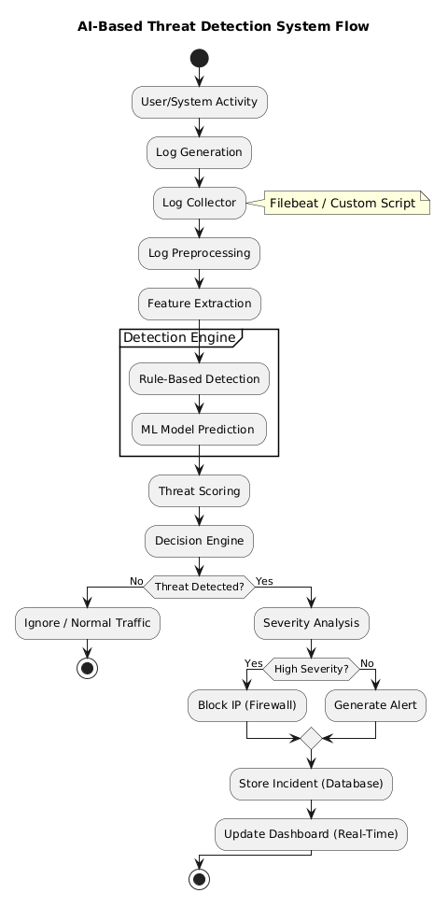
3.2 Use Case Diagram

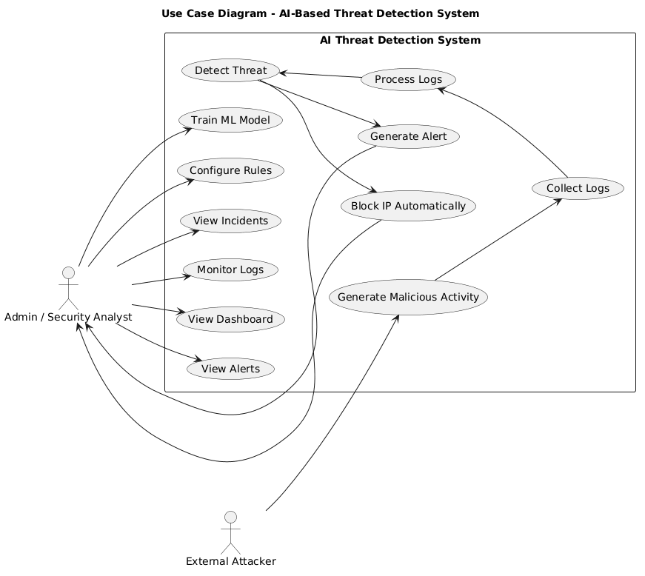

3.3 Class Diagram

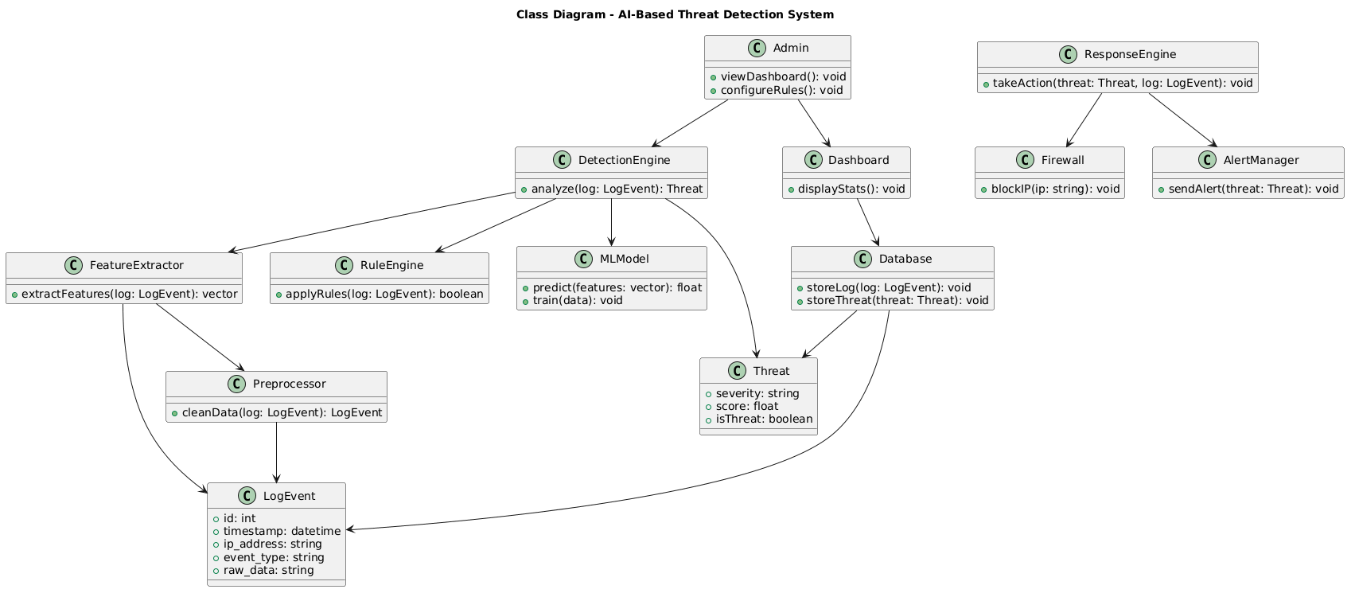
3.4 Interaction Diagram
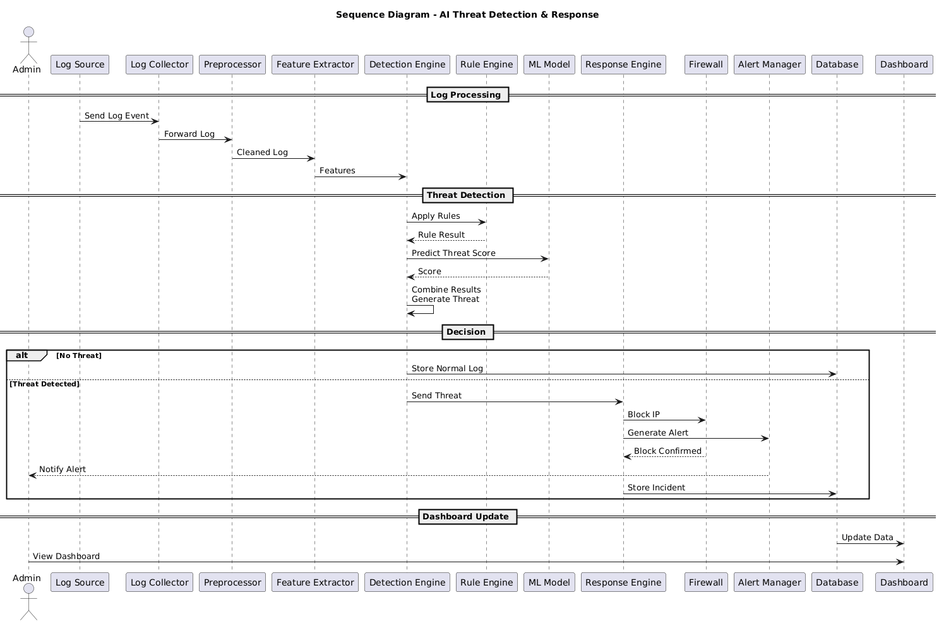

3.5 Activity Diagram

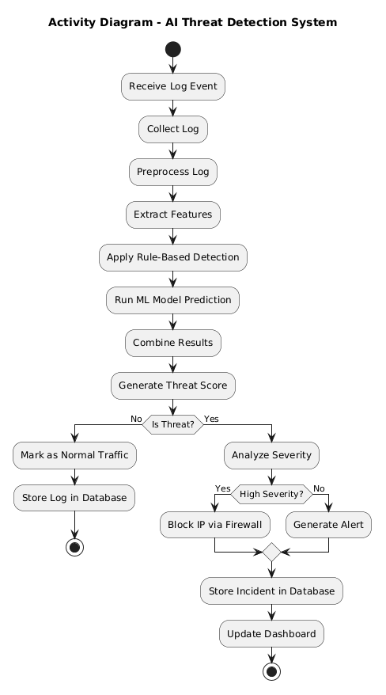
3.6 Data Dictionary

3.7.1 Incident Table

Field Name | Data Type | Description
id | Integer (PK) | Unique identifier for each incident
source_ip | String | IP address from which the threat originated
event_type | String | Type of event (e.g., SSH login failure, brute force)
severity | String | Threat level (Low, Medium, High, Critical)
status | String | Incident status (open, resolved, investigating)
is_blocked | Boolean | Indicates whether the source IP is blocked
timestamp | DateTime | Time when the incident was created

3.7.2 log_offset Table

Field Name | Data Type | Description
id | Integer (PK) | Unique identifier
source_name | String | Name of log source (e.g., auth.log)
file_path | String | Path of the log file
last_offset | BigInteger | Last read position in the file

3.7.3 event Table
Field Name | Data Type | Description
id | Integer (PK) | Unique event ID
source_name | String | Source of log (system/app name)
raw_line | Text | Original log line
line_hash | String | Unique hash to avoid duplicate logs
event_type | String | Type of event
status | String | Event status (success/failure)
source_ip | String | IP address involved
username | String | Username used in event
port | Integer | Port number used
timestamp | DateTime | Event timestamp

3.7.4 Table

Field Name | Data Type | Description
id | Integer (PK) | Unique identifier
worker_name | String | Name of detection worker
last_event_id | Integer | Last processed event ID

Chapter 4: Development Progress / Implementation

4.1 Coding standards
The project follows standard coding practices to ensure, maintainability, and reliability of the system. Meaningful naming conventions are used for variables, functions, and classes to improve code clarity. The code is organized into modular components such as text processing, image detection, authentication, and report generation, which helps in better management and scalability.Proper indentation, spacing, and formatting are maintained throughout the code to enhance readability. Error handling is implemented using try-except blocks to manage runtime exceptions and prevent system failures. Reusable functions are created to avoid code duplication and improve efficiency.
Standard libraries and frameworks such as Django, OpenCV, and Transformers are used following best practices. Additionally, comments are included in the code to explain important logic and functionality. Security measures, such as user authentication and restricted access to report downloads, are also implemented to ensure data protection.

4.2 Screen Shots

4.2.1 Home

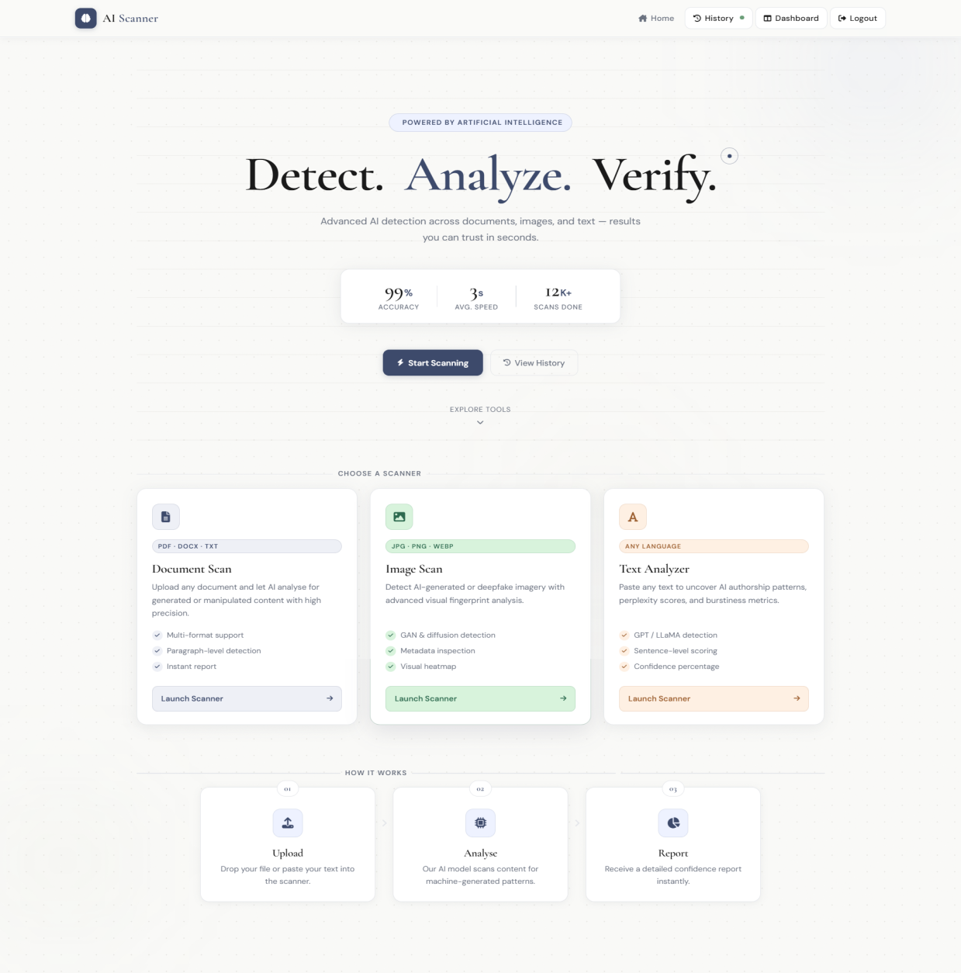

4.2.2 Document Scanner

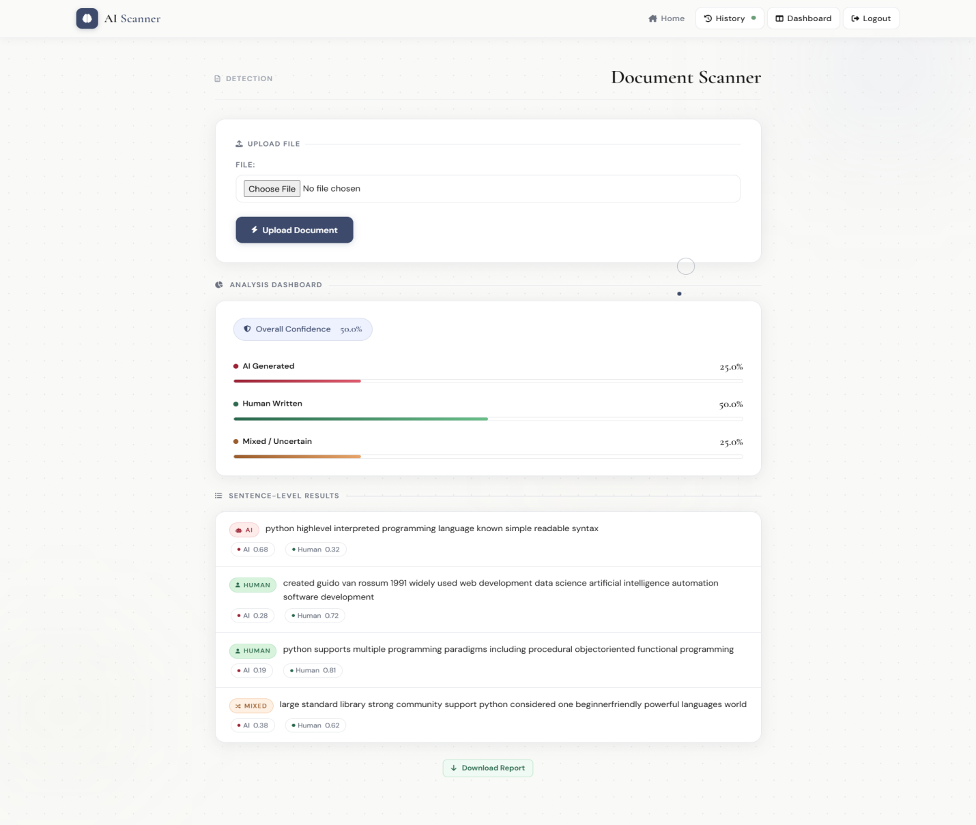

4.2.3 Image Scanner

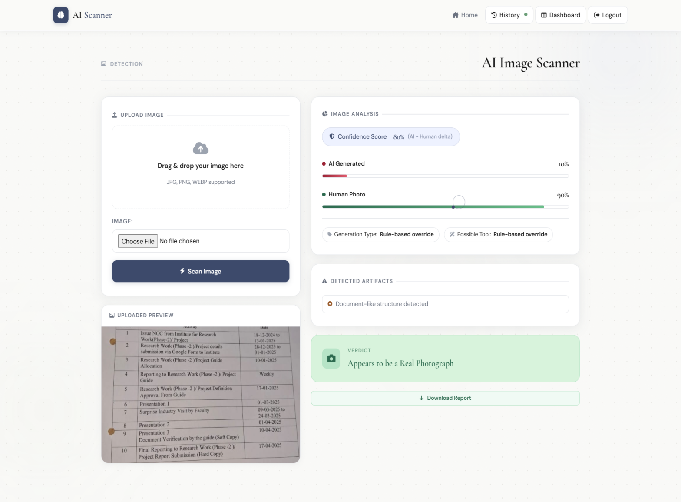

4.2.4 Text analyzer

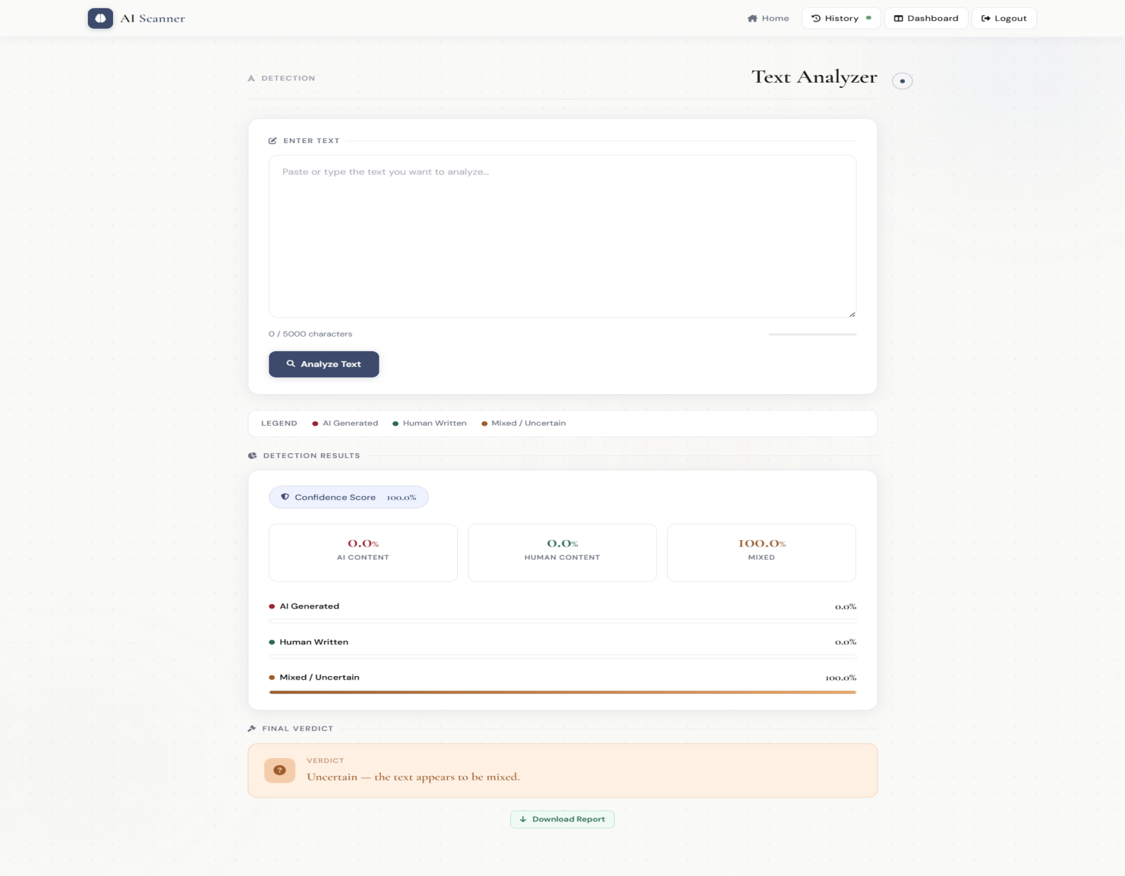

4.2.5 Dashboard

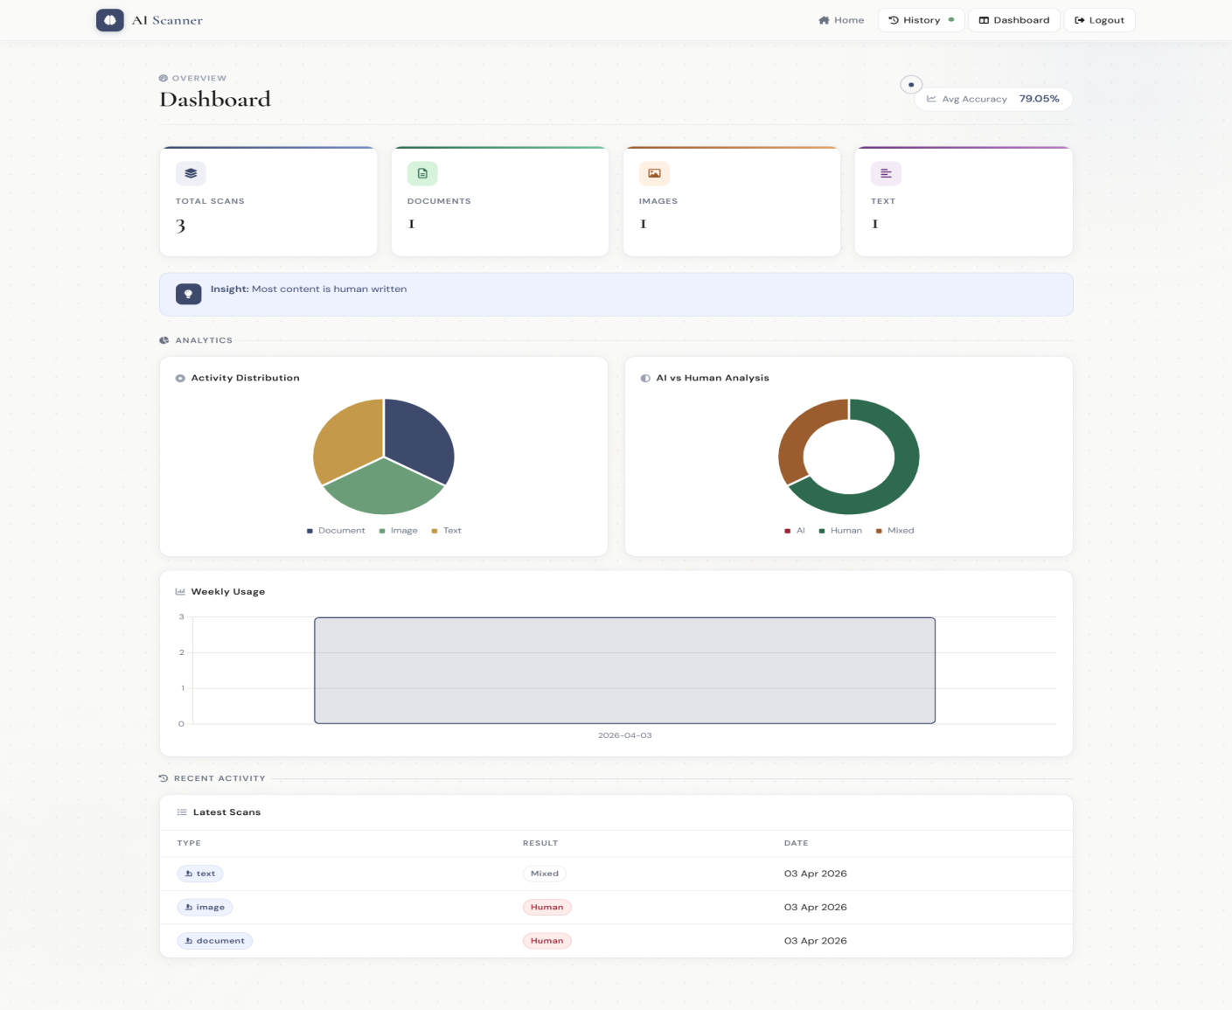

4.2.6 History

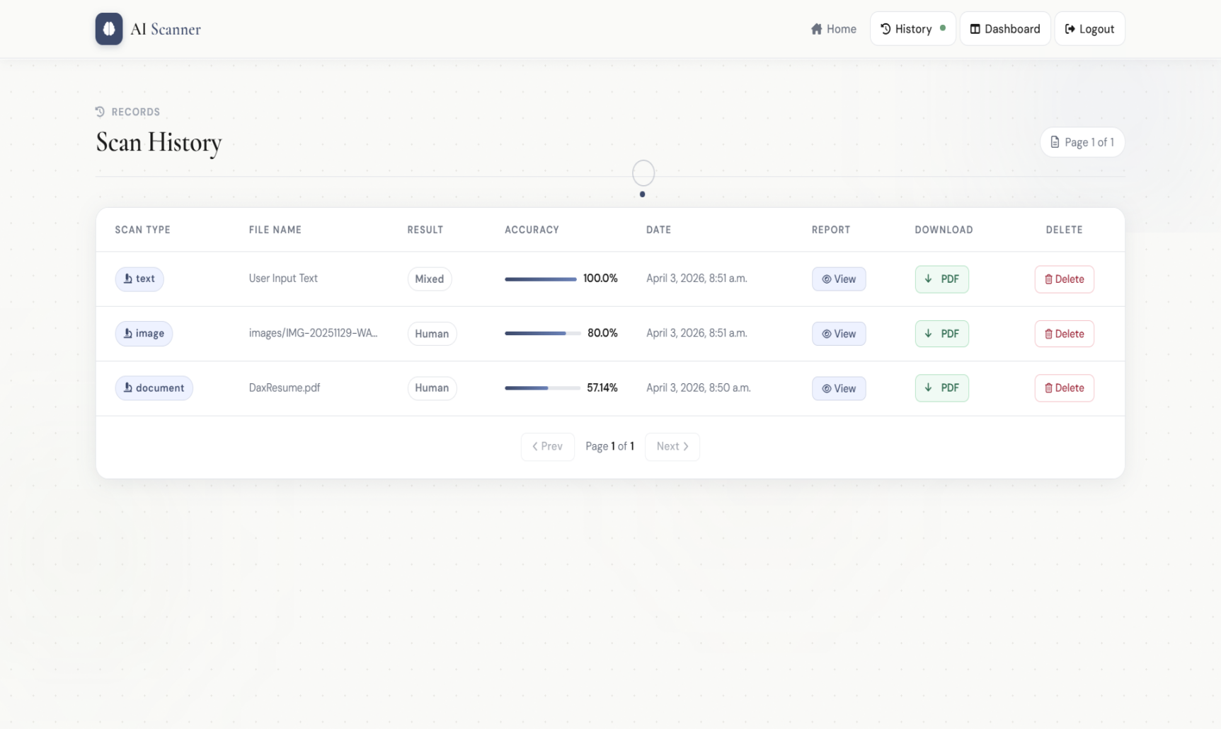

4.2.7 Login

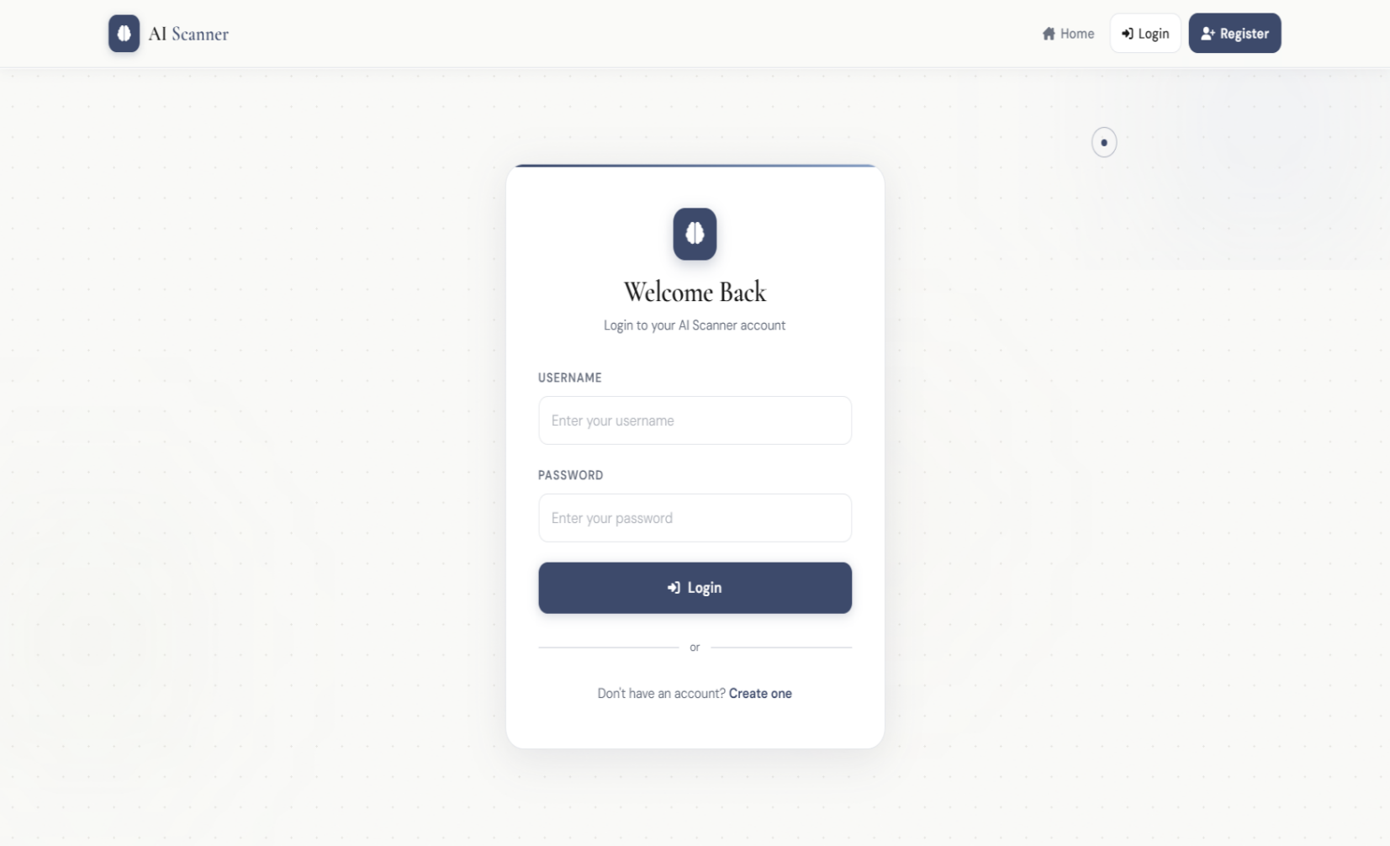

4.2.8 Register

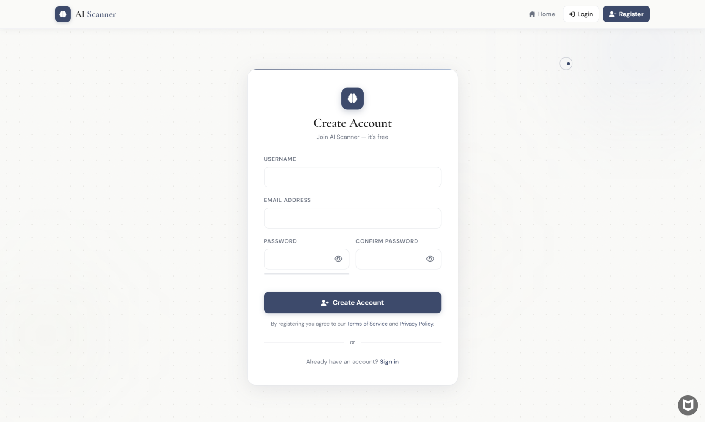

Chapter 5: Agile Documentation

5.1 Agile Project Charter
The objective of this project is to develop an AI-based threat detection and automatic incident response system for monitoring system and network logs. The system continuously collects logs from various sources, processes them, and detects potential security threats using a combination of rule-based techniques and machine learning models such as Random Forest.
The system analyzes events such as failed logins, suspicious IP activity, and abnormal patterns. Based on detection results, it classifies threats into different severity levels and automatically performs actions such as generating alerts or blocking malicious IP addresses through firewall integration.
The system includes a real-time dashboard that visualizes incidents, severity distribution, and attack trends. It also maintains a database for storing logs, events, and detected incidents.
The scope of the project includes log collection, preprocessing, threat detection, automated response, and real-time monitoring. The expected outcome is an intelligent and efficient security monitoring system that reduces manual effort and improves threat response time.

5.2 Agile Roadmap / Schedule

No | Time | Phase | Task
1 | Dec 2025 – Jan 2026 | Initial Phase | Project topic finalization and proposal submission
2 | Jan 2026 | Planning Phase | Requirement analysis and system design approval
3 | Jan – Feb 2026 | Development Phase 1 | Log collection, preprocessing, and database setup
4 | Feb – March 2026 | Development Phase 2 | Rule-based detection and ML model integration
5 | March 2026 | Development Phase 3 | Response engine and firewall integration
6 | March – April 2026 | Evaluation Phase | Dashboard development and system testing
7 | April 2026 | Final Phase | Documentation, report submission, and project review

5.3 Agile Project Plan
The project was developed using an incremental Agile approach, where the system was divided into multiple modules and implemented step-by-step. Initially, the log collection and preprocessing modules were developed to handle raw log data. After that, the detection engine was implemented using both rule-based logic and machine learning models.
Next, the response engine was developed to automatically block malicious IPs and generate alerts. A database was integrated to store logs, events, and incidents. Finally, a real-time dashboard was developed using WebSockets to visualize threat data dynamically.
Continuous testing and iterative improvements were performed at each stage to enhance system performance and accuracy.

No | Task | Priority | Start | End | Status
1 | Requirement Analysis | High | 01-01-26 | 10-01-26 | Completed
2 | System Design | High | 11-01-26 | 20-01-26 | Completed
3 | Log Processing Module | High | 21-01-26 | 10-02-26 | Completed
4 | Detection Engine (Rule + ML) | High | 11-02-26 | 05-03-26 | Completed
5 | Response Engine | High | 06-03-26 | 15-03-26 | Completed
6 | Dashboard Development | High | 16-03-26 | 30-03-26 | Completed
7 | Testing & Optimization | High | 01-04-26 | 10-04-26 | Completed

5.4 Agile User Story

No | Story Name | User Story
1 | Log Monitoring | As a system, I want to collect logs continuously so that no event is missed
2 | Threat Detection | As a system, I want to detect threats using rules and ML so that attacks can be identified
3 | Incident Management | As an admin, I want to view detected incidents so that I can monitor system security
4 | Automated Response | As a system, I want to block malicious IPs automatically so that attacks are prevented
5 | Dashboard Monitoring | As an admin, I want to view real-time dashboards so that I can analyze threats easily

5.5 Agile Release Plan
- Release 1 – System Setup:
Project setup, database configuration, and log collection module
- Release 2 – Detection Engine:
Implementation of rule-based detection and ML model integration
- Release 3 – Response System:
Development of automated response actions such as IP blocking and alert generation
- Release 4 – Dashboard Integration:
Real-time dashboard with charts, severity analysis, and live incident feed
- Release 5 – Testing & Deployment:
System testing, bug fixing, performance tuning, and final deployment

5.6 Agile Sprint Backlog
Sprint | Tasks
Sprint 1 | Project setup, database design, log collection module
Sprint 2 | Log preprocessing and feature extraction
Sprint 3 | Rule-based detection implementation
Sprint 4 | ML model integration and threat scoring
Sprint 5 | Response engine (block IP, alerts)
Sprint 6 | Dashboard (charts + WebSockets integration)
Sprint 7 | Testing, debugging, and performance optimization

5.7 Agile Test Plan

Testing Type | Description | Status
Unit Testing | Individual modules like log parsing, detection, and response were tested separately | Success
Functional Testing | Features like threat detection, alert generation, and dashboard updates were tested | Success
Integration Testing | End-to-end flow from log input to dashboard output was verified | Success
UI Testing | Dashboard UI tested for usability and real-time updates | Success
Error Handling Testing | Tested invalid logs, missing fields, and duplicate events handling | Success

5.8 Earned-value and burn charts
The project progress was evaluated using Earned Value Management (EVM) techniques.
- Planned Value (PV): Estimated effort
- Earned Value (EV): Completed work
- Actual Cost (AC): Actual effort spent
5.8.1 EVM Table
No | Task | PV | EV | AC | SV
1 | System Design | 80 | 80 | 80 | 0
2 | Log Processing | 150 | 150 | 150 | 0
3 | Detection Engine | 200 | 200 | 200 | 0
4 | Response System | 120 | 120 | 120 | 0
5 | Dashboard & Testing | 100 | 100 | 100 | 0

5.8.2 burn charts

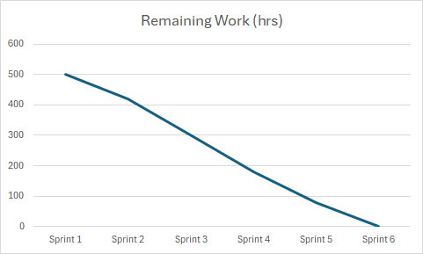

Chapter 6: Proposed Enhancements
The current AI-based threat detection and incident response system provides real-time monitoring, log analysis, and automated response capabilities. However, several enhancements can further improve its scalability, accuracy, and real-world applicability.

6.1 Improved Machine Learning Models
The current system uses a basic machine learning model (Random Forest) for threat detection. In future, advanced deep learning models such as LSTM or Transformer-based anomaly detection can be integrated to improve accuracy in sequential log analysis and detect complex attack patterns.

6.2 Advanced Threat Intelligence Integration
The system can be enhanced by integrating external threat intelligence feeds such as IP reputation databases, malware signature repositories, and global attack datasets. This will help in identifying known malicious sources more effectively.

6.3 Scalable Distributed Architecture
Currently, the system operates in a single-node environment. Future improvements can include migration to a distributed architecture using tools like Apache Kafka and Elasticsearch for handling large-scale log streams efficiently.

6.4 Enhanced Real-Time Visualization
The dashboard can be improved with advanced analytics such as attack heatmaps, geo-location tracking of IPs, and predictive trend analysis for future attack forecasting.

6.5 Automated Incident Response Improvements
Future versions can include adaptive response mechanisms where the system dynamically selects actions based on threat confidence level, such as rate limiting, temporary bans, or escalation to administrators.

6.6 Model Retraining Pipeline
A feedback loop can be introduced where confirmed incidents are used to retrain the machine learning model periodically, improving detection accuracy over time.

Chapter 7 : Conclusion

The AI-based threat detection and automatic incident response system successfully demonstrates the application of machine learning and rule-based techniques for real-time cybersecurity monitoring. The system effectively processes log data, detects potential threats, and performs automated responses such as alert generation and IP blocking.
The integration of a detection engine, response mechanism, and real-time dashboard provides a complete monitoring solution for identifying suspicious activities in system logs. The use of both rule-based logic and machine learning improves detection reliability and reduces false positives compared to traditional systems.
This project highlights the importance of automated security systems in modern IT environments where manual monitoring is not sufficient due to high data volume and fast attack patterns. The system provides a scalable foundation for further enhancements in threat intelligence and distributed processing.
Overall, the project achieves its objective of building an intelligent and automated security monitoring system and demonstrates practical implementation of AI in cybersecurity.

Chapter 8: Bibliography

1.Liu, Y. et al. (2019). RoBERTa: A Robustly Optimized BERT Pretraining Approach.
Available at: https://arxiv.org/abs/1907.11692
2. Radford, A. et al. (2021). Learning Transferable Visual Models From Natural Language Supervision (CLIP).
Available at: https://arxiv.org/abs/2103.00020
3. Hugging Face Documentation.
Available at: https://huggingface.co/docs
4. OpenCV Documentation.
Available at: https://opencv.org/
5. PyTorch Documentation.
Available at: https://pytorch.org/docs/
6. Python Software Foundation.
Available at: https://docs.python.org/3/
7. Django Documentation.
Available at: https://docs.djangoproject.com/
8. NLTK Documentation.
Available at: https://www.nltk.org/
9. PDFPlumber Documentation.
Available at: https://github.com/jsvine/pdfplumber
10. ReportLab Documentation.
Available at: https://www.reportlab.com/docs/
11. Chatgpt
Available at: https://chatgpt.com/
12.PlantUML Web Server
Available at: https://www.plantuml.com/plantuml/uml/

