Department of Computer Science and Engineering,
School of Technology,
Pandit Deendayal Energy University (PDEU)
Software Engineering(24CS209P)

Lab Experiment - 7

Name: Dax B Patel
Roll no: 24BCP269

Objective:
Start coding the project.

Basic Theory:
Clean code is easy to read and understand.

Git is used to manage code changes.

Lab Activities:

1. Create GitHub repository
2. Setup coding environment
3. Create class files
4. Implement basic features

Deliverables

1. Github repository link:

https://github.com/Daxptl7/UnilearnPDEU.git

2. IDE Screenshots:

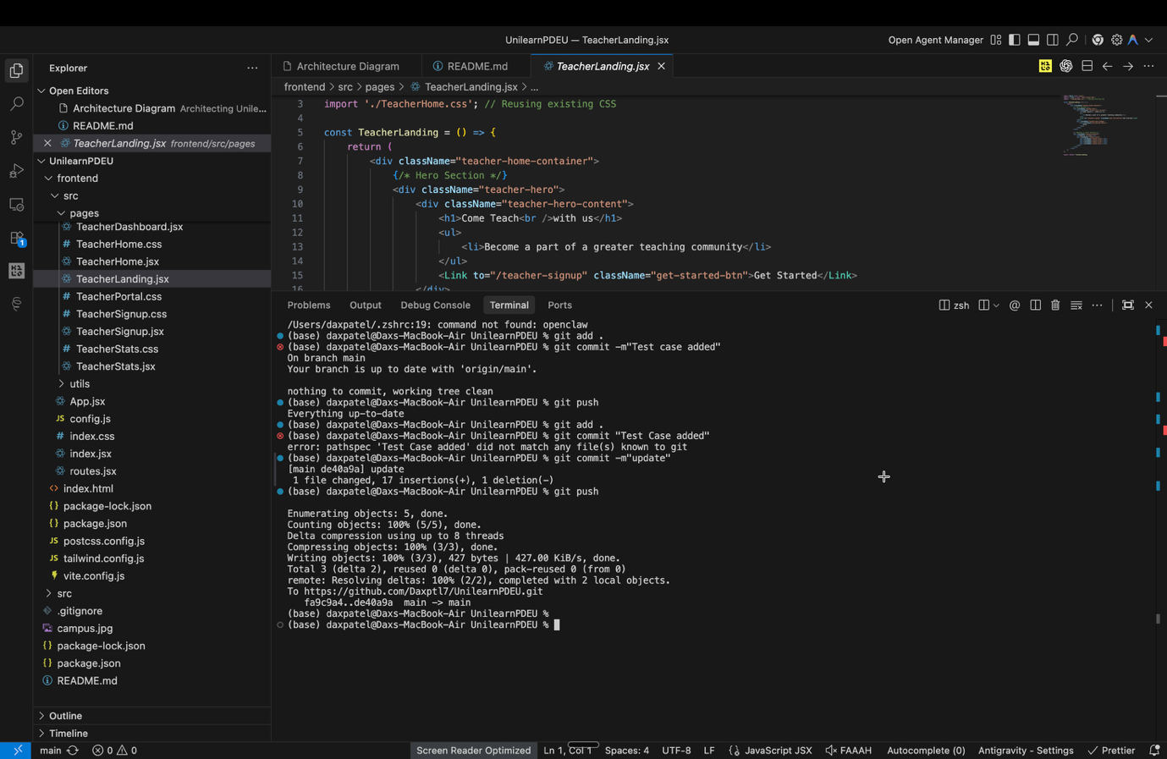

3. Sample source code:

import React, { useState, useEffect } from 'react';
import { Link } from 'react-router-dom';
import TeacherDashboard from './TeacherDashboard';
import './Home.css';

const Home = ({ user, viewMode, toggleViewMode }) => {
// State declarations
const [recommended, setRecommended] = useState([]);
const [loading, setLoading] = useState(true);
const [opacity, setOpacity] = useState(0.3);

// Teacher View Handler
if (user?.role === 'teacher' && viewMode === 'teacher') {
return <TeacherDashboard toggleViewMode={toggleViewMode} />;
}

useEffect(() => {
const loadCourses = async () => {
try {
const { fetchPublicCourses } = await import('../api/course.api');
const response = await fetchPublicCourses();
if (response.success) {
let allCourses = response.data;
console.log("Fetched courses:", allCourses);

// Filter by Student School if applicable
if (user && user.role === 'student' && user.school) {
console.log("Filtering for school:", user.school);
const schoolCourses = allCourses.filter(c => c.category === user.school);
setRecommended(schoolCourses);
} else {
setRecommended(allCourses);
}
}
} catch (error) {
console.error('Failed to load courses:', error);
} finally {
setLoading(false);
}
};
loadCourses();
}, []);

// Scroll Opacity Effect
useEffect(() => {
const handleScroll = () => {
const scrollFactor = Math.min(window.scrollY / 2000, 0.2);
setOpacity(0.3 + scrollFactor);
};
window.addEventListener('scroll', handleScroll);
return () => window.removeEventListener('scroll', handleScroll);
}, []);

return (
<div className="home-wrapper">
{/* HERO SECTION */}
<section
className="heroContainer"
style={{
backgroundImage: `linear-gradient(rgba(0, 0, 0, ${opacity}), rgba(0, 0, 0, ${opacity})), url('/campus.jpg')`
}}
>
<div className="heroContent">
<h1 className="heroTitle">UniLearn | PDEU</h1>
<p className="heroSubtitle">Empowering the future through DIgital education and research.</p>
</div>
</section>

{/* RECOMMENDED COURSES */}
<div className="section-container">
<h3>
{user && user.role === 'student' && user.school
? `Recommended for you (${user.school})`
: "Recommended for you / Trending"}
</h3>

{loading ? (
<p>Loading courses...</p>
) : (
<div className="scroll-container">
<div className="scroll-content">
{/* Duplicate list for seamless loop (A + A) */}
{[...recommended, ...recommended].map((course, index) => (
<Link key={`${course._id}-${index}`} to={`/course/${course.slug}`} className="course-card" style={{
minWidth: '280px', borderRadius: '12px', overflow: 'hidden', boxShadow: '0 4px 10px rgba(0,0,0,0.1)', background: 'white', display: 'block', color: 'inherit', flexShrink: 0
}}>
<div className="course-card-thumb" style={{
height: '160px',
backgroundImage: `url(${course.thumbnail})`,
backgroundSize: 'cover',
backgroundPosition: 'center',
backgroundColor: '#eee'
}}></div>
<div style={{ padding: '15px' }}>
<span style={{ fontWeight: '600', fontSize: '16px', display: 'block', marginBottom: '8px', overflow: 'hidden', textOverflow: 'ellipsis', whiteSpace: 'nowrap' }}>{course.name}</span>
<span style={{ fontSize: '14px', color: '#666' }}>By {course.instructor?.name || 'Instructor'}</span>
</div>
</Link>
))}
</div>
</div>
)}
</div>

{/* STATS SECTION (Placeholder for IdeaLab2 Stats) */}
<div className="section-container" style={{ background: '#f9f9f9', textAlign: 'center' }}>
<h3 style={{ borderLeft: 'none' }}>Our Impact</h3>
<div style={{ display: 'grid', gridTemplateColumns: 'repeat(auto-fit, minmax(200px, 1fr))', gap: '40px', marginTop: '40px' }}>
<div>
<h2 style={{ fontSize: '48px', color: '#A6192E', fontWeight: '800' }}>50+</h2>
<p>Lab Equipment</p>
</div>
<div>
<h2 style={{ fontSize: '48px', color: '#A6192E', fontWeight: '800' }}>200+</h2>
<p>Projects Completed</p>
</div>
<div>
<h2 style={{ fontSize: '48px', color: '#A6192E', fontWeight: '800' }}>1000+</h2>
<p>Students Trained</p>
</div>
</div>
</div>
</div>
);
};

export default Home;

