Department of Computer Science and Engineering,
School of Technology,
Pandit Deendayal Energy University (PDEU)
Software Engineering(24CS209P)

Lab Experiment - 5

Name: Dax B Patel
Roll no: 24BCP269

Interection Diagram-1
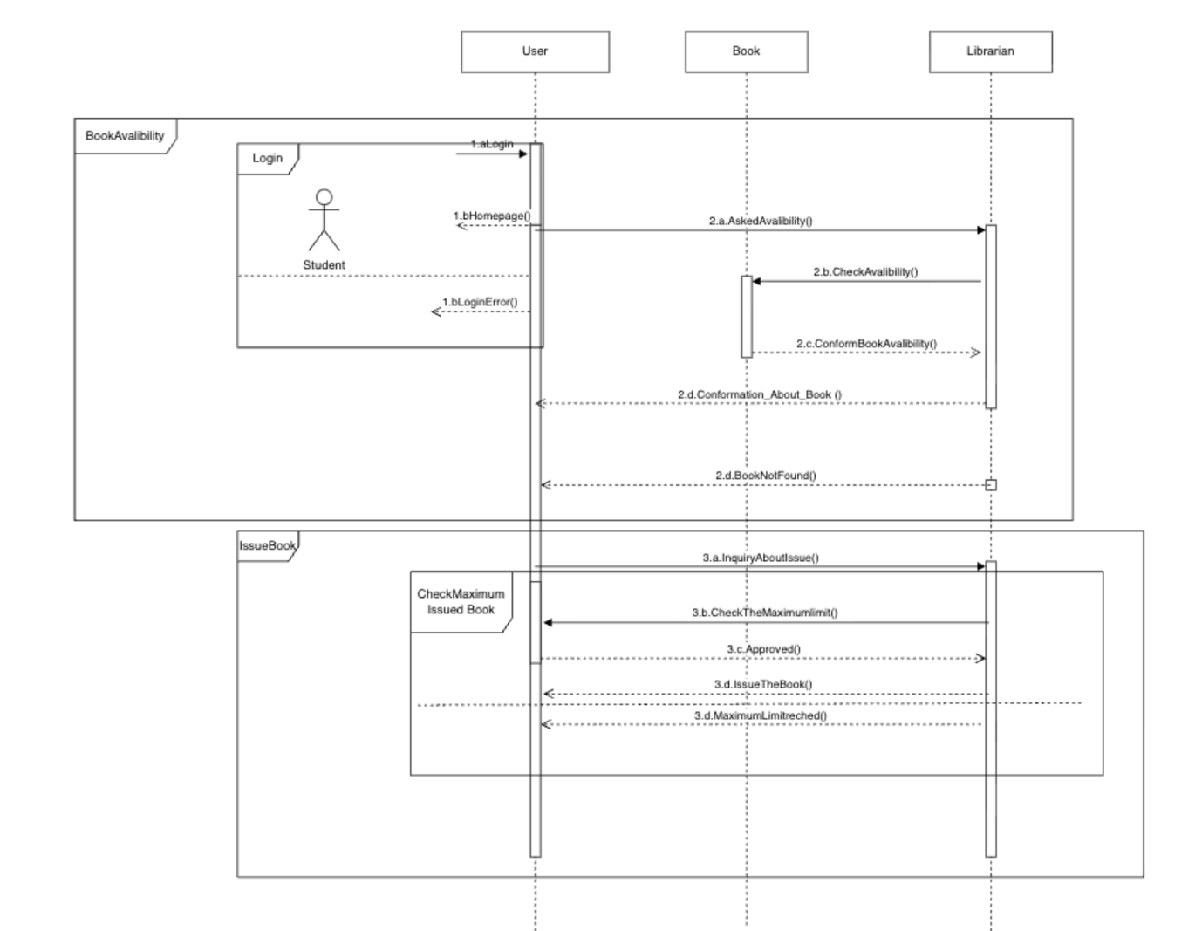

Interection Diagram-2:
