Department of Computer Science and Engineering,
School of Technology,
Pandit Deendayal Energy University (PDEU)
Software Engineering(24CS209P)

Lab Experiment - 4

Name: Dax B Patel
Roll no: 24BCP269

SequenceDiagram1:
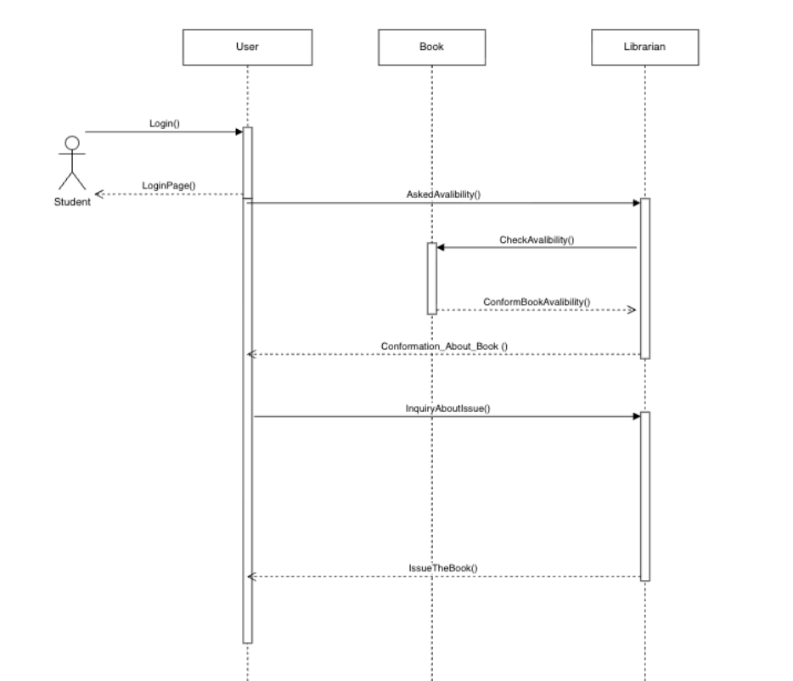

SequenceDiagram2:
