01 / PRODUCT VISION

A Crew that builds on its work
  - Memory V2 executive vision
A researcher keeps source criteria, a delivery member retains rollout rules, and a communications member remembers audience guidance. In Crew Mode, the coordinator assigns their work and brings their findings together. Private Memory V2 gives each participating member a separate place to retain its role knowledge.
Source draft fd5ed8c1. Historical 44546 evidence is separate. Current CI, security and reviews remain open. Not sealed.
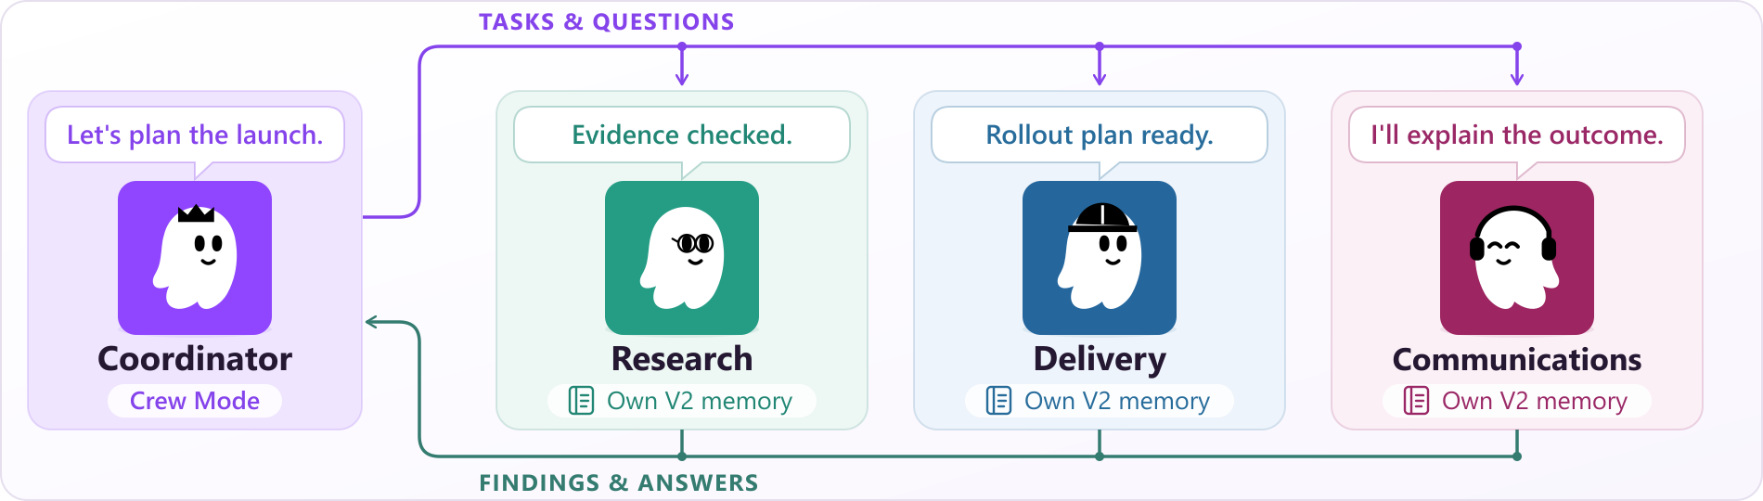
Illustrative V2 Crew: native Crew Members exchange assignments and findings through the coordinator. Their private memories remain separate; copying memories is an owner choice.

Crew Mode: one request, several responsibilities
For a product launch, ask the coordinator to assemble the plan. Research checks the evidence, delivery prepares the rollout, and communications drafts the announcement. Members return findings, receive follow-up work and contribute to the combined result. Each participating V2 member keeps its own memory.

Without Crew Mode: work directly with one member
Open Chat with this member for a focused follow-up. Ask the research member to reassess a source, or the delivery member to revise a rollout checklist. A V2 member receives its core guidance each turn and recalls relevant records when requested. Private member memory is available without assembling a Crew.

Adopt it when the role is ready
New members start with empty V2 when the setup supports it. Existing members keep their current Global or named V1 memory, even as the default agent. The owner chooses and confirms the move to private memory. Copy selected memories when useful; members do not automatically share or move memory.
02 / MEMORY V2

From a role to a repeatable workflow
Use case | Member journey | Owner checks
Product launch · Crew Mode | Assign research, rollout and communications work. Collect results and issue follow-ups. | Did each role use the right guidance and sources? Did the coordinator combine the findings correctly?
Ongoing research · Crew Mode off | Chat with the research member. Revisit a prior source or decision and inspect the recalled evidence. | Is the relevant decision recalled and correctly applied to the new task?
Recurring review · Agent schedule | Schedule a supported Agent task from the member’s current conversation. | Does the task use the intended member and produce a useful, traceable result?
Correct a working rule | In Memories, select records, make an edit and review the preview before Apply. | Does the next relevant task respect the correction and its source?

An explicit change of memory
An existing V1 member’s status describes the memory it uses today. After finishing or stopping its work and child tasks, choose Create private memory in Crew Manager. The opt-in confirmation explains the empty memory, fresh next chat and inability to return to previous V1 memory. Cancel keeps the current memory, conversation and unsaved edits. Old data, chats and existing schedules remain.

Control stays visible
Memories, Profile and Recovery separate records, guidance and backups. Facts, Lessons and Experiences identify record types. Copy memories names the destination; Global V1 opens its editor under Edit saved memories. The Set up private memory shortcut opens Crew Manager; creation starts only after confirmation there. A creating status shows the active request. V1 keeps the latest 20 accepted revisions per record; V2 does not automatically trim them. Proposals remain in both.

Pilot conditions and evidence
Run a small pilot on a supported setup and name an owner for backups and recovery. For memory setup problems, the gateway owner can run kirocrew doctor to see the affected member and reason. During an incident, pause new private memories and opt-ins while existing work follows its normal checks. Already-admitted work is not cancelled. Active V2 has automatic backups; V1 backups are manual. Monitor storage use and response time.
The pilot should test whether real tasks need less repeated briefing and fewer corrections. Historical 44546 retrieval found relevant records for 49 of 50 authored topics, using the examples that informed calibration. Nine memory-interface scenarios passed first attempt. The prior visual review found no concrete defect in 29 screenshots and 84 video samples; it was not continuous playback. Current CI, security and reviews remain open. No improvement in answers, teamwork or productivity is established.

