01 / ENGINEERING

Memory V2 technical design
  - Ownership, execution, retrieval and recovery
New or opted-in Crew Members own unique V2 stores. Valid existing Global or named V1 bindings remain usable. This reviews fd5ed8c1; verified 44546 evidence is historical. V1 retains established retrieval and conflict policies, with new accepted-history retention and shared repairs. [T1, T7, T8]
Source draft fd5ed8c1. Historical 44546 evidence is separate. Current CI, security and reviews remain open. Not sealed.
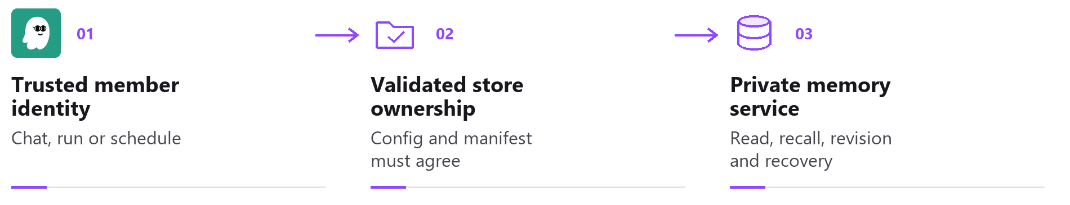
For a V2 member, verified identity resolves one owned store. Sharing gateway services does not share persisted memory.

Ownership and an explicit V1 choice
Admitted new members get empty V2. Existing members, including default_agent aliases, keep exact valid V1 until confirmed Create private memory. Dashboard opt-in refuses active member work or attached children, then retires idle V1 context. Passive V1 labels describe current state; opt-in confirmation explains an empty store, a fresh next chat and no switch back to V1. Old V1 data, conversations and scheduled identities remain; conflicting old threads cannot continue under the new binding. [T1, T2]
Data | Global V1 location | Private V2 location
Vector database | <home>/memory.db | <home>/memory_stores/<store>/memory.db
Core and history | <home>/workspace/memory/ | <home>/memory_stores/<store>/memory/
Text search index | <home>/memory_index.db | <home>/memory_stores/<store>/memory_index.db

Physical layout and algorithm version are separate axes. memory_items holds ID, kind, text or JSON, vector, source, timestamps, deletion state and optional scope/session provenance, with separate revision, event and proposal metadata. Compatibility views preserve legacy reader shapes. An unmarked crew-layout legacy store can still run V1. Private V2 requires crew layout and matching durable ownership; legacy physical tables beneath a V2 manifest are refused. [T1, T4]

Failures preserve identity
Creation checks edit fields, the member chat backend and OS sandbox before allocation or V1 context retirement. Failed or cancelled publication retires only the exact new, undeclared, unreferenced generation under the config lock; files remain. Published or uncertain ownership is preserved. Existing V2 is excluded from this cleanup. Safely retired failure permits retry from the existing V1 binding. Damaged V2 never falls back. Member deletion retains files; name reuse gets a fresh identity. [T1, T6]
02 / MEMORY V2

Core guidance and trusted execution
Each private turn refreshes member identity, conduct and owner persona, including minimal context. Task instructions cannot replace that persona. V2 skips speculative prewarming and resume prefetch; ACP resolves private identity off the event loop and checks capability before launch. Global V1 may prewarm; no latency gain is established. [T2, T5]

A complete core envelope
Core guidance has a 64,000-character envelope including wrappers and identity. It is complete or the turn refuses; ordinary context yields space first. Profile saves validate before commit and external edits are revalidated next turn. This does not guarantee a fit in every model window. [T2]
Project essentials include root AGENTS.md and SOUL.md, default/always steering and declared template Markdown. Other steering keeps its triggers. Optional root files may be absent; unreadable declared sources and malformed templates fail with a named reason. Bounded reads reject linked or foreign memory. [T2]
Four guarded hooks.py readers check the opened regular-file descriptor’s kernel path against the canonical name and sensitive paths before reading. Unknown locations or swapped parents refuse. Nonblocking admission prevents FIFO opens from waiting for a writer. Inode-allowlist, internal, copy and export readers retain distinct checks. [T2, T5]
Execution surface | Identity contract
Private chat | Existing V1 members retain their exact binding. Private V2 uses protected assignment or owner action; restored labels grant no authority. Own-session callbacks remain. Opt-in starts a fresh conversation identity.
Crew and spawned work | Continue, steer, status, results and history authenticate protected store identity. Lists, cleanup and spawned work keep that scope. Owner coordination remains available.
Agent schedules | Private jobs retain their verified creating session. Owner aggregate cron routes refuse private callers. Trigger text gates automatic Crew matching; explicit owner and own-member scheduling remain available.
TaskRunner and webhooks | Planning, retries, result reads and continuations keep trusted scope. Hook names include store identity. Shared provider refinement, private file planning and command/script schedules are unavailable.

Execution requires an enforced boundary
Private execution requires Linux or WSL namespaces, or macOS outer Seatbelt with Kiro internal delegation off. Kiro, Claude Code and KAS provide direct MCP support; native Windows and public Codex ACP remain unavailable. Member chat uses its backend; assigned work, Agent schedules and consolidation use the default backend. Linux/macOS fences include configured workspace roots. On Linux, loose root files are read-only; new ones enter the view after provider recreation. Eligible child directories remain writable within existing fences. [T5]
Delegated proofs recheck process incarnation, session, store and isolation; legacy proofs retain expiry. Darwin inherited Global authority requires live kernel read permission. With private boundaries active, shared kiro-cli logs reject private/unverified readers; verified Global V1 remains supported. Every tools/list request supplies proof, since session policy may be cached. Owner attribution may require gateway-host login. A denial-audit write failure preserves typed 403 refusal and never grants access. [T5, T7]
03 / MEMORY V2

Retrieval and embedding work
Core assembly does not embed a query or search historical memory. An explicit memory_recall request resolves the trusted store, admits candidates and packs evidence. V1 retains its session start injection and original semantic conflict, decay and live capacity policies. [T3, T7]
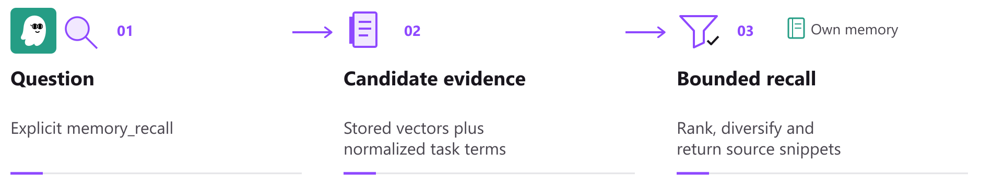
V2 scans the active episode population before final selection. Bounded responses do not imply bounded search cost.

Admission and ranking
Provisional cosine thresholds are 0.62 for short fragments and 0.57 above 300 characters. Lexical admission needs half the meaningful query terms and at least two distinct matches when the query has two or more terms. Text uses NFKC and casefold normalization, English function word filtering and adjacent pairs for Chinese, Japanese and Korean runs. JSON values are decoded before matching. [T3]
Episode rank combines 70 percent nonnegative cosine with 30 percent query coverage, then applies an importance multiplier from 0.85 to 1.0. Missing comparable vectors contribute zero cosine; coverage does not become the whole score. Optional MMR diversifies episodes. Facts use cosine plus coverage, with eligible pref.* keys bypassing query filtering. Age adds no penalty. [T3]

Packing records for HTTP and MCP
Recall has a 3,000-character body allowance and a separate 16 KiB transport limit. V2 can fit a long result with its full ID and truncation flag; V1 keeps its initial fitting policy. MCP text is normalized before character and byte counting, including NFC expansion. Actual UTF-8 HTTP JSON and the Unicode-escaped MCP frame are counted separately. The sole-result shortening floor is now one character, allowing a smaller marked snippet when it fits. Impossible wrapper budgets still require omission. Current integrated validation remains open. [T3]

Shared embedding capacity
Built-in embedding backends share one worker and a bounded priority queue, with caching and duplicate coalescing. Native threads default to four for interactive work and one for bulk, with explicit settings CPU-clamped. A signature hashes declared model_id and dimension, not model weights. Equal dimensions alone do not establish comparability; matching signatures do not prove identical weights. Changed signatures invalidate vectors for repair. Copies omit vectors. [T3, T7]
The sweep visits active Global and already-open named V1 and V2 stores; only Global waits for its boot migration and full repair task. It advances before a failure, handles at most 16 rows of each kind, opens no idle store and loads no absent model. Successful bounded repair appends to an existing resident index without rebuilding or saving the whole index per page. [T3, T7]
V1 FAISS bounds returned-hit filtering and fetches selected bodies in one batch. A starved window falls back to complete SQLite scoring. Native flat-index search can still scan the full index, which may retain deleted entries until rebuild; V2 still scans active episodes. No latency, CPU or cost gain is measured. [T3, T7]
04 / MEMORY V2

Revisions, learning and owner control
Opening V1 creates shared metadata/revision tables and indexes, backfills records and journals later changes by older binaries. Original rows and lineage remain; SQLite bytes change. Metadata tracks identity, validity, provenance and revision. Hashes exclude updated_at; timestamp-only edits add no revision unless forced. Writers own the content and revision transaction. Events API responses recursively redact credentials and unsafe URLs in nested values; event identity and persisted events remain unchanged. [T4, T7]

Accepted history has a versioned policy
Global and named V1 keep the latest 20 accepted snapshots per record, ordered by monotonic revision-row ID. Accepted writes and startup catch-up remove older accepted rows in the same transaction. Current records, metadata, revision counters, CAS and all proposals remain. This is auxiliary accepted-history retention. V2 never automatically prunes revisions and has no age/capacity eviction. The V1 bound does not cap total storage or shrink SQLite files; removed snapshots no longer appear in live history audits. [T4]

Compaction is an explicit offline procedure
memory compact-revisions can remove older accepted snapshots from one V1 or V2 store. Stop every writer on every host, disable auto-restart and verify a complete offline archive first. Preview opens SQLite read-only, but first configuration loading can complete normal migrations; archive original config before invoking the CLI. Apply requires the exact preview count and a new owner-restricted SQLite backup. Include --stopped to acknowledge that all writers are stopped. The database copy does not replace the complete archive. [T4, T6]
Existing private-store admission, SQLite exclusive locks, backup comparisons and one deletion transaction protect apply. Current content, metadata, counters, proposals and each latest accepted snapshot survive. The acknowledgement does not check for live writers. The CLI does not coordinate remote hosts, run VACUUM, shrink files or securely erase history. [T4, T6]

Learning and edits require current evidence
Extraction freezes its transcript and rechecks generation, source and revisions before writing. V2 uncertain corrections become proposals; verified evidence can authorize correction, but not replacement of owner notes. Semantic consolidation keeps source consolidation:<key> even at confidence 1, so it cannot automatically overwrite an active user_explicit fact. The separate V1 lesson writer still uses user_explicit. Topic overlap uses the larger keyword set. V1 source/confidence checks remain; V2 does not reject or delete distinct lessons merely for similarity. [T4, T7]
Bulk previews bind store, selection and operation for 15 minutes. Pages of 25 keep the digest and expiry; paging failure blocks Apply. Apply rechecks content and membership transactionally. Bounds are 500 explicit IDs or 10,000 filtered records and 32 MiB; restart invalidates previews. Redacted Profile sources are read-only. PUT checks do not reject every stale browser draft. [T2, T4]
Copy memories validates up to 50 selected source records, then commits each independently with provenance. Existing target identities are preserved; partial failure identifies completed, uncertain and unattempted items. Forget removes recall eligibility, not conversations or backups; retained revisions follow the policy above. There is no direct Undo. A suitable whole-store backup can recover an earlier state after restart. [T4, T6]
05 / MEMORY V2

Recovery and shared operations
A private backup contains an online SQLite backup and current memory documents. Its manifest records owner, store, time and file hashes; derived indexes are rebuilt. SQLite is transaction-consistent, but separate document reads do not form one atomic snapshot with it. [T6]
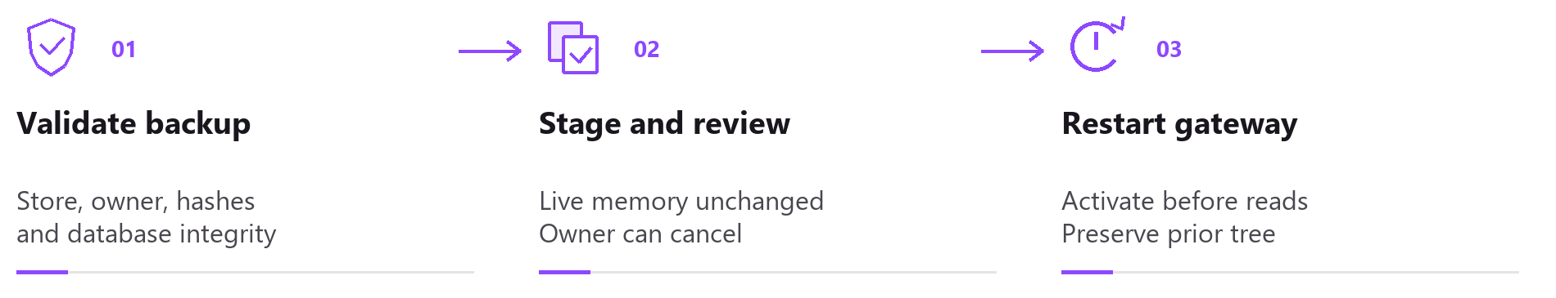
Restore is staged for a gateway restart. The activation journal preserves the previous tree; cancellation is only available where safe.

Validation before activation
Restore checks ownership, inventory, hashes, SQLite integrity and limits of 8,192 files and 1 GiB. Unsafe paths, links and foreign content refuse. POSIX private vector/Markdown users hold a shared lifetime lock outside the replaced directory; restore holds its exclusive peer through validation and replacement. Arbitrary host writes remain outside this protocol. Windows retains open-handle replacement refusal. [T6]

Recovery failures are tracked by store
Startup loads cron disarmed and publishes shared preparation before READY. Preparation gates Global restore/open and memory work. Agent turns wait at most 30 seconds before provider allocation or metadata; timeout asks for retry without cancelling preparation or counting a session failure. After preparation, cron, heartbeat and migration start. Structural failure pauses memory work; store failure fences that store. Shutdown remains supervised. [T6]
Failed-store status, safe cancellation and another restore remain available; reopening requires restart. Record restore cannot directly undo Forget and invalidates Global queries and episode/FAISS caches. Leaving the Memory panel has its own discard explanation; declining preserves drafts. Creating status belongs only to the current member request. [T2, T6, T7]
For unavailable or mismatched bindings, the editor points to kirocrew doctor on the gateway. It reports each member, configured store and refusal reason, and continues with peers. Its binding check does not initialize, allocate, rebind or repair memory, or prove full database health or execution capability. Normal CLI config loading and data-home setup still apply. [T2, T7]

Operations also affect Memory V1
Automatic V2 backups default on and retain seven copies; V1 backups are manual. V1 backups created at the same instant receive unique names; older names still list and restore. Global restore requires structural V1 lineage; named V1 also accepts unowned crew schema. Source and staged copy reject private, empty or unrelated databases before publishing a restore journal. Activation preserves displaced database, WAL and SHM files for owner cleanup. [T6, T7]
The dedicated data home is owner-restricted. File tools fence named stores; Global behavior remains. V1 keeps FAISS/NumPy and is outside V2 writer locks. Internal SHA256 imports stay private and add no public export. Main adds a cause-aware notice for empty turns. Monitor retained history and recovery copies. [T7]
06 / MEMORY V2

Evidence and release boundaries
Source fd5ed8c1ca00a296117c737e526c1bdcd057c4a5 is the fixed report baseline; parent/tree are in the notes. Current CI and reviews are pending. CodeQL retains 12 failed annotations. Opus858 had no discovery marker and gives no verdict. All four 858 frontend shards, coverage and bundle passed; BackendLint passed on dacb. These earlier results do not validate fd5. Not sealed. [T8]
During a provisioning or storage incident, memory.private_provisioning_enabled=false pauses new allocations and V1 opt-ins without restart. Existing V1/V2 work retains normal checks; admitted work is not cancelled. The separate emergency-withdrawal maintenance draft is unapplied and has no deployment validation. [T1, T7]

Historical 44546 retrieval measurement
Run 34433763685 used source 44546ae46d5dd3b2f67c6db813c3473cd9dc617a via merge e74dbe6ec831747774c3906698ddef7a7d4c94b9. All 1,426 reported canonical Python seals match the immutable head and corresponding merge blobs. Five native-library hashes and the model pin remain CI provenance claims; those bytes were not independently downloaded in this review. [T8]
Qwen artifact 10135513019 uses Qwen3 Embedding 0.6B, 1,024 dimensions, NumPy active and FAISS absent. Its report is byte-identical to the prior result. The authored English corpus has 50 topics, 100 fragments and 5,000 pairs per mode; the same corpus informed provisional thresholds. Model and corpus pins are retained in provenance. [T8]
Measurement mode | Topics hit | Relevant fragments | Irrelevant selections | Context nDCG@8
Full vectors | 49 / 50 | 93 / 100 | 5 | 0.931972
Short vectors absent | 48 / 50 | 73 / 100 | 5 | 0.769785
No embeddings | 37 / 50 | 56 / 100 | 5 | 0.596207

Full-vector precision is 94.9 percent; recall is 93 percent. Maximum reported context is 1,296 characters. Two oversized fixtures each pass eight predicates within 200 total context characters; estimated MCP size is 2,762/16,384 bytes. The 268 true Boolean fields are not independent tests. [T8]

Historical interface and isolation checks
44546 FAISS artifact 10135478508 records six expected passes; one case uses NumPy only. Both real Linux isolation canaries passed. UI artifact 10135852001 has all nine memory scenarios passing first attempt. The recorded visual review inspected 29 PNGs and 84 chronological samples across nine WebMs without a concrete defect; it was not continuous playback. Synthetic data and stub ACP do not establish live-provider quality or restart activation. [T8]
Exact original captures are hosted under temp-screenshots/memory-v2/ci-44546. Hosting fd5 does not make them fd5 captures; they predate later helper wording. The 858 E2E run may be superseded or cancelled and is not fresh fd5 evidence. No held-out, V1/V2 A/B, answer, task, productivity, CPU, latency or cost gain is established. Full rankings, rendered benchmark snippets and wire frames are absent. [T3, T8]
Sources: T1 ownership; T2 core/UI; T3 retrieval; T4 editing; T5 execution; T6 recovery; T7 V1; T8 evidence. Exact fd5 references and hashes: b02-qwen-review-notes.md.

