B.Tech. BCSE497J - Project-I
IDENTIFYING FAILURE-PRONE MICROSERVICES USING GRAPH CENTRALITY METRICS
Submitted in partial fulfillment of the requirements for the degree of
Bachelor of Technology
in
Computer Science and Engineering with Specialization in Data Science
by
23BDS0299 | DAKSHRAJSINH TANK

Under the Supervision of
Dr. BADRINATH N
Associate Professor
School of Computer Science and Engineering (SCOPE)

October 2026

DECLARATION
I hereby declare that the project entitled Identifying Failure-Prone Microservices Using Graph Centrality Metrics submitted by me, for the award of the degree of Bachelor of Technology in Computer Science and Engineering with Specialization in Data Science to VIT is a record of bonafide work carried out by me under the supervision of Dr. Badrinath N.
I further declare that the work reported in this project has not been submitted and will not be submitted, either in part or in full, for the award of any other degree or diploma in this institute or any other institute or university.

Place : Vellore
Date :

Signature of the Candidate

CERTIFICATE
This is to certify that the project entitled Identifying Failure-Prone Microservices Using Graph Centrality Metrics submitted by Dakshrajsinh Tank (23BDS0299), School of Computer Science and Engineering, VIT, for the award of the degree of Bachelor of Technology in Computer Science and Engineering with Specialization in Data Science, is a record of bonafide work carried out by him under my supervision during Fall Semester 2026-27, as per the VIT code of academic and research ethics.
The contents of this report have not been submitted and will not be submitted either in part or in full, for the award of any other degree or diploma in this institute or any other institute or university. The project fulfills the requirements and regulations of the University and in my opinion meets the necessary standards for submission.

Place : Vellore
Date :

Signature of the Guide

Signature of Examiner(s)

[Head of the Department]
[Department of the Head of the Department]

ACKNOWLEDGEMENTS
I thank the management of Vellore Institute of Technology for the opportunity and the facilities to carry out this project, and Dr. Jaisankar N, Dean of the School of Computer Science and Engineering (SCOPE), for the support of the School.
I am grateful to my guide, Dr. Badrinath N, for his supervision throughout the project, and in particular for supporting the decision to rebuild the study from measurement once problems with the first version were found.
An AI assistant (Claude, by Anthropic) was used during the project to help write and review code and to draft and edit the text of this report from the project's own records. I ran the experiments, checked the content of this report against the logged data, and take responsibility for it.
Dakshrajsinh Tank

TABLE OF CONTENTS
Sl.No | Contents | Page No.
 | ABSTRACT
1. | INTRODUCTION
1.1 | Background
1.2 | Motivations
1.3 | Scope of the Project
1.4 | Changes Since the Review-2 Draft
2. | PROJECT DESCRIPTION AND GOALS
2.1 | Literature Review
2.2 | Research Gap
2.3 | Objectives
2.4 | Problem Statement
2.5 | Project Plan
3. | TECHNICAL SPECIFICATION
3.1 | Requirements
3.1.1 | Functional
3.1.2 | Non-Functional
3.2 | Feasibility Study
3.2.1 | Technical Feasibility
3.2.2 | Economic Feasibility
3.2.3 | Social Feasibility
3.3 | System Specification
3.3.1 | Hardware Specification
3.3.2 | Software Specification
4. | DESIGN APPROACH AND DETAILS
4.1 | System Architecture
4.2 | Design
4.2.1 | Data Flow Diagram
4.2.2 | Use Case Diagram
4.2.3 | Class Diagram
4.2.4 | Sequence Diagram
5. | METHODOLOGY AND TESTING
5.1 | Module Description
5.1.1 | Graph Reconstruction Module
5.1.2 | Predictor Module
5.1.3 | Run and Fault-Injection Module
5.1.4 | Measurement Module
5.1.5 | Analysis Module
5.1.6 | Preregistration and Deviations
5.2 | Testing
6. | PROJECT DEMONSTRATION
7. | RESULT AND DISCUSSION
7.1 | Campaign Completion
7.2 | The Caller Count (H1)
7.3 | The Fan-Out Metric (H2)
7.4 | Replication and Direction of Propagation
7.5 | Limits of the Design
7.6 | Discussion
7.7 | Objective Attainment
7.8 | Cost Analysis
8. | CONCLUSION
9. | REFERENCES
 | APPENDIX A – SAMPLE CODE

LIST OF FIGURES
Figure No. | Title | Page No.
2.1 | Project timeline, built from the dates of the repository's commits; each phase ends at a milestone commit.
4.1 | Deployment of the test bed: the host, the Docker virtual machine with the application, Jaeger and Pumba containers, and the load generator and campaign runner on the host.
4.2 | Pipeline in execution order, with the repository files that carry out each step.
4.3 | Data flow diagram, Level 0 (context diagram).
4.4 | Data flow diagram, Level 1. Data stores D1 to D6 are folders and files of the repository.
4.5 | Use case diagram.
4.6 | Sequence diagram of one campaign run (function one_run in tools/run_pilot.py).
5.1 | Social Network dependency graph as observed in traces, with the gateway marked.
5.2 | Hotel Reservation dependency graph as observed in traces, with the gateway marked.
5.3 | Per-service p95 under a latency fault in search, measured on the end-to-end root span (left) and on each service's own spans (right); an asterisk marks a service flagged as degraded.
7.1 | Caller count X against the measured number of degraded callers Y for each Social Network service; points on the dashed line are saturated.
7.2 | Leave-one-out check (post hoc): ρ between X and Y on Social Network under kill faults, with each service withheld in turn.
7.3 | Rank of each Social Network service by the hybrid metric and by caller count, with compose-post-service highlighted.
7.4 | Post hoc weight sensitivity: ρ of the hybrid metric against degraded callers and against gateway error rate for every weight triplet.

LIST OF TABLES
Table No. | Title | Page No.
2.1 | Comparison of the works closest to this project
3.1 | Hardware of the test host
3.2 | Software used, with versions as recorded
5.1 | Commands issued by the runner in each run
5.2 | Deviations from the locked plan
7.1 | Graph predictors and measured outcomes, Social Network
7.2 | The primary test in each family and application
7.3 | The hybrid criticality metric against degraded callers
7.4 | What the design could detect
7.5 | Status of the project objectives
7.6 | Project cost

LIST OF ABBREVIATIONS
Abbreviation | Full Form
BCa | Bias-corrected and accelerated (bootstrap interval)
BH | Benjamini-Hochberg (false discovery rate procedure)
CSV | Comma-separated values
DFD | Data flow diagram
FDR | False discovery rate
HC | Hybrid criticality (the fan-out-weighted metric of the original proposal)
HR | Hotel Reservation (DeathStarBench application)
p95, p99 | 95th and 99th latency percentiles
RPC | Remote procedure call
SN | Social Network (DeathStarBench application)
SRE | Site reliability engineering
WSL | Windows Subsystem for Linux

SYMBOLS AND NOTATIONS
Symbol | Meaning
X | Caller count: the number of transitive callers (ancestors) of a service
Y | Primary outcome: the median number of degraded callers when the service is faulted
HC | Hybrid criticality metric (fan-out-weighted centrality)
ρ | Spearman's rank correlation coefficient
p | p-value of a permutation test
q | False discovery rate level of the Benjamini-Hochberg procedure
H1, H2 | Hypotheses of the study (Section 2.4)
u → v | Edge of the call graph: service u calls service v
W | Warm-up and baseline window of a run
H | Time for which a fault is held
P | Interval of the recovery probe
C | Cap on the measured recovery time

ABSTRACT
Operators of microservice applications have to decide which services to harden first, and a tempting shortcut is to rank services by their place in the call graph instead of injecting faults into each one. A widespread intuition, and the starting point of this project, is that a service which calls many others is the most dangerous to lose. A failed service, however, mainly hurts the services that wait on it, which are its callers, so a ranking by callers could be the better guide.
This project tested both views with a fault-injection campaign on two applications of the DeathStarBench benchmark suite, Social Network and Hotel Reservation, deployed with Docker on a single laptop host. The hypotheses and every analysis choice were written down and locked before the campaign began. Dependency graphs were rebuilt from Jaeger traces, every analysable service received a process kill and a 500 ms network delay with 5 repetitions each, giving 180 runs, and the latency and error rate of each service were measured on the spans that the service itself emits. Every degraded service was then classified as a caller (ancestor), a callee (descendant) or an unrelated service of the faulted one.
On Social Network under kill faults, the number of transitive callers of a service and the number of callers that degraded correlated at Spearman ρ = 0.785, but none of the 44 confirmatory tests survived Benjamini-Hochberg correction (adjusted p = 0.3451), and the latency-fault replication gave the same verdict. Much of that correlation holds by construction, because most services degraded every caller they had. The fan-out-weighted centrality metric of the original proposal correlated negatively with degraded callers for both applications and both fault types, and in no case could it be told apart from zero. The clearest finding concerns direction: no callee of the faulted service degraded in 179 of 180 runs, so failures travelled to callers and almost never to callees.
The project therefore answers its title question mostly in the negative: the centrality metric it set out to validate did not identify the failure-prone services. It also shows that charging a request's end-to-end latency to every service on its path flags unrelated services, and it provides scripts that regenerate every number in this report from the logged data.
Keywords: microservices, fault injection, distributed tracing, graph centrality, failure propagation, preregistration.

CHAPTER 1. INTRODUCTION

1.1 Background
A microservice application is split into many small services that communicate over the network and can be developed, deployed and scaled independently [1, 2]. That independence is the reason teams adopt the style, but it moves complexity into operations: practitioners report real pains alongside the gains [3], performance engineering for such systems still has open problems [4], and outage studies and industrial surveys show that failures in service-based systems are frequent and slow to diagnose [5, 6]. When one service fails, the effect can spread through the services that depend on it.
Distributed tracing records, for each request, which service called which, so the call graph of a running application can be recovered from its traces [7]. Graph theory offers many measures of how central a node is [8], and network measures computed on software dependency graphs have helped predict where defects occur [9]. This suggests reading a service's risk from its position in the call graph.

1.2 Motivations
The direct way to learn which service does the most damage when it fails is to inject faults into every service, once for each fault type and with repetitions. That is slow and costly on a large system. A ranking computed from the call graph would be almost free, so it is worth knowing whether such a ranking can be trusted.
The project began with a specific ranking: a hybrid criticality metric that boosts out-degree centrality by fan-out, on the argument that a service calling many others cuts many links when it fails. There is an argument in the opposite direction. When a service fails, the services left waiting are the ones that call it; the services it calls simply receive less traffic. If that is right, the number of services that degrade should follow a service's callers, and a fan-out ranking would be wrong exactly for the services it rates highest. Settling this question with measurement, rather than with intuition, was the motivation for the project.

1.3 Scope of the Project
The study covers the Social Network and Hotel Reservation applications of DeathStarBench [10], built from one pinned commit and run with Docker Compose on a single laptop host, one application at a time. two fault types were used: a process kill and an injected network delay. Load came from a synthetic workload with a fixed request mix. The call graphs were reconstructed from traces collected under that workload.
Outside the scope are production systems, Kubernetes orchestration, multi-host deployments, containment mechanisms such as retries and circuit breakers, and fault types other than kill and delay. CPU contention was tried in the pilot and dropped because its effect was too small to classify reliably. The results describe these two benchmark applications under this workload and are not a claim about production behaviour.

1.4 Changes Since the Review-2 Draft
The draft report presented at Review 2 reported strong correlations between centrality metrics and failure impact. After that review, an audit of the project's own pipeline found that those results were not supported by measurement: part of the measurement log consumed by the correlation scripts had been generated by a script rather than measured, the recovery-time column did not measure what its definition said, and the metric weights had been chosen by searching for the weighting that maximised the same correlation that was then reported.
The preliminary results of the Review-2 draft are therefore withdrawn. The affected files were moved to a quarantine folder rather than deleted (14 items, each with a note of why), the measurement code was corrected, the hypotheses and analysis were locked in advance, and a new campaign was run. Everything in this report comes from that new campaign. The registered project title is kept unchanged as required, but it should be read as the question the project tested; the answer, as Chapter 7 shows, is largely negative.

CHAPTER 2. PROJECT DESCRIPTION AND GOALS

2.1 Literature Review
Microservices and their operation. Dragoni and colleagues trace the evolution of the microservice style and define its main traits [1], and Jamshidi and colleagues review its history and the challenges ahead [2]. A systematic review of grey literature collects the pains and gains reported by practitioners [3], and Heinrich and colleagues set out research challenges in performance engineering for microservices [4]. On failures, Gunawi and colleagues draw lessons from hundreds of cloud service outages [5], and Zhou and colleagues combine an industrial survey of fault analysis in microservice systems with a benchmark system and an empirical study [6]. The applications studied here come from DeathStarBench, an open-source suite of end-to-end microservice benchmarks [10].
Graph measures. Freeman clarified several distinct notions of centrality, from direct ties to shortest paths, and gave them normalised forms [8]. Brandes made betweenness practical on large graphs with a faster algorithm [11]. Bonacich proposed a family of power-based centrality measures related to eigenvector centrality [12], PageRank came from the design of a web search engine [13], and Lengauer and Tarjan gave a fast algorithm for dominators in flow graphs [14]. The NetworkX library used here implements these measures [15].
Robustness of networks. Albert, Jeong and Barabási studied how complex networks tolerate random errors and targeted attacks [16], and Motter and Lai examined attacks that act through cascades [17]. These studies remove nodes from a graph; in a running microservice system the failed service stays in the graph and its effect shows up as latency and errors in other services, which must be measured on the running system.
Graphs in software engineering. Zimmermann and Nagappan showed that network measures on the dependency graph of a large system help predict which components contain defects [9]. Ma and colleagues built a service dependency graph to analyse and test microservice systems [18]. This project shares the premise that position in a dependency graph carries information about risk, but its outcome is the run-time spread of a failure under load.
Fault injection and chaos engineering. Basiri and colleagues describe chaos engineering at Netflix, where controlled experiments build confidence that a system tolerates failure [19], and later its automation in production [20]. Gremlin tests the resilience of microservices by injecting faults between services [21], and Meiklejohn and colleagues bring fault injection testing down to individual services [22]. Lineage-driven fault injection reasons backwards from a correct outcome to choose the faults most likely to break it [23]. Huang and colleagues describe gray failure, where a component keeps running but works badly [24]; an injected delay is a controlled form of such a partial failure. These tools look for bugs or check fallbacks; here faults are used as a measuring instrument in a fixed, balanced design.
Tracing and call graphs. Dapper introduced the span model followed by most tracing systems, in which a request becomes a tree of spans with parent links [7]; the parent-child links between spans of different services give the caller-to-callee edges used in this project. Luo and colleagues found that call graphs in Alibaba's production traces are highly dynamic [25], a reminder that a graph built from traces depends on the traffic that produced it.
Failure diagnosis. Pinpoint addressed problem determination in large Internet services [26]. For microservices, Microscope locates performance problems using causal graphs [27], MicroRCA ranks candidate root causes on a graph of the running system [28], and Seer applies large-scale data analysis to performance debugging [29]. Soldani and Brogi survey anomaly detection and root-cause analysis for service-based cloud applications [30]. These methods start after an anomaly has begun; this project asks whether graph structure alone, before any fault, indicates which services matter most.
Statistical method. Preregistration separates planned analyses from those found after seeing the data [31]. The Benjamini-Hochberg procedure controls the false discovery rate across a family of tests [32]. Permutation p-values should never be zero, which is ensured by adding one to both counts [33]. Bias-corrected and accelerated bootstrap intervals [34] and the Cox proportional hazards model [35] complete the toolkit used here.
Table 2.1 compares the works closest to this project.
Table 2.1: Comparison of the works closest to this project
S.No | Paper | Objective | Methodology | Pros/Cons | Key Findings
1. | Freeman (1978), Centrality in Social Networks: Conceptual Clarification [8] | Clarify what makes a node central in a network | Conceptual analysis of degree, betweenness and closeness, with normalised forms | Pro: defines measures used as predictors here. Con: no link to failures or load | Different notions of centrality capture different structural roles
2. | Albert, Jeong and Barabási (2000), Error and attack tolerance of complex networks [16] | Study how complex networks tolerate random failures and targeted attacks | Removal of nodes from model and real networks while tracking connectivity | Pro: classic link between structure and robustness. Con: failure is node removal, not latency and errors in a running system | Scale-free networks tolerate random failures but break quickly when the most connected nodes are removed
3. | Motter and Lai (2002), Cascade-based attacks on complex networks [17] | Examine attacks that act through cascades of overload | Load-redistribution model on networks with uneven load | Pro: shows one failure can spread. Con: simulated load, no measurement | Removing one highly loaded node can set off a large cascade
4. | Zimmermann and Nagappan (2008), Predicting Defects Using Network Analysis on Dependency Graphs [9] | Predict defect-prone components from dependency graphs | Network measures on the dependency graph of a large commercial system, compared with complexity metrics | Pro: graph position carried risk information. Con: outcome is defects, not run-time failure spread | Network measures identified defect-prone binaries better than complexity metrics alone
5. | Gan et al. (2019), An Open-Source Benchmark Suite for Microservices and Their Hardware-Software Implications for Cloud & Edge Systems [10] | Provide open benchmark applications built from microservices | Several end-to-end applications studied for hardware and software implications | Pro: realistic, open applications, used as the test bed here. Con: synthetic workloads | Microservice performance is sensitive to network processing and tail latency, and slowdowns can spread across dependent services
6. | Basiri et al. (2016), Chaos Engineering [19] | Describe chaos engineering at Netflix | Controlled fault-injection experiments on production systems | Pro: fault injection as a way to learn how a system fails. Con: aims at confidence, not at ranking services | Experiments on live systems build confidence that they tolerate failure
7. | Heorhiadi et al. (2016), Gremlin: Systematic Resilience Testing of Microservices [21] | Test the resilience of microservice applications | Gremlin injects faults into messages between services and checks recovery behaviour | Pro: service-level fault injection. Con: checks fallbacks, not impact ranking | Systematic fault injection exposes missing or faulty failure handling
8. | Sigelman et al. (2010), Dapper, a Large-Scale Distributed Systems Tracing Infrastructure [7] | Trace requests across a large distributed system | Dapper: spans with parent links, sampling and always-on collection | Pro: span model gives the caller-to-callee edges used here. Con: traces alone do not say which service matters most | Low-overhead tracing is practical at production scale
9. | Luo et al. (2021), Characterizing Microservice Dependency and Performance: Alibaba Trace Analysis [25] | Characterise microservice call graphs in production | Analysis of large-scale production traces from Alibaba | Pro: real call graphs at scale. Con: no fault injection | Call graphs are highly dynamic and vary between requests and over time
10. | Lin, Chen and Zheng (2018), Microscope: Pinpoint Performance Issues with Causal Graphs in Micro-service Environments [27] | Locate the cause of performance problems in microservices | Microscope builds a causal graph from service communication and ranks root causes | Pro: uses graph structure for diagnosis. Con: works only after an anomaly begins | Causal graphs help pinpoint the services behind performance anomalies
11. | Wu et al. (2020), MicroRCA: Root Cause Localization of Performance Issues in Microservices [28] | Rank candidate root causes of performance issues | MicroRCA: attributed graph of the running system ranked with personalised PageRank | Pro: combines centrality with run-time metrics. Con: needs an anomaly and metrics | Graph-based ranking located root causes in a benchmark microservice system
12. | Soldani and Brogi (2022), Anomaly Detection and Failure Root Cause Analysis in (Micro) Service-Based Cloud Applications: A Survey [30] | Survey anomaly detection and root-cause analysis for service-based cloud applications | Systematic review of published techniques | Pro: maps the diagnosis field. Con: diagnosis, not prediction before faults | Techniques are grouped by whether they use logs, distributed traces or monitored metrics
13. | Nosek et al. (2018), The Preregistration Revolution [31] | Argue for preregistering research plans | Position paper separating confirmatory from exploratory analysis | Pro: basis for locking the plan here. Con: general, not specific to systems research | Preregistration separates prediction from postdiction and makes results more credible
14. | Benjamini and Hochberg (1995), Controlling the False Discovery Rate: A Practical and Powerful Approach to Multiple Testing [32] | Control errors when many hypotheses are tested | Step-up procedure on ordered p-values | Pro: used for every test family here. Con: original proof assumes independent tests | Controlling the false discovery rate gives more power than family-wise error control

2.2 Research Gap
Graph measures have been used to rank software components by defect risk, network studies examine tolerance to node loss, fault-injection tools test whether systems survive failures, and diagnosis methods use the graph once an anomaly is under way. Among the works reviewed, none reports a test, fixed in advance, of whether a graph-derived ranking of services anticipates how far failures spread when they are measured in a controlled campaign. In particular, the common fan-out intuition and the opposing caller-based argument had not been compared against measured outcomes with a correction for the many tests involved. This project fills that gap, and reports the result even though it came out null.

2.3 Objectives
- Reconstruct the call graph of each application from traces of the running system rather than from documentation, and freeze it as a file.
- Compute, for every service, the caller count (number of transitive callers), the hybrid criticality metric of the original proposal and further graph measures as comparators.
- Write down and lock the hypotheses, outcomes, thresholds and statistical tests before collecting any campaign data, and log every later change as a dated deviation.
- Run a fully crossed, balanced fault-injection campaign in which every analysable service receives each fault type the same number of times.
- Measure latency and error rate per service on that service's own spans, and classify every degraded service by its graph relation to the faulted one.
- Test whether the caller count (H1) or the hybrid metric (H2) tracks the number of degraded callers, with permutation tests and Benjamini-Hochberg correction.
- Make every number in the report reproducible by a script from the logged data.

2.4 Problem Statement
Let the call graph of an application have the services as nodes and an edge from u to v when u calls v under the traced workload. The ancestors of a service v are all services from which v can be reached (its transitive callers) and its descendants are all services v can reach (its transitive callees). When a fault is applied to v, the degraded set is the set of other services whose own latency or error rate crosses the degradation rule during the fault window. The primary outcome Y of a service is the median, over its repetitions, of the number of degraded ancestors; degraded descendants and degraded unrelated services are counted separately and never added to Y.
The problem is to find out whether a graph property of a service, known before any fault, predicts Y. The primary predictor X is the caller count. The comparator of interest is the hybrid criticality metric HC, which adds weighted in-degree centrality, out-degree centrality scaled by the service's share of the maximum out-degree, and betweenness centrality, with weights 0.4, 0.4 and 0.2. Hypothesis H1 states that X is positively correlated with Y. Hypothesis H2 states that HC is not positively correlated with Y, that is, that the fan-out premise points the wrong way.

2.5 Project Plan
The project timeline is shown in Fig. 2.1. It is built by a script from the dates of the commits in the project repository, so it shows what was actually done and when, rather than a plan drawn afterwards. Work before the first commit, such as topic selection and the first review, left no dated record in the repository and is not shown. The audit, the rebuilt pipeline, the pilot, the locked plan and the campaign took place within a few days of one another, after which the analysis and the write-up followed.
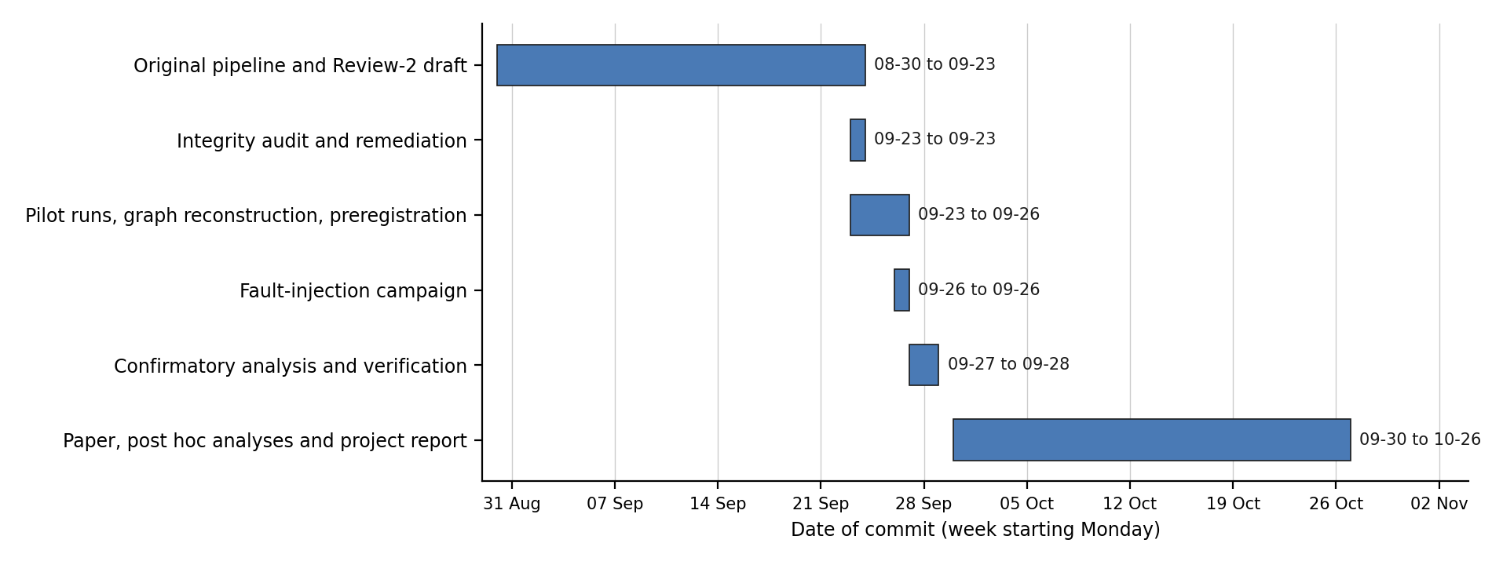
Fig. 2.1: Project timeline, built from the dates of the repository's commits; each phase ends at a milestone commit.

CHAPTER 3. TECHNICAL SPECIFICATION

3.1 Requirements

3.1.1 Functional
- Trace collection: query the Jaeger API for the traces of each application service and store the raw spans.
- Graph reconstruction: build a directed caller-to-callee graph from parent-child span links between different services, and save it as a frozen file.
- Predictor computation: compute the caller count, descendant count, hybrid criticality, degree-based, path-based and spectral centralities and dominator subtree size for every service.
- Target resolution: find the container to fault as the single container whose compose service label equals the service name, and stop if none or several match.
- Fault injection: apply a kill (SIGKILL) or a network delay with jitter through Pumba, hold it for a fixed time, and restore the service afterwards.
- Per-service measurement: compute each service's latency percentiles and error rate from its own spans in the baseline and fault windows.
- Blast-radius classification: split the degraded services into ancestors, descendants and unrelated services of the faulted one.
- Recovery probe: measure the time from fault removal until all indicators are back within tolerance of the baseline, or record the run as censored.
- Run records: write one record per run, with the raw spans of the baseline and fault windows stored alongside.
- Integrity gates: before any statistics, confirm that every expected service was present in every run and that no baseline was anomalous.
- Statistical analysis: compute Spearman correlations with permutation p-values, bootstrap intervals and Benjamini-Hochberg correction within each test family.
- Reproducibility: regenerate every number, table and figure from the logged data with one build command.

3.1.2 Non-Functional
- Integrity: no measurement, impact value or recovery time may be generated rather than measured; a value that cannot be traced to a script and an input file is reported as missing.
- Reproducibility: the benchmark code is pinned to one upstream commit (6ecb097), and raw spans are kept so that any metric can be recomputed without re-running the experiment.
- Isolation: only one application stack runs at a time, and a lock file prevents two runs from overlapping.
- Robustness: the campaign runner is resumable after a crash and repeats a run with incomplete telemetry in its own cell, never filling it in.
- Traceability: every number in the paper and in this report carries a claim id that names its source file and script.
- Safety: faults are injected only into local containers of the benchmark applications; no production system or real user data is involved.

3.2 Feasibility Study

3.2.1 Technical Feasibility
All components are mature open-source tools: Docker and Docker Compose for deployment, Jaeger for tracing, Locust for load, Pumba for fault injection, and Python with NetworkX, SciPy and statsmodels for analysis. The whole campaign ran on one laptop, with the two stacks brought up one at a time to stay within the memory available to Docker. The 180 campaign runs took about 8.5 hours of wall-clock time, so the experiment is feasible without a cluster.

3.2.2 Economic Feasibility
No licence fees or cloud resources were needed. The software is open source, Docker Desktop is free for educational use, and the experiments ran on the author's own laptop. The only cost is computing time on an existing machine, which makes the method affordable for a student project and easy for others to repeat.

3.2.3 Social Feasibility
The experiments use public benchmark applications in an isolated local environment, so no real users or personal data are affected. The findings are relevant to operations teams who must decide where to spend resilience effort. Reporting a null result honestly, instead of presenting a favourable one, is itself part of the project's contribution to sound practice.

3.3 System Specification

3.3.1 Hardware Specification
Table 3.1: Hardware of the test host
Item | Value | Source
Host OS | Microsoft Windows 11 Home Single Language (10.0.26300) | measured on 2026-10-20
Host CPU | 12th Gen Intel(R) Core(TM) i7-1255U, 10 cores, 12 threads | measured on 2026-10-20
Host RAM (GB) | 15.7 | recorded 2026-09-24
Docker VM memory (GiB) | 7.598 (WSL2 default) | recorded 2026-09-24
Containers per stack | Social Network 27, Hotel Reservation 24 | recorded 2026-09-24; one stack at a time

3.3.2 Software Specification
Table 3.2: Software used, with versions as recorded
Item | Value | Source
Docker Desktop | 4.91.0, WSL2 backend | version measured on 2026-10-20
Docker client / Compose | 29.8.0 / 5.5.1 | client recorded 2026-10-18; Compose measured on 2026-10-20
DeathStarBench commit | 6ecb097 | pinned upstream commit
Jaeger | 1.62.0 all-in-one, in-memory storage | compose override file
Pumba | ghcr.io/alexei-led/pumba, untagged image | version not recorded
Python | 3.13.2 | repository README
Python libraries | NumPy 2.1.2, pandas 2.2.3, SciPy 1.14.1, statsmodels 0.14.6, NetworkX 3.6.1, matplotlib 3.9.2 | repository README
Locust | 2.46.3; 25 users, spawn rate 10 users/s, 0.5 to 1.5 s between requests | runner and Locust files

CHAPTER 4. DESIGN APPROACH AND DETAILS

4.1 System Architecture
The test bed is a single Windows host. The application stack, the Jaeger tracing backend and the Pumba fault injector run as containers inside the virtual machine of Docker Desktop's WSL2 backend, while the Locust load generator and the campaign runner run on the host (Fig. 4.1). The Social Network stack has 27 containers and the Hotel Reservation stack 24; the runner never runs both at once.
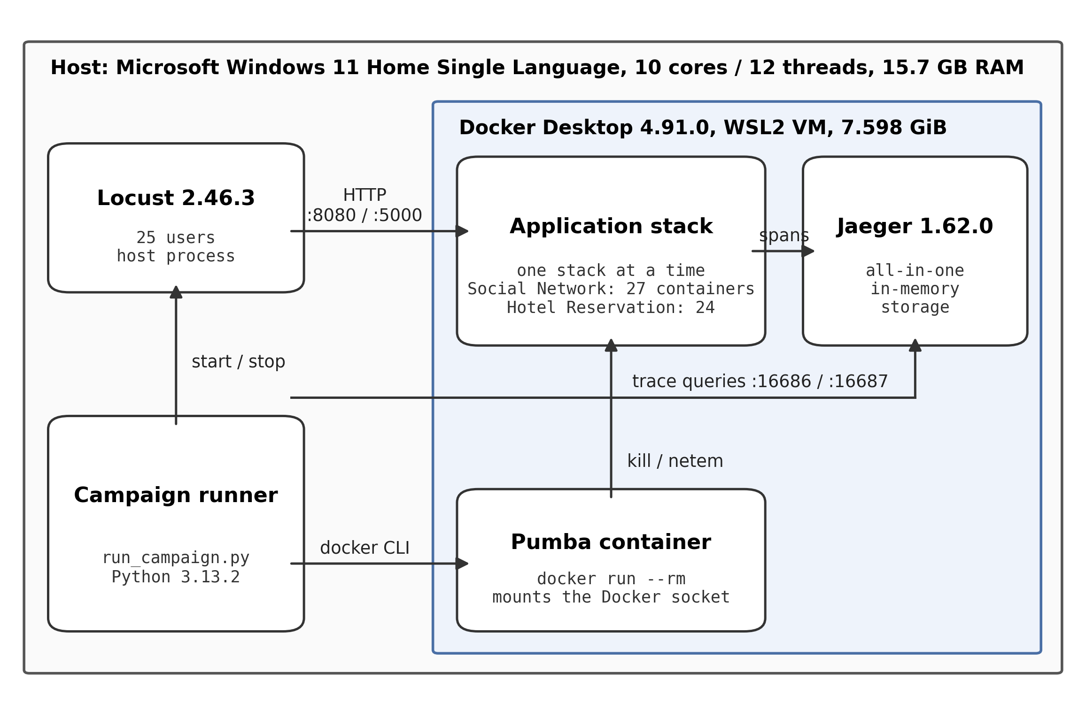
Fig. 4.1: Deployment of the test bed: the host, the Docker virtual machine with the application, Jaeger and Pumba containers, and the load generator and campaign runner on the host.
The software is organised as a pipeline (Fig. 4.2). The first steps build the dependency graphs and predictors and lock the plan before any campaign data exist; the middle steps repeat in every run; the final steps run once the campaign is complete. Each box names the files that implement the step.
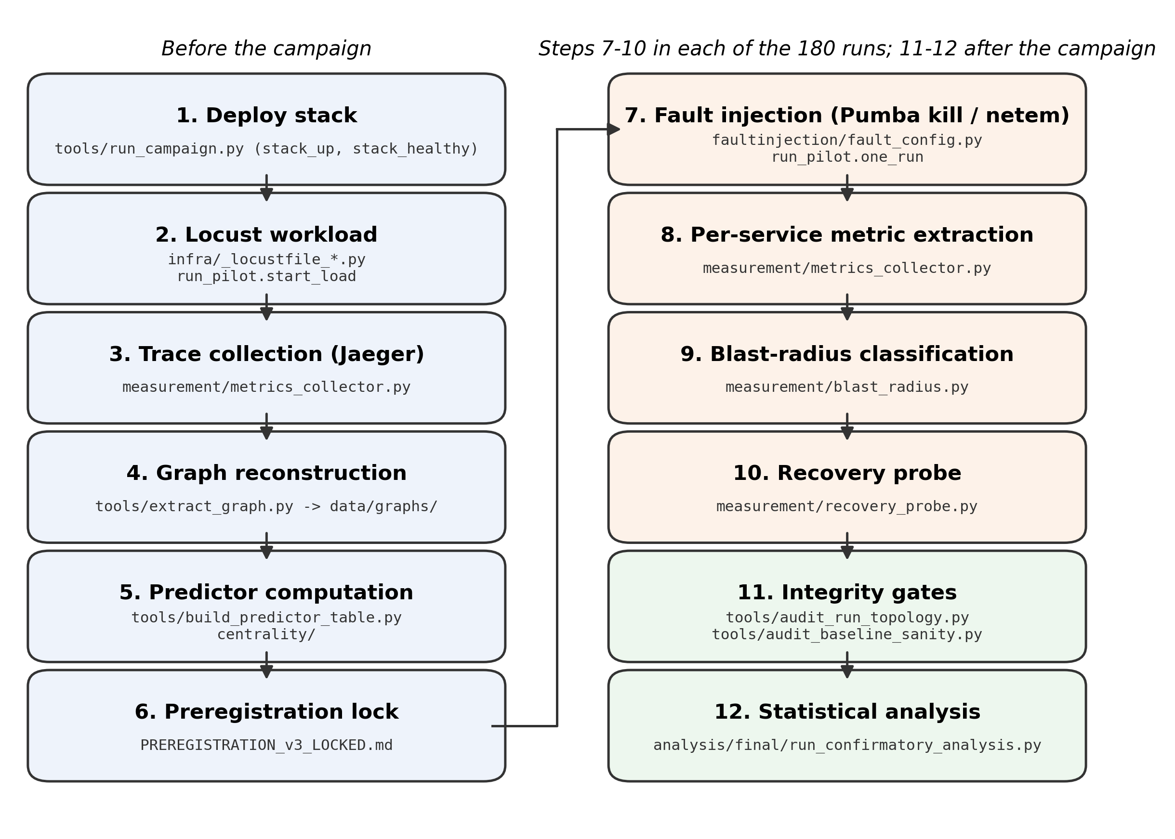
Fig. 4.2: Pipeline in execution order, with the repository files that carry out each step.

4.2 Design

4.2.1 Data Flow Diagram
At the context level (Fig. 4.3) the pipeline exchanges data with its external entities: the researcher, who supplies the locked plan and the run manifest and receives the results; the application stack, which receives load, fault and restore commands; and the Jaeger backend, which supplies the spans that the services emit.
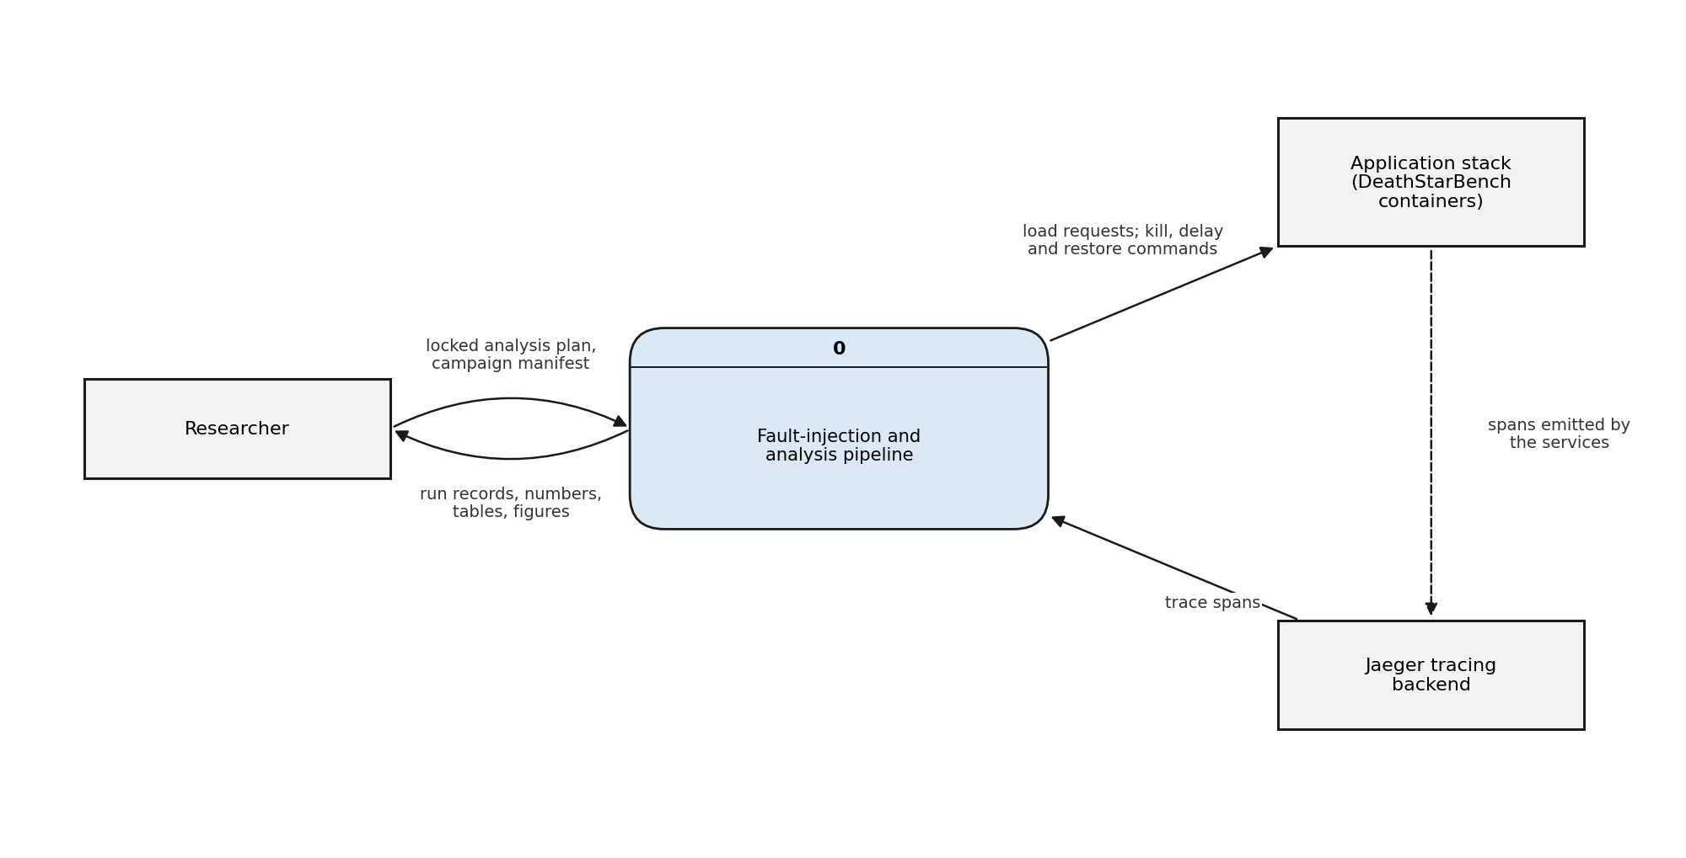
Fig. 4.3: Data flow diagram, Level 0 (context diagram).
At Level 1 (Fig. 4.4) the pipeline splits into processes 1.0 to 6.0. Graph reconstruction (1.0) and predictor computation (2.0) run before the campaign. For every entry of the run manifest, process 3.0 drives one run while process 4.0 measures its outcome from the spans and writes a run record. Statistical analysis (5.0) reads all run records and the predictor table, and the build step (6.0) turns the analysis outputs into the numbers, tables and figures of the paper and this report.
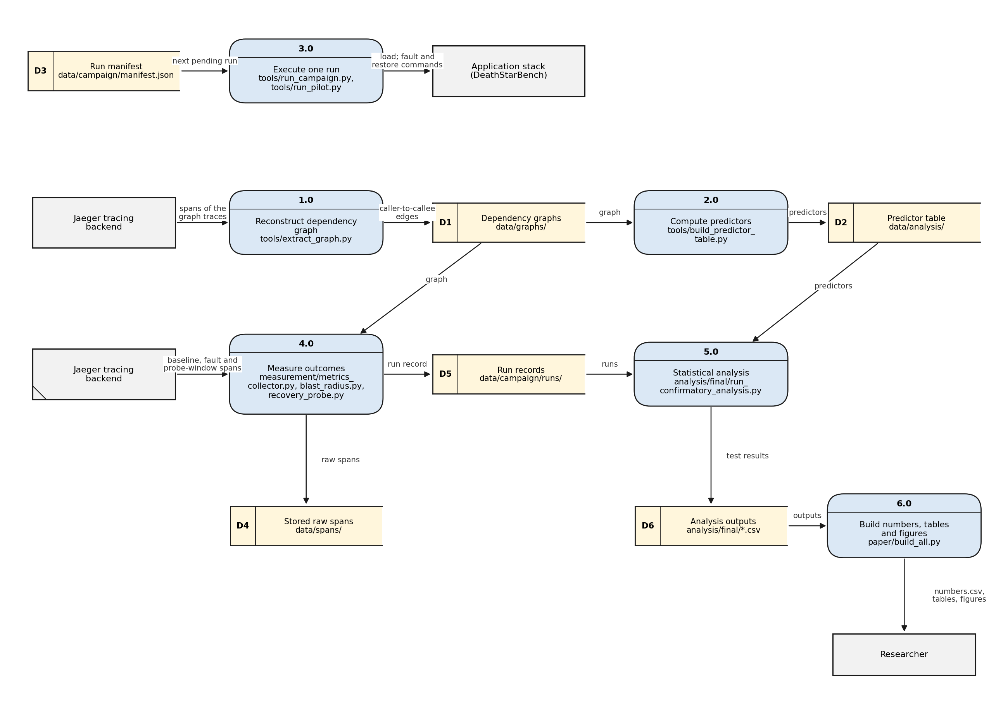
Fig. 4.4: Data flow diagram, Level 1. Data stores D1 to D6 are folders and files of the repository.

4.2.2 Use Case Diagram
Fig. 4.5 shows the actors. The researcher locks the plan, reconstructs the graphs, runs the campaign (which includes injecting a fault and measuring its effect) and checks run integrity. A reviewer can rerun the confirmatory analysis, regenerate every number, table and figure, and inspect the stored run records and spans without access to the test bed.
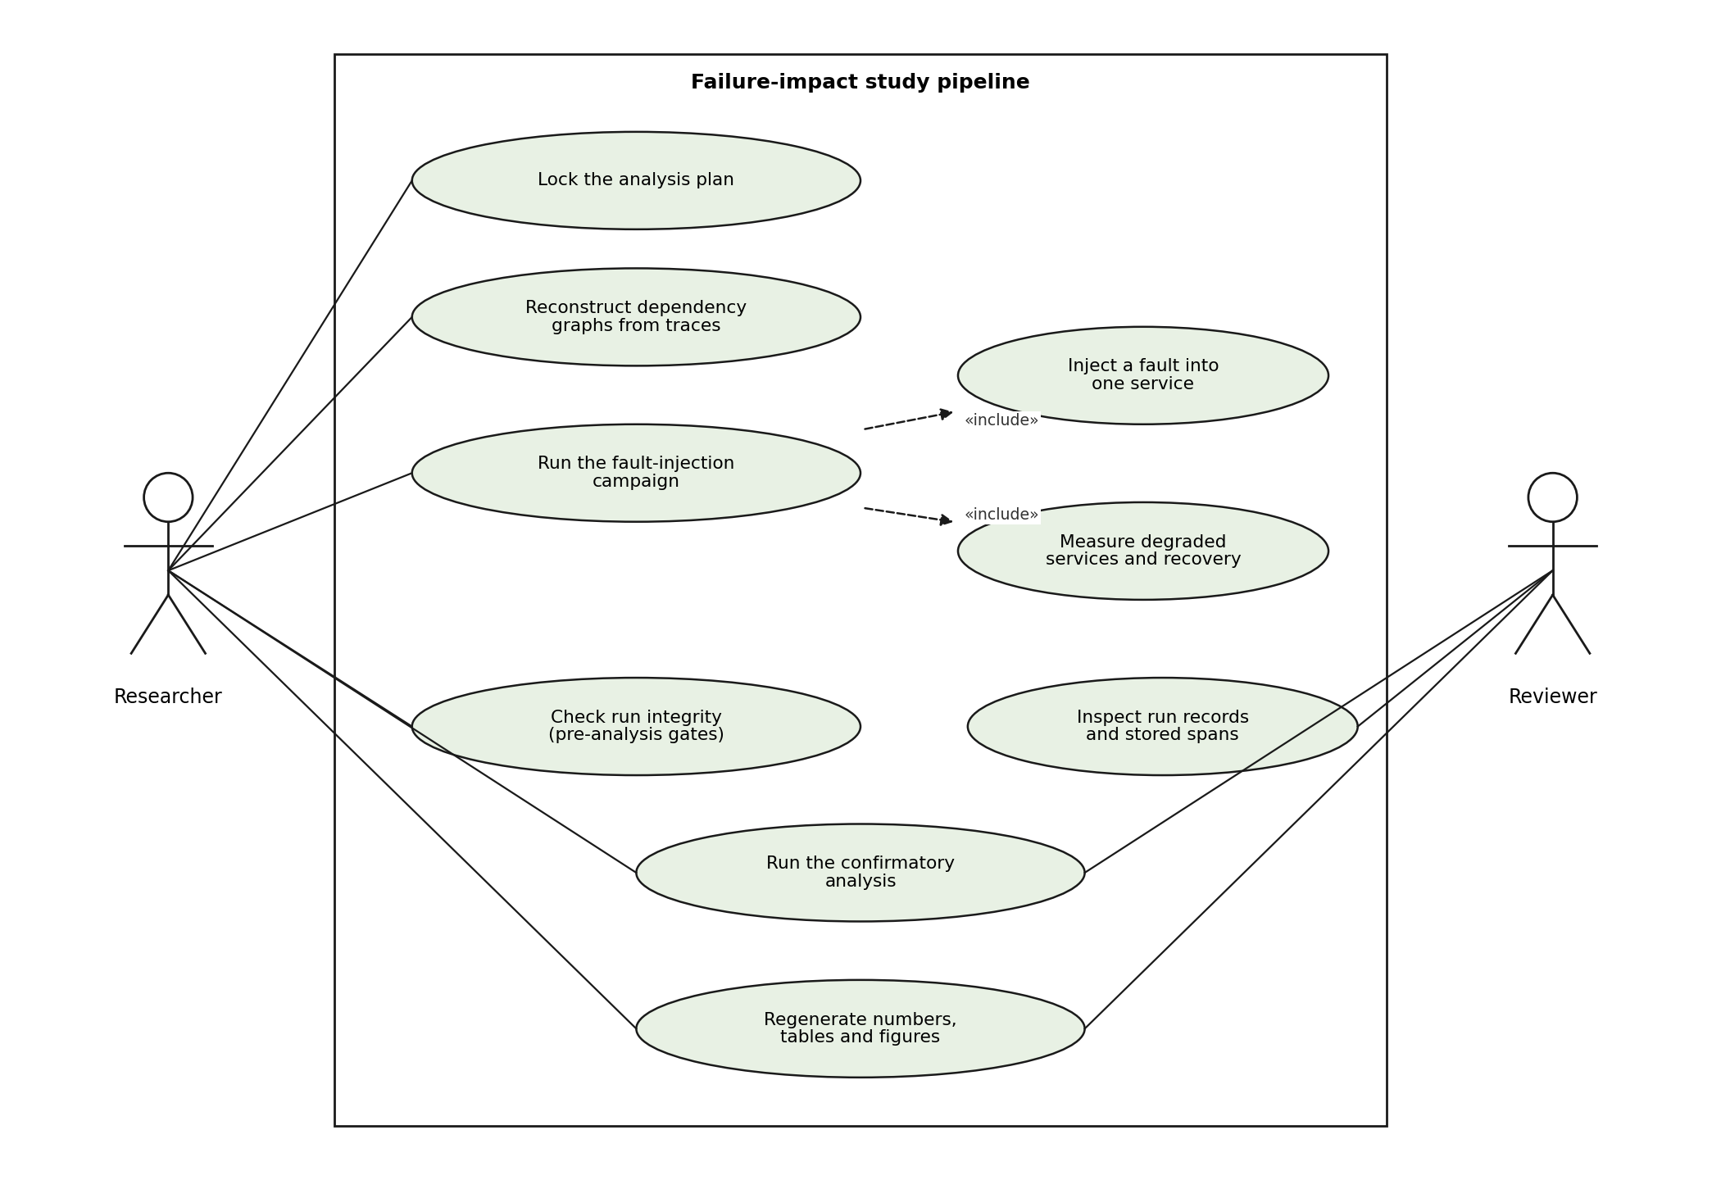
Fig. 4.5: Use case diagram.

4.2.3 Class Diagram
The pipeline is written as Python modules of functions that pass plain data (graphs, dictionaries and CSV rows) between steps; the only classes are small helpers such as the run lock and the recovery-probe result. A class diagram would therefore add little, and the module structure is described by Fig. 4.2 and the data flow diagrams instead.

4.2.4 Sequence Diagram
Fig. 4.6 shows the messages exchanged in one campaign run. W is the warm-up and baseline window, H the fault hold, P the recovery-probe interval and C the recovery cap; their values are given in Section 5.1.3.
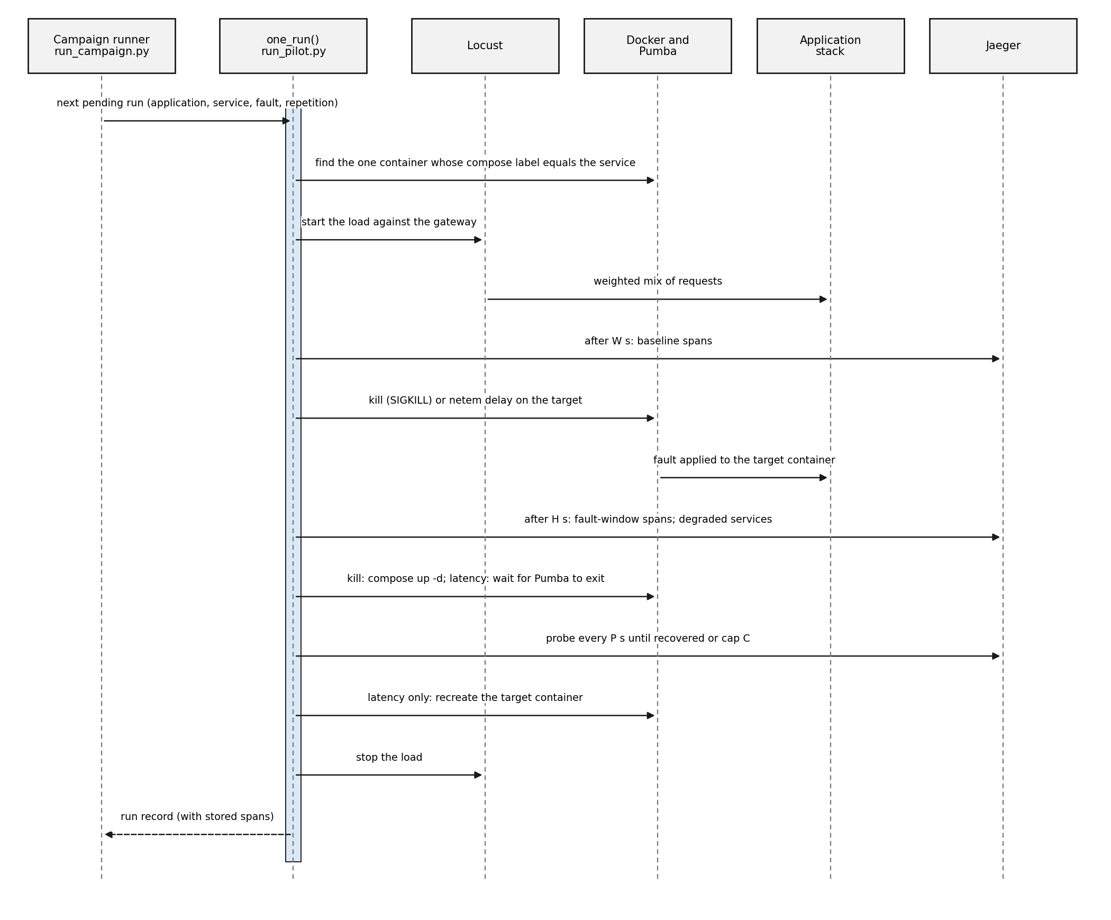
Fig. 4.6: Sequence diagram of one campaign run (function one_run in tools/run_pilot.py).

CHAPTER 5. METHODOLOGY AND TESTING

5.1 Module Description

5.1.1 Graph Reconstruction Module
tools/extract_graph.py asks Jaeger for the traces of every application service and adds a directed edge from service a to service b whenever a span of a is the parent of a span of b. The Social Network graph was built from 2449 traces holding 32847 spans, and the Hotel Reservation graph from 3446 traces holding 31155 spans. The graphs have 12 and 8 services with 17 and 7 edges (Fig. 5.1 and Fig. 5.2). Graphs from traces show the calls the system actually makes: for Hotel Reservation, the traces recover 6 of the 8 call edges implied by its documentation, and the observed graph was used.
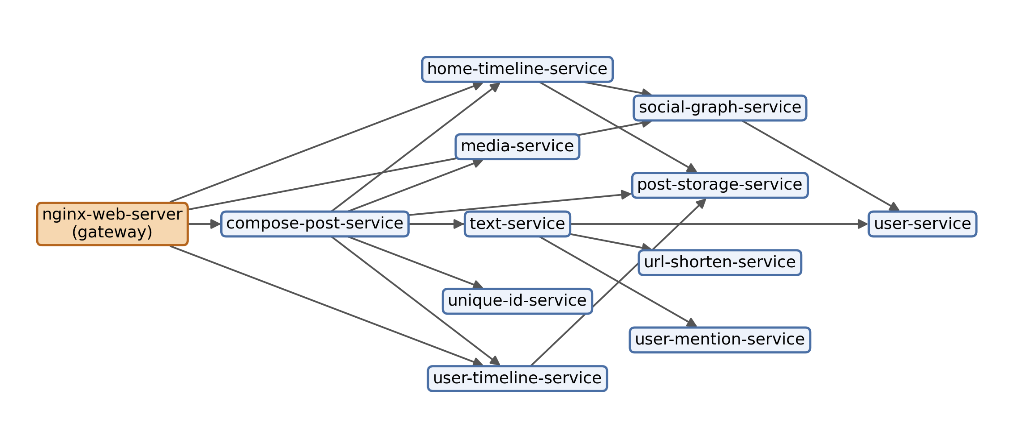
Fig. 5.1: Social Network dependency graph as observed in traces, with the gateway marked.
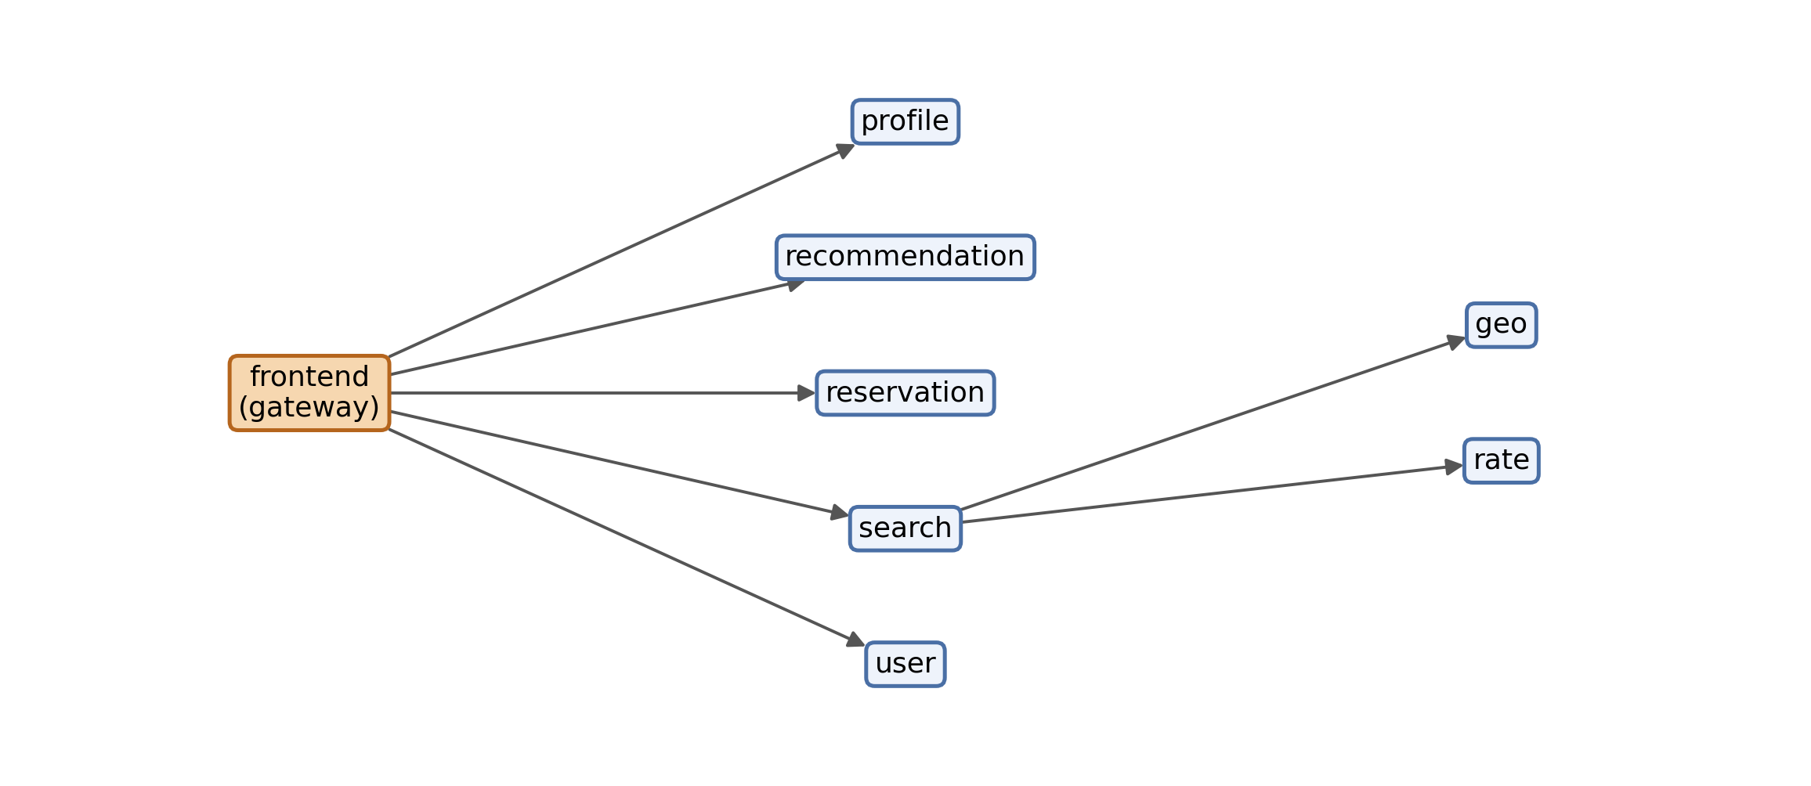
Fig. 5.2: Hotel Reservation dependency graph as observed in traces, with the gateway marked.
The gateway of each application (nginx-web-server and frontend) has no caller in the graph, because its traffic comes from the load generator, so it is left out of every correlation. That leaves 11 services in Social Network and 7 in Hotel Reservation.

5.1.2 Predictor Module
tools/build_predictor_table.py and centrality/compute_centrality.py compute the caller count, the hybrid metric and the comparators: degree, in-degree, out-degree, betweenness, closeness, eigenvector centrality, PageRank, a composite rank, descendant count and dominator subtree size. The hybrid metric keeps the weights of the original proposal; the tuning step planned in the preregistration was never run (Deviation 10), and no weight was re-tuned on campaign data. Where a predictor is constant across services, as eigenvector centrality is on the acyclic Social Network graph, the correlation is undefined, so two such pairs were declared degenerate in advance, leaving 22 testable pairs.

5.1.3 Run and Fault-Injection Module
tools/run_campaign.py works through the run manifest and calls one_run in tools/run_pilot.py for each run. Locust starts 25 users at 10 per second, each waiting between 0.5 and 1.5 s between requests drawn from a fixed weighted mix. After 60 s, which also serve as the baseline window (W), the fault is applied and held for 30 s (H). A kill fault sends SIGKILL; a latency fault adds 500 ms of delay with 100 ms of jitter through a netem rule. The recovery probe then polls every 1 s (P), with a cap of 180 s (C), and a 20 s cooldown separates runs. The exact commands, generated from the runner code, are listed in Table 5.1.
Table 5.1: Commands issued by the runner in each run
Step | Command | Source
Start the load | python -m locust -f <locustfile> --host <url> --headless --users <users> --spawn-rate 10 --run-time <duration>s --only-summary --loglevel ERROR | runner, load start
Find the target container | docker ps --filter label=com.docker.compose.service=<service> --format '{{.Names}}\t{{.Label "com.docker.compose.service"}}' | runner, target resolution
Kill fault | docker run --rm -v /var/run/docker.sock:/var/run/docker.sock ghcr.io/alexei-led/pumba kill --signal SIGKILL <container> | fault configuration
Latency fault | docker run --rm -v /var/run/docker.sock:/var/run/docker.sock ghcr.io/alexei-led/pumba netem --duration 30s delay --time 500 --jitter 100 <container> | fault configuration
Restore after a kill | docker compose up -d <service> | runner, restore
Clean up after a latency fault | docker compose up -d --force-recreate <service> | runner, clean-up

5.1.4 Measurement Module
measurement/metrics_collector.py computes each service's latency percentiles and error rate from the spans that service emits itself. This choice matters. A tracing backend returns, for a service, every trace that touches it, and the root span of each trace times the whole request; a percentile over root spans therefore gives every service on a request path the same end-to-end value. In two pilot runs on Hotel Reservation with a delay in the search service, that shortcut flagged several services that were not faulted, some of them neither callers nor callees of search; per-service attribution flagged only one, an actual caller of search (Fig. 5.3).
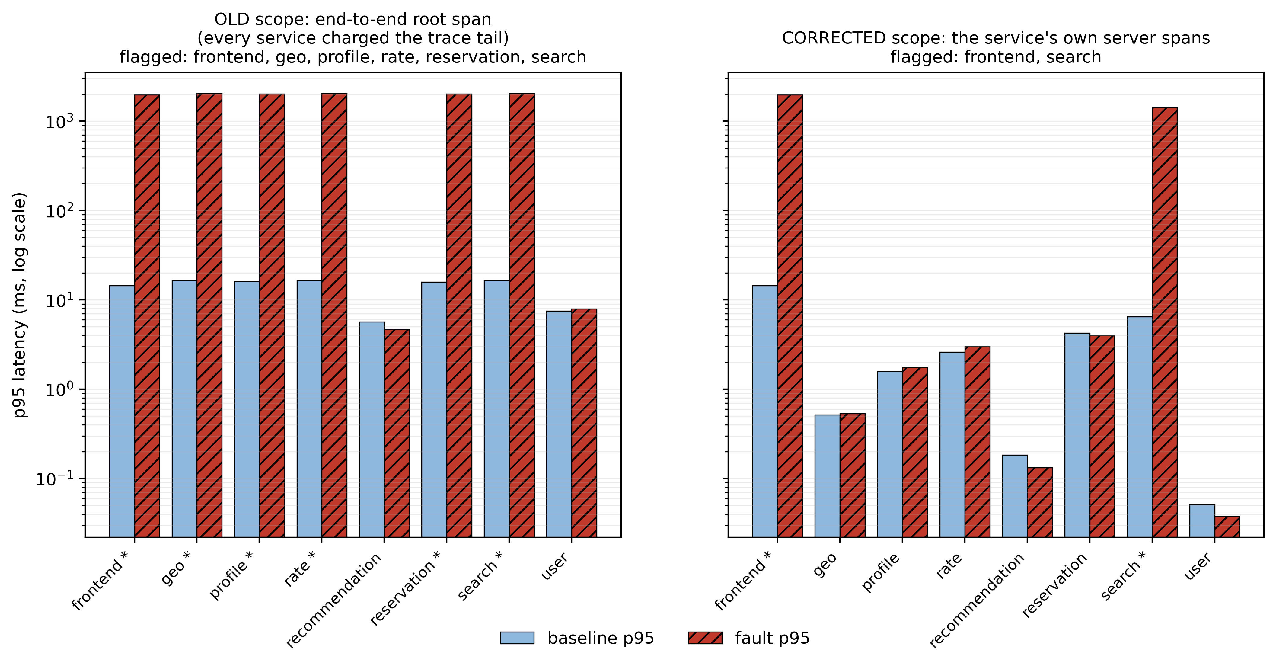
Fig. 5.3: Per-service p95 under a latency fault in search, measured on the end-to-end root span (left) and on each service's own spans (right); an asterisk marks a service flagged as degraded.
A service counts as degraded when its p95 exceeds 2.0 times its baseline and rises by at least 1.0 ms, or when its error rate rises by at least 0.05. measurement/blast_radius.py then splits the degraded services into ancestors, descendants and unrelated services of the faulted one (Appendix A). measurement/recovery_probe.py measures recovery time from fault removal until p95, p99, error rate and the affected count are all within 10% of baseline for 5 s; a run that does not recover within the cap is recorded as censored, never filled in.

5.1.5 Analysis Module
analysis/final/run_confirmatory_analysis.py takes the median outcome of each service over its repetitions and computes Spearman's ρ between each predictor and each outcome. P-values come from permutation tests (10000 random permutations where exact enumeration is impractical), intervals from the bias-corrected and accelerated bootstrap, and each family of tests is corrected with the Benjamini-Hochberg procedure at q = 0.05. Kill faults form the confirmatory family of 44 tests, and latency faults repeat every test as a replication family of 44.

5.1.6 Preregistration and Deviations
The hypotheses and analysis were locked before the campaign, and every later change was logged with its date (Table 5.2). Of the 13 deviations, 10 invalidated no data; the other three invalidated 17 runs, each of which was collected again in its own cell, so the final data set is complete and balanced.
Table 5.2: Deviations from the locked plan
No. | Date | Deviation | Runs affected | Action
1 | 2026-09-26 | Absolute floor added to the latency rule | 3 | Floor added; rehearsal runs discarded
2 | 2026-09-26 | Wrong container targeted by a substring match | 3 | Exact label matching; affected runs collected again
3 | 2026-09-26 | Name mismatch stopped the campaign on a healthy stack | 0 | Stack check corrected; no data affected
4 | 2026-09-26 | Network-delay rule outlived its run | 11 | Affected runs collected again; container recreated after each latency run
5 | 2026-09-27 | Two choices the plan left open | 0 | Settled before the analysis was written
6 | 2026-09-27 | No run censored | 0 | Rank test made primary for recovery time as the plan required
7 | 2026-09-27 | Asymptotic p-value quoted in the plan | 0 | Exact value used
8 | 2026-09-27 | Statistical routines vectorised | 0 | Tested against the reference implementation
9 | 2026-09-28 | Exact p-values computed after the results | 0 | Reported as supplementary; verdict unchanged
10 | 2026-10-06 | Weight-tuning step not run | 0 | Inherited weights kept; not re-tuned
11 | 2026-10-06 | Social Network latency drew on all spans | 0 | Server-only replay; no service-level change
12 | 2026-10-06 | One latency run attempted twice | 0 | Only the completed attempt analysed
13 | 2026-10-20 | Baseline window includes the load ramp-up | 0 | Disclosed; baseline gate found no anomalies

5.2 Testing
Testing worked at several levels.
Unit tests. The repository has a pytest suite covering the statistics, the degradation rule and per-service metrics, container resolution, the recovery probe, the structural metrics, the campaign runner and the report and reference builders. With the Docker-dependent integration tests deselected, 123 tests passed and 0 failed in the run made for this report; 23 integration tests need the live stacks and were not run.
Pre-analysis integrity gates. Before any statistic was computed, one gate confirmed that every expected service was present in every run and another compared each run's fault-free baseline with all other runs using the median and the median absolute deviation. All 10 checks passed. These gates are what exposed Deviation 4, a delay rule that outlived its run.
Verification of the analysis. An independent reimplementation of the primary statistic, written without reference to the analysis code and reading only the stored spans and the graph, reproduced the reported correlation and agreed on which services were affected in all 110 Social Network runs. A replay restricted to server spans changed 2 of 110 run outcomes and none of the service-level medians. A leave-one-out recomputation is reported with the results.

CHAPTER 6. PROJECT DEMONSTRATION
The project can be demonstrated in stages. The first needs only the repository and shows that every result follows from the logged data:
- python -m pytest -q -m "not integration" runs the unit tests.
- python analysis/final/run_confirmatory_analysis.py reruns the full preregistered analysis from the run records.
- python paper/build_all.py regenerates paper/numbers.csv, the tables and the figures, and fails if any claim in the paper does not resolve to a row.
The second needs Docker and the DeathStarBench checkout, and shows the live experiment:
- python tools/run_campaign.py --status shows the run manifest and which runs are pending.
- python tools/run_campaign.py --max-runs 1 executes one run: the load starts, the fault is applied to the target container, the degraded services are listed by relation, the recovery probe runs, and a run record is written to data/campaign/runs/.
Each row of paper/numbers.csv names a claim, its value, its unit, the file it was read from and the script that produced it. This report is itself built the same way: python report/build_report.py fills every number in the text from those rows and refuses to build if a number was typed by hand.

CHAPTER 7. RESULT AND DISCUSSION

7.1 Campaign Completion
All 180 planned runs completed across 36 balanced cells, 110 on Social Network and 70 on Hotel Reservation. No run was lost to telemetry failure and no recovery time was censored. The campaign ran from 2026-09-26 05:02 to 2026-09-26 13:35 UTC. Table 7.1 lists the graph predictors and measured outcomes of the Social Network services.
Table 7.1: Graph predictors and measured outcomes, Social Network
Service | Ancestors | Descendants | In-degree | Out-degree | HC | Degraded ancestors (kill) | Degraded ancestors (latency) | T_{rec} kill (s) | T_{rec} latency (s)
post-storage-service | 4 | 0 | 3 | 0 | 0.109 | 4 | 4 | 15.3 | 15.4
user-service | 4 | 0 | 2 | 0 | 0.073 | 2 | 2 | 14.5 | 14.8
social-graph-service | 3 | 1 | 2 | 1 | 0.081 | 3 | 3 | 15.0 | 15.4
url-shorten-service | 3 | 0 | 1 | 0 | 0.036 | 3 | 3 | 16.1 | 15.2
user-mention-service | 3 | 0 | 1 | 0 | 0.036 | 3 | 3 | 14.5 | 14.4
home-timeline-service | 2 | 3 | 2 | 2 | 0.096 | 2 | 2 | 15.4 | 15.6
media-service | 2 | 0 | 1 | 0 | 0.036 | 2 | 2 | 16.1 | 14.8
text-service | 2 | 2 | 1 | 2 | 0.064 | 2 | 2 | 15.3 | 14.4
unique-id-service | 2 | 0 | 1 | 0 | 0.036 | 2 | 2 | 14.2 | 14.6
user-timeline-service | 2 | 1 | 2 | 1 | 0.079 | 2 | 2 | 15.7 | 14.9
compose-post-service | 1 | 10 | 1 | 7 | 0.302 | 1 | 1 | 15.6 | 15.6

7.2 The Caller Count (H1)
On Social Network under kill faults, the caller count X and the number of degraded callers Y correlated at ρ = 0.785 across 11 services, with a bootstrap interval from 0.000 to 1.000. The uncorrected p-value was 0.0080, but after correction across the 44 tests of the confirmatory family it became 0.3451. None of the confirmatory tests was significant (Table 7.2), so H1 is not confirmed.
Table 7.2: The primary test in each family and application
Family | Fault | Application | Services | ρ | 95% CI | CI method | p (raw) | p method | p (BH) | Significant | Note
confirmatory | kill | Social Network | 11 | 0.785 | 0.000 to 1.000 | BCa | 0.0080 | Monte Carlo, 10,000 permutations | 0.3451 | no
confirmatory | kill | Hotel Reservation | 7 | 1.000 | 1.000 to 1.000 | percentile | 0.0476 | exact, 5,040 permutations | 0.3451 | no | saturated; directional only
replication | latency | Social Network | 11 | 0.785 | 0.000 to 1.000 | BCa | 0.0076 | Monte Carlo, 10,000 permutations | 0.1848 | no
replication | latency | Hotel Reservation | 7 | 1.000 | 1.000 to 1.000 | percentile | 0.0476 | exact, 5,040 permutations | 0.2328 | no | saturated; directional only

The correlation is also partly definitional. Y counts degraded callers and X counts callers, so Y can never exceed X, and when every caller degrades the two coincide. On Hotel Reservation this happened for every service in every run, so its results only restate the predictor and are treated as directional. On Social Network, all but one of the 11 services lay exactly on the line y = x (Fig. 7.1); only user-service, with 4 callers of which 2 degraded in every kill run, departed from it. Withholding one service at a time moves ρ between 0.696 and 1.000 (Fig. 7.2), and withholding user-service gives 1.000.
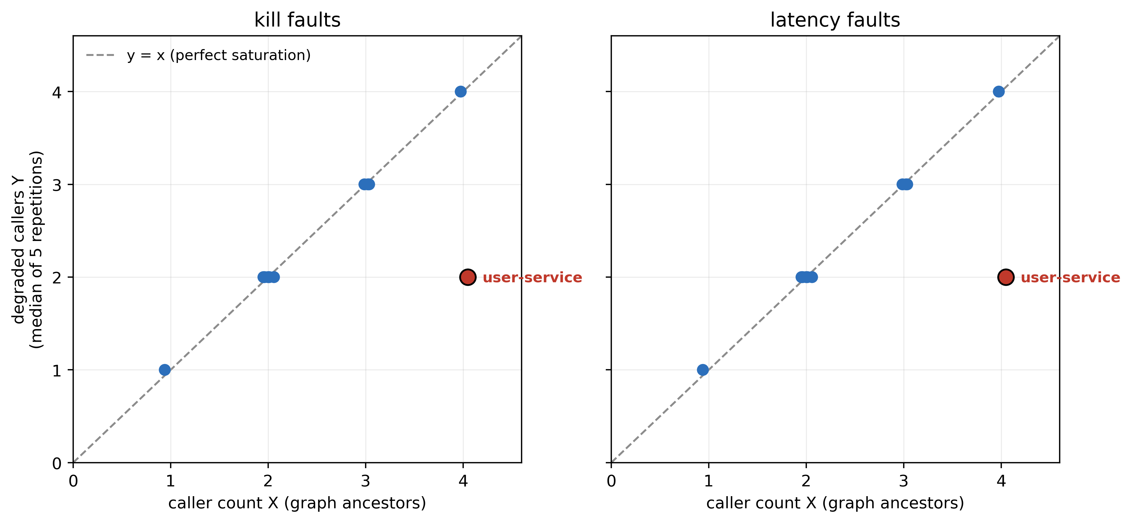
Fig. 7.1: Caller count X against the measured number of degraded callers Y for each Social Network service; points on the dashed line are saturated.
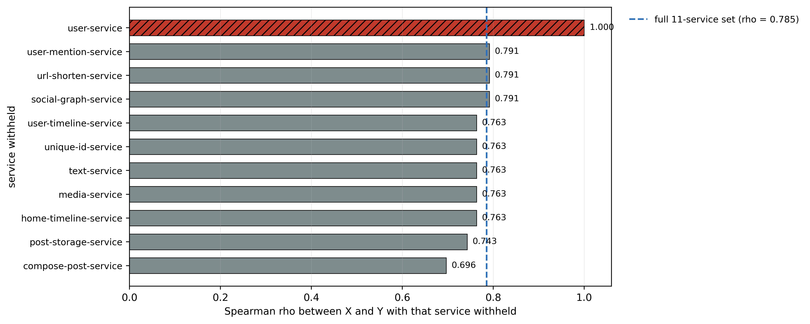
Fig. 7.2: Leave-one-out check (post hoc): ρ between X and Y on Social Network under kill faults, with each service withheld in turn.

7.3 The Fan-Out Metric (H2)
The hybrid criticality metric correlated negatively with degraded callers in every application and fault type: ρ = -0.144 on Social Network and ρ = -0.258 on Hotel Reservation (Table 7.3). After correction no cell could be told apart from zero, so no negative relationship is claimed; the data simply give the fan-out premise no support.
Table 7.3: The hybrid criticality metric against degraded callers
Family | Fault | Application | Services | ρ | 95% CI | p (raw) | p (BH) | ρ ≤ 0 | Distinguishable from zero after BH
confirmatory | kill | Social Network | 11 | -0.144 | -0.810 to 0.698 | 0.6688 | 0.9925 | yes | no
confirmatory | kill | Hotel Reservation | 7 | -0.258 | -0.730 to -0.167 | 1.0000 | 1.0000 | yes | no
replication | latency | Social Network | 11 | -0.144 | -0.805 to 0.713 | 0.6656 | 0.9152 | yes | no
replication | latency | Hotel Reservation | 7 | -0.258 | -0.750 to -0.167 | 1.0000 | 1.0000 | yes | no

The case that motivated the metric shows why. compose-post-service calls 7 services directly and has 10 descendants, so the hybrid metric ranks it first of 11; by callers it ranks last, with a single caller (Fig. 7.3). In all 10 of its runs exactly one caller degraded, and that caller was always the gateway.
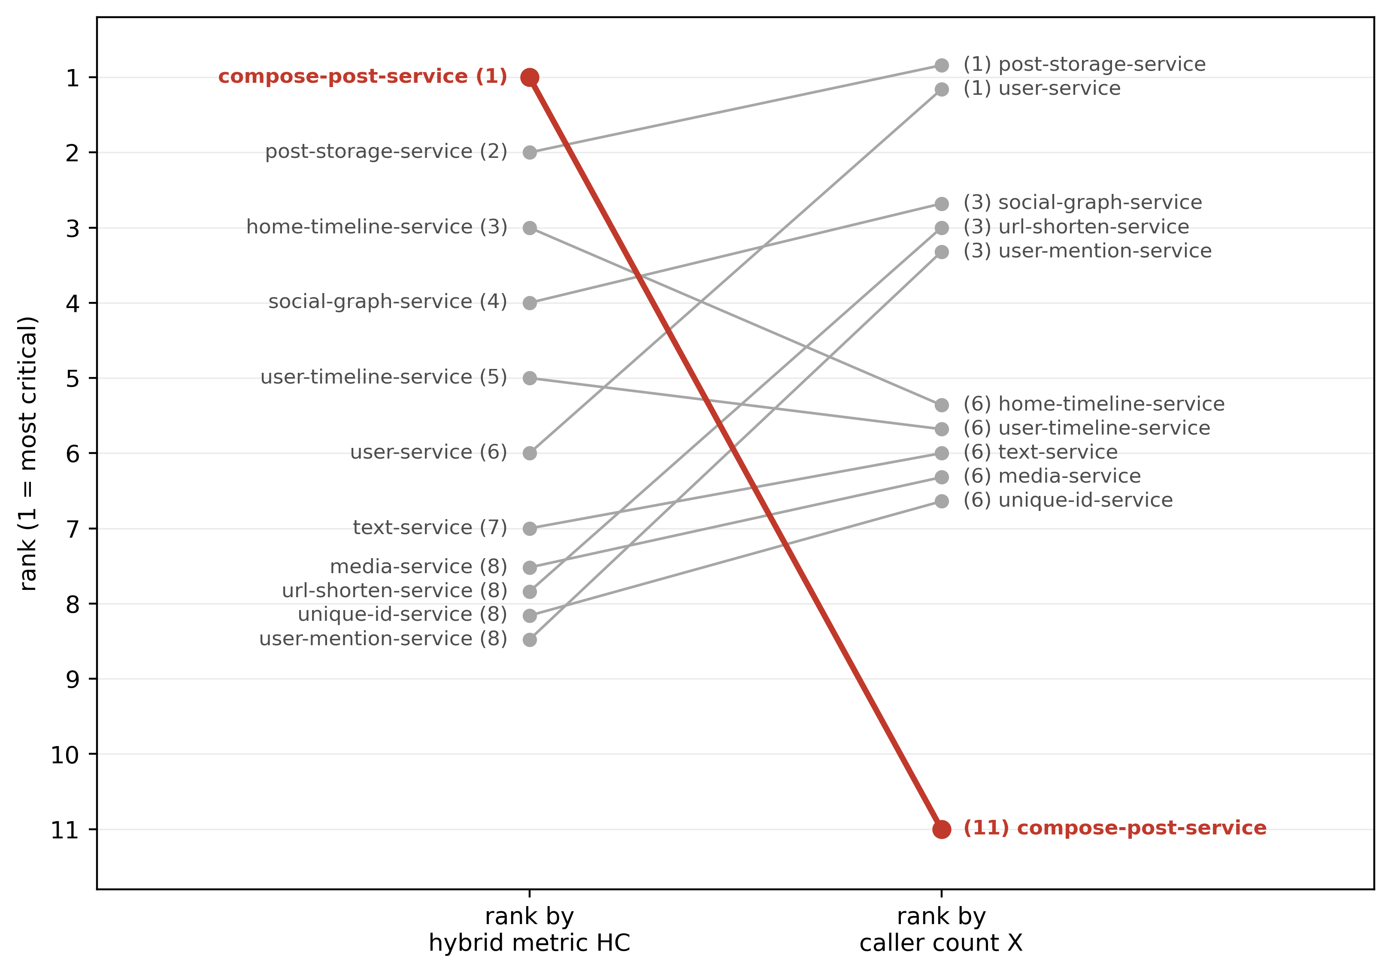
Fig. 7.3: Rank of each Social Network service by the hybrid metric and by caller count, with compose-post-service highlighted.
A sweep over all 231 weightings on the preregistered grid, run after the confirmatory results were known, found no weighting with a significant association with degraded callers (Fig. 7.4), so the null result does not depend on the inherited weights.
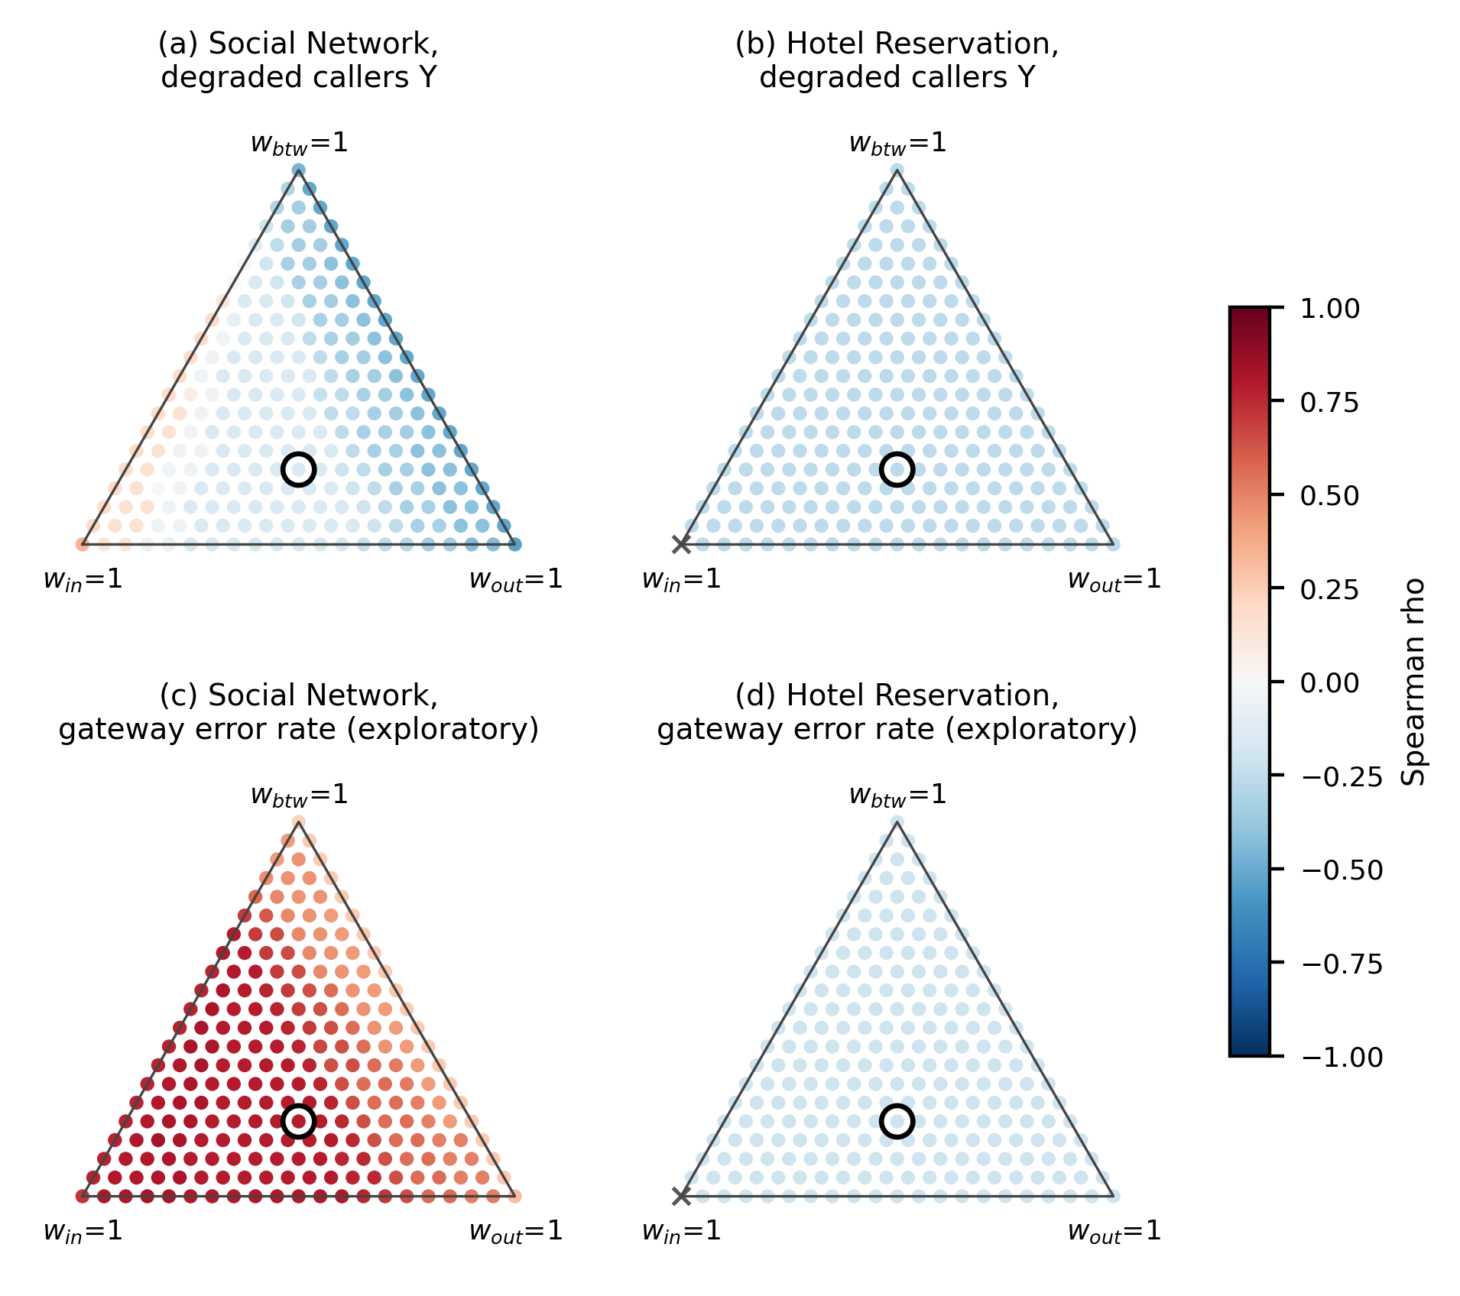
Fig. 7.4: Post hoc weight sensitivity: ρ of the hybrid metric against degraded callers and against gateway error rate for every weight triplet.

7.4 Replication and Direction of Propagation
The latency-fault replication family also had no significant test after correction; its smallest adjusted p-value was 0.1848. Which services degraded hardly depended on how the fault was delivered: 17 of 18 services showed identical per-run counts under kill and delay.
The clearest result is the direction of propagation. No descendant of the faulted service degraded in 179 of 180 runs, and unrelated services stayed unaffected in 179 of 180. A failure travelled up to the services that wait on the failed one and almost never down to the services it calls. This is consistent with the reasoning in Section 1.2: a callee of a dead or slow service simply receives fewer requests.

7.5 Limits of the Design
With the service as the unit of analysis, the sample sizes are 11 and 7 services, and the caller count takes only four and two distinct values. These ties cap the correlation an untied outcome could reach at 0.941 and 0.791 (Table 7.4). On Hotel Reservation even that ceiling gives a p-value of 0.0952, above the usual threshold before any correction, so that application could not have produced a significant result on its own. These limits were computed before data collection.
Table 7.4: What the design could detect
Quantity | Social Network | Hotel Reservation
Services, realised / preregistered | 11 / 11 | 7 / 7
Distinct X values, realised / preregistered | 4 / 4 | 2 / 2
X values | 1, 2, 2, 2, 2, 2, 3, 3, 3, 4, 4 | 1, 1, 1, 1, 1, 2, 2
Ceiling ρ, outcome without ties, realised / preregistered | 0.941 / 0.941 | 0.791 / 0.791
Ceiling p, outcome without ties, permutation | 0.0002 | 0.0952
Ceiling p, outcome without ties, asymptotic (not for inference) | <0.0001 | 0.0343
Ceiling ρ, outcome tied like X | 1.000 | 1.000
Ceiling p, outcome tied like X, permutation | 0.0001 | 0.0476
p quoted in the preregistration |  | 0.034

Recovery time showed no significant association with either predictor in either family. Observed recovery times ranged from 9.72 to 156.27 s, with a median of 15.74 s.

7.6 Discussion
The findings point towards looking up the graph, at callers, and away from looking down it, at callees, when ranking services for hardening. The caveat is important: the project's own test of the caller ranking did not reach significance, so it is not claimed that the caller count predicts failure impact. In an exploratory analysis, the error rate seen at the gateway followed the share of traffic that passed through the failed service, which suggests that a ranking weighting callers by traffic is worth testing as a new, preregistered hypothesis.
Measurement also taught lessons. Attributing latency per service, rather than charging end-to-end latency to every service on a path, changed which services counted as degraded. And a structural predictor tested against a structurally defined outcome needs a saturation measure next to the correlation; without it, a high ρ can look like evidence when it mostly restates the definition.
The main threats to validity are the small number of services, the single benchmark suite and workload, a call graph that depends on the traffic used to build it, and fault types limited to a kill and a delay.

7.7 Objective Attainment
Table 7.5: Status of the project objectives
Objective | Status | Evidence
Reconstruct the call graph of each application from traces and freeze it | Achieved | Graphs of 12 and 8 services built from traces (Section 5.1.1)
Compute the caller count, the hybrid metric and comparator measures | Achieved | Predictor table; 22 testable predictor-outcome pairs (Section 5.1.2)
Lock the plan before data collection and log every change | Achieved | Plan locked before the campaign; 13 dated deviations (Table 5.2)
Run a fully crossed, balanced fault-injection campaign | Achieved | 180 runs in 36 balanced cells, none lost (Section 7.1)
Measure each service on its own spans and classify degraded services | Achieved | Per-service attribution (Fig. 5.3); callers, callees and unrelated services counted separately
Test H1 and H2 with permutation tests and correction | Achieved; neither hypothesis supported | H1 not confirmed (adjusted p = 0.3451); the hybrid metric was not distinguishable from zero (Section 7.2 and Section 7.3)
Make every number reproducible from logged data | Achieved | One build command regenerates every number, table and figure (Chapter 6)

7.8 Cost Analysis
The project incurred no monetary cost (Table 7.6). The main cost was machine time: the campaign itself took about 8.5 hours, and the full analysis can be rerun from the stored data without Docker.
Table 7.6: Project cost
Item | Cost
Software (Docker, Jaeger, Locust, Pumba, Python, NetworkX, SciPy, statsmodels) | Free and open source, or free for educational use
Computing (the author's own laptop) | No additional cost
Cloud resources | Not used
Total | No monetary cost

CHAPTER 8. CONCLUSION
The project set out to identify failure-prone microservices from graph centrality metrics, and tested that idea with a preregistered fault-injection campaign of 180 balanced runs on two benchmark applications. The centrality metric the project began with, which favours services with high fan-out, did not identify the services whose failure did the most damage: its correlation with degraded callers was negative everywhere and never distinguishable from zero. The caller count correlated strongly with degraded callers on Social Network, but no test survived correction, and much of that correlation follows from how the outcome is defined.
What held without any statistical test is the direction of propagation: failures reached callers and almost never callees. The project also showed that per-service latency attribution is essential when traces are used to judge which services degrade, and it rebuilt its pipeline so that every number can be regenerated from logged data after an audit of the earlier version.
Future work follows from these results: test a ranking of services by callers weighted by the traffic they carry, as a new preregistered hypothesis; use larger applications to lift the ceiling that a handful of services place on any correlation; and study how containment mechanisms such as retries and circuit breakers change how far a failure travels. A manuscript describing the study has been prepared for submission to IEEE Access.

CHAPTER 9. REFERENCES
[1] N. Dragoni et al., "Microservices: Yesterday, Today, and Tomorrow," Present and Ulterior Software Engineering (Springer), pp. 195–216, 2017. doi: 10.1007/978-3-319-67425-4_12.
[2] P. Jamshidi, C. Pahl, N. C. Mendonca, J. Lewis, and S. Tilkov, "Microservices: The Journey So Far and Challenges Ahead," IEEE Software, vol. 35, no. 3, pp. 24–35, 2018. doi: 10.1109/ms.2018.2141039.
[3] J. Soldani, D. A. Tamburri, and W. J. Van Den Heuvel, "The pains and gains of microservices: A Systematic grey literature review," Journal of Systems and Software, vol. 146, pp. 215–232, 2018. doi: 10.1016/j.jss.2018.09.082.
[4] R. Heinrich et al., "Performance Engineering for Microservices: Research Challenges and Directions," in Proceedings of the 8th ACM/SPEC on International Conference on Performance Engineering Companion, pp. 223–226, 2017. doi: 10.1145/3053600.3053653.
[5] H. S. Gunawi et al., "Why Does the Cloud Stop Computing? Lessons from Hundreds of Service Outages," in Proceedings of the Seventh ACM Symposium on Cloud Computing, pp. 1–16, 2016. doi: 10.1145/2987550.2987583.
[6] X. Zhou et al., "Fault Analysis and Debugging of Microservice Systems: Industrial Survey, Benchmark System, and Empirical Study," IEEE Transactions on Software Engineering, vol. 47, no. 2, pp. 243–260, 2021. doi: 10.1109/TSE.2018.2887384.
[7] B. H. Sigelman et al., "Dapper, a Large-Scale Distributed Systems Tracing Infrastructure," Google Technical Report dapper-2010-1, 2010. [Online]. Available: https://research.google/pubs/dapper-a-large-scale-distributed-systems-tracing-infrastructure/
[8] L. C. Freeman, "Centrality in Social Networks: Conceptual Clarification," Social Networks, vol. 1, no. 3, pp. 215–239, 1978. doi: 10.1016/0378-8733(78)90021-7.
[9] T. Zimmermann, and N. Nagappan, "Predicting Defects Using Network Analysis on Dependency Graphs," in Proceedings of the 30th International Conference on Software Engineering (ICSE '08), pp. 531–540, 2008. doi: 10.1145/1368088.1368161.
[10] Y. Gan et al., "An Open-Source Benchmark Suite for Microservices and Their Hardware-Software Implications for Cloud & Edge Systems," in Proceedings of the 24th International Conference on Architectural Support for Programming Languages and Operating Systems (ASPLOS '19), pp. 3–18, 2019. doi: 10.1145/3297858.3304013.
[11] U. Brandes, "A Faster Algorithm for Betweenness Centrality," The Journal of Mathematical Sociology, vol. 25, no. 2, pp. 163–177, 2001. doi: 10.1080/0022250X.2001.9990249.
[12] P. Bonacich, "Power and Centrality: A Family of Measures," American Journal of Sociology, vol. 92, no. 5, pp. 1170–1182, 1987. doi: 10.1086/228631.
[13] S. Brin, and L. Page, "The anatomy of a large-scale hypertextual Web search engine," Computer Networks and ISDN Systems, vol. 30, no. 1-7, pp. 107–117, 1998. doi: 10.1016/s0169-7552(98)00110-x.
[14] T. Lengauer, and R. E. Tarjan, "A fast algorithm for finding dominators in a flowgraph," ACM Transactions on Programming Languages and Systems, vol. 1, no. 1, pp. 121–141, 1979. doi: 10.1145/357062.357071.
[15] A. A. Hagberg, D. A. Schult, and P. J. Swart, "Exploring Network Structure, Dynamics, and Function using NetworkX," in Proceedings of the 7th Python in Science Conference (SciPy2008), G. Varoquaux, T. Vaught, J. Millman (Eds.), Pasadena, CA, USA, pp. 11–15, 2008. [Online]. Available: http://conference.scipy.org/proceedings/SciPy2008/paper_2/
[16] R. Albert, H. Jeong, and A. L. Barabási, "Error and attack tolerance of complex networks," Nature, vol. 406, no. 6794, pp. 378–382, 2000. doi: 10.1038/35019019.
[17] A. E. Motter, and Y. C. Lai, "Cascade-based attacks on complex networks," Physical Review E, vol. 66, no. 6, 2002. doi: 10.1103/physreve.66.065102.
[18] S. P. Ma, C. Y. Fan, Y. Chuang, W. T. Lee, S. J. Lee, and N. L. Hsueh, "Using Service Dependency Graph to Analyze and Test Microservices," in 2018 IEEE 42nd Annual Computer Software and Applications Conference (COMPSAC), pp. 81–86, 2018. doi: 10.1109/compsac.2018.10207.
[19] A. Basiri et al., "Chaos Engineering," IEEE Software, vol. 33, no. 3, pp. 35–41, 2016. doi: 10.1109/MS.2016.60.
[20] A. Basiri, L. Hochstein, N. Jones, and H. Tucker, "Automating Chaos Experiments in Production," in 2019 IEEE/ACM 41st International Conference on Software Engineering: Software Engineering in Practice (ICSE-SEIP), pp. 31–40, 2019. doi: 10.1109/icse-seip.2019.00012.
[21] V. Heorhiadi, S. Rajagopalan, H. Jamjoom, M. K. Reiter, and V. Sekar, "Gremlin: Systematic Resilience Testing of Microservices," in 2016 IEEE 36th International Conference on Distributed Computing Systems (ICDCS), pp. 57–66, 2016. doi: 10.1109/ICDCS.2016.11.
[22] C. S. Meiklejohn, A. Estrada, Y. Song, H. Miller, and R. Padhye, "Service-Level Fault Injection Testing," in Proceedings of the ACM Symposium on Cloud Computing, pp. 388–402, 2021. doi: 10.1145/3472883.3487005.
[23] P. Alvaro, J. Rosen, and J. M. Hellerstein, "Lineage-driven Fault Injection," in Proceedings of the 2015 ACM SIGMOD International Conference on Management of Data, pp. 331–346, 2015. doi: 10.1145/2723372.2723711.
[24] P. Huang et al., "Gray Failure: The Achilles' Heel of Cloud-Scale Systems," in Proceedings of the 16th Workshop on Hot Topics in Operating Systems, pp. 150–155, 2017. doi: 10.1145/3102980.3103005.
[25] S. Luo et al., "Characterizing Microservice Dependency and Performance: Alibaba Trace Analysis," in Proceedings of the ACM Symposium on Cloud Computing (SoCC '21), pp. 412–426, 2021. doi: 10.1145/3472883.3487003.
[26] M. Chen, E. Kiciman, E. Fratkin, A. Fox, and E. Brewer, "Pinpoint: problem determination in large, dynamic Internet services," in Proceedings International Conference on Dependable Systems and Networks, pp. 595–604, 2002. doi: 10.1109/dsn.2002.1029005.
[27] J. Lin, P. Chen, and Z. Zheng, "Microscope: Pinpoint Performance Issues with Causal Graphs in Micro-service Environments," in Lecture Notes in Computer Science, pp. 3–20, 2018. doi: 10.1007/978-3-030-03596-9_1.
[28] L. Wu, J. Tordsson, E. Elmroth, and O. Kao, "MicroRCA: Root Cause Localization of Performance Issues in Microservices," in NOMS 2020 - IEEE/IFIP Network Operations and Management Symposium, pp. 1–9, 2020. doi: 10.1109/NOMS47738.2020.9110353.
[29] Y. Gan et al., "Seer: Leveraging Big Data to Navigate the Complexity of Performance Debugging in Cloud Microservices," in Proceedings of the Twenty-Fourth International Conference on Architectural Support for Programming Languages and Operating Systems, pp. 19–33, 2019. doi: 10.1145/3297858.3304004.
[30] J. Soldani, and A. Brogi, "Anomaly Detection and Failure Root Cause Analysis in (Micro) Service-Based Cloud Applications: A Survey," ACM Computing Surveys, vol. 55, no. 3, pp. 1–39, 2022. doi: 10.1145/3501297.
[31] B. A. Nosek, C. R. Ebersole, A. C. DeHaven, and D. T. Mellor, "The Preregistration Revolution," in Proceedings of the National Academy of Sciences, vol. 115, no. 11, pp. 2600–2606, 2018. doi: 10.1073/pnas.1708274114.
[32] Y. Benjamini, and Y. Hochberg, "Controlling the False Discovery Rate: A Practical and Powerful Approach to Multiple Testing," Journal of the Royal Statistical Society: Series B (Methodological), vol. 57, no. 1, pp. 289–300, 1995. doi: 10.1111/j.2517-6161.1995.tb02031.x.
[33] B. Phipson, and G. K. Smyth, "Permutation P-values Should Never Be Zero: Calculating Exact P-values When Permutations Are Randomly Drawn," Statistical Applications in Genetics and Molecular Biology, vol. 9, no. 1, 2010. doi: 10.2202/1544-6115.1585.
[34] B. Efron, "Better Bootstrap Confidence Intervals," Journal of the American Statistical Association, vol. 82, no. 397, pp. 171–185, 1987. doi: 10.1080/01621459.1987.10478410.
[35] D. R. Cox, "Regression Models and Life-Tables," Journal of the Royal Statistical Society Series B: Statistical Methodology, vol. 34, no. 2, pp. 187–202, 1972. doi: 10.1111/j.2517-6161.1972.tb00899.x.

APPENDIX A – SAMPLE CODE
The function below classifies the services that degraded in a run by their relation to the faulted service. It is read from the repository when this report is built, so it matches the code that produced the results.
measurement/blast_radius.py, function classify_affected:
def classify_affected(
graph: nx.DiGraph,
faulted_service: str,
affected_services: Iterable[str],
) -> dict[str, object]:
"""Split the degraded set by graph relationship to the faulted service.

Args:
graph: the service dependency graph (edge X->Y means "X calls Y").
faulted_service: the service the fault was injected into.
affected_services: services observed to degrade during the fault window.

Returns:
Counts and member lists for each of the three categories, plus the structural
sizes |ancestors| and |descendants| so a run record is self-describing and the
classification can be re-checked without reloading the graph.
"""
if faulted_service not in graph:
raise ValueError(f"{faulted_service!r} is not a node in the graph")

ancestors = nx.ancestors(graph, faulted_service)
descendants = nx.descendants(graph, faulted_service)

anc, desc, unrel = [], [], []
for svc in affected_services:
svc = svc.strip()
if not svc or svc == faulted_service:
continue
if svc in ancestors:
anc.append(svc)
elif svc in descendants:
desc.append(svc)
else:
unrel.append(svc)

return {
# PRIMARY blast-radius outcome. Predicted by |ancestors|, NOT by out-degree.
"ancestor_affected_count": len(anc),
"descendant_affected_count": len(desc),
"unrelated_affected_count": len(unrel),
"ancestor_affected_services": ",".join(sorted(anc)),
"descendant_affected_services": ",".join(sorted(desc)),
"unrelated_affected_services": ",".join(sorted(unrel)),
# Structural reference values, for checking predictor vs outcome.
"n_ancestors": len(ancestors),
"n_descendants": len(descendants),
"in_degree_raw": graph.in_degree(faulted_service),
"out_degree_raw": graph.out_degree(faulted_service),
}

