PROJECT PROPOSAL
Care Transition Risk & Coordination Copilot
A layered ML → Agent → Agentic AI system for predicting readmission risk and orchestrating personalized discharge follow-up

1. What This Solves
About one in five hospital patients ends up back in the hospital within 30 days of going home, and much of that is preventable — not because doctors missed something, but because follow-up care falls through the cracks. Hospitals usually already know who's at risk. The real problem is that the risk score, the patient's chart, and the follow-up plan live in three separate places, so a high-risk patient can leave without anyone coordinating what happens next.
This project connects those three pieces into one flow: predict who is at risk, pull together what care staff need to know about that patient, and walk through the follow-up steps — instead of stopping at a risk score and hoping someone acts on it.

2. Business Value: Metrics & Use Cases Solved
Before the technical layers, here's the business case in one picture: what the system actually does (left), and the results it leads to (right).
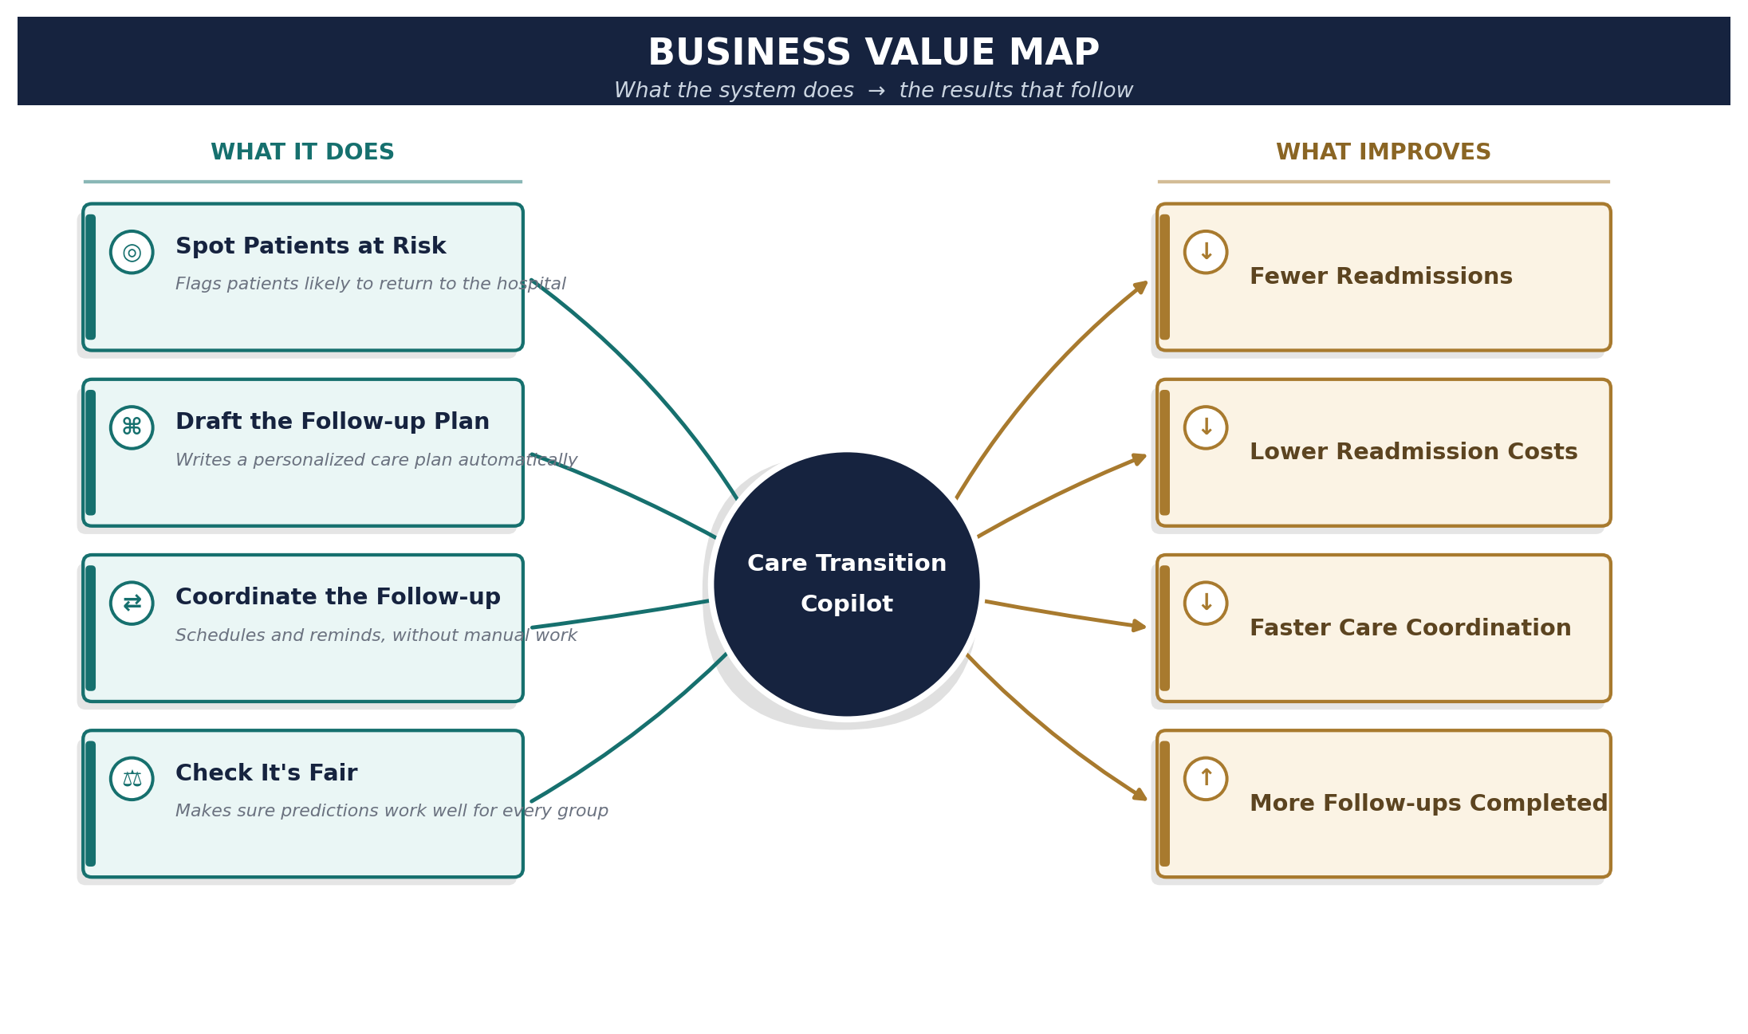
None of the four use cases is valuable on its own — stratifying risk without a follow-up plan just produces a list; drafting plans without clinician review isn't safe to ship. Together, they're what moves the four metrics on the right.

3. What Makes This Use Case Distinct
- Right tool for each job. Prediction is handled by a simple, explainable model — not an AI agent “thinking” about it — while agents are only used for steps that genuinely need reasoning or lookup. That keeps the system easier to trust, debug, and explain to a non-technical stakeholder.
- Fairness is checked, not assumed. The risk model is tested to confirm it works equally well across different patient groups, not just accurate on average — a real compliance concern in healthcare, and something most portfolio projects skip.
- Drafts get a second opinion before a human sees them. The care plan is checked by a second model against a fixed checklist — missed follow-up windows, drug contraindications — before it reaches the clinician, on top of (not instead of) the clinician's own review.
- One project, one clear story. It shows — inside a single working system — exactly when to use a plain prediction model, a single AI agent, and a coordinated team of agents, instead of three disconnected demos.
- Safe to demo anywhere. It runs on synthetic/de-identified patient data, so it can be shown to any audience without real patient information ever being involved.

4. How It Solves It — Layer by Layer
Layer | Responsibility | Why this paradigm
ML / DS | Predicts which patients are likely to be readmitted within 30 days, and checks that the prediction is equally accurate across different patient groups. | This is one clear yes/no prediction with a stable answer — a plain model is the simplest, most explainable tool for that job.
Agent (single loop) | Looks up one patient's chart, notes, and discharge instructions, and answers a coordinator's questions with sources cited. | It's one self-contained task — look something up and answer — so a single agent handles it well without extra complexity.
Agentic AI (multi-agent) | Passes the work between specialized agents in sequence: flag the patient, look up their chart, draft a plan, have a second model critique it, then hand off for review. | Several different jobs need to happen in order and hand off to one another — that back-and-forth is exactly what a coordinated team of agents is built for.

5. Architecture
The same four stages as before, drawn the way a system design doc usually is: numbered end to end, with the two human check-ins and the always-on platform services called out separately.
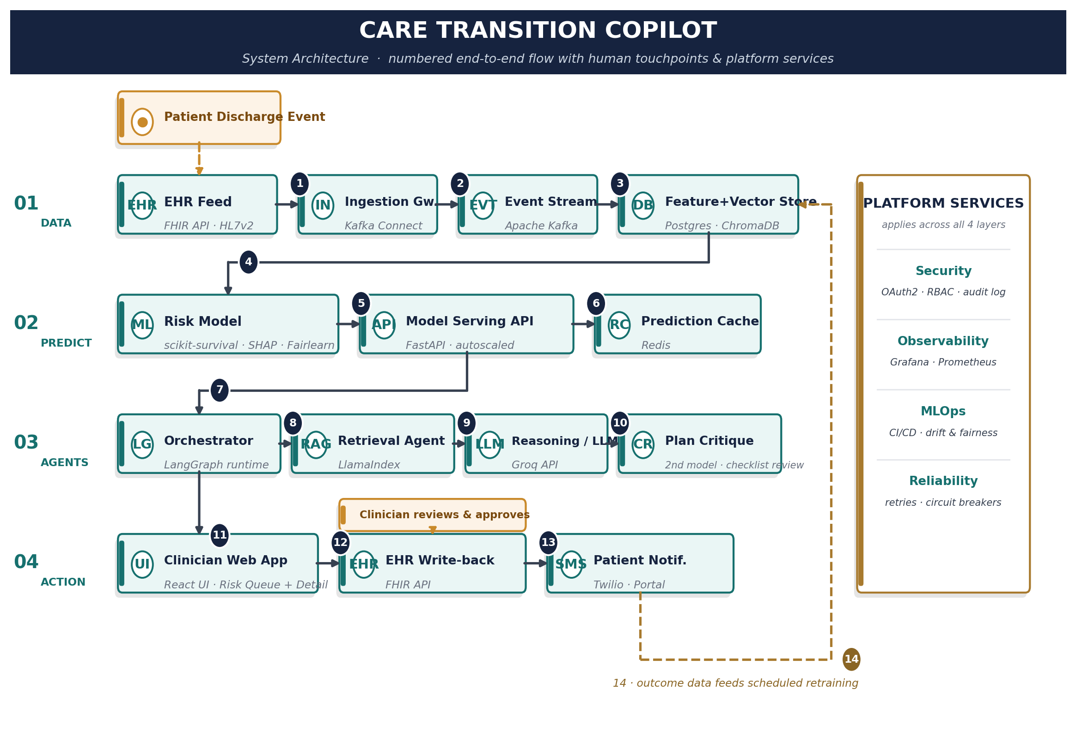
- Data (1–3): A discharge event flows in from the hospital system, moves through a queue, and lands in storage built for both structured data and clinical text (FHIR/HL7v2 → Kafka Connect → Apache Kafka → Postgres + ChromaDB).
- Prediction (4–6): The stored data feeds a risk model, which is served through an API and cached so repeat lookups are fast (scikit-survival model with SHAP/Fairlearn checks, FastAPI, Redis cache).
- Agents (7–10): A high-risk score hands off to an orchestrator, which pulls in the patient's chart, drafts a plan, and runs it past a second model as a checklist-based critique before it ever reaches a clinician (LangGraph, LlamaIndex, Groq-hosted LLM, plus a second critique model).
- Review & action (11–13): A clinician reviews and signs off in the web app before anything reaches the patient record or the patient themselves (React UI → FHIR write-back → Twilio/portal notification).
- Feedback loop (14): what actually happened after discharge flows back into the data layer, so the model keeps improving on real outcomes instead of going stale.
- Platform services: security, monitoring, model-ops, and reliability aren't a separate step — they run underneath all four stages the whole time (OAuth2/RBAC/audit logging, Grafana/Prometheus, CI/CD and drift monitoring, retries and circuit breakers).

6. Application Functionality Map
A different cut of the same system — grouped by feature instead of by data flow, so it's easy to see what the application actually does and which specific software powers each piece.
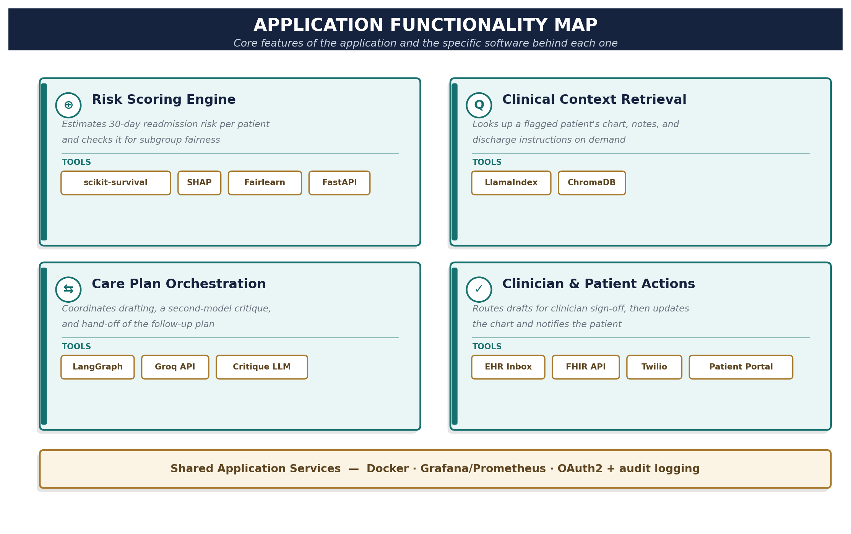

7. UI/UX Design
The web application clinicians use day to day. Three views cover the core loop: see who's flagged, review the details, act on it.

User flow
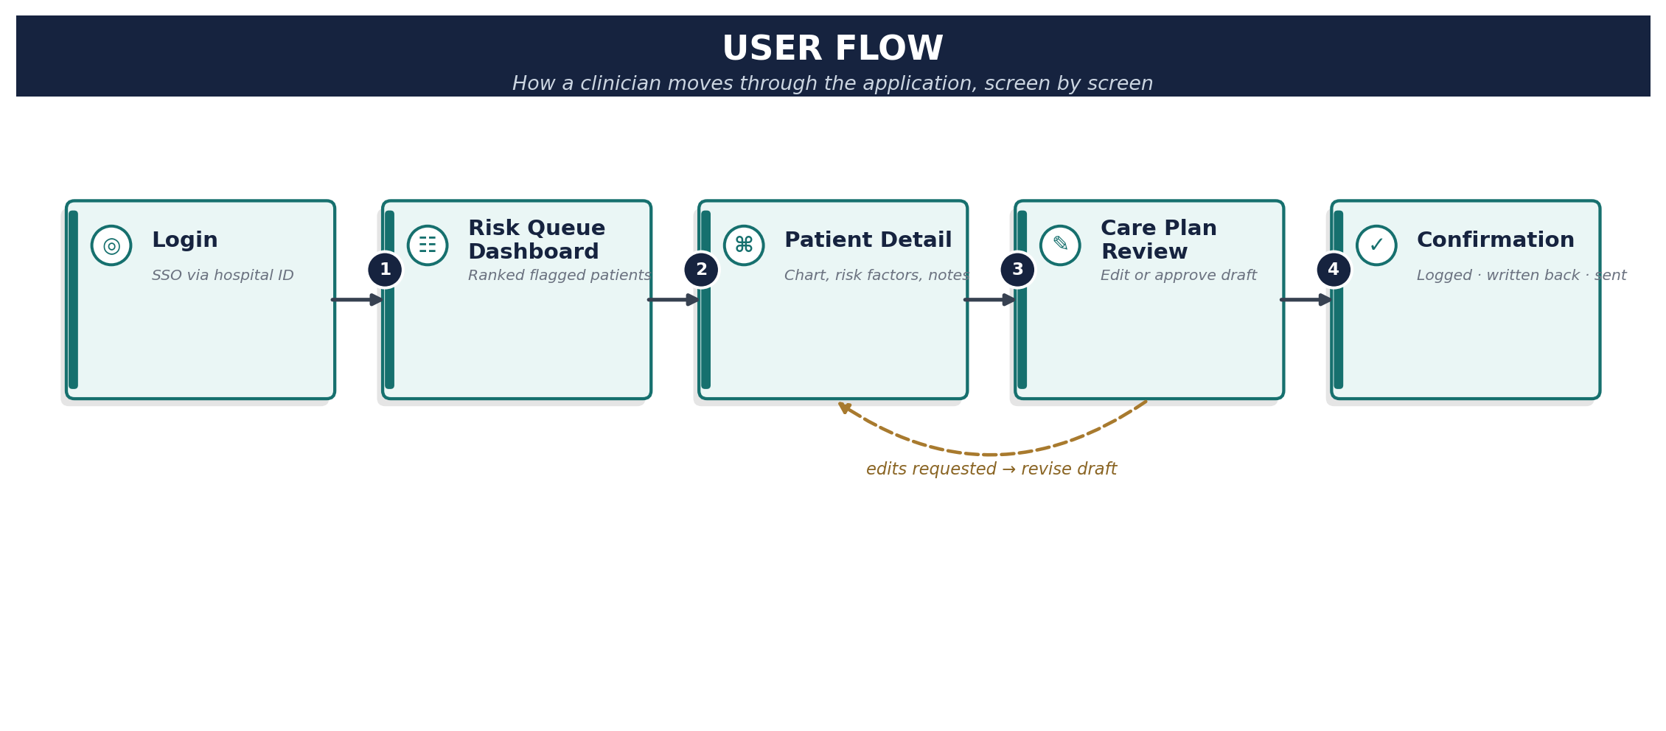

Risk queue dashboard
The landing screen after login. KPI cards give an at-a-glance read on today's volume and fairness status; the table below ranks flagged patients by risk so the highest-priority cases surface first.
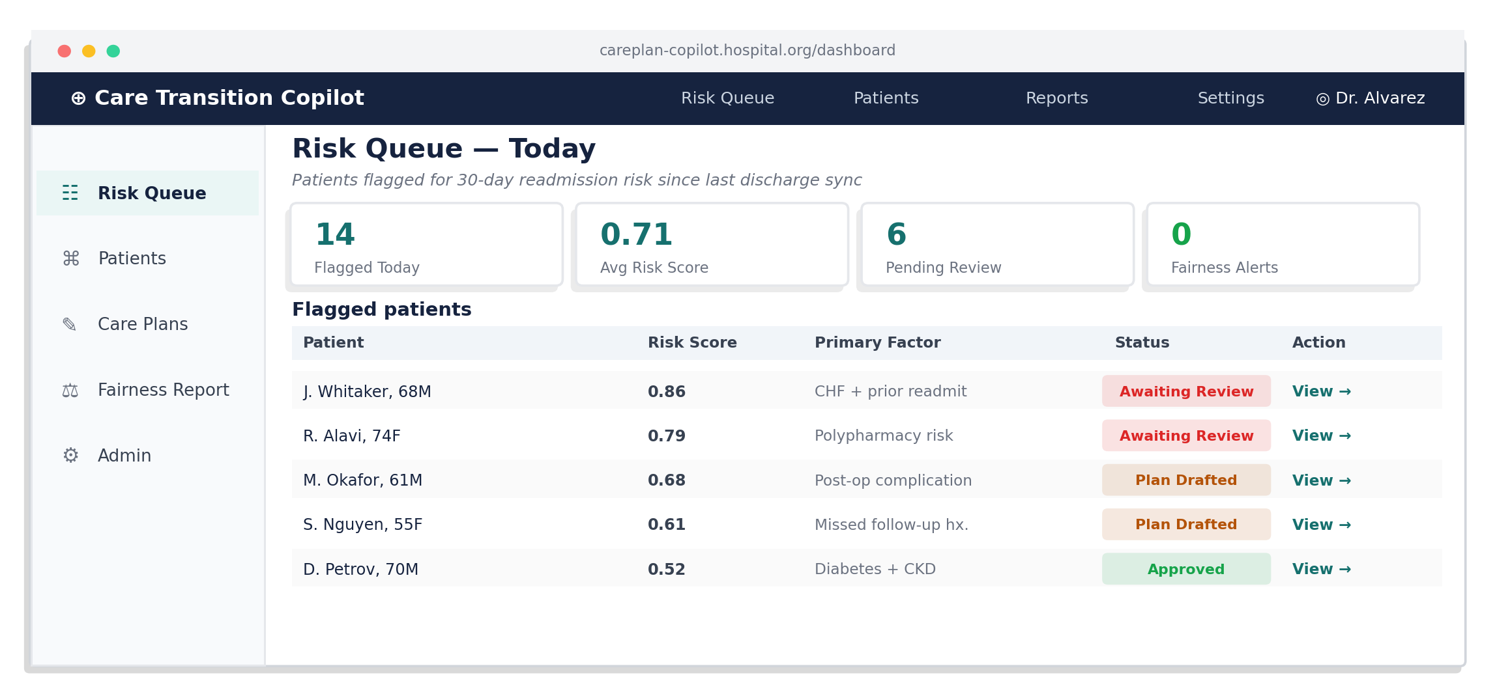

Patient detail & care plan review
Clicking into a patient shows the risk score, the specific factors driving it, and the chart context the agent retrieved (with a citation back to the source note). The AI-drafted plan sits alongside it, and nothing moves forward until the clinician explicitly approves, edits, or rejects it.
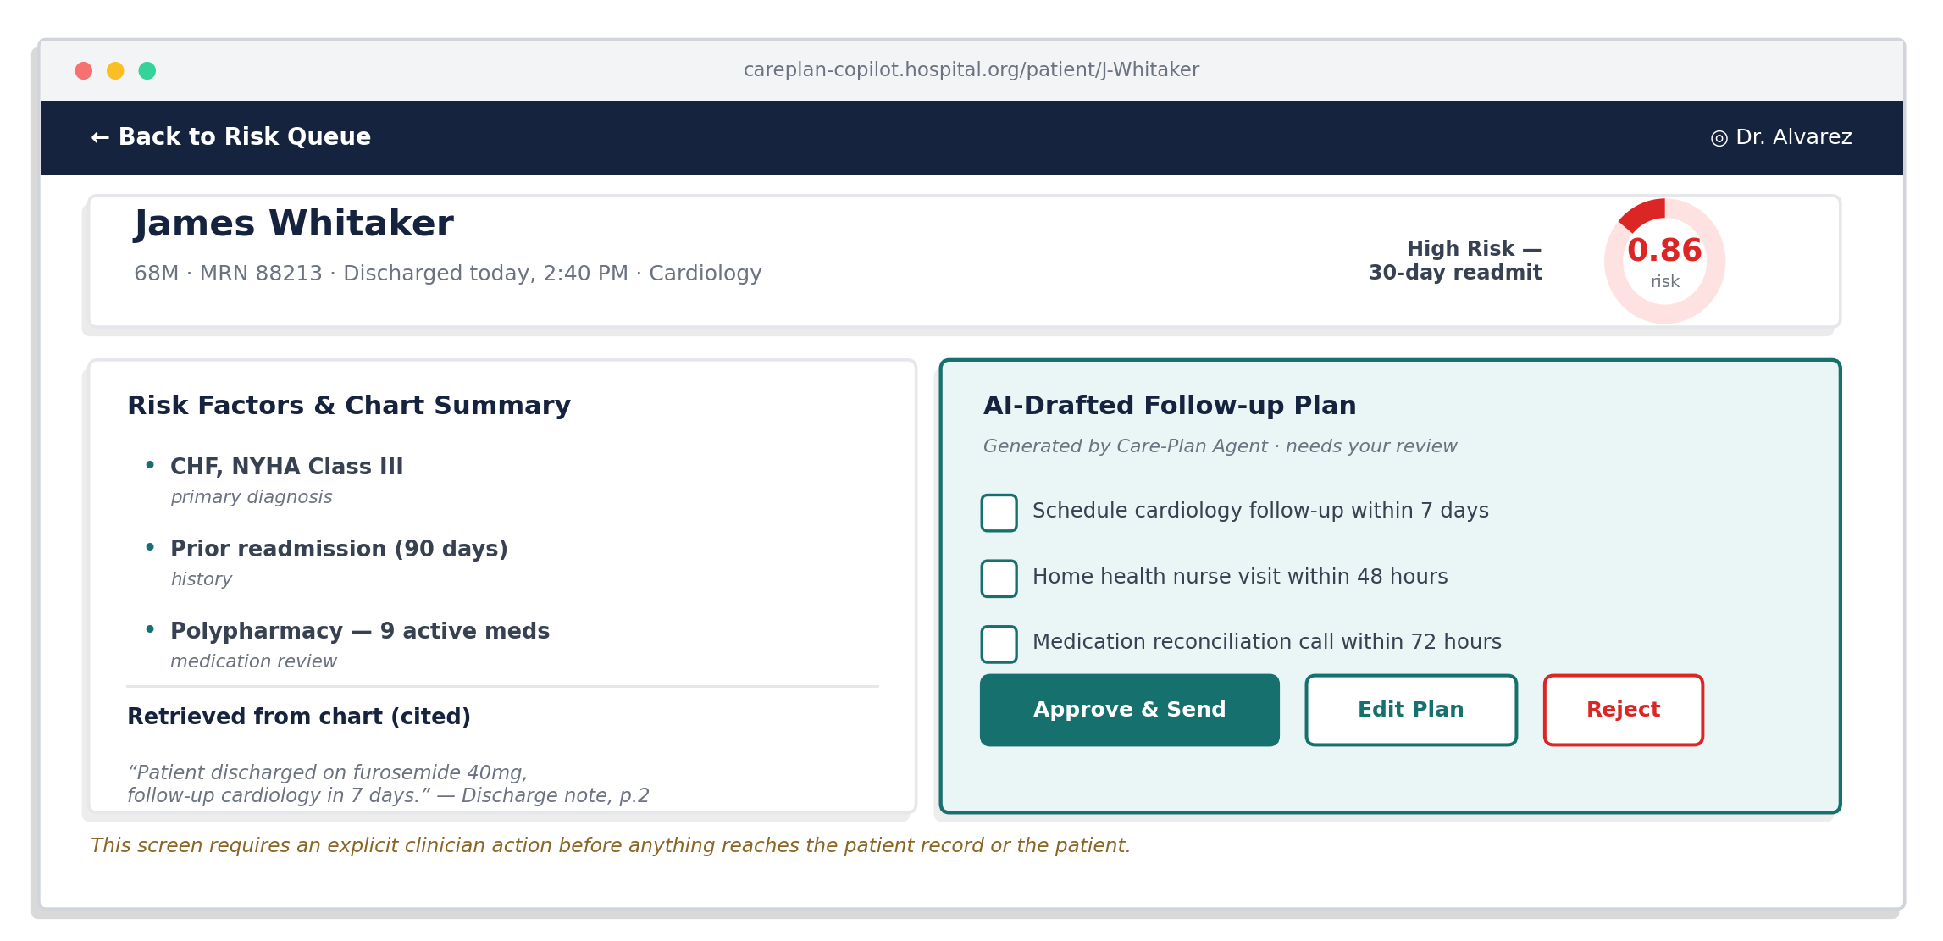
- Design principle: the AI's work is always visibly a draft (distinct panel color, “needs your review” label) until a clinician acts on it — never presented as already-final.
- Design principle: every risk score and chart fact is traceable back to its source, so a clinician can verify before trusting.
- Design principle: the fairness alert count lives on the main dashboard, not buried in a settings page, so equity issues surface without anyone going looking for them.

8. MVP Technology Stack
Component | Stack (MVP)
Risk model | Python, scikit-survival or lifelines (Cox/hazard model), SHAP for explainability, Fairlearn or Aequitas for subgroup fairness audit
Data layer | Synthetic/de-identified EHR data (e.g., MIMIC-IV demo or Synthea-generated records), feature store as a simple Postgres/Parquet layer
RAG / Care-Plan Agent | LlamaIndex or LangChain, ChromaDB for chart/notes embeddings, FastAPI service wrapping the agent
Orchestration | LangGraph (or CrewAI) for the intake → care-plan → critique → explainer → coordinator handoff graph, with shared state object per patient episode
Plan Critique | A second model (e.g., Claude or GPT via an OpenAI-compatible endpoint) reviews the drafted plan against a fixed checklist — missed follow-up windows, drug contraindications — before it reaches the clinician
Explainer / Coordinator | LLM call (Groq or OpenAI-compatible endpoint) constrained to plain-language templates; calendar/reminder stub instead of a real scheduling system for the MVP
Serving & demo | Streamlit or a small React front end for the clinician-facing view; Docker for packaging
Evaluation | Offline fairness metrics dashboard (calibration, FNR parity by subgroup) reported alongside model accuracy

9. Four-Week MVP Timeline
Week | Milestone
1 | Source and prep synthetic/de-identified EHR data; stand up feature store; baseline hazard model trained and validated.
2 | Fairness audit on the risk model (calibration + FNR parity by subgroup); build Care-Plan RAG agent over chart/notes with citation support.
3 | Build the orchestration graph (Intake → Care-Plan → Explainer → Coordinator) with shared episode state and failure recovery on agent timeout.
4 | Wire the clinician-facing demo (Streamlit/React), run end-to-end test episodes, package with Docker, write up results and fairness findings.

10. Success Criteria
- The risk model predicts as well as published research on readmission, and works about equally well across different patient groups.
- When the agent pulls information from a patient's chart, it points back to the correct part of the record — checked by hand on a set of test cases.
- The full process — flag a patient, predict their risk, look up their chart, draft a plan, explain it — runs smoothly end to end without anyone stepping in, including one test where a step fails on purpose and the system recovers.

