Make :
g++ camera_socket.cpp -o camera_socket -D_GNULINUX -finline-limit=10000 -std=gnu++11 -Wall -Wno-long-long -fexpensive-optimizations -fomit-frame-pointer -funroll-loops -pipe -fexceptions -Wpointer-arith -Wcast-align -Wsign-compare -pedantic -O3 -DNDEBUG -rdynamic /usr/local/lib/baumer/libbgapi2_genicam.so -lpthread -ldl -Wl,-rpath,/usr/local/lib/baumer `pkg-config --cflags --libs opencv` -lzmq -I /usr/local/src/baumer/inc

start camera_socket: ./camera_socket
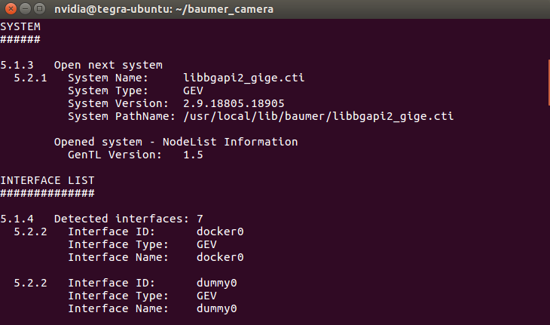
start client: python client.py

ip config :
