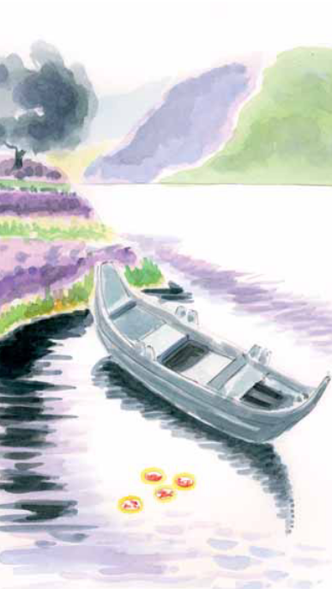
BERGEN, HOLLAND 1421

In 1421, on the Sunday before the Feast of Pentecost, the pastor of the church of Sts. Peter and Paul, not believing the Real Presence of Jesus in the Eucharist, threw consecrated Hosts left over from Mass into the canal. Several months later, some fisherman found the Hosts floating in the water and soaked in coagulated Blood. News of the miraculous recovery of the Hosts spread quickly, and immediately many pilgrims came to see.

