BETANIA, VENEZUELA 1991
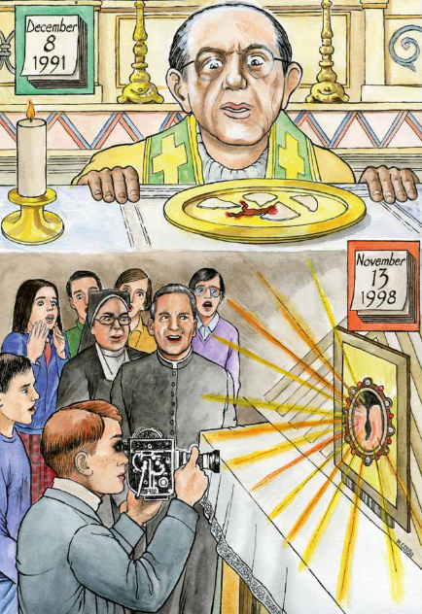
On December 8 of 1991, during the consecration in the chapel of the Shrine of Betania in Cua, Father Otty Ossa Aristizabal broke the host into four sections and consumed one piece himself. Shortly after, one of the remaining pieces began to display a red spot that exuded a red substance.
After a series of studies and hundreds of tests, it was confirmed that the red spot was blood of the AB group and determined to be taken from a living heart. The blood of the priest was also confirmed to be of a different group than the blood of the host, counting out the chance that the priest bled on it.
Today, the Miraculous Host is permanently on display for public adoration in Los Teques at the convent of the Augustinian Recollects Nuns of the Sacred Heart of Jesus.

