CHIRATTAKONAM, INDIA 2001
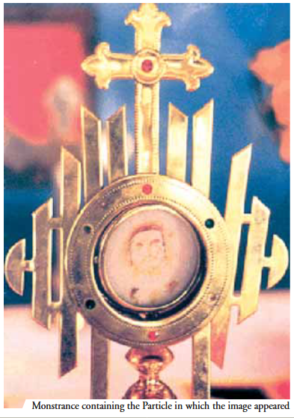
During Eucharistic Adoration at St. Mary’s parish, three red stains suddenly appeared on the Eucharistic host. Unsure of what to do, the priest placed the host back into the tabernacle. Several days later, the priest looked at the host more closely. The red stains had arranged themselves to look like a man. He found a photographer to take pictures of the host, and today, many consider the shape of the face to be that of Jesus. The monstrance containing the miraculous Host is to this day kept in the church.

