ETTISWIL, SWITZERLAND 1447

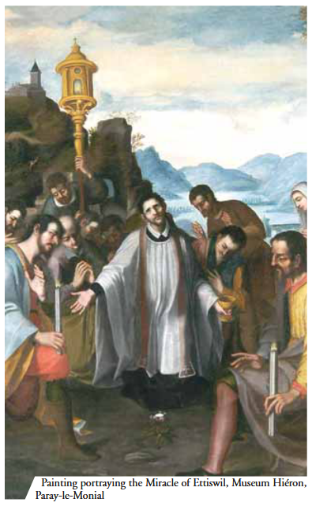
On May 23, 1447 Ann Vogtli, a member of a satanic sect, was able to steal the pyx containing the large Host from the parish church of Ettiswil. As soon as she went beyond the cemetery wall, the Host became so heavy that she was unable to carry it any longer. She threw away the Host. The Host was found close to a fence in the middle of some nettle bushes, lifted high up and surrounded by a vivid light, and was divided into 7 pieces, which were joined together so that they looked like a flower. The local priest was informed and went there at once to bring the Sacred Host back to the church.

