MONCADA, SPAIN 1392

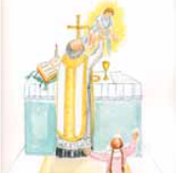
Father Mosen Jaime Carros, a priest in Moncada, was living in anguish that his ordination was invalid. He ardently prayed for the Lord to give him some sign of confirmation. On Christmas Day in 1392, an wealthy woman Angela Alpicat attended Mass with her 5 year old daughter Ines (the future St. Ines de Moncada). At the end of Mass, the little wanted to stay there to play with the beautiful child the pastor had held in his arms during Mass. On December 26, Lady Angela went to Mass again, and when the priest lifted the Host, the little girl saw the child in the hands of the priest. The priest wanted to test her and invited her to attend Mass on the following day. At that time, he took two hosts but consecrated only one of them. Then, taking the consecrated Host, he asked the little what she could see in his hands. Ines answered , “I see Baby Jesus.” Then he lifted the unconsecrated host and asked the same question. “I see a white little disc,” Ines answered. The priest was overwhelmed with joy. His prayer had been answered.

